11-18-16 WSA Board Meeting Minutes

Highlights

- Bob Deyle made a motion for the WSA to write a letter to the WMD and Wakulla County in support of acquisition of Camp Indian Springs and the Corbett property by the WMD or the FL Communities Trust. The motioned was seconded by Tom Taylor and passed unanimously.
- The board approved asking other groups to support the septic system strategy laid out in the pamphlet and then work with the Commissioners and others to implement the appropriate actions. WSA members are encouraged to reach out to leaders and groups to request endorsements of this approach.
- Jamie Hughes asks that you send questions, comments and suggestions regarding her GIS septic system conversion prioritization approach to hughesjn@cdmsmith.com.

Upcoming Events

- BMAP Meeting Tuesday, December 6, 2016, 2:00 PM, Wakulla County Public Library, 4330 Crawfordville Hwy. For more information, contact Moira Hormann at 850-245-8460 or by e-mail at Moira.Homann@dep.state.fl.us.
- Next WSA Meeting: December 16, Renaissance Building, 1st floor Growth Management Conference Room. Ask guards in the hall to let you in.
- Apalachee Audubon Program Meeting, Thursday, January 19, 2017, Thu, January 19, 2017, 7pm – 9pm, King Life Sciences Building, FSU, Jim Stevenson, "Protecting the Values of Florida's State Parks." Jim has been associated with Florida's state park system for 50 years and served as chief naturalist for 20 years.
- Wine & Chocolate Valentines Cruise (February 11, 2017), Wakulla Springs
- View this important video on Florida’s water: “Trouble Waters” https://www.youtube.com/watch?v=sUSyUYfJJwI

Overview

The Wakulla Springs Alliance held a Board meeting on November 18, 2016 at the Renaissance Building. The draft agenda and list of participants can be found in Appendices A and B. Review the action items underlined below for your commitments and actions you can help with. This report is based on the recorder’s notes and does not capture everything or exactly what was said.

Opening

Chair Sean McGlynn welcomed everyone, reviewed the meeting agenda and everyone introduced themselves. Bob Deyle made the motion to approve the minutes of the last Board meeting, which was seconded by Cal Jameson and approved unanimously.
Archeology Update

Jim Dunbar and others from his team reported on past, current and projected archeological studies. Sea levels have been higher in the past and as much as 120 meters lower. Archeology sites in the area date human artifacts that are 14,500 years old; the oldest in America. They showed seeds that would have been eaten by mastodons 37,400 to 38,500 years ago. There was concern expressed about the possible removal of artifacts as the result of proposed legislation and commercial diving.

Legislative Update

Ryan Smart, President of 1000 Friends of Florida, said that there will be nothing to report until next month after the leadership and committees have been designated.

Camp Indian Springs (YMCA) Acquisition

The Wakulla County Board is anti-land acquisition. They don't want more public land. We need to emphasize that there is economic opportunity in acquisition. The YMCA site (Camp Indian Springs) could support diving and recreation with economic benefits. Indian Springs connects to Wakulla Springs by caves and surface water flow. It has been used for diving and recreation for years. It can be a growth industry for Wakulla County which can build an environmental ethic. We have opposed development at Cherokee Sink. The Woodville Karst Plain Project, WKPP. divers are clear that commercial divers can be destructive. There are 37 miles of mapped cave systems. State acquisition has been shut down unless it is for a buddy or recreation. We need money for both acquisition and management, so we can regulate diving and other activities. The NWFWMD may put it on the list for 2017 for Springs funding. They would probably give it to the Wakulla Springs Sate Park. Jim Dunbar said that here are no known artifacts at Indian springs.

Corbett Property Update

The Corbett property is on the Florida Acquisition list. It has swallets and sinkholes and sheet floods. It will go before the Wakulla County Planning Commission for a comprehensive plan change. About ½ of the 360 acres are wetlands and the whole property sheet floods. The proposal calls for 180 single family homes and 50 townhomes. Ryan Smart reported that the attorney for 1000 Friends of Florida has sent a letter (available by request to ttaylor@fsu.edu) to Wakulla County and will speak at the Planning Commission meeting. Cal Jamison and others have good relations with the owners and there was support for helping them get a fair price for acquisition by the State. Bob Deyle made a motion for the WSA to write a letter to the WMD and Wakulla County in support of acquisition of Camp Indian Springs and the Corbett property by the WMD or the FL Communities Trust. The motioned was seconded by Tom Taylor and passed unanimously.

WSA Website and Social Media, Updates

Tom Taylor introduced Rob Gelhardt the WSA new webmaster. He explained and showed what he has been doing. The site is still under construction but can be viewed at http://www.wakullaspringsalliance.org.

GIS Septic System Conversion Prioritization for Wakulla Springs

Jamie Hughes-Davis presented her impressive thesis results that she had presented to State agency GIS experts the day before. She created a GIS raster analysis that prioritizes septic tank conversions by septic parcel within the BMAP primary focus areas. This effort should help focus funds being applied to projects that will provide the greatest benefit to groundwater quality in the springshed. The prioritization criteria included these layers:
Layer 1: Groundwater pollution vulnerability
Layer 2: Locational density of septic systems
Layer 3: Distance to existing central wastewater system infrastructure
Layer 4: Location within springshed
Layer 5: Proximity to underground caves
This should be very useful for the BMAP OSTDS committee, local governments and others. Here is a link to the septic tank conversion prioritization web map she put together with her project inputs and outputs. Jamie Hughes asks that you send questions, comments and suggestions regarding her GIS septic system conversion prioritization approach to hughesjn@cdmsmith.com.

Septic System Strategy

Pam Hall, Debbie Lightsey, Anthony Gaudio, Bob Deyle, Bob Henderson and Tom Taylor have been working on the pamphlet in Appendix D that calls for the City of Tallahassee and Leon County to adopt land development regulations which require new development and redevelopment within the Primary Spring Protection Zone (PSPZ) to meet higher standards for reducing nitrates from OSTDS (septic tanks), as required by Conservation Element policy 4.2.5 in the Comprehensive Plan. The City and County should also advance fund the Sales Tax Project #26, the Alternatives to Sewer Study. This will create a 2-part wastewater management and facilities plan for unincorporated Leon County. The board approved asking other groups to support the septic system strategy laid out in the pamphlet and then work with the Commissioners and others to implement the appropriate actions. WSA members are encouraged to reach out to leaders and groups to request endorsements of this approach including the following:
- Friends of Wakulla Springs [Sean]
- Sustainable Tallahassee [Tom/Pam]
- Apalachee Audubon [Sean]
- Tallahassee Builders Association [who?]
- Septic tank industry [who?]
- Sierra Club [who?]
- Homeowner groups? [who?]
- LWV [who?]
- Other?

Other News
- The State Parks Friends groups (CSOs) meeting with managers will be in September and they may pull out of the park service and operate independently.
- There was a film crew from FSU on Wakulla Springs boat ride. It was a very international crew.
- Chuck Hess is a new Commissioner Elect for Wakulla County.

Appendix A

Wakulla Springs Alliance Board Meeting
11-18-16 Agenda

9:00 Opening
- Welcome and meeting agenda review (Seán McGlynn)
- Introductions (Board)
- Secretary Minutes (Tom Taylor)
- Treasurer Report (Howard Kessler)
9:10 Parks in Peril - Jim Stevenson
- 9:30 Questions
9:40 Wakulla Springs BMAP and the OSTDS committee meeting update– Bob Deyle
- 10:00 Questions
10:10 What’s new
- 11:20 US Highway 319 / Crawfordville Road Widening – Bob Deyle
- Trump, and possible impact to parks and the environment – update
- WSA webmaster, Website and Social Media, Updates – Tom Taylor
- Legislative Update – Ryan Smart, President of 1000 Friends of Florida
- FDEP Water Quality Rule Change – update
- Lake Munson restoration – update
- St Marks Land Acquisition – update
- Corbett property update
- Ferrell property update
- Springshed Updates – Cal Jamison
- Foley Perry Plant, update – Howard Kessler
- Florida Forever Funding – update
- Wakulla Springs Archeology – update
- License Plate Grant and Tracing Studies – Bob Deyle and Seán McGlynn
12:00 Adjourn

Next WSA Meeting: December 16, room 912, Renaissance Building

Upcoming Events
- BMAP Meeting Tuesday, December 6, 2016, 2:00 PM, Wakulla County Public Library
4330 Crawfordville Hwy
- Apalachee Audubon Program Meeting, Thursday, January 19, 2017, Thu, January 19, 2017, 7pm – 9pm, King Life Sciences Building, FSU, Jim Stevenson, "Protecting the Values of Florida's State Parks." Jim has been associated with Florida's state park system for 50 years and served as chief naturalist for 20 years.
- Wine & Chocolate Valentines Cruise (February 11, 2017), Wakulla Springs

Appendix B
Board Advisors and Guests
* Indicates 10-21-16 Participants

Board Members

Bob Deyle *
Gail Fishman
Albert Gregory
Cal Jamison *
Howard Kessler
Todd Kincaid
Debbie Lightsey *
Terrance McCaffrey
Sean McGlynn *
Ryan Smart *
Jim Stevenson
Tom Taylor *
Rob Williams

Guests

Willet Boyer *
Ed Green *
Kathleen Greenwood *
Mark Heidecker *
Chuck Hess *
Bill Howell *
Jamie Hughes *
Joseph Latvis *
Nicole Pezzotei *
Johnny Richardson *
Karel Wolberg *
Nick Wooten *

WSA Advisors

Anthony Gaudio
Pam Hall
Julie Harrington
Bob Henderson *
Bob Knight
Pam McVety
Dan Pennington
Bob Thompson

Appendix C
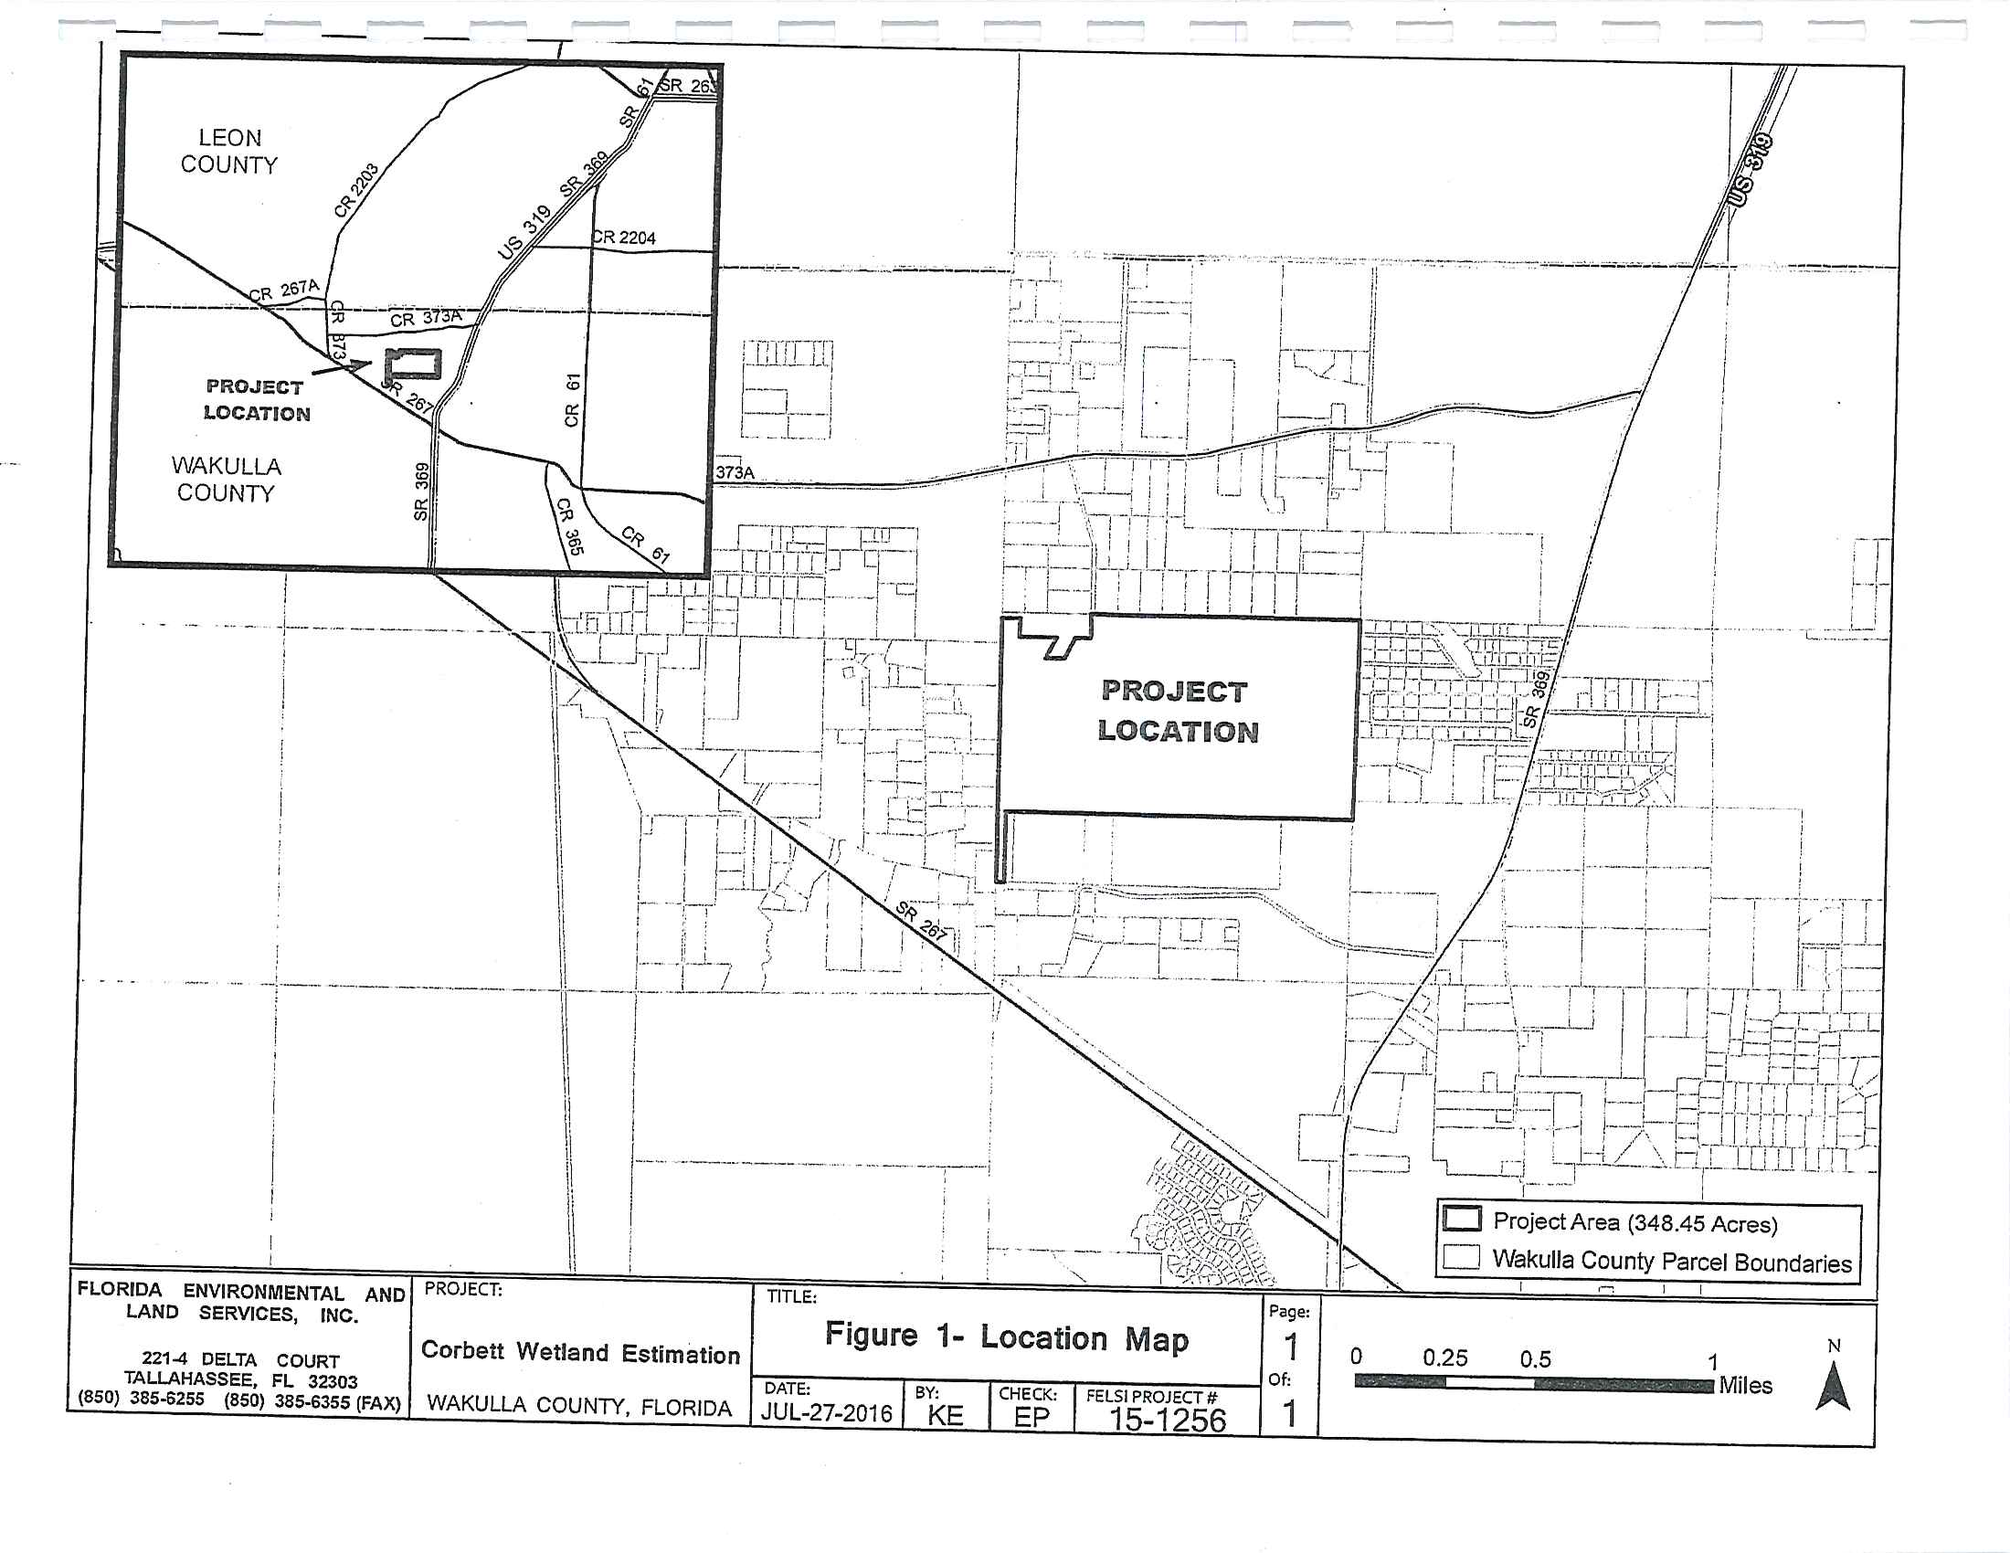
Appendix C


