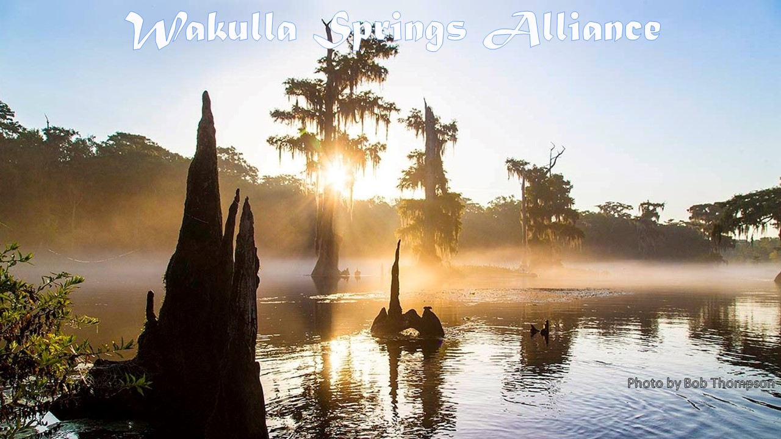

**Minutes: Annual General Meeting and Board Meeting**

**Friday, January 22, 2021**

**9:00 to 11:45 am, via Zoom**

**WSA Annual General Meeting**

**Opening**

* Welcome and introductions - Bob Deyle
* Agenda review – Deyle
* Quorum determination – 33% of 38 members = 13; 14 members present

**Annual financial report**

* Treasurer, Jim Davis, presented the report in Appendix C
* Albert Gregory made motion to approve the financial report, seconded by Howard Kessler and approved unanimously
* Bob Deyle took a moment to recognize Dana Bryan who is our first Life Member with a contribution of $2,000. That very generous contribution would have covered him for 133 years at the retiree rate of $15 per year or 80 years at the regular member rate of $25. Thanks Dana!

**Election of directors**

* The Nominating Committee slate included current board members Bob Deyle, Cal Jamison, Terry Ryan, Lindsay Stevens and Tom Taylor and new directors Rob Gelhardt, Andreas Hagberg and Brian K. Katz.
* No additional nominations were offered.
* Jim Davis made the motion to approve the nomination committee slate, which was passed unanimously.

**January WSA Board of Directors Meeting**

**Minutes of December 18, 2020, meeting**

* Cal Jamison made a motion to approve the minutes, seconded by Jim Davis, which was approved unanimously.

**Election of officers**

* The Nominating Committee nominates the following individuals for election as Officers by the Board. All meet the Bylaws’ eligibility requirements and have consented to be nominated.
  + Chair: Bob Deyle
  + Vice-Chair: Howard Kessler
  + Treasurer: Jim Davis
  + Secretary: Tom Taylor (consents to serve until a replacement is found)
* Lindsey Stevenson made the motion to accept the slate, which passed unanimously.

**WSA strategic plan reminder**

* Tom Taylor presented the [Google Doc with draft set of Wakulla Springs Alliance goals, measures, strategic actions and responsibilities](https://docs.google.com/document/d/1fUeXuM0DL0eHWG_7K4_FEyePC0RbdZUPEfAow7iPEs4/edit?usp=sharing).
* There was a general agreement on these next steps:
* Everyone reviews the draft strategic goals and actions, add comments and suggestions and volunteers for goals and/or specific strategic actions **BY FEBRUARY 15**.
* The WSA Strategic Planning Team (Debbie Lightsey, Gail Fishman, and Tom Taylor) will incorporate input and revise the draft plan for refinement and adoption at the February and/or future meetings.
* Committees and/or individuals will carry out implementation responsibilities.
* There will time at board meetings to report on progress and refine specific strategies.
* If each person makes a commitment to implement one or more action items, we can make a real difference in the incredible Wakulla Springs resources we all love.

**Update on Leon County Comprehensive Wastewater Facilities Plan**

* Anna Padilla is now serving as project coordinator for the CWFP. Theresa Heiker remains involved. We should communicate with both in future.
* The consultants, Stidham Associates, are responding to staff comments on their draft Task 2 report (Cost Effectiveness of Alternative Technologies).
* Staff are now reviewing the consultants first draft of the Task 3 report (Factors Other Than Cost Effectiveness that Influence Selection of Treatment Technology).
* Anna confirmed that the county will send us copies of each task report once consultants have completed any revisions requested by staff.
* Anna confirmed that the county is at loggerheads with the consultant over the comprehensiveness of their assessment of wastewater treatment capacity needs and costs for managing wastewater generated within the unincorporated areas of the county.
* The $1.5m for the pilot has only installed 8 in-ground nitrogen reduction systems and no monitoring has been installed.

**Proposed comments on Wakulla County planned rapid infiltration basin in Wakulla Spring Primary Focus Area**

* Bob Deyle stated that the draft letter circulated with the agenda was prepared with Anthony Gaudio and Ryan Smart at the direction of WSA Board members who participated in the Jan 6 Zoom meeting with Wakulla County and FDEP.
* He acknowledged that they had taken into consideration comments that Doug Barr submitted.
* Bob reported that Big Bend Sierra Club, Florida Springs Council, 1000 Friends of Florida, and Florida Wildlife Federation are interested in co-signing a letter. Friends of Wakulla Springs will be sending a separate letter.
* The focus of concern is treated effluent from the Otter Creek WWTF which is currently disposed of via a spray field adjacent to the WWTF, some of which is planned to be disposed of at a new RIB located on the Jerry Moore property.
* Both the WWTF and the spray field are outside of the BMAP basin and PFA2 while the RIB is within PFA2
* Currently some of the wastewater being treated at the Otter Creek WWTF originates from within the BMAP basin and PFA2 while other portions of the service area, i.e., Sopchoppy and Panacea, lie outside the BMAP basin and PFA2
* The argument we make in the letter is that if treated effluent from wastewater that currently originates within PFA2 were to be disposed of back within the PFA that would comprise an increase in the nitrogen load to the aquifer within the PFA and would set back efforts to reduce total nitrogen loading to Wakulla Spring so as to attain the TMDL.
* Using data collected by Kathleen Coates from the county, Bob calculated estimates of how many new septic tank conversions to sewer would be required to offset the nitrogen loading from diversion of treated effluent to the RIB 2027 that originated from existing connections within the PFA in 2020
  + Offsetting somewhere between 1892 and 2271 lbs.-N/yr. will require converting between 199 and 239 existing OSTDS to sewer connections.
  + If the RIB were situated outside the PFA those conversions would accrue to reducing the nitrogen load to Wakulla Spring.
* In addition, Doug Barr conducted a field visit and a review of satellite imagery to ascertain the presence of sinkhole lakes on or near the RIB site and sent a letter to FDEP yesterday raising concerns about potential impacts of the RIB.
* Meanwhile, the FDEP State Revolving Fund Program issued a Notice of Availability of a Finding of No Significant [Environmental] Impact (FONSI) on January 14.
* The Board agreed that the letter should be expanded to raise concerns with possible pollution of sinkhole lakes.
* Cal Jamison pointed out that the site has not received large quantities of water in the past. If an RIB is constructed the underlying soils and karst limestone will adjust to the inflow which may lead to new conduits and possibly new sinkholes thereabouts. He will review the detailed LIDAR imagery he has to see what other karst features may exist near the site.
* Andreas Hagberg indicated that he had mapped some caves in the area and offered to provide that information.
* Gail Fishman noted that concerned citizens are sharing information about this on the Wakulla County Environmental Caucus Face Book group.

**Update on FDEP rulemaking to protect Outstanding Florida Springs from harmful water withdrawals** – Ryan Smart

* The 2016 Florida Springs and Aquifer Protection Act required FDEP to adopt rules to prohibit ground water withdrawals harmful to springs. At a Senate committee meeting two weeks, FDEP Secretary Noah Valenstein acknowledged that FDEP has not undertaken any efforts to develop such a rule. They want to take the Central Florida Water Initiative approach which is not about protecting springs or aquifers per se; instead, it is focused on developing alternative water supplies. Their plan is to replace the term “harm” with “adverse impact.” This is a less protective standard in Florida case law. The Springs Council will keep us apprised of the status of this move and alert us to opportunities to comment.
* There is a proposal in the works to use the PACE Program to help homeowners pay for sewer connections.
* Budget - Current statutory allocation: $264 million annually for Everglades Restoration; $50 million for Springs and River; $0 for Florida Forever. Currently two bills in the works. The first would allocate $100 each year for Florida Forever. The second would increase springs and rivers allocation to $150 million. Both of these would be good for North Florida waters.

**Approach to commenting to Northwest Florida Water Management District Board on proposed minimum flow for Wakulla and Sally Ward Springs**

* Bob Deyle reported that he, Doug Barr, and Terry Ryan submitted personal comments on the Draft Wakulla Spring and Sally Ward Spring Minimum Flows and Levels Technical Report. Copies of Doug Barr’s comments and his are on the WSA website.
* The WSA will have the opportunity to formally comment on the draft proposed rule during a 21-day window that will follow publication of the Water Management District’s notice of rulemaking which Carlos Herd indicated would likely happen around April 1. Carlos noted, however, that comments could be submitted sooner.
* In the meantime, the district plans to hold a public workshop in mid-February somewhere between the 12th and the 19th. Exact timing will depend on when the district receives written comments from its peer review team which are expected the first week of February. Staff will provide a briefing to the Governing Board on March 11.
* Bob indicated he would request copies of the peer review and other comments submitted on the draft technical report.
* Brian Katz agreed to work with Bob to prepare draft comments for the Board’s consideration.

**Upcoming meetings and events** – Deyle

* **February 26** - Why is the Water Dark? Part III
* **March 26** - TBA

**Insurance update**

* Bob Deyle reported continuing problems getting responses from both the insurance agent and the carrier.
* Rob Gelhardt recommended trying Waterhouse Insurance for whom he designed their website. He will provide contact information. (Jacob Waterhouse, 850-412-1099).

**What’s new?**

* **Springshed and river update**
  + Cal Jamison reported that the river stage is low – 0.6 ft at the boat dock staff gauge, while the water remains quite dark. All of the major sinking streams are flowing as well as the smaller swallets. Visibility was 7 feet last week; 16 feet this week.
  + Specific conductivity has increased to over 300 micro Seimens. Nitrates have been above 0.40 and 0.50 mg/L in recent days.
  + Cal related seeing a black vulture fall off the railing of one of the swimming rafts and proceeding to swim across the river to get out of the water. Who knew?
* **Rob Gelhardt reported** that he has identified some people who he thinks would be willing to donate money to the Alliance. He also reported that he has about 100 copies of a Clyde Butcher print of a 30” x 18” photo of the Wakulla River that could be offered for sale, or as a gift to people who contribute, or even to public officials, if that wouldn’t violate the state’s public officials gift rules.
* **Jim Stevenson promoted** Bob Knight’s new book, *Silent Springs*, published by Alta Press.

**Adjourn**

Appendix A

**Agenda: Annual General Meeting and Board Meeting**

**Friday, January 22, 2021**

**9:00 to 11:45 am, via Zoom**

**Annual WSA General Meeting**

**9:00 Opening**

* Welcome and introductions - Bob Deyle
* Agenda review – Deyle
* Quorum determination – Tom Taylor

**9:10 Annual financial report** – Jim Davis

**9:20 Election of Directors**

* Presentation of nominees - Nominating Committee
* Nominations from the floor – Deyle
* Vote by members [anonymous] – Deyle

**9:35 Adjourn**

**January WSA Board of Directors Meeting**

**9:40 Minutes of December 18, 2020, meeting** - Taylor

**9:45 Election of Officers**

* Presentation of nominees - Nominating Committee
* Nominations from other directors - Deyle
* Vote by directors [anonymous] - Deyle

**10:00 Strategic plan reminder** - Taylor

**10:05 Update on Leon County Comprehensive Wastewater Facilities Plan** – Anna Padilla, Leon County Public Works

**10:25 Proposed comments on Wakulla County planned rapid infiltration basin in Wakulla Spring Primary Focus Area** – Bob Deyle, Anthony Gaudio, Ryan Smart

**10:55 Update on FDEP rulemaking to protect Outstanding Florida Springs from harmful water withdrawals** – Ryan Smart

**11:05 Approach to commenting to Northwest Florida Water Management District Board on proposed minimum flow for Wakulla and Sally Ward Springs** - Deyle

**11:15 Upcoming meetings and events** – Deyle

* February 26 - Why is the Water Dark? Part III
* March 26 - TBA

**11:20 Insurance update** - Deyle

**11:25 What’s new?**

* Springshed and river update - Cal Jamison
* What else?

**11:45 Adjourn**

Appendix B

**1-22-21 WSA Meeting Participants**

**\* indicates those present**

Officers

Robert E. Deyle, Chair *  
Debbie Lightsey, Vice-Chair *  
Gail Fishman, Secretary, *   
Jim Davis, Treasurer *

Directors

Albert Gregory *  
Cal Jamison *  
Howard Kessler *  
Terry Ryan   
Lindsay Stevens *  
Jim A. Stevenson *  
Tom Taylor *

Members

Andreas Hagberg *

Anthony R. Gaudio

Bill Carroll

Bob Thompson

Chuck Hess *

Craig Diamond

Dan Pennington

Dana Bryan

Don Lanham

Doug Barr

George Apthorp

Grant Gelhardt

Hal Davis

John Outland

Meredith Tanguay

Michael Hill

Nico Wienders

Pamela Hall

Peter Scalco

Rob Gelhardt *

Ryan Smart *

Sandy Cook

Sophie Wacongne-Speer *

Steve Urse

Thomas Sawicki

Zoe Kulakowski

Guests

Carlos Herd *

Wayne Cooper *

Mark Heidecker *

Johnny Richardson *

Anna Padilla *

Sue Damon *

Appendix C

**WAKULLA SPRINGS ALLIANCE  
FINANCIAL REPORT  
FOR THE YEAR ENDED DECEMBER 31, 2020**

** $**

page1image5023296page1image5016576