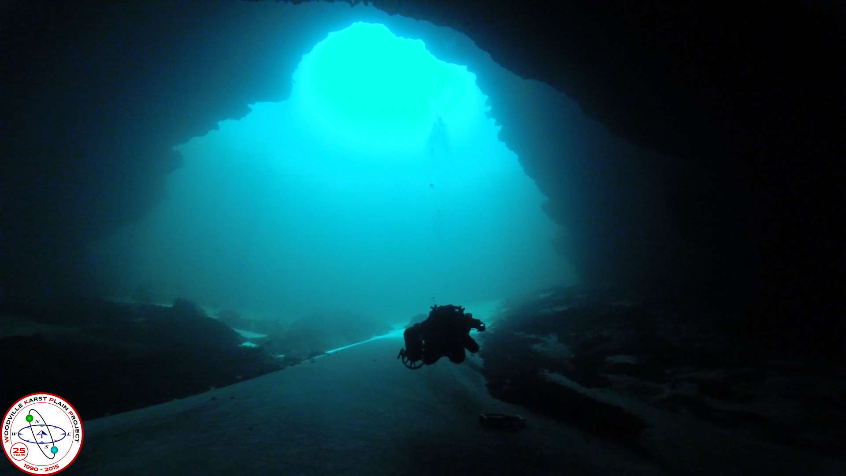
Wakulla Springs Alliance

Minutes for Friday, December 15, 2017
Woodville Community Center
8000 Old Woodville Rd, Tallahassee, FL 32305

This section provides information on what you and others can do to support research-based actions to enhance water quality and quantity in Wakulla Springs and springshed and to improve related environmental, economic and social systems. Efforts by all, produce results!

Background

• Wakulla Springs Information
• WSA Purpose and Plans
• WSA Action Resources

Upcoming Events

- Put the WSA Board meeting on your calendar (4th not 3rd Fridays) Jan 26, Feb 23, Mar 23, Apr 20, May 25, Jun 22, Jul 27, Aug 24, Sep 28, Oct 26, Nov 30 (5th Fri), Dec 21. All 2018 WSA Board Meetings will be held in the 2nd floor conference room at the Renaissance Building, 435 N. Macomb St.
- BMAP OSTDS Committee meeting in January at a date TBD.
- Camp Indian Springs Auction on January 14

Action Items

- Jim Stevenson provided copies of the video and Bob Deyle will take them to the City and County Commissioners. Share the Water’s Journey video on the WSA website.
- Bob Deyle, Pam Hall and others may meet with staff on the Wastewater Facilities Engineering Plan RFP revisions. Wakulla County needs to do something similar. Copy City commissioners and staff on correspondence.
- FDEP’s has revised Nitrogen Source Inventory Loading tool, NSIL, that the OSTDS Committee uses this in developing amendments to the BMAP. Pam Hall, John Buss and Bob Deyle raised concerns about calculations and assumptions. Bob Deyle sent email to Greg Diangilo and will have a meeting with Greg and Pam Hall in January.
- We need to be prepared for the next OSTDS meeting on January 9. A draft plan is to be sent out before the meeting that will look like those for other springs. The plans don’t allocate responsibility for pollution. They list the planned projects and the gap to be met by the BMAP. We need to advocate for a meaningful plan. We can use the WSA meeting to talk about recommendations. Bart Bibler will talk to Bob Knight, Rob Williams, Ryan Smart and others about potential litigation and media advocacy.
- Camp Indian Springs will be auctioned on January 14. Rick Kearney has submitted a bid and he presented his proposal. A motion was approved for Howard Kessler, Albert Gregory and Debbie Lightsey to prepare a letter of support for the concepts proposed, including public access to the springs and trails, waste treatment, etc. The letter will go to the trustee. The letter will be circulated to the full board for comment with approval by the executive committee. Howard Kessler will research the other bidders.
- Bob Deyle, Bart Bibler and Chuck Hess were approved to be the nominating committee. The plan is to send out the slate of nominations no later than February 9, 14 days before the February 23 Annual General Meeting for election of Board Members to be followed by the February Board Meeting for election of Officers and regular business. The bylaws call for the selection of the nominating committee 90 days before the elections. This bylaw provision will need to be amended at the January 26th or February 23 meeting. It is here by proposed that the Bylaws of the WSA be amended to eliminate the provision for selection of the nominating committee 90 days before the annual election.
- Seán McGlynn, Bob Deyle provided a Lake Jackson Dye Study update. They reported that they are changing the method of measuring dye and have an extension on the grant until June. The results show a 30 days travel time from Lakes Jackson, Lafayette and Munson to Wakulla Springs; about 5 miles per day. The results will be prepared soon. The City and County representatives want the results and to participate in the future dye studies. This can be a game changer in terms of sewering. They may do dye tests of other lakes. Johnny Richardson suggested that they explore the Ochlocknee watershed connection. The water may flow there from Lake Jackson. He encouraged coordination with FGS that is doing dye testing that could have interactive impacts. BMAP septic system study needs to consider lake contributions to impacts at Wakulla Springs.

12-15-17 WSA Board Meeting Minutes

Overview

The Wakulla Springs Alliance held their regular Board meeting on December 15, 2017 at the Woodville Library. The agenda and participants are in Appendices A and B. Review the action items underlined for your commitments and actions you can help with. Our success in protecting and enhancing Wakulla Springs depends on the actions of the WSA board, advisors and supporters. This report is based on the recorder’s notes and does not capture everything or exactly what was said.

Opening

- Welcome and meeting agenda review (Seán McGlynn)
- Introductions (Board, advisors and guests)
- The minutes were approved
- Treasurer Report: Jim Stevenson had a $568 check from his tours. The motion to approve the Treasurer’s Report was made by Tom Taylor and seconded by Bob Deyle with unanimous approval.
- Wakulla Springs Tour Video: Jim Stevenson provided copies of the video and Bob Deyle will take them to the City and County Commissioners. Everyone should share the Water’s Journey video on the WSA website.
- Ted Turner’s book was passed around

Wakulla Springs BMAP / OSTDS update

Leon County’s RFP for the Wastewater Facility Engineering Plan – Bob Deyle
- This will be a 3-part initiative to identify the most cost-effective way to mitigate Nitrogen from septic systems. The WFEP Plan has been funded by Blueprint. The Request for Services was presented to the OSTDS committee for comment and has been rewritten to be a RFP. The County Commission met, considered comments before and at the meeting and will be revising the RFP. It will be reconsidered in January. Bob Deyle, Pam Hall and others may meet with staff on the WFEP RFP revisions.
- Wakulla County needs to do something similar.
- This was one of the most successful advocacy efforts and response by government. Some commissioners may not be supportive. Copy City commissioners and staff on issues. Woodville may be the issue.

FDEP’s Revised Nitrogen Source Inventory Loading Tool – Bob Deyle
- The OSTDS Committee is developing an amendment to the BMAP.
- New NSIL was presented at the last OSTDS Committee meeting.
- Pam Hall, John Buss and Bob Deyle raised concerns about calculations and assumptions.
- Bob Deyle sent email to Greg Diangilo and will have a meeting with Greg and Pam Hall in January.
- January (date TBD) is the next OSTDS meeting with a draft plan to be sent out before the meeting like those for other springs. They don’t look like plans or allocate responsibility. It lists the planned projects and the gap to meet the BMAP. We need to advocate for a meaningful plan. We can use the WSA meeting to talk about recommendations.
- The shrinking % contribution from septic systems is a concern.
- Hal Davis says only 2% of atmospheric deposition reaches the aquifer. Jim Stevenson and Had Davis drove all over S. Georgia and only found a few ag operations. Most are quail plantations. DEP uses GIS maps to calculate ag area and applied concentration levels from other areas in the FL.
- A mitigation plan needs to acknowledge that the focus should be on calculating the non-mitigatable load.
- Bart Bibler is on the FL Springs Council and there was a meeting of Springs Groups and they formulated a statement that the FL Springs Protection Act is a sham. This is a state problem. There is a legal challenge to the Suwannee basin BMAP. We have 6 months to work with DEP to get it right.
- There is a long-term decrease in Nitrogen coming to Wakulla Spring and a steeper decline since 2012 when the City Waste Treatment Plant upgrades came on line. We also need to look at the biological conditions.
- Science and politics come together. The new NSIL looks like a political decision. The home rule issue in the Legislature may infringe on local governments’ ability to do anything about septic systems. It may require a legal challenge. We can develop a media challenge too.
- We may need a litigation fund and get good legal advice pro bono. Bob Palmer found conflicting provisions on when a BMAP is final and when it can be litigated. 1000 Friends attorney, Thomas Hawkins, may give us advice. We may support a FSC suit or file our own. Filing a suit can open negotiations without a lot of litigation expenses.
- The WSA will explore the BMAP litigation potential. Bart Bibler will talk to Bob Knight, Rob Williams, Ryan Smart and others about potential litigation and media advocacy. Bart Bibler made the motion and Tom Taylor seconded it with unanimous. Approval. See talking points in Appendix E.
- Jim is taking law students on the tour in February.

Camp Indian Springs Auction
- There will be an auction on January 14.
- Rick Kearney talked about his bid and proposal for the property.
- He has a history of business and community leadership, successful real estate development, including the homeless center, small house community, transitional housing, and more.
- Wakulla County has a proposal, if the State purchases it for recreational uses and development.
- It will take a lot of money to develop it.
- Kearney said it can be a diving and tourist destination in restored cabins and camping. It would be a place for veterans and public service people with PTSD housing and treatment isolated from the tourist area. It could include dog rescue and care therapy. Waste would be managed.
- Kearney wants to partner with WSA and other groups on restoration efforts including exotic removal, trails, etc.
- The spring and trails would be open to the public.
- He is open to best ways to deal with waste.
- There are good dog rescue and therapy programs to partner with.
- There is demand for camping in the area at certain times of the year.
- If the state purchased it there may not be money to make improvements.
- Bart has helped install solar, rain gardens, etc. at the small house project.
- There is an Indian mound and there will be an archeological study as part of the permit process.
- Talk to the Friends of Wakulla Springs about the visitor center at Wakulla Springs that can be complementary. Visitors will have a menu of experiences and programs. Talk to Park staff and Cal Jameson about ideas.
- The water is very clear in Indian Spring so there can be more days for diving.
- The site could be connected to the central sewer for Wakulla Springs or create a model cluster system.
- Kearney has a track record of keeping his commitments.
- Howard Kessler will research the other bidders.
- A motion was approved for Howard Kessler, Albert Gregory and Debbie Lightsey to prepare a letter of support for the concepts proposed including public access to the springs and trails, waste treatment, etc. The letter will go to the trustee. The letter will be circulated to the full board with approval by the executive committee.

Update on the closure of Highway 61 south of Hwy 267
- Chuck Hess reported that it isn’t died but there is no movement.

Land use in the unconfined aquifer areas
- Gail Fishman reported that there has been some burning on Tram road but no planting.
- Gail is following development around the widening of Capital Circle across from the airport. There are digging a retention pond.

Selection of a “Nominating Committee”
- Bob Deyle, Bart Bibler and Chuck Hess were approved to be the nominating committee. The plan is to send out the slate of nominations no later than February 9, 14 days before the February 23 Annual General Meeting for election of Board Members to be followed by the February Board Meeting for election of Officers and regular business. The bylaws call for the selection of the nominating committee 90 days before the elections. This bylaw provision will need to be amended at the January 26th or February 23 meeting. It is here by proposed that the Bylaws of the WSA be amended to eliminate the provision for selection of the nominating committee 90 days before the annual election.
- The following directors’ terms end in January 2018: Bob Deyle, Gail Fishman, Albert Gregory, Howard Kessler, Debbie Lightsey, Sean McGlynn, Ryan Smart, Jim Stevenson, and Tom Taylor

Lake Jackson Dye Study Update
- Seán McGlynn, Bob Deyle reported that they are changing the method of measuring dye and have an extension on the grant until June.
- The results show a 30 days travel time from Jackson, Lafayette and Munson to Lakes to Wakulla Springs; about 5 miles per day.
- There is a relation to Spring Creek, which has reversed this week for the first time in a year. There is no dye at Spring Creek. Colored water goes to Spring Creek when it is flowing.
- The results will be prepared soon. The City and County representatives want the results and to participate in the future.
- This can be a game changer in terms of sewering.
- They may do dye tests of other lakes. Tannin could come from lakes.
- Johnny Richardson suggested that they explore the Ochlocknee watershed connection. The water may flow there from Lake Jackson.
- Coordinate with FGS that is doing dye testing that could have interactive impacts.
- Lake Iamonia has been draining and probably going to Wakulla.
- BMAP septic system study needs to consider lake contributions to Wakulla Springs.

The Springs of America (other States)
- Jim Stevenson showed slides of springs he has visited in Georgia, Alabama, Maine, Texas, New Mexico, Arizona, Utah, Idaho, Wyoming, California, New Jersey, Turkey, Romania, Morocco (Albert Gregory).
- There was nothing like what we have in Florida.

Adjourn
- Bob Deyle made the motion, seconded by Debbie Lightsey and approved unanimously.

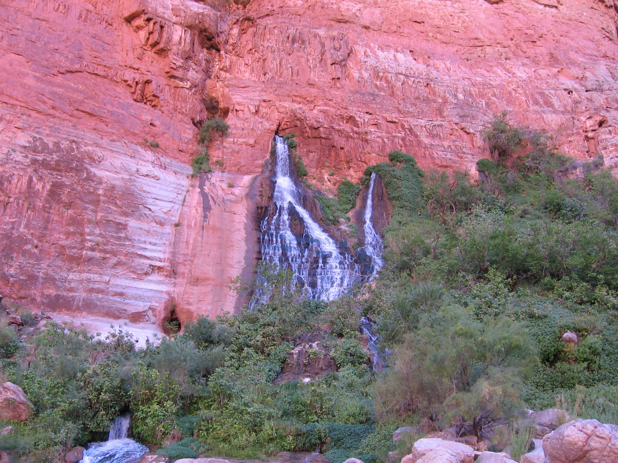
Springs in the Grand Canyon, Jim Stevenson
Merry Christmas

Appendix A
Wakulla Springs Alliance Board Meeting Agenda
Woodville Library and Community Center
12-15-17
9:00 Opening
Welcome and meeting agenda review (Seán McGlynn)
Introductions (Board)
Secretary Minutes (Tom Taylor)
Treasurer Report (Bob Henderson)
9:10 Wakulla Springs BMAP / OSTDS update – Bob Deyle
- Leon County’s RFP for the Wastewater Facility Engineering Plan – Bob Deyle
- FDEP’s Revised Nitrogen Source Inventory Loading Tool – Bob Deyle
10:00 Springshed Updates – Cal Jamison
- Camp Indian Springs for Auction – Cal Jamison
- Update on the closure of Highway 61 south of Hwy 267 – Chuck Hess
- Land Acquisition – Cal Jamison
- Land use in the unconfined aquifer areas – Gail Fishman
10:30 Selection of a “Nominating Committee” – Tom Taylor (see Attachment 3)
- Website and Social Media, Updates – Tom Taylor
10:45 Lake Jackson Dye Study Update – Seán McGlynn, Bob Deyle, Cal Jamison
11:00 Items from the floor
11:30 The Springs of America (other States) – Jim Stevenson
12:00 Adjourn

Attachments: 10-20-17 Minutes and Action Items
Attachments: WSA Financial Statement 30Nov2017
Attachments: WSA Comments Leon County’s RFP for the Wastewater Facility Engineering Plan
Attachments: Note regarding nomination committee

Springs in the Grand Canyon, Jim Stevenson
Merry Christmas

Appendix B
Board Advisors and Guests
* Indicates 9-15-17 Participants

Board Members

Bart Bibler *
Bob Deyle *
Gail Fishman *
Albert Gregory *
Bob Henderson
Cal Jamison
Howard Kessler *
Debbie Lightsey *
Sean McGlynn *
Ryan Smart
Jim Stevenson *
Tom Taylor *
Rob Williams

Guests

Kathleen Coates *
Jim Davis *
Jon W. Dodrill *
Mark Heidecker *
Rick Kearney *
Somer Pell *
Bob Rackleff *
Johnny Richardson *
Carol Swartz *
Debbie Tipton *

WSA Advisors

Anthony Gaudio *
Pam Hall
Julie Harrington
Chuck Hess *
Todd Kincaid
Bob Knight
Terrance McCaffrey
Pam McVety
Dan Pennington
Bob Thompson *
Appendix C

 | Financial Statement
 | Wakulla Springs Alliance
 | For Period Ended
 | November 30, 2017
INCOME | Budget | In-Kind | Current Month | Y-T-D  Trans |  | Checking Account
Fund Balance (January 1, 2017) | 3854.46 |  |  | 3854.46 | BFB | 3854.46
Palmetto Tours |  |  |  | 581.00 | Income | 831.00
Board Member Contributions (4) |  |  |  | 250.00 | Expense | 930.51
Other Donations |  |  |  |  | Grant
 |  |  |  |  | EFB | 3754.95
Subtotal | 0.00 | 0.00 | 0.00 | 831.00
TOTAL | 3854.46 | 0.00 | 0.00 | 4685.46
EXPENDITURES |  |  |  |  | Rest
Secretary Expenses |  |  |  |  | Unrest | 3754.95
Web Support |  |  | 60.51 | 499.26
Corporate Filing Fee | 61.25 |  |  | 61.25
Grants |  |  |  | 200.00 | Bank Statement | 3754.95
Board Workshop |  |  |  | 170.00 | Checks not
 |  |  |  |  | Recorded
RESERVES
 |  |  |  |  | Deposits not
 |  |  |  |  | Recorded
 |  |  |  |  | Due to/from
 |  |  |  |  | Projects Fund
 |  |  |  |  | EFB | 3754.95
TOTAL | 61.25 | 0.00 | 60.51 | 930.51 | (Overage) | 0.00

Appendix D
Wakulla Springs Alliance

Board of Directors

Chairman
Seán McGlynn Ph.D.
McGlynn Laboratories, Inc.

Vice Chairman
Robert Deyle, Ph.D.
Professor Emeritus
Florida State University

Treasurer
Robert Henderson
Sustainable Tallahassee; Community Carbon Fund; retired Leon County Commission

Secretary
Tom Taylor, Ph.D.
FSU Adjunct Faculty
and Private Consultant

Jim Stevenson
Former Chair, Florida Springs Task Force

Gail Fishman
St. Marks National Wildlife Refuge

Albert Gregory
Retired, Department of
Environmental Protection

Cal Jamison
Supervisor, Wakulla County Soil & Water Conservation District

Debbie Lightsey
Retired Tallahassee
City Commissioner

Ryan Smart
President, 1000 Friends of Florida

Rob Williams
Attorney, Center for Earth Jurisprudence

“Protecting and restoring water quality, spring flow and ecological health of Wakulla Spring.”

Dear Mr. Long and Members of the Leon County Commission – I write on behalf of the Wakulla Springs Alliance to commend staff for their response to comments received on the original Scope of Services for the Comprehensive Wastewater Treatment Facilities Plan (CWTFP). They did an outstanding job of acting on the comments submitted and documenting how they disposed of those comments in the draft RFP that will come before the Commission on December 12th. At this point we have one remaining concern to raise and a few minor refinements to recommend.
We urge the County Commission to provide clear direction that the RFP should instruct the contractor to fully assess alternatives to central sewer for remediating septic tank impacts within all 14 of the Unsewered Target Areas defined in the City of Tallahassee 2035 Master Sewer Plan Update (Hatch Mott MacDonald, 2016), including the Woodville Rural Community. These areas were designated for connection to central sewer without the benefit of the comprehensive cost-effectiveness assessment of alternatives which the CWTFP is intended to provide.
While we recognize that Comprehensive Plan Policy 4.2.5: [C] states that “the preferred method of wastewater treatment in the PSPZ within the Woodville Rural Community . . . shall be connection to sewer facilities designed to achieve Advanced Wastewater Treatment standards,” that policy also was not informed by a comprehensive analysis of alternatives as intended by the CWTFP. While the contractor should acknowledge the predisposition of Policy 4.2.5[C], their analysis should provide the basis for assessing the cost-effectiveness of that policy choice against the other technical and engineering alternatives.
Our minor recommendations include the following:
- We do not read Section 28 of the Florida Springs Protection Act of 2016 as prohibiting any and all onsite treatment and disposal systems (OSTDS) on lots of less than 1 acre as stated on page 2 of the staff report. The statute (Section 373.811(2)) prohibits within a priority focus area “New onsite sewage treatment and disposal systems on lots of less than 1 acre, if the addition of the specific systems conflicts with an onsite treatment and disposal system remediation plan incorporated into a basin management action plan . . . ” We read this as requiring that any new or replacement OSTDS installed on lots of less than 1 acre must comply with any design or technology standards contained within the Wakulla OSTDS Remediation Plan which is to be adopted no later than July 2018.
- The RFP (Attachment #1, p. 2 of 11) should acknowledge in Section II. A. State of Florida Activities that FDEP is developing revised nitrogen source inventory and loading (NSILT) estimates as well as a revised BMAP that will include an OSTDS Remediation Plan which is to be adopted by July 2018.
- Section II.B. Leon County Activities item #14 (Attachment #1, p. 8 of 11) concerning lake TMDLs also should mention the 2012 federal TMDL for Upper Lake Lafayette which calls for a 0 percent reduction in total nitrogen and a 36 percent reduction in total phosphorus.
- In Section 1 of the Scope of Services the list of criteria to be considered in establishing target nitrogen reduction rates (Attachment #1, p. 10 of 11) should specify use of the attenuation and loading factors in FDEP’s revised NSILT rather than the 2014 NSILT (see preceding comment #2)
- The Section 1 Scope of Services list of criteria to be considered also should include the BMAP OSTDS Remediation Plan that is to be adopted by July 2018.
- In Section 5 of the Scope of Services, the RFP should direct the contractor to document their assumptions about the following in estimating total annual nitrogen reduction that will be achieved:
  - Participation rates by properties in the recommended retrofit strategy for each area;
  - Rates at which existing conventional septic tanks will fail thereby triggering required retrofits per the policies set forth in Comprehensive Plan Policy 4.2.5[C]; and
  - Any other policy assumptions that dictate which properties must engage in what retrofits at what point in time over the 20-year planning horizon.
Thanks for making this an open and transparent process for developing the project scope of services. We believe that as a result, the CWTFP will have the potential to be a critically important element in our community’s effort to remediate nutrient impacts on water resources in our county and to do our share to restore Wakulla Springs.
Sincerely,
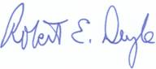
Robert E. Deyle, Vice Chair
Wakulla Springs Alliance

Appendix E
DRAFT

The Florida Springs Protection Act,
as Currently Being Implemented,
is a Sham

The necessary nitrogen reduction calculations by the FDEP are wrong

The estimated nitrogen loadings for septic tanks by the FDEP are wrong

Project information required by the Florida Springs Protection Act is not provided

Responsibility for the enforcement of septic tank hookup by residential owners after a new sewer line is constructed and available is often disputed between FDOH and local governments

The FDACs refuses to provide fertilizer use information from farms, claiming that it is proprietary.

The Suwannee River BMAP won’t achieve the TMDL in 20 years, as required by the Florida Springs Protection Act.

The latest draft Volusia Blue Spring BMAP by FDEP:
- has no projects for septic tank remediation, though they are the majority of the nitrogen load
- the boundary of the Priority Focus Area (PFA) has been politically drawn, not scientifically, resulting in over 15,000 septic tanks not required to be remediated, and
- the existing and future septic tanks outside the PFA, but within the springshed, will more than offset the nitrogen reductions accomplished within the PFA.

