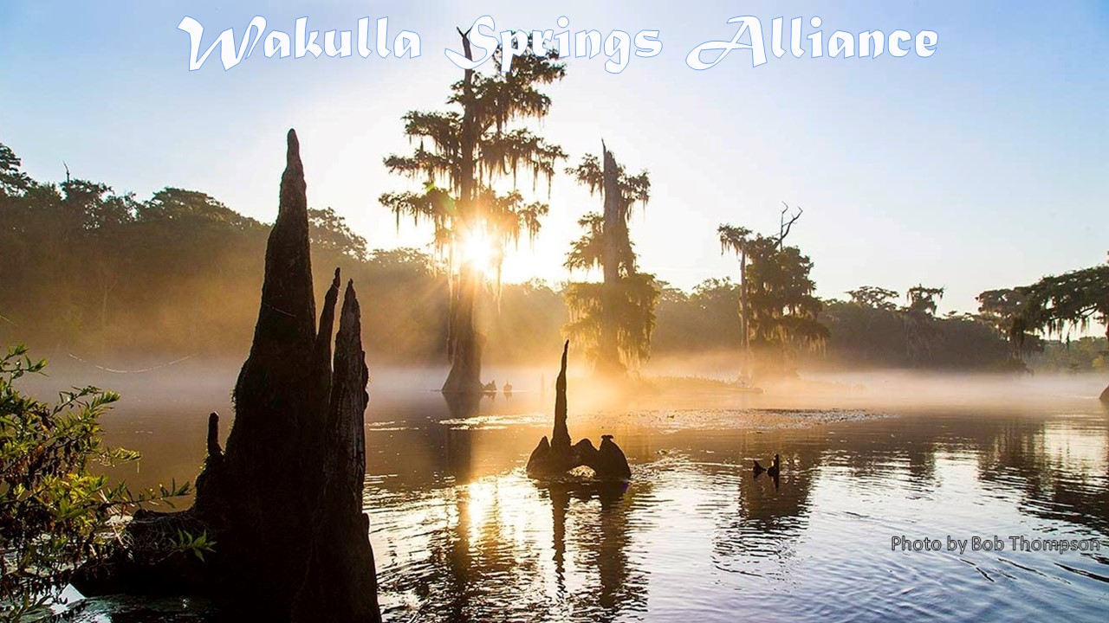

**Minutes**

**Friday, December 17, 2021**

**9:00 to 11:50 am, via Zoom**

**Opening**

* Welcome and introductions - Bob Deyle (see Appendix A)
* Agenda review - Bob Deyle (see Appendix B)

**November 2021 minutes** - Tom Taylor

* Jim Davis made the motion to adopt, seconded by Debbie Lightsey, which passed unanimously.

**November 2021 financial report** - Jim Davis (see Appendix C)

* Howard Kessler made the motion to adopt, seconded by Albert Gregory, which passed unanimously.

**America’s Alligator** - Doug Alderson, author, photographer, and Outreach and Advocacy Director for Apalachicola Riverkeeper

* Doug shared material from his 2020 book, *America's Alligator: A Popular History of Our Most Celebrated Reptile*
* Alligators are part of Florida history.
* Early alligator wrestling was lucrative.
* Mark Twain and other authors wrote about alligators.
* The Ma Barker Gang hid out in FL and were tracked down because her son killed “Old Joe.”
* The 70’s films Gator Bait and The Alligator People spread their reputation.
* There were many FL alligator souvenirs and postcards shown, that Doug has collected.
* Special souvenirs included beer steins, bottle stopper, banks, ash trays, thermometers, pipes, nut crackers, snow globes and more.
* Both males and females, bellow. Males have lower bellows.
* Gators are generally not aggressive. He has seen many while kayaking.
* C - People get excited about alligators on the Wakulla Springs boat tours.
* C – Howard Kessler went to Alligator College and there was a 6’ gator on campus.
* C – Debbie has a 1957 picture of her holding an alligator from her first trip to Florida.
* C – Jim Stevenson worked in Gator Land. He was fined $25 for catching gators to rescue them from poachers and relocate them.
* C – Cal had gators in a canal that he caught and kept in a tub. They tamed right down. They knew the difference between a hand and a hot dog. He would put them on a leash.
* Q – Are they moving north? A – They have been found in Arkansas and Virginia. There is no evidence of moving much further north. Their breeding may change with climate change.
* Q – How are the books selling? A - They are selling but it is a labor of love.

**Legislative update** – Ryan Smart

* The [FL Springs Council](https://www.floridaspringscouncil.org/) has an alert system that you can sign up for. You access it from their emails or directly on their website at <https://www.floridaspringscouncil.org/action-alert>
* Thanks for the donations WSA and individual members to the Springs Council’s BMAP litigation
* HB 1078 abolishes the Soil and Water Conservation Commissions and transfers power to the WMDs. They need to be made more meaningful. Ag folks want these.
* SB 198 creates seagrass mitigation banks. Wetland mitigation banks have been a failure; they don’t stop wetland habitat loss. Success is unlikely and needs to be opposed.
* SB 1000 is destructive. It would allow increasing fertilizer use beyond the fertilization rates set by IFAS. Those are already high, based on maximizing growth not environmental impacts.
* SB 864 filed by Sen Ausley would create a cost-share program for agriculture, aquaculture, and timber operations within the Department of Agriculture and Consumer Services in consultation with academic research institutions, and provide for a study of the value of environmental services provided by these industries. It would pay 75% of the environmental services provided by existing agriculture compared to the worst possible land use.
* There is some good legislation . . .

**Springshed and river update -** Cal Jamison

* The water is clearing at Wakulla Springs
* There has been less rain and lower flows at the sinks so there is less tannic coming from the forest.
* However, Spring Creek is in reverse flow and that can force more tannic water out at Wakulla Springs.
* Cal met with Tall Timbers at the Park Subdivision and they will help with invasive plants and a burn team will come in January.
* The Guy Revel property was acquired by the WMD and will be managed by Wakulla County.
* The water quality survey team had oak flour pancakes made from acorns from the tree in the background of the picture shown.
* Jeff Hugo is retiring from the Park Service. He has been a great resource.
* Lake Jackson bottom has been exposed since December 5.

**Cave exploration updates**

* Chris Werner with WKPP reported clear water in several springs and that divers will be diving in coming weeks.
* We need water tests in Sullivan and other springs. The divers will help.
* Andreas Hagberg reported that no dye has been detected at 30 sites from dye injected at Lake Jackson on August 14.

**Gator Cam Data**

* Rob Gelhardt reported there have been 1089 views; some for many minutes.

**Membership report** – Deyle

* The membership roster as of January 14 will be the basis for determining the quorum for the annual membership meeting on January 28th.
* We have 29 memberships paid. 20 current members have not renewed.
* Bob sent out reminders this week.

**Appointment of WSA representative to Big Bend Environmental Forum** – Deyle

* We pay to be a sponsor and we need a representative to the committee.
* This is a worthwhile group and has representatives from most environmental organizations.
* We always come up with a list of questions for the candidates related to Wakulla Springs.
* [Rob Williams, who has been nominated to be elected to serve on the Board, has agreed to serve in this capacity.]

**10:45 Southwest Georgia Oil Company comp plan amendment (Wakulla County) –** Cal Jamison and Casey McKinlay

* The site is on the NW corner of Hwys 267 and 319. See map in Appendix D
* It may be on the January County Commission agenda.
* Cal did a public records request for information.
* Casey McKinlay thanked Cal Jamison, Sue Damon, Andreas Hapsburg and others for work on several spring’s platforms. He thanked the WMD for new flow monitoring equipment they will be installing.
* Casey showed slides of the Chips Hole Cave System that connects to the Wakulla Caves system. WKP is 450 sq. miles. 45+ miles are mapped. Chips is 6+ miles.
* The gas station is about 100’ above the cave system with potential runoff and tank leakage.
* They did a dye trace and it is 8 days to flow to Wakulla Springs from Chips Hole
* The land at Chips Hole is owned by St. Joe and is leased by a hunt club.
* FDOT has signs that indicate that there are caves below.
* Q – Is the limestone porous so any water on the site will get into the cave system and go to Wakulla Springs? A – Yes.
* C - This is like the gas station at Kirton’s Corner at Hwy’s 61 and 267 that was stopped. It was purchased and is now public land. The FL Defenders of Wildlife filed a law suit that led to stopping the project.
* Q – Is this parcel on the FDEP acquisition list? No, but it should be.
* C – Someone said that the County can’t restrict uses. A – Property owners don’t have a presumptive right to change the Comp Plan, so the county has discretion. Bob Deyle has checked with attorneys on this. We can look for language in the comp plan objectives that call for protection of springs and ground water.
* We should take this to David Edwards, St. Joe and Georgia Oil to share information on the cave system and our concerns.
* Ryan Smart will see if there is a lawyer who would write a letter to the County and landowner on our behalf.
* Any owner can apply for anything and the County’s role is to apply the law.
* Bob Deyle will send an email to David Edwards with copies to Sue Damon and Cal Jamison.
* Howard will reach out to FL Defenders of Wildlife.

**English property planned unit development comp plan amendment and rezoning** **(City of Tallahassee)** – Deyle

* This comprises an amendment to the existing English Property PUD increasing the acreage of the area zoned as PUD by 494 acres (currently zoned Critical Planning Area = CPA) for a total of 744 acres.
* The existing parcels and the proposed new parcels that will comprise the English Property PUD are designated as Planned Development on the Future Land Use Map so there is no change to the comp plan involved.
* Staff has found that the four PUD district designations for the added property (Neighborhood Village Center (VC), Medium Density Residential (MDR), Mixed Office Use/Commercial (MUOC) and Open Space (OS)), are consistent with the Southeast Sector Plan, which serves as the PUD’s master plan.
* The concern for WS is nutrient-laden stormwater entering wet sinkholes. The city’s Land Development Code requires that stormwater management facilities in “active karst” features comply with applicable state rules which currently comprise the Northwest Florida Water Management District’s *Environmental Resource Permit Applicant’s Handbook* Volume II.
* However, the Natural Features Inventory completed by the consultant does not identify “active karst” features applying the city LDC criteria; it only identifies “karst features” and “potential karst features” based on a Leon County GIS map layer. Furthermore, the definition of active sinkhole/karst feature in Tallahassee LDC (section 5-2) does not appear to be consistent with authoritative hydrogeological references, nor will it protect ground water from contamination with pollutants in stormwater runoff.
* But more importantly, the LDC distinction between active and inactive karst features (Sec 5-81(a)(2)(e)) appears to not conform to the applicable rules in the Water Management District’s Handbook which makes no such distinction. Deyle interprets that section of the Handbook to require that all stormwater management facilities within designated Sensitive Karst Areas must comply with the applicable requirements in the Handbook regardless of whether or not they are located in or discharging to a designated karst feature. These comprise most of Leon County.
* Deyle has raised these concerns with City Growth Management Director Karen Jumonville and Carlos Herd at the WMD and am awaiting their replies
* This won’t be considered until February by the City Commission
* Q – Where is the Cody Scarp? A – It seems to be on the edge of this property. The Paul Russel Road seems to be the last ridge before the Cody Scarp.
* C – The proposed general land use plan is misleading; the green conservation areas can still be developed.

**Horton comp plan amendment application** – Lightsey

* This is on Woodville Highway in the Springs Protection Zone and off Apalachee Parkway.
* This expands the USA by 196 acres, shortly after the Walaunee expansion. There is already capacity for the development for many years. The Commissions have been approving USA expansions.
* Horton is a national development company
* There are text and map amendments. It goes from rural (1 unit per 10 acres) to urban residential (20 units per acre).
* There will be a Jan 4 Planning Commission meeting on this. There will be workshops from February to June.
* Many groups came together on Walaunee. Debbie will contact these groups.
* Q – Is city sewer available? A – This may depend on the Woodville sewer extension. This will be new nitrogen to Wakulla Springs regardless.

**Wakulla County wastewater feasibility analysis** – Deyle

* Deyle sat in on the County Commission’s workshop on the draft Wastewater Feasibility Analysis prepared by Dewberry as required under the Wakulla BMAP. This is comparable to the Comprehensive Wastewater Facilities Plan being prepared for Leon County. Both are funded by the state.
* The workshop discussion revealed that as is the case elsewhere Commissioners appeared to be unaware that the so-called passive in-ground nitrogen reducing biofilters currently permitted by FDEP have not been demonstrated to achieve the 65% nitrogen reduction that seems to be ascribed to them in the BMAPs.
* This is the issue we raised with the Leon County septic tank replacement project that led to them adding two INRBs designed to include the liners and dosing systems that were included in the prototype tested by Hazen and Sawyer that was the basis for the 65% reduction assumption.
* Deyle will be emailing Wakulla County Commissioners informing them of this.

**Solar Farm Update**

* Bob Deyle and Jim Stevenson have been following-up on the sheep concept as an alternative to herbicide use. The sheep herder with whom Jim consulted did not think the sheep would be bothered by the proximity of the airport. Bob is attempting to find out if FAA regulations might preclude having sheep grazing this close to the runways.
* Jim Stevenson reviewed notes from an early community meeting about the project where the city said there would be no herbicide use.
* Herbicide use was not addressed in the NEPA assessments prepared by the FAA nor by the review conducted by the city’s Aquifer Protection Program. Jim talked to the city reviewer who was not aware of the Cody Scarp.

**Upcoming meetings and events** – Deyle

* **January 28** – Annual meeting - elections of directors and officers; “Manatee in the Northern Gulf of Mexico and Wakulla River” – Michelle Pasawicz, FWC
* Can we get Theresa Heiker give a report on the WW Facilities and special projects at the start of the agenda?
* **February 25** - TBA

**Adjourn**

* Jim Stevenson made the motion to adjourn, seconded by Debbie Lightsey, which passed unanimously.

**Appendix A**

**12-17-21 WAKULLA SPRINGS Board Meeting Participants**

**\* Indicates those present**

Officers

Robert E. Deyle, Chair *  
Howard Kessler, Vice-Chair *  
Tom Taylor, Secretary *   
Jim Davis, Treasurer *

Directors

Gail Fishman

Albert Gregory *  
Rob Gelhardt

Andreas Hagberg *

Cal Jamison *  
Brian K. Katz   
Debbie Lightsey *

Terry Ryan

Lindsay Stevens   
Jim A. Stevenson *

Members and Guests

Kathleen Coates *

Gil Damon *

Sue Damon *

Anthony Gaudio *

Chad Hansen *

Maddy Hart *

Mark Heidecker *

Carlos Herd

Chris Keller *

Mike Keys *

Scott Knight *

Brian Luipani *

Casey McKinlay *

Charles Ouimet *

Ryan Smart *

Paul Thurman *

Sophie Wacongne *

Chris Werner *

Robert Williams *

**Appendix B: Agenda**

**Friday, December 17, 2021**

**9:00 to 11:50 am, via Zoom**

**9:00 Opening**

* **Welcome and introductions** - Bob Deyle
* **Agenda review** - Bob Deyle

**9:10 November 2021 minutes** - Tom Taylor [attached]

**9:15 November 2021 financial report** [attached]- Jim Davis

**9:20 America’s Alligator** - Doug Alderson, author, photographer, and Outreach and Advocacy Director for Apalachicola Riverkeeper

**10:05 Legislative update** – Ryan Smart

**10:15 What’s new?**

* **Springshed and river update -** Cal Jamison
* **Cave exploration updates**
* **What else?**

**10:35 Membership report** - Deyle

**10:40 Appointment of WSA representative to Big Bend Environmental Forum** - Deyle

**10:45 Southwest Georgia Oil Company comp plan amendment (Wakulla County) –** Cal Jamison and Casey McKinlay

**11:00 English property planned unit development comp plan amendment and rezoning** **(City of Tallahassee)** - Deyle

**11:15 Horton comp plan amendment application** - Lightsey

**11:25 Wakulla County wastewater feasibility analysis** - Deyle

**11:40 Upcoming meetings and events** – Deyle

* **January 28** – Annual meeting - elections of directors and officers; “Manatee in the Northern Gulf of Mexico and Wakulla River” – Michelle Pasawicz, FWC
* **February 25** - TBA

**11:45 Other business**

**11:50 Adjourn**

**Appendix C**

|  |  |
| --- | --- |
| **WAKULLA SPRINGS ALLIANCE** |  |
| **FINANCIAL REPORT** |  |
| **FOR THE ELEVEN MONTHS ENDED NOVEMBER 30, 2021** | |
|  |  |
| **INCOME** |  |
| Donations | $ 165.00 |
| Memberships | 1,290.00 |
|  | 1,455.00 |
|  |  |
| **EXPENSES** |  |
| Contribution to Florida Springs Council | 1,000.00 |
| Florida Corporate Annual Report | 61.25 |
| Website related | 143.88 |
| PayPal Fees | 27.94 |
| Earl Bacon Agency - Insurance | 1,089.00 |
|  | 2,322.07 |
|  |  |
| **SURPLUS/(DEFICIT)** | (867.07) |
|  |  |
| **BANK BALANCE - 12/31/2020** | 2,664.70 |
| **PAYPAL BALANCE - 12/31/2020** | 3,444.57 |
| **TOTAL - 12/31/2020** | 6,109.27 |
|  |  |
| **BANK BALANCE - 11/30/2021** | 4,619.47 |
| **PAYPAL BALANCE - 11/30/2021** | 622.73 |
| **TOTAL - 11/30/2021** | **$ 5,242.20** |

**Appendix D**

**Chips Hole Cave System Map**

**The proposed gas station is on the NW Corner of Hwy’s 319 and 267**

…

