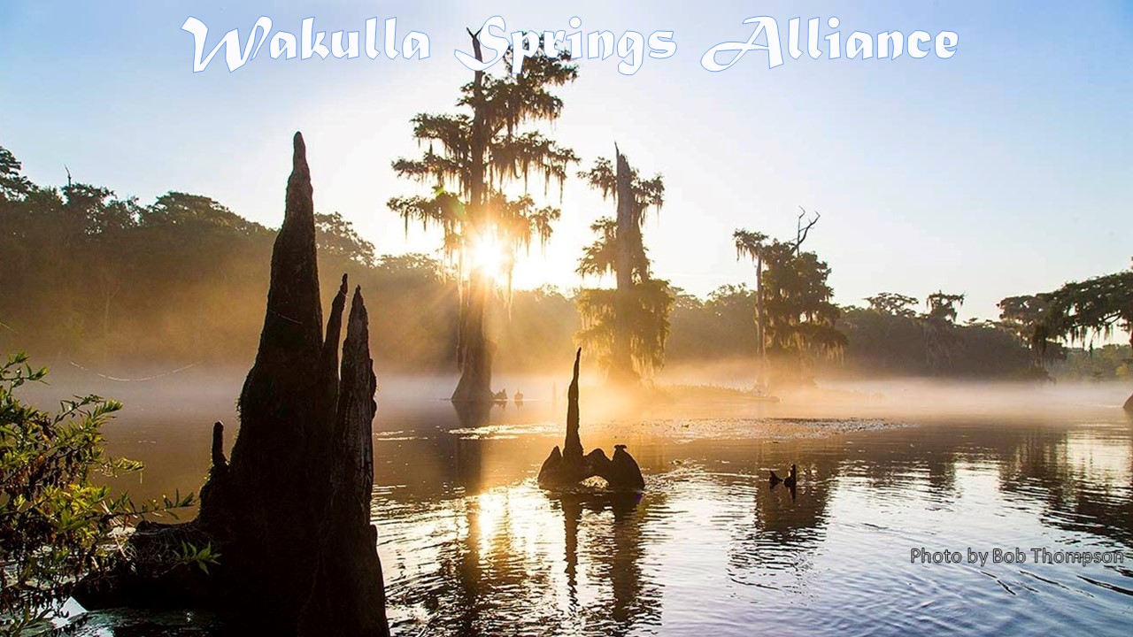

**Annual General Meeting and**

**February Board Meeting Minutes**

**Friday, February 25, 2022**

**9:00 to 11:45 am, via Zoom**

[Decisions and action items are underlined]

Annual General Meeting

**Opening**

* Welcome and introductions – See appendix B, Participant List
* Agenda review – See Appendix A
* Quorum determination – 49 members > 30% = 15 is a quorum we have 18+

**Annual financial report**

* Jim Davis went over the report in Appendix C
* Terry Ryan made a motion to adopt the report, seconded by Gail Fishman, which passed unanimously

**Recognition of Jim Stevenson as a Wakulla Springs Champion**

* Lindsey Stevens provided highlights of Jim’s career and stories that illustrated his impact on Florida’s springs.
* He also nurtured and mentored many who are carrying on his work.
* He could translate science into acceptable and understandable messages tailored to diverse audiences. He has a magic to get people on board to protect springs.
* Bob Deyle recognized him as the father of Florida springs and the Wakulla Springs Alliance.
* Susan Poplin told of how Jim took her on the Follow the Water Tour, which was the most impactful thing that could have happened for me and so many others.
* Debbie Lightsey has known Jim forever and has a lovely manner that brings everyone in and puts no one off.
* Albert has known Jim for 35 years and it has always been a pleasure. Jim was key in saving parks.
* Howard Kessler and Jim’s middle name is “Persistence.”
* Tom Taylor highlighted what an honor it was to work with Jim on springs around the state.
* Presentation of Wakulla Springs Champion Award.
* Jim was the lead on Springs protection until retiring 19 years ago. The follow the water tours have hosted many politicians, leaders and others.
* There are 7 springs alliances including the WSA that fill gaps that agencies don’t fill. Bill Moyers said that organized people are essential for government to be effective.
* Local citizens were effective in attacking the gas station in Wakulla county.

**Election of directors**

* **Presentation of nominees** – Howard Kessler

Nominees presently on the Board of Directors to serve new two-year terms:

* Jim Davis
* Gail Fishman
* Albert Gregory
* Debbie Lightsey
* Howard Kessler

Nominees to fill vacant positions on the Board of Directors to serve two-year terms:

* Michael Keys
* Brian Lupiani
* Rob Williams
* **There were no new nominations from the floor** – Deyle
* A motion to accept the slate was made by Albert Gregory, which passed unanimously.
* A motion to close the nominations was made by Debbie Lightsey, seconded by Albert Gregory, which passed unanimously
* Terry Ryan made a motion to accept the slate of directors, seconded by Steve Urse, which passed unanimously.

**Adjourn**

* Howard Kessler made the motion, seconded by Chuck Hess, which passed unanimously.

February WSA Board of Directors Meeting

**Opening**

* Bob Deyle presented the proposed agenda.
* Debbie Lightsey made a motion to adopt the agenda, seconded by Howard Kessler, which passed unanimously.

**Minutes of January 28 meeting** – Tom Taylor

* Jim Davis made the motion to adopt the minutes, seconded by Albert Gregory, which passed unanimously

**January Financial Report**

* We received more than any month before because of a $2000 life member.
* 8,178 .85 balance
* Howard Kessler made a motion to adopt the report, seconded by Rob Williams, which based unanimously.

**FSC Proposal**

* FSC is considering a new employee in Tallahassee and would like to consider sharing staff roles and costs with WSA.
* FSC has grown in membership and revenue and WSA can do the same.
* Marco Phillips said that he will donate 20 hours a week to this.
* Anthony Gaudio said that we need to do more development and he will help with organizational development.
* This sounds wonderful and I will be willing to help.
* Q – What can this person do? A – This will be up to WSA. A staff person can take a lot of burden off the chair.
* Bob Deyle listed a number of things that he has done that could be done by staff or volunteers. Bob wants to be Vice Chair and focus on the policy work.
* Bob also did a lot of work on grants.

**Election of officers**

* **Presentation of nominees** – Albert Gregory

Chair – no candidate

Vice Chair – Bob Deyle

Secretary – Tom Taylor

Treasurer – Jim Davis

* Vote to waive Bylaws 14-day notice requirement for officer nominees (sec. XIV.4)
* A motion was made by Brian Luipani, seconded by Terry Ryan, which passed unanimously.
* Howard Kessler made motion to accept the slate, which passed unanimously.
* There were no other nominations
* The nominating committee recommended having a rotating chair for one year
  + This is a workable and only alternative to disbanding the organization.
  + This is a way for people to give chairing a try
  + Anthony will work with Ryan and Jim Davis to explore the FSC offer.
  + Tom Taylor made a motion that we have a rotating chair for 2+ months each for a year or until a chair is elected, seconded by Brian Lupiani, which passed unanimously.
  + We need people who take on some of the responsibilities of the chair, secretary and others.
  + Mike Keys can do it in November.
  + Rob Williams can do it in May to July
  + Albert Gregory will do March and April
* Howard Kessler made a motion to have a shared chair position, seconded by Brian Luipani, which passed unanimously
* Rob Williams made a motion to have Albert Gregory to serve as chair for March and April and for Rob Williams to be interim chair for May, June and July, seconded by Jim Davis, which passed unanimously

**Springshed and river update**

* Visibility is down one foot, 21 feet. It is fairly dark because of the head differentials with Spring Creek and changes in scouring of the channel.
* The state is buying 313 acres in 3 properties E and NE of WS state park acquired from Boudreau, Doyle and Buford Lanvers, LLC.
* Mike Keys looked at other petroleum storage sites near the cave sites. Of the 396 total tanks in WC only the Chevron was close to the cave systems. Bob Deyle encouraged Mike to contact FDEP to check with them.
* Spring Creek in in reversal and there is some flow of the tannic water to Wakulla Springs

**Cave exploration updates Chris Werner and Andreas Hapsberg**

* We did further study of Chips Hole so the maps are more accurate.
* We have had poor visibility everywhere. Chips Hole had 10’ visibility last week.
* They will check Sullivan this weekend. Two weeks ago, it was taking water.
* The water is a little clearer in recent dives

**Southwest Georgia Oil Company comp plan amendment (Wakulla County)** – Deyle

* There was a large turnout at the meeting even though the agenda item was pulled.
* Bob participated in 2 conversations with Commissioners and they weren’t willing to change their votes. They agreed to add language to the Springs Protection Ordinance to address petroleum tanks.
* Randy Merritt does soil boring and indicated that there may be a clay layer on the site. This is not captured the current vulnerability analysis. Bob has suggested to David Edwards that Wakulla County may want to have a meeting of hydrogeologists to recommend needed assessments.
* Pipe clay can be patchy so multiple borings may be needed.
* Advocacy by CWW and WSA made a difference.
* We have had items pulled from the agenda in the past and it has been brought back later. We need to be vigilent!
* It was pulled because Commissioner Quincy was on the fence.

**Wakulla County Wildwood Golf Course master plan** –

* There will be a series of rapid infiltration basins, RIB, at different locations on the golf course.
* Work will begin in May and will take about a year.
* Distribution may be expanded to the middle and high school grounds, right of ways and other properties.
* They hope to get 50% for the funding from grants.

**Tallahassee solar farm update** – Deyle and Jim Stevenson

**WSA strategic plan review** – Tom Taylor

* **Overview**
  + All WSA members, agency representatives and other WS supporters are encouraged to suggest additional strategies and tasks and volunteer to work on at least one aspect of the [WSA Strategic Plan](https://docs.google.com/document/d/1fUeXuM0DL0eHWG_7K4_FEyePC0RbdZUPEfAow7iPEs4/edit).
  + This is a living document ([Google Doc](https://docs.google.com/document/d/1fUeXuM0DL0eHWG_7K4_FEyePC0RbdZUPEfAow7iPEs4/edit)), not a “sit on the shelf plan.” It will evolve in response to changing conditions, crises and commitments by individuals and groups.
  + In a volunteer group the only priorities are what someone is willing to do.
* **WSA Goals** [Additions at the meeting are underlined]

1    Improve Water Quality Policies and Program [Bob Deyle, Cal Jamison & Debbie Lightsey, Anthony Gaudio]

* Debbie will get an update on septic tank additions and removals in the spring shed, including # of advanced sysems.  Contact Somer Tell in Wakulla county.
* Eberhardt Roder reports that some alternatives are getting good results. There are less than 5 in the state. Many others have not been studied.  Theresa Hiker reported that some sampling has been done. Anthony will follow up.

2    Maintain Water Quantity [Cal Jamison]

3    Restore Ecosystems [Gail Fishman]

* Mike and Gail will help with land management/maintenance of forests.  The US Forest service and State Forests owns much of the WS watershed

4    Acquire and Manage Land [Cal Jamison, Lindsay Stevens and Albert Gregory, Rob Williams] The Sentinals Land Project has Defense Department funding for acquisition that can supplement state funds. We need to identify land in the springshed.

5    Advance Science/Research [Bob Deyle, & Cal Jamison]

6    Educate the Public & Leaders [Gail Fishman (chair), Debbie Lightsey, Howard Kessler, and Jim Stevenson]

7    Build a More Effective Organization [Howard Kessler]

* Marco will help as a consultant.

8    Response to sewerage spills, public and private plans and projects that impact WS

**Upcoming meetings and events** – Deyle

* March 25 – TBA
* April 22 (4th Friday!) – TBA

**Adjourn**

* Albert Gregory made the motion to adjourn, seconded by Rob Williams, which passed unanimously.

**Appendix A**

**Agendas: Annual General Meeting and February Board Meeting**

**Friday, February 25, 2022**

**9:00 to 11:45 am, via Zoom**

Annual General Meeting

**9:00 Opening**

* **Welcome and introductions** – Bob Deyle
* **Agenda review** – Deyle
* **Quorum determination** – Deyle

**9:10 Annual financial report** – Jim Davis **[to be attached]**

**9:20 Election of directors**

* **Presentation of nominees** – Howard Kessler **[report and bios distributed 1/14/22; attach again]**
* **Nominations from the floor** – Deyle
* **Vote by members**

**9:35 Adjourn**

Board of Directors Meeting

**9:40 Minutes of January 28 meeting** – Tom Taylor **[to be attached]**

**9:45 Vote to waive Bylaws 14-day notice requirement for officer nominees (sec. XIV.4)**

**9:50 Election of officers**

* **Presentation of nominees** – Albert Gregory **[report to be attached]**
* **Nominations from other directors**
* **Vote by directors**

**10:00 Recognition of Jim Stevens** – Lindsay Stevens and Bob Deyle

**10:15 Wakulla County Wildwood Golf Course master plan** – David Edwards, Wakulla County Administrator

**10:30 What’s new?**

* **Springshed and river update –** Cal Jamison
* **Cave exploration updates**
* **What else?**

**10:50 Membership update** – Deyle

**10:55 Southwest Georgia Oil Company comp plan amendment (Wakulla County)** – Deyle

**11:05 Tallahassee solar farm update** – Deyle and Jim Stevenson

**11:15 Strategic plan review** – Tom Taylor

**11:40 Upcoming meetings and events** – Deyle

* **March 25** – TBA
* **April 22 (4th Friday!)**  – TBA

**11:45 Adjourn**

**Appendix B**

**2-25-22 WAKULLA SPRINGS Board Meeting Participants**

**\* Indicates those present**

Officers

Robert E. Deyle, Chair *  
Howard Kessler, Vice-Chair *  
Tom Taylor, Secretary *   
Jim Davis, Treasurer *

Directors

Gail Fishman

Albert Gregory *  
Rob Gelhardt

Andreas Hagberg *

Cal Jamison   
Brian K. Katz   
Debbie Lightsey *

Terry Ryan *

Lindsay Stevens *  
Jim A. Stevenson *

Members and Guests

Kathleen Coates *

Sue Damon *

Anthony Gaudio *

Mark Heidecker *

Chuck Hess *

Mike Keys *

Brian Luipani *

Marco Phillips *

Susan Poplin *

Johnny Richardson *

Ryan Smart *

Steve Urse *

Sophie Wacongne *

Nico Wienders *

Chris Werner *

Robert Williams *

**Appendix C – Financial Report**



Appendix D



Appendix E

Wakulla Springs Alliance Nominating Committee Slates of Nominees for January 28, 2022, Elections

Nominating Committee Members: Howard Kessler, Cal Jamison, Terry Ryan

Nominees for Board of Directors

To be elected by WSA members in the annual general meeting

Nominees presently on the Board of Directors to serve new two-year terms:

* Jim Davis
* Gail Fishman
* Albert Gregory
* Debbie Lightsey
* Howard Kessler

Nominees to fill vacant positions on the Board of Directors to serve two-year terms:

* Michael Keys
* Brian Lupiani
* Rob Williams

Short bios of Director nominees to fill vacant positions:

* Michael Keys is a professional Geographic Information Systems (GIS) specialist and wildlife biologist working with federal, state, and non-governmental partners to sustainably manage public and private conservation lands throughout the Southeast.
* Brian Lupiani is a concerned citizen who has regularly attended WSA meetings and has been concerned with the health of Wakulla Springs. He actively helps with testing the water quality of Wakulla Spring and is an advocate for springs protection and restoration.
* Rob Williams is a retired attorney who has worked at Florida Rural Legal Services and has a long track record of representing refugees and farm workers in Florida. He has been active in the field of environmental law and is a present board member of the Apalachee Audubon Society.