**Draft March Board Meeting Minutes**

**Friday, March 25, 2022**

**9:00 am to 11:00 am, via Zoom**

**Opening**

* Welcome and introductions – Albert Gregory
* Review and approval of agenda - Albert Gregory
* Howard Kessler made a motion to approve the agenda, seconded by Rob Williams, which was approved unanimously.

**Review and approval of February 25, 2022, meeting minutes** **(attached)** – Tom Taylor

* Gail Fishman made a motion to approve the minutes, seconded by Debbie Lightsey, which was approved unanimously

**Review and approval of March 2022 financial report** **(attached)**– Jim Davis

* Howard Kessler made a motion to approve the agenda, seconded by Debbie Lightsey, which was approved unanimously.

**Legislative/policy update** – Ryan Smart

* SB 2508 passed It changes the balance between FL Forever, $100 million and the Rural Family Land Protection Program, $300 million that can now be used for all ag activities. It also allows for wetlands to qualify for mitigation funds.
* 404 dredge and fill applications to FDEP can be paid by developers.
* Owners can now sue local governments if profits impacted by more than 15%. This will have a chilling effect on new regulation and other government decisions.
* Certified experts can overrule IFAS on fertilizer application rates for citrus.
* HB 965 creates water quality enhancement areas. Local government can create or pay a private entity to treat water. One will be used in the Peace River area. We could see one here. It may not work.
* Springs got $75 million for infrastructure.
* Fertilizer costs $2 for a pound going in and $2,000 for taking a pound out.
* $232 million for park capital improvements funding for repair and new construction.
* 2016 SB552 required rules to prevent harm to springs. FSC has pushed for rules. DEP just proposed the same rule as in 2014. This will address every CUP.

**Strategic plan review and refinement** – Tom Taylor

* See the list of legislative funding for water quality, land acquisition and other environmental issues in Appendix D.
* Everyone is encouraged to review the [WSA Strategic Plan](https://docs.google.com/document/d/1fUeXuM0DL0eHWG_7K4_FEyePC0RbdZUPEfAow7iPEs4/edit) and commit to lead and/or support efforts to work with local governments, the NWFWMD and DEP to develop priority projects and apply for funding.

**Update on septic tank conversions in Wakulla and Leon Counties** – Debbie Lightsey

* We are trying to determine how many septic tanks have been removed.
* Anna Podilla, with Leon County, reports 43 in-ground nitrogen reducing biofilter (INRB) systems have been installed.
* Some projects are in the design phase.
* Total 200 septic to sewer conversions with more in the works
* Wakulla County has completed 476 septic systems to sewer conversions. Total about 800
* We have concern about the unproven performance of the passive INRBs and are trying how to get the information on the monitoring that is being done
* Anthony has been talking to Leon County.
* We will try to harvest the information from permits.
* Eberhart Roder at FDEP will help with testing results, which have been poor and good. They are refining testing protocols.
* Leon County will install 90 systems. The average cost is $14,111 in the DEP Leon Grant with $225,000 for administration and contractor and $1.25 million, which makes that cost per system now over $16,000.
* Dozens were installed with $10,000 DEP grants. DEP may have more information
* Leon County has 60+ advanced treatment systems, both new and conversions and conventional with only 5 being NSF45 so 90% are INRBs.
* There will be a written report at the next WSA meeting.
* This would be great work for an intern who could go to the Leon County DOH. Check last month’s minutes for the student who volunteered to be a WSA intern.

**Expanding the Tallahassee Urban Services Area at Woodville Highway and Capital Circle SE** – Debbie Lightsey

* There will be public hearings in the comp plan amendment process.
* This is in addition to the USA expansion in [Welaunee Plantation](https://en.wikipedia.org/wiki/Welaunee_Plantation,_Florida).
* There is a USA expansion formula that limits expansion based on projected developable land capacity. Without expanding the USA, Leon County has enough developable land for the next 50 years.
* The 3 parcels each have expansions of the USA. They could exclude the non-USA areas in the text have a lot of development potential.
* All properties are St. Joe’s and the developer is Horton, a national developer.
* We need to inform the elected officials about the potential impacts.
* Anthony Gaudio and Ken Goldberg have written a letter concerning the property on Southwood Plantation Road. This may be a way to avoid impact fees. This letter is in Appendix F.
* Debbie sent a letter on this as an individual, not representing WSA.
* Anthony contacted the developer about the lack of infrastructure.
* Some areas do not have water and sewer and could impact Wakulla Springs.
* Howard Kessler made a motion to send a letter to the City, seconded by Tom Taylor, which passed unanimously.
* There was a suggestion to ask Friends of Wakulla Springs to comment on this.

**Springshed and river update** – Cal Jamison

* Visibility was 25’.
* Springs and creeks flows are up with the rain.
* Water height (stage) is up as measured at Wakulla Springs boat dock.
* Conductivity is higher from Spring Creek.
* Flow is 1300 feet/second at the bridge, which is high.

**Cave exploration updates** – Chris Werner and Andreas Hagberg

* Andreas reported that there was a week of clear water but it was still too dark to dive.

**Renewal of WSA’s liability insurance** – Bob Deyle

* Carolina Causality rate increased to $1097, which has been paid.

**Revisions to Wakulla County springs protection ordinance** – Bob Deyle

* The proposed gas station on Hwy. 319 discussion, led the Wakulla County Commission to direct staff to assess how caves should be addressed in the SPA, not just sinkholes and springs.
* Bob recommended to county staff that they consult with Hal Davis, retired USGS and DEP, Chris Werner, science advisor for WKKP and with staff from DEP.
* David Phillips at DEP recommended people that Bob forwarded to Wakulla County Administrator, David Edwards.
* WSA may want to be involved in this process along with Clean Water Wakulla.
* Debbie Lightsey made a motion send a letter regarding WSA involvement in a committee to develop changes in the springs’ protection ordinance, seconded by Howard Kessler, which passed unanimously.

**Tallahassee solar farm update** – Bob Deyle

* Bob shared a letter to David Byrne approved by the Executive Committee in January asking the city to take the lead in persuading Origis Services to consider sheep grazing as an alternative to herbicide use.
* David forwarded the letter to the Origis and is waiting for a response.
* Pam McVety shared the letter with the Tally 100 committee.
* Bob and Jim have been in communication with Michael Olson.
* There seems to be a move away from herbicide use, possibly with mowing.

**English property PUD amendment** - Bob Deyle

* Bob shared a personal letter with the commission. See Appendix E.
* The applicant’s proposal covers the remaining 400 plus acres in the PUD beyond the 36 acres covered by the previously approved amendment.
* Bob attended the City Commission meeting on Tuesday and pointed out the disconnect between City and NWFWMD on karst feature stormwater discharge regulation.
* Sean McGlynn and Doug Barr also spoke.
* The PUD was approved.
* Debbie sent an email to the Commissioners stating that the PUD decision is key because citizens are not heard at the site plan approval level. She suggested that the Commission be involved in the site plan review process.
* Mark Heidecker emphasized that applicants still have to get state, WMD and local permits. He stated that the city’s stormwater management regulations are more stringent the WMD’s
* However, the WMD applies its karst feature regulations more broadly than does the city.
* The WMD regulates all stormwater management within “karst sensitive areas” which comprise most of Leon County but the City only applies its karst feature protections to so-called “active” ones.
* The active/inactive determination is made at the site plan permit level not the PUD level.
* There is a natural features investigation, NFI, done at the PUD level that did not identify any active features based on a lidar map. The distinction can only be made from site-level analysis.
* There will be a more detailed NFI at the site plan stage.
* Bob will be meeting with staff about the stormwater regulations.
* The applicant states that there is not a developer yet for any of the property covered by the PUD amendment. When there is the property will be sold.

**Upcoming meetings and events** – board members

* April 22 board meeting on Land Acquisition + – Albert Gregory
* Rob has attended BBEF meetings and requests questions regarding Wakulla Springs
* [FL Springs Summit](https://www.floridaspringscouncil.org/summit), April 8-10 in Crystal River
* Mark Heidecker sent links to [TAPP program videos](https://tappwater.org/videos).

**Adjourn**

* Debbie Lightsey made the motion to adjourn, seconded by Howard Kessler, which was approved unanimously.

**Appendix A**

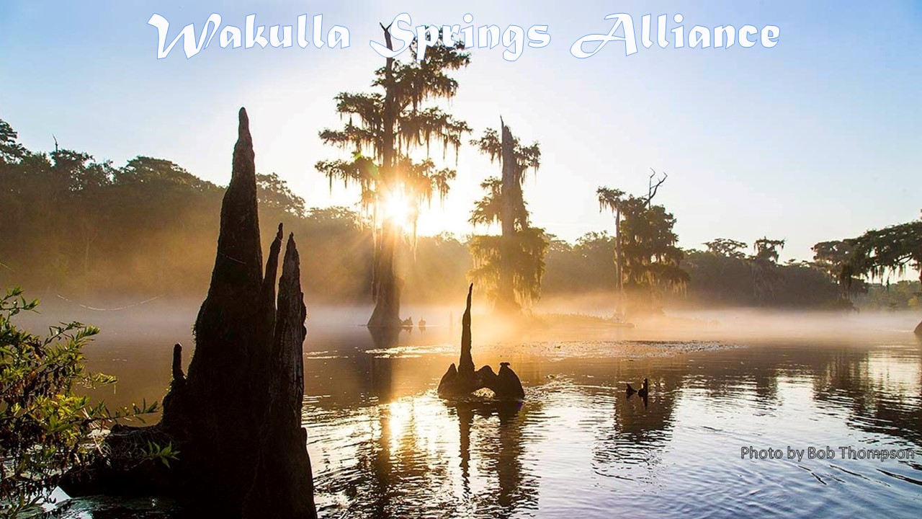

**March Board Meeting Agenda**

**Friday, March 25, 2022**

**9:00 am to 11:00 am, via Zoom**

**Opening**

* **Welcome and introductions** – Albert Gregory
* **Review and approval of agenda** - Albert Gregory

**Review and approval of February 25, 2022, meeting minutes** **(attached)** – Tom Taylor

**Review and approval of March 2022 financial report** **(attached)**– Jim Davis

**Update on Septic Tank Conversions in Wakulla and Leon Counties** – Debbie Lightsey

**Strategic plan review and refinement** – Tom Taylor

**Expanding the Tallahassee Urban Services Area at Woodville Highway and Capital Circle SE** – Debbie Lightsey

**What’s new?**

* **Legislative/policy update** – Ryan Smart
* **Springshed and river update** – Cal Jamison
* **Cave exploration updates** – Chris Werner and Andreas Hagberg
* **Renewal of WSA’s liability insurance** – Bob Deyle
* **Revisions to Wakulla County springs protection ordinance** – Bob Deyle
* **Tallahassee solar farm update** – Bob Deyle and Jim Stevenson
* **English property PUD amendment** - Bob Deyle

**Upcoming meetings and events** – board members

**April 22 board meeting** – Albert Gregory

**Adjourn**

**Closed Board Meeting** - A closed meeting of the board will follow immediately after adjournment.

**Appendix B**

**3-25-22 WAKULLA SPRINGS Board Meeting Participants**

**\* Indicates those present**

Officers

Albert Gregory, Chair *  
Robert E. Deyle, Vice-Chair *  
Tom Taylor, Secretary *   
Jim Davis, Treasurer

Directors

Gail Fishman *  
Rob Gelhardt *

Andreas Hagberg *

Cal Jamison *  
Howard Kessler *

Mike Keys *

Debbie Lightsey *

Brian Luipani *

Lindsay Stevens *

Chris Werner *

Robert Williams *

Members and Guests

Kathleen Coates *

Sue Damon *

Anthony Gaudio *

Mark Heidecker *

Chuck Hess *

Dallas Marshall *

Courtney Schoen *

Ryan Smart *

Paul Thurman *

Sophie Wacongne *

**Appendix C**

|  |  |
| --- | --- |
| **WAKULLA SPRINGS ALLIANCE** |  |
| **FINANCIAL REPORT** |  |
| **FOR THE 2 MONTHS ENDED FEBRUARY 28, 2022** |  |
|  |  |
| **INCOME** |  |
| Donations | $ - |
| Memberships | 2,600.00 |
|  | 2,600.00 |
|  |  |
| **EXPENSES** |  |
| Contribution to Florida Springs Council | - |
| Florida Corporate Annual Report | - |
| Website related | - |
| PayPal Fees | 119.30 |
| Earl Bacon Agency - Insurance | - |
|  | 119.30 |
|  |  |
| **SURPLUS/(DEFICIT)** | 2,480.70 |
|  |  |
| **BANK BALANCE - 12/31/2021** | 5,412.79 |
| **PAYPAL BALANCE - 12/31/2021** | 454.17 |
| **TOTAL - 12/31/2021** | 5,866.96 |
|  |  |
| **BANK BALANCE - 2/28/2022** | 8,178.85 |
| **PAYPAL BALANCE -2/28/2022** | 168.81 |
| **TOTAL - 2/28/2022** | **$ 8,347.66** |

Appendix D

**1000 Friends Legislative Summary**





**Other Environmental Budget Highlights**





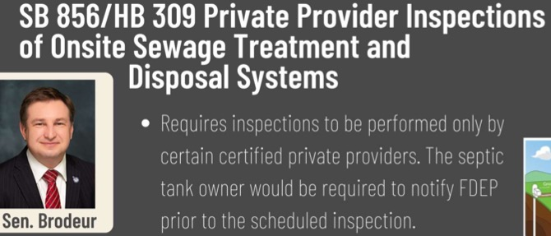

**For more details see:** [**https://1000fof.org/legis/2022-legislative-session/**](https://1000fof.org/legis/2022-legislative-session/)

Appendix E

**Deyle Email to Tallahassee City Commission re English PUD Amendments**

Recommended Stipulations re Proposed English Property PUD Concept Plan Amendment - Ordinance 21-Z-27AA

Dear Commissioner X/Mayor Dailey:

I am concerned about the potential impact on the water quality of Wakulla Spring from stormwater discharges to sinkholes on the English Property if it is developed as laid out in the proposed general land use plan without adequate regulation by the City of Tallahassee. Nitrogen from fertilizer runoff will add to the burden of excessive nitrogen that continues to plague the spring and river ecosystem if stormwater is not properly managed. I believe that the city’s rules governing stormwater discharges to sinkholes are not consistent with applicable state regulations and therefore will not assure even the minimum level of protection that those rules require.

If you decide to approve the PUD concept plan amendments sought by Mr. English, I urge you to do so with the following stipulations:

1. Condition approval of the PUD amendment on compliance with applicable state regulations governing stormwater management systems constructed within Sensitive Karst Areas, i.e. Section 13 of the Northwest Florida Water Management District’s *Environmental Resource Permit Applicant’s Handbook Volume II*.
2. Direct staff to consult with the Water Management District to review the city’s stormwater rules governing stormwater discharges to sinkholes (Sec 5-81(a)(2)(e) LDC) and bring back to the Commission any revisions needed to assure that those rules are based on accepted hydrogeologic principles and consistent with applicable state law before they are applied to any future site plan reviews within the city’s jurisdiction.

We need to continue to do all we can to minimize new nitrogen discharges to the aquifer that feeds Wakulla Spring.

Elaboration on these points follows.

Insufficiency of Current City Regulation of Stormwater Discharges to Sinkholes

The city’s land development code requires that runoff to be discharged directly into an “active karst feature (sinkhole)” must be treated to comply with Section 62-28.700(2), Florida Administrative Code, prior to discharge (Sec 5-81(a)(2)(e)). Growth Management staff have informed me that the citation is no longer accurate, and the applicable state rule is now in the Northwest Florida Water Management District’s *Environmental Resource Permit Applicant’s Handbook* Volume II.

The definition of active sinkhole/karst feature in Tallahassee LDC section 5-2 is not consistent with authoritative hydrogeological references. But more importantly, the WMD rule makes no distinction between active or inactive karst features. Section 13.3 of the WMD *Handbook* requires all stormwater management systems constructed within Sensitive Karst Areas, as designated in Figure 13.0-1 and Appendix A of the *Handbook*, to meet design criteria specified in sections 13.3.2 and 13.3.3 of the *Handbook*. As shown below, almost all of Leon County is designated as a sensitive karst area. Furthermore, the WMD requirements in section 13.3.3 are far more rigorous than what is specified in section 5-12 of the City’s Land Development Code, i.e., the presence of a “natural sand filter medium between the water and the underlying limestone formation.”

Potential Impact on Wakulla Spring

In the absence of adequate treatment, nitrogen from fertilizer in stormwater runoff that is discharged to sinkholes in this area will likely contribute to the excessive nitrogen pollution of Wakulla Spring. Sinkholes provide pathways for the introduction of contaminants to the Floridan aquifer in this region of the Wakulla springshed.[1] Dye tests conducted at the nearby city wastewater spray fields on Tram Road revealed a direct connection to Wakulla Spring.[2] Nitrate nitrogen levels measured at Wakulla Spring continue to exceed the established total maximum daily load thereby contributing to the continued proliferation of nuisance algal mats that have displaced much of the native submerged aquatic grasses that are the foundation of the spring and river food webs. A number of the wildlife species that are monitored weekly along the tour boat route at Wakulla Spring have declined in abundance over the past nine years despite the substantial reduction in nitrogen loading to the spring that resulted from the improvements to the city’s Thomas P. Smith water reclamation facility completed in 2013.[3] We need to continue to do all we can to minimize new nitrogen discharges to the aquifer that feeds the spring.

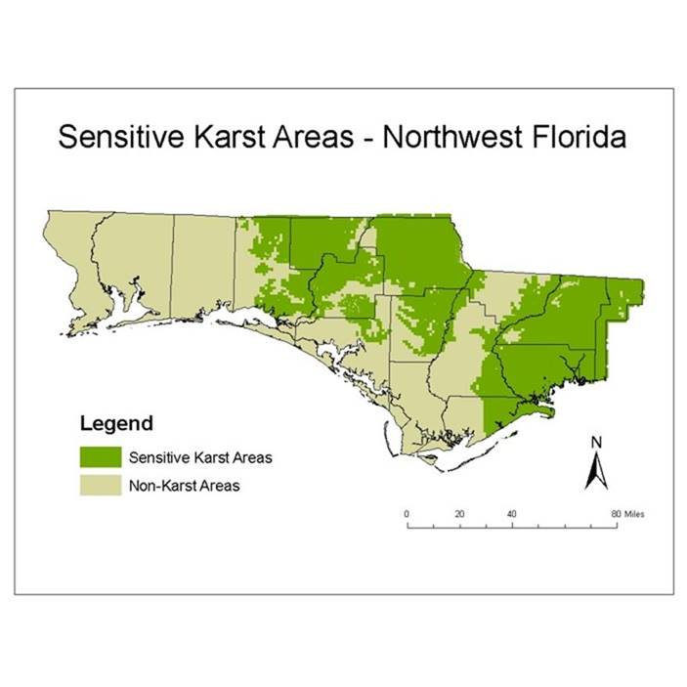

Figure 13.0-1 Sensitive Karst Areas within the NWFWMD

Thank you for considering these comments.

Robert E. Deyle, Professor Emeritus

Dept. of Urban and Regional Planning

Florida State University

850-443-6657

1. Florida Department of Environmental Protection. 2015. *Draft Basin Management Action Plan for the Implementation of the Total Maximum Daily Load for Nutrient (Biology) by the Florida Department of Environmental Protection in the Upper Wakulla River and Wakulla Springs Basin*, p. 25.
2. Kincaid et al. 2012. *Demonstrating Interconnection Between a Wastewater Application Facility and a First Magnitude Spring in a Karstic Watershed: Tracer Study of the Tallahassee, Florida Treated Spray Field, 2006-2007*. Florida Geological Survey Report of Investigation No. 111.
3. Deyle, R.E. 2022. *Upper Wakulla River Wildlife Abundance Trends September 1992 through May 2021*. <http://wakullaspringsalliance.org/wp-content/uploads/2022/03/Upper-Wakulla-River-Wildlife-Abundance-Trends-1992-May-2021.final_.pdf>.

   Appendix F

   Mr. Oluwasey and Commisioners

   I am following up on our discussion by telephone last week regarding land use amendments LMA202203 and LTA202201 that have been proposed for the County’s Comprehensive Land Use Map. The amendments propose changing 129.8-acre parcel presently located in a Critical Planning Area and designated Rural to the Suburban land use category.

   On behalf of the undersigned, residents in the Grassroots Community and members of the Grassroots Community Membership Association, Inc. (GCMA), our issues of concern are as follows:

   **Southwood Plantation Road Lacks Capacity for the Development of the Proposed Land Use Change.** The subject property is located between St. Augustine Road, a designated canopy road to its south, and Apalachee Parkway to its north.  The property abuts the eastern side of Southwood Plantation Road, which is a narrow, winding single lane rural road bordered by open ditches.

   Southwood Plantation Road provides the sole access to/from Apalachee Parkway and Old St. Augustine Road from the eastern side of the Southwood DRI/PUE.  It also provides the sole point of ingress and egress to and from the 240 unit Apalachee Point Apartments, adjacent to the northern boundary of the subject property, as well as other single family residences abutting Southwood Plantation Road.  The proposed land use change from Rural to Suburban changes the parcel from the present density of one unit per 10 acres, to a future density of 20 units per acre.  Southwood Plantation Road does not have the capacity to safely handle this proposed increase in density for a 129 acre parcel.  Even at 8 units per acre, which you represented would be the zoning density sought through rezoning, this single lane rural road neither has the capacity, nor can it safely support, the level of development proposed for this site.

   **Relocation of Southwood Plantation Road.**As a condition of approval of the original Southwood DRI/PUD, St. Joe agreed to redirect future traffic in the DRI off Southwood Plantation Road onto a newly developed internal road system.  This new internal road necessitated the creation of a new intersection at St. Augustine Road that will connect the DRI development south of St. Augustine Road, to the future DRI development proposed north of St. Augustine Road.  The intersection will be located in an area west of Southwood Plantation Road, that is more central to the DRI.  In exchange for the creation of a new intersection that will require significant safety and sight clearing of St. Augustine Road’s protected canopy, St. Joe agreed to close the existing intersection at Southwood Plantation and St. Augustine Roads to offset the canopy impacts on the new intersection to the west.  (It is our understanding that access to St. Augustine Road from the portion of Southwood Plantation Road south of St. Augustine Road would not be closed in order to maintain the east/west access St. Augustine Road provides to the existing homes abutting Southwood Plantation Road that are not part of the Southwood DRI).

   It is imperative that the proposed 129-acre land use and zoning change be evaluated for potential impacts this development will have on Southwood Plantation Road, including an assessment of the project based on the closure of access to St. Augustine Road from Southwood Plantation Road.  It is also imperative that any land use change, rezoning, or development order issued for the subject parcel be conditioned on the closure of this intersection, in conformity with St. Joe’s commitment to offset its new canopy road intersection with the closure.

   **Density** - This 129 acre site now Zoned Rural can have up to 20 units per acre after the changes to the land use map requested. Even if the developer only goes to 8 units per acre, as you stated in our telephone conversation, this could mean up to 1000 or more additional housing units that will be in that development, on a parcel that is itself designated rural, within a much larger area east and south of the site, that is also designated rural.  The proposed land use change is incompatible with the area, and inconsistent with the underlying purpose of having designated the parcel as rural, in recognition of the existing natural systems and ecosystems in the area, and the rural development patterns that presently exists around this site.  This is underscored by the fact that a portion of the parcel is located outside the USA boundary.

   **Urban Services Area** – It is my understanding that a portion of the property is not now in the Urban Services Area. Adding this development will add significantly to the Concurrency needs for transportation, sewage, Schools, Fire, etc.  Given the thousands of approved residences and commercial development still undeveloped in the Southwood DRI/PUD, all within the the USA, what is the rationale for having to expand the USA to accommodate the change in land use sought by these amendments?  It seems piecemeal at the expense of infilling remaining for the existing USA.

   **Concurrency Requirement for $10 Million dollars to be paid to the City for Concurrency after Southwood expands or develops north of its current northern most boundary.**  This 129-acre parcel is proposed to be developed by a subsequent purchaser from the current owner, St. Joe, subject to the approval of the change in land use and zoning.  The concurrency deficits and future needs that have been identified in the area are directly the result of the approval of the Southwood DRI/PUD.  These deficits will be exacerbated by the approval of the land use change that has been requested for the subject property and should be assessed and evaluated based on the reality of the deficits existing today, not on the basis of the improvements that may be made in the future when, and if, St. Joe develops the northern portion of the DRI.

   We do not want the future developer of the subject parcel to be allowed to offset the impacts of its proposed development on the basis of concurrency improvements that might be made if the Southwood DRI moves forward on the northern portion of the DRI.  The proposed project should pay its own fair share for its own impacts independent of any improvements that might occur in the future, just as St. Joe should be required to pay its full $10 million share of the impacts its DRI will have if it completes its development north of Old St. Augustine Road, irrespective of the impacts created by the proposed development of the 129 acre parcel.

             Again, thank you for your time and the opportunity to follow up on our conversation last week.  Please feel free to contact either of the undersigned if you have any questions.

   Ken Goldberg,

   President, GCMA

   511China Berry Lane

   Tallahassee, FL 32311

   850-567-6225

   Anthony Gaudio

   Registered Agent, GCMA

   2335 Grassroots Way

   Tallahassee, FL 32311

   850-528-6350