Wakulla Springs Alliance
6-16-17 Minutes and Action Items
WSA Action Info

This section provides information on what you and others can do to support research-based actions to enhance water quality and quantity in Wakulla Springs and the water/springshed and improve related environmental, economic and social systems. Efforts by all, produce results!

Background
- Wakulla Springs Information
- WSA Purpose and Plans
- WSA Action Resources

Upcoming Events
- There will not be a WSA Board meeting in July or August
- Next WSA Meeting: Board meeting, September 15, 2017., 2nd floor, Renaissance Building

Action Items from the 6-16-17 WSA Board Meeting
- Bob Henderson needs to send the donation to the Florida Springs Coalition.
- Brett Cyphers, Executive Director of the NWFWMD, will contact Bob Sellers, the Corbett’s representative.
- Chuck Hess will follow-up on the closure of Highway 61 south of Hwy 267.
- It is important to get support solutions from higher levels in FDOT and FDEP and if appropriate FWC, early in the design process for better highway stormwater solutions.
- Dr. Spencer at the MagLab, Bob Ballard at WEI, Nick Wooten at the NWFWMD and Johnny Richardson with Leon County may be able to contribute to the UF Wakulla studies.
- Volunteers are needed for wildlife monitoring. Contact Jackie Turner or Bob Thompson.
- The Intergovernmental Agency administering Blueprint funds agreed (9-0 vote) to provide early funding of the Wastewater Facility Engineering Plan. We had a letter encouraging early funding of the Plan with 15 groups signing it.
- The RFP is due September 19.
- The next piece will be to get agreement on septic system project financing and management approaches.
- We need to document the benefits to developers, residents and the environment.
- It may be helpful to test private wells for nitrogen, which does not taste or smell but had human health and environmental impacts.

6-16-17 WSA Board Meeting Minutes

Overview

The Wakulla Springs Alliance held their regular Board meeting on June 16, 2017 at the Renaissance Building. The draft agenda, treasurer’s report and list of participants can be found in Appendices A, B and C. Review the action items underlined for your commitments and actions you can help with. Our success in protecting and enhancing Wakulla Springs depends on the actions of the WSA board, advisors and supporters. This report is based on the secretary’s notes and does not capture everything or exactly what was said.

Opening

- Welcome and meeting agenda review by Seán McGlynn, then everyone introduced themselves.
- Ryan Smart made a motion, seconded by Debbie Lightsey to approve the minutes and it passed unanimously
- Debbie Lightsey made a motion, seconded by Gail Fishman to approve the minutes and it passed unanimously
  - Bob Henderson needs to send the donation to the Florida Springs Coalition.

Corbett Property Update

- Background from the previous meeting:
  - Last year there was a proposal for 300 single family and multifamily, which was challenged by 1000 Friends
  - The Corbetts have a new proposal and have met with the County.
  - The current proposal has 230 homes with central sewer and a conservation area around karst features. They are asking for intense zoning rather than a conservation residential zone, which would be better.
  - They haven’t done the geophysical analysis yet.
  - The parcel is on the WMD acquisition list. There is money in the budget for properties like this.
  - Black Creek flows across the property. There are flooding problems and flows into sinks and swallets. This is above the mapped cave system.
  - The Corbetts have owned the land for 40-50 years.
- 1000 Friends sent a letter to the County and the Corbetts.
- Cal Jameson and Ryan Smart met with the Corbetts about the advantages of a conservation easement that will allow them to continue to live on the property, grow pines, etc. and other options. The Corbetts expressed interest in State acquisition of an easement.
- Brett Cyphers, Executive Director of the NWFWMD, will contact Bob Sellers, the Corbett’s representative.

Acquisition of Other Properties

- The Ferrell’s sign says the property is $5 million. They are not interested in selling it to the State at the appraised value. It is still on the WMD list but there are no current negotiations.
- Camp Indian Spring’s negotiations are getting close to an agreement. The appraisal is 1.42 million and the asking price is 1.6 million. Wakulla Springs State Park is willing to be the land manager.
- The closure of Highway 61 south of Hwy 267 is still being discussed. The Park does not want the dedication if the asphalt is not removed. Chuck Hess will follow-up on this.
- Brett Cyphers asked to be contacted about acquisition proposals earlier in the process for springs funds approved this year by the legislature.
- There are 5 properties being considered as mitigation for the Highway 319 holding ponds.

Highway 319 Holding Ponds

- FDOT rejected proposals to use Biologically Active Materials, BAM. It is important to get support solutions from higher levels in FDOT and FDEP and if appropriate FWC, early in the design process for better highway stormwater solutions.

Wakulla Springs Wildlife Monitoring Results, 1997 to 2016

- Bob Thompson presented the results of almost 20 years of wildlife monitoring.
- Overall there has been a significant decrease in wildlife (See Appendix D).
- Factors include: hydrilla coverage, uptake of oxygen, manatees, weather, use of chemicals, loss of native vegetation, dark water, flow, food sources (apple snails, etc.) and more.
- The NWFWMD is funding UF to study climate, wastewater, stormwater, macro-invertebrates, etc. statewide. Dr. Spencer at the MagLab, Bob Ballard at WEI, Nick Wooten at the NWFWMD and Johnny Richardson with Leon County may be able to contribute to the UF Wakulla studies.
- We need to look at transitions from eel grass to hydrilla to lingua over time.
- It would be helpful to monitor fish and other food sources.
- Volunteers are needed for wildlife monitoring. Contact Jackie Turner or Bob Thompson.
- We can link the park visitor experience to wildlife levels and the factors that affect them.

Blueprint Funding of the Wastewater Facility Engineering Plan
- The Intergovernmental Agency administering Blueprint funds agreed (9-0 vote) to provide early funding of the Wastewater Facility Engineering Plan. We had a letter encouraging early funding of the Plan with 15 groups signing it.
- The RFP is due September 19.
- The next piece will be to get agreement on septic system project financing and management approaches.
- We need to document the benefits to developers, residents and the environment.
- It may be helpful to test private wells for nitrogen, which does not taste or smell but had human health and environmental impacts.

Legislative Update Ryan Smart, President of 1000 Friends of Florida reported that:

- No money for FL Forever or FL Communities Trust.
- DEP was cut by 20%, All environmental funding cut 18%.
- There is funding for springs ($50m) and beaches,
- Senate bill 10 had $250m for an Everglades reservoir that goes back to a plan from 10 years ago.
- Ag lands will get $10m.
- There were very few policy changes.
- The fracking bill died.
- There is lots to work on next year. The coalition is seeking $50m.
- Litigation on FL Forever will proceed. Amendment 1 should provide $300m/year. Some of it is used for projects but not land acquisition.
- Blue Springs acquisition was approved by the cabinet.
- We need to focus on key links to connect parcels, greenways and areas that need to be burned.

Other Issues

- Gail Fishman met with the airport officials and they said that they must meet FAA requirements by mowing down milkweed and other plants needed for butterflies. Gail read more and they must consider endangered species like the monarch butterflies. They have agreed to move the plants. They can’t move plants now. They will mow now and then move plants in November to compatible locations possibly at the Museum of Natural History, Panacea, Horen Trace, Debbie Lightsey Park, etc.
- Jim Stevenson had recommended that we give Springs Champion awards to leaders and do a press release. There was a request for nominations and Bob Thomson and Pam Hall were suggested. Others were mentioned at the meeting but there was no long a quorum for a decision was deferred to the next meeting.

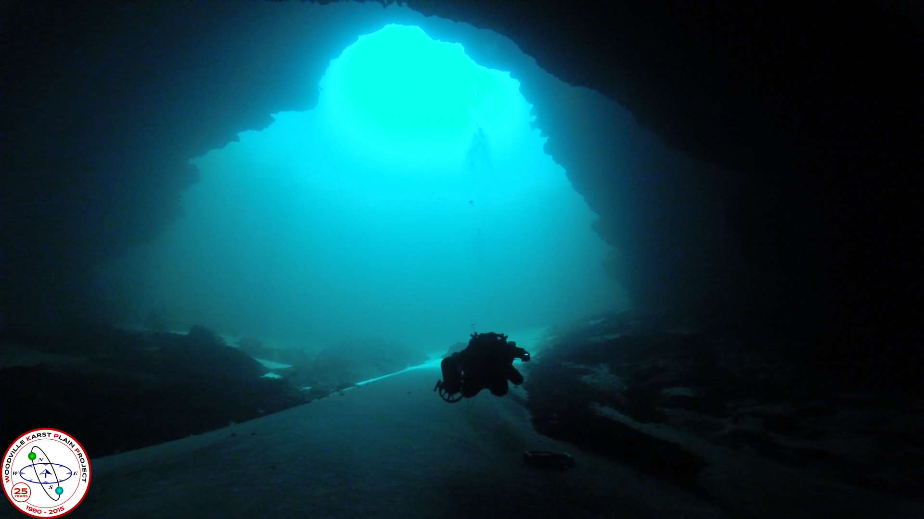
Wakulla Springs Alliance

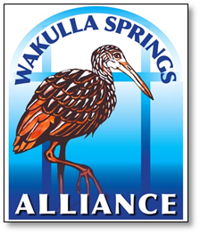
Agenda 06/16/17
9 am to 12 pm, Renaissance Center
435 N. Macomb Street, 2nd Floor Conference Room

WSA Board Meeting

9:00 Opening
- Presidents Welcome and meeting agenda review (Seán McGlynn)
- Introductions (Board)
- Secretary Minutes (Tom Taylor)
- Treasurer Report (Bob Henderson)
9:10 Park Status Update - Jim Stevenson
- 9:25 Questions
9:30 Volunteer Wakulla Springs Wildlife Monitoring, summary of results, 01/97-12/16
– Robert Thompson
- 10:15 Questions
10:30 What’s new (about 5 minutes each)
- New letters and update on the IA meeting
  - A letter was sent to all the commissioners of Leon County and the City of Tallahassee (Intergovernmental Agency (IA) of Blueprint 2020) who will vote on the proposal to provide early funding for the development of a Comprehensive Wastewater Treatment Facility Plan (CWTF Plan),
- Legislative Update (analysis of the new budget and environmental funding – Ryan Smart, President of 1000 Friends of Florida
- Springshed land acquisition – Cal Jamison, Ryan Smart, Albert Gregory
  - Corbett property – update
  - Ferrell property – update
  - Indian Springs – update
  - Wakulla Springs Road Closure – update
  - FDOT 319 Holding Ponds – update
- Wakulla Springshed, land use in the unconfined aquifer areas – Gail Fishman
- Springshed Updates – Cal Jamison
- Wakulla Springs Champion Award - Jim Stevenson
- Website and Social Media, Updates – Tom Taylor
11:30 Wakulla Springs BMAP / OSTDS update – Tom Taylor
- 11:45 Questions
11:55 Items from the floor
12:00 Adjourn

Appendix B
Board Advisors and Guests
* Indicates 6-16-17 Participants

Board Members

Bart Bibler
Bob Deyle
Gail Fishman *
Albert Gregory *
Bob Henderson
Cal Jamison *
Howard Kessler
Debbie Lightsey *
Sean McGlynn *
Ryan Smart *
Jim Stevenson *
Tom Taylor *
Rob Williams

Guests

Brett Cyphers *
Jack Hines *
Bill Howell *
Johnny Richardson *
Peter Scalco *
Nick Wooten *

WSA Advisors

Anthony Gaudio
Pam Hall
Julie Harrington
Chuck Hess *
Todd Kincaid
Bob Knight
Terrance McCaffrey
Pam McVety
Dan Pennington
Bob Thompson *

Appendix C

 | Financial Statement
 | Wakulla Springs Alliance
 | For Period Ended
 | April 30, 2017
INCOME | Budget | In-Kind | Current Month | Y-T-D Trans |  | Checking Account
Fund Balance (January 1, 2017) | 3854.46 |  |  | 3854.46 | BFB | 3854.46
Palmetto Tours |  |  |  |  | Income | 150.00
Board Member Contributions |  |  | 150.00 | 150.00 | Expense | 386.25
Other Donations |  |  |  |  | Grant
 |  |  |  |  | EFB | 3618.21
Subtotal | 0.00 | 0.00 | 150.00 | 150.00
TOTAL | 3854.46 | 0.00 | 150.00 | 4004.46
EXPENDITURES |  |  |  |  | Rest
Secretary Expenses |  |  |  |  | Unrest | 3618.21
Web Support |  |  |  | 325.00
Corporate Filing Fee | 61.25 |  |  | 61.25
 |  |  |  |  | Bank Statement | 3618.21
 |  |  |  |  | Checks not
 |  |  |  |  | Recorded
RESERVES
 |  |  |  |  | Deposits not
 |  |  |  |  | Recorded
 |  |  |  |  | Due to/from
 |  |  |  |  | Projects Fund
 |  |  |  |  | EFB | 3618.21
TOTAL | 61.25 | 0.00 | 0.00 | 386.25 | (Overage) | 0.00

Appendix D
Wakulla Springs Wildlife Monitoring Results, 1997 to 2016 (Excerpts)

Figure 2. Plot of total number of animals observed of all 34 animals monitored on wildlife monitoring boat tours from 1997 through 2016

Figure 3. Plot of annual mean, minimum, and maximum total number of animals observed of all 34 animals monitored on wildlife monitoring boat tours from 1997 through 2016

Table 5. Abundance of Animals Sorted on the Most Recent (2016) Annual Mean

 | 15-year  Mean | 5-year  Mean | Annual Means  During Recent 5 Years |  |  |  |  | 20-year Trend | 5-year Trend
 | 1997-2011 | 2012-2016 | 2012 | 2013 | 2014 | 2015 | 2016 | (1997-2016) | (2012-2016)
Limpkin | 0 | 0 | 0 | 0 | 0 | 0 | 0 | Decreasing | 5-year Mean=0
American Widgeon | 80 | 0 | 0 | 0 | 0 | 0 | 0 | Decreasing | 5-year Mean=0
*Blue-Winged Teal | 3 | 0 | 0 | 0 | 0 | 0 | 0 | Decreasing | 5-year Mean=0
Purple Gallinule | 1 | 0 | 0 | 1 | 0 | 0 | 0 | Decreasing | 5-year Mean=0
Green Heron | 3 | 0 | 1 | 0 | 0 | 1 | 0 | Decreasing | 5-year Mean=0
Snowy Egret | 2 | 0 | 1 | 1 | 0 | 0 | 0 | Decreasing | 5-year Mean=0
Osprey | 2 | 1 | 1 | 1 | 1 | 1 | 0 | No Trend | No Trend
Tri-Colored Heron | 2 | 1 | 1 | 1 | 1 | 1 | 1 | Decreasing | No Trend
**Cattle Egret | 0 | 10 | 12 | 21 | 16 | 1 | 1 | Increasing | No Trend
Great Blue Heron | 1 | 1 | 2 | 1 | 2 | 1 | 1 | No Trend | No Trend
Wood Duck | 13 | 4 | 4 | 7 | 4 | 4 | 2 | Decreasing | No Trend
Great Egret | 3 | 2 | 2 | 1 | 2 | 2 | 2 | No Trend | No Trend
*Manatee | 3 | 6 | 12 | 8 | 5 | 3 | 3 | No Trend | Decreasing
Yellow-cr. Night Heron | 3 | 2 | 1 | 2 | 2 | 2 | 3 | Decreasing | Increasing
Double-crested Cormorant | 2 | 3 | 3 | 2 | 3 | 2 | 5 | No Trend | No Trend
Little Blue Heron | 5 | 4 | 4 | 4 | 3 | 4 | 5 | No Trend | No Trend
*American Coot | 48 | 29 | 88 | 40 | 30 | 13 | 10 | No Trend | Decreasing
Anhinga | 15 | 12 | 13 | 10 | 12 | 13 | 14 | Decreasing | No Trend
Cooter Turtle | 19 | 16 | 15 | 14 | 16 | 20 | 16 | No Trend | No Trend
American Alligator | 24 | 16 | 14 | 15 | 16 | 16 | 17 | Decreasing | Increasing
Pied-Billed Grebe | 12 | 20 | 27 | 20 | 20 | 19 | 19 | Increasing | No Trend
*Hooded Merganser | 3 | 12 | 6 | 7 | 13 | 8 | 21 | Increasing | No Trend
*White Ibis | 21 | 25 | 25 | 22 | 24 | 23 | 30 | No Trend | No Trend
Common Gallinule | 82 | 37 | 64 | 44 | 33 | 31 | 34 | Decreasing | No Trend
* Migratory/Seasonal; ** Cattle Egret abundance was extremely low, except during nesting from 2012 to 2014.

