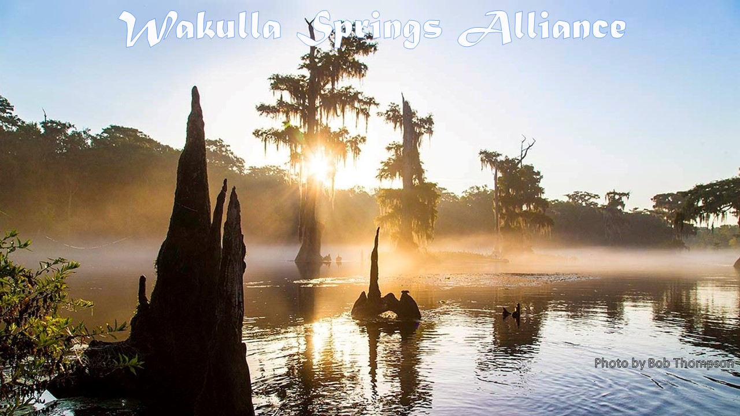

Mission: Protecting and restoring water quality, spring flow and ecological health of Wakulla Spring

Board Meeting Minutes
Friday, July 23, 2021
9:00 to 11:45 am, via Zoom

Meeting highlights
- Harley Means, Florida Geological Survey described the geology and history of Lake Jackson’s drawdowns.
- Chad Hanson presented a proposal to create a Spring Creek springshed protection district.
- Cal Jamison and others reported on the visibility, nitrate levels at Wakulla Springs.
- There was a cave exploration update by Andreas Hagberg.
- Wakulla County has made an offer to purchase a golf course for use as a sewerage spray field.
- A motion was passed for the WSA Executive Committee to draft a letter to the City regarding sewerage spills for approval at the August 27 WSA meeting.
- Bob Deyle reported on the emergent marsh distress along upper river
- Jim Stevenson provided an update on the City of Tallahassee solar farm herbicide use.

Minutes

Opening

- Welcome and introductions - Bob Deyle
- Agenda review - Bob Deyle

May 2021 minutes - Tom Taylor

- Approved as submitted.

Financial reports - Jim Davis

- May 2021 financial report - Approved as submitted.
- June 2021 financial report - Approved as submitted.

Lake Jackson geology – Guy “Harley” Means, Florida Geological Survey

- FGS Interim Director, Harley Means described how Florida’s limestone deposits
accumulated and sea levels changed over millions of years.
- The Cody Scarp divides the bluffs and ravines (including Lake Jackson) from the Woodville Karst Plain, Leon Sinks and Apalachicola Delta.
- He explained how karst features are formed and the linear fracture patterns. Lake Jackson is approximately 4,000 acres in size and is one of several large sinkhole lakes located in this area.
- There have been lake draining events in 1907, 1909, 1932, 1935/36, 1957, 1982, 1999/2000, 2002, 2007, 2012 and 2021. Concrete was used to plug sinkholes in 1954 and 59.
- Dye tracing has demonstrated the connections to Wakulla Spring.
- A pdf of his presentation is available on the WSA website at http://wakullaspringsalliance.org/wp-content/uploads/2021/07/Geology-of-Lake-Jackson_7-23-21_WSA.pdf.

Proposal to create a Spring Creek springshed protection district – Chad Hanson

- Chad Hanson, former of the Concerned Citizens of Wakulla Group which dissolved about five years ago made the case of expanding the Wakulla County’s Wakulla Spring Protection Zone (WSPZ) to include the Spring Creek Springs group portion of the joint Wakulla-Spring Creeks Springs springshed. He reported that the original 1994 WSPZ was based on the mapped cave system at the time. It was expanded south in 2008 to Shadeville Road. That boundary does not reflect what has been learned from subsequent dye studies. It only includes a small portion of the BMAP PFA2.
- He suggested that there is an opening in the county comprehensive plan to do this because the Spring Creek Springs are included in Objective 2.0 of the comp plan’s Surface Water and Springs Protection goals and Policy 12.2 calls for considering additional springshed protection such as creating a Spring Creek Special Planning Area. This would not stop development but could regulate septic systems etc. He noted, however, that much of this area is already developed or slated for development.
- Reaction from board members was positive but it was noted that only one of our members is currently a resident of Wakulla County so the Board felt it probably wouldn’t be politically viable for WSA to take the lead on this. Chad was encouraged to pursue building support for such an initiative among Wakulla County residents and to let WSA know how we can help at an appropriate time.
- A pdf of Chad’s presentation is available on the WSA website at http://wakullaspringsalliance.org/wp-content/uploads/2016/11/Wakulla-Springs-Special-Planning-Area-WSA.pdf.

Springshed and river update - Cal Jamison and others

- There have been a few glass bottom boat tours.
- Visibility has gone from 70’ to 32’ on Thursday. See table in Appendix D.
- The water color is green.
- Rain has been hitting different places in the Apalachicola Nation Forest daily.
- Nitrate levels measured at the USGS gauge on the boat dock from slightly below the TMDL of 0.35 ug/L in late 2019 to concentrations between 0.45 and 0.50 ug/L beginning March 2020. See Appendix D.
- Nitrate levels may be noise and can be verified by checking weekly and monthly sampling data. James Sutton said there may be problems with the sensors. Mark Heidecker suggested using IWR data and having USGS check and calibrate the probes.
- There may be a timing correlation with the emergent plant die-offs.
- Check for the causes, such as, sea level rise, the mix of surface and aquifer water, etc.
- USGS gauge results are at the Mobile Water Data Site.
- John Bowdin from UF is sampling 24 sites in the area for non-nitrate pollutants.
- Cal also shared a photo of Sullivan Sink that he explored with Jim Stevenson. See Appendix E.

Cave exploration update - Andreas Hagberg

- He has been continuing his diving and mapping efforts.

Wakulla County golf course purchase offer – Bob Deyle

- Bob Deyle reported that Wakulla County Executive David Edwards has made an offer to the owner of the Wildwood Gold Course for the county to purchase it.
- The county would then operate the golf course and use it to dispose of some of the treated effluent from the Otter Creek wastewater treatment facility via irrigation.

Proposed letter to Tallahassee City Commission re sewage spill transparency – Terry Ryan

- Board member Terry Ryan presented a draft letter to be sent on behalf of the WSA Board to county commissioners; see Appendix C.
- The letter references Commission’s July 7, 2021, Agenda Item 13.05, “Update on Contaminated Sites and Consent Orders,” and requests more transparency and actions in the future as well as raising concerns about financing.
- There was a motion made and approved to draft a more narrowly focused letter for review by the Executive Committee prior to bringing it back to the full board at the August 23 meeting.

Investigation of emergent marsh distress along upper river – Deyle

- Bob Deyle summarized efforts to investigate the die-off of several species of emergent along the upper Wakulla River. Deyle and others noticed signs of distress among three species: knotweed (Polygonum sp.), water hemlock (Cicuta sp.), and pickerel weed (Pontederia chordata) beginning in late April and early May.
- Park staff contacted the Fish and Wildlife Commission which has arranged for its plant pathologists to examine the affected plants. FWC also is arranging to have plants tested for cyanotoxins. Reconnaissance down river revealed similar conditions in the two miles of rover within the park below the tour boat turnaround as well as downstream of the Shadeville Road bridge.
- Deyle investigated emergent plant communities in systems upstream from Wakulla Spring including the Sally Ward run, McBride Slough, Munson Slough, Lake Munson, and Lake Henrietta. He found no evidence of similar conditions in those waterbodies. FWC reports nothing similar along the Wacissa River either.
- Park staff are working with FDEP and others to investigate possible evidence of herbicides being involved.

City of Tallahassee solar farm herbicide use – Jim Stevenson

- Jim Stevenson described efforts he has made to explore alternatives to using herbicides to control weeds under the solar panels at the solar farm next to the Tallahassee airport. The solar farm is now owned by an international investment firm and operated by Origis Services. Origis applies herbicides once a year to control weeds in areas where mowers cannot reach under the panels. They also spot treat vines that start to grow up the pipers that support the panels.
- Jim has learned that a number of solar farms in Florida and elsewhere are using sheep to manage vegetation rather than herbicides. He is gathering more information.
- See map of the site near the airport and the larger area in Appendix F.

Upcoming meetings and events – Deyle

- August 27 – Bob Deyle will offer a presentation on findings from the Wakulla Springs State Park Wildlife Survey Update 1992-2021
- September 24 – TBA

Appendix A
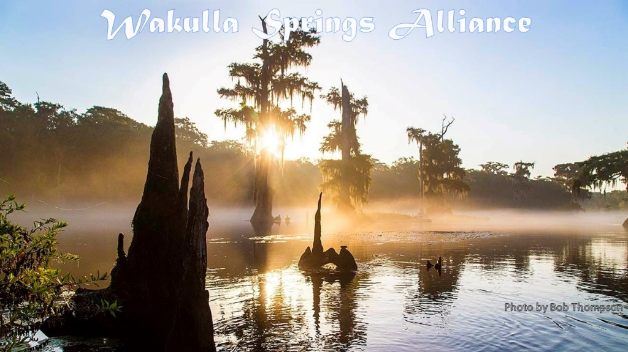
Final Agenda
Friday, July 23, 2021
9:00 to 11:45 am, via Zoom

9:00 Opening
- Welcome and introductions - Bob Deyle/Howard Kessler
- Agenda review - Bob Deyle/Howard Kessler
9:10 May 2021 minutes - Tom Taylor [attached]
9:15 Financial reports - Jim Davis
- May 2021 financial report [attached]
- June 2021 financial report [attached]
9:20 Lake Jackson geology – Harley Means, Florida Geological Survey [invited]
10:05 Proposal to create a Spring Creek springshed protection district – Chad Hanson
10:25 What’s new?
- Springshed and river update - Cal Jamison
- Cave exploration update - Andreas Hagberg
- Wakulla County golf course purchase offer - Deyle
- Discussion re: Preserving Trees, Green Space, & Wildlife Corridors in & around Tallahassee - Deyle
- What else?
10:45 Proposed letter to Tallahassee City Commission re sewage spill transparency – Terry Ryan [attached draft letter plus referenced exhibit]
11:00 Investigation of emergent marsh distress along upper river – Deyle
11:15 City of Tallahassee solar farm herbicide use – Jim Stevenson
11:30 Upcoming meetings and events – Deyle/Kessler
- August 27 – Wakulla Springs State Park Wildlife Survey Update 1992-2021 - Deyle
- September 24 – TBA
- Moving to hybrid meeting format (Zoom and in person)
11:40 Other business
11:45 Adjourn

Appendix B
7-23-21 WAKULLA SPRINGSA Meeting Participants
* indicates those present

Officers
Robert E. Deyle, Chair *
Howard Kessler, Vice-Chair *
Tom Taylor, Secretary *
Jim Davis, Treasurer *

Directors
Gail Fishman *
Albert Gregory *
Rob Gelhardt *
Andreas Hagberg *
Cal Jamison *
Brian K. Katz *
Debbie Lightsey *
Terry Ryan *
Lindsay Stevens *
Jim A. Stevenson *
Members and Guests
Jodie Cahoon *
Lauren Cruz *
Laura Edwards *
Anthony Gaudio *
Scott Hannahs *
Chad Hanson *
Mark Heidecker *
Michael Hill *
Clint Kromhaut *
Brian Luipani *
James Sutton *
Sophie Wacongne *

Appendix C

Draft Letter to the City Regarding Sewerage Discharge Violations

Commissioners,

Agenda Item 13.05, “Update on Contaminated Sites and Consent Orders,” of the July 7, 2021 commission meeting is of particular interest to the Wakulla Springs Alliance.

The update, while giving a brief historical overview of contaminated sites and consent orders related to the numerous raw sewage spills, is the first on-record summary of the City’s sewage spills to the general public. We feel this is of concern to us and the citizens of Tallahassee, given the history of spills in Tallahassee and resulting FDEP consent orders, fines, and penalties, plus, the need for EPA to become involved in 2010 for a more stringent consent order.

As such, in order to create more transparency with our citizens, we feel that all future new or amended consent orders should be reviewed and approved by commissioners at a regular meeting. Additionally, all status updates to FDEP and/or EPA or other regulatory entity should be reviewed at a regular commission meeting.

Secondly, in addition to asking for more transparency, we, also, note the City’s Underground Utility Department presentation failed to provide important information related to the timeframe and cost to complete the necessary collection system upgrades and contaminated site cleanups (only 6 of approximately 240 contaminated sites were discussed). Naturally, the longer wastewater collection system upgrades and contaminated site cleanups are outstanding, the more likely sewage spills and contaminated site leachate will threaten local water resources and Wakulla Springs.

Likewise, there was no mention of the environmental implications of over 11,000,000 gallons of spilled raw sewage between 2009 to present day. Sewage spills associated with pump station and aging sewage collection system failures and exfiltration contribute a host of physical, chemical, pharmaceutical, and biological constituents that threatens the primary springs protection zone and associated karst features; most especially threatens the water quality of the aquifer.

Additionally, although 2019 and 2020 showed promising reductions in sewage spills, we note that 2019 rainfall was 35% lower than average (60”/year) with 2020, also, below the average.

While recognizing the system improvements mentioned in the City’s Underground Utility Department’s recent presentation, we hope these will be of significant benefit during periods of higher rainfall, recognizing the importance of rainfall in the history of the City’s sewage spills.

Equally important, there was no information provided about the cost to upgrade the collection system or the timeframe to address the repeated spills related to pump station failures, leaks associated with failing vitrified clay pipes, Infiltration/inflow and exfiltration. We believe this essential information should be reported to the City Commission on a quarterly basis, at a minimum; thus, providing additional transparency to us and fellow citizens.

As such, we believe every effort should be made to expedite the upgrades to the wastewater collection system and contaminated site remediation. We also suggest that Blueprint funds could be used expedite the necessary upgrades and remediation as the increased cost to treat millions of gallons of inflow and infiltration is currently being passed on to the taxpayer. As noted in Exhibit I, the City’s consultant indicated in 2020 over one-hundred and twenty (120) infiltration/inflow (I/I) rehab issues across the entire City. The consultant further indicated I/I of almost 6 million gallons during their identified “wet” month. We understand another consultant estimated almost 9 million gallons during its wet month and an average of about 2 million gallons daily with treatment costs of about $41 million over the past ten years, plus, millions yearly! As such, BluePrint funding would help tremendously in addressing current I/I rehab projects and reduce treatment expenses in a more timely manner.

In closing, thank you for your continued mutual efforts to improve our environment and most importantly addressing those events which contribute to the degradation of Wakulla Springs.

Regards,

Appendix D
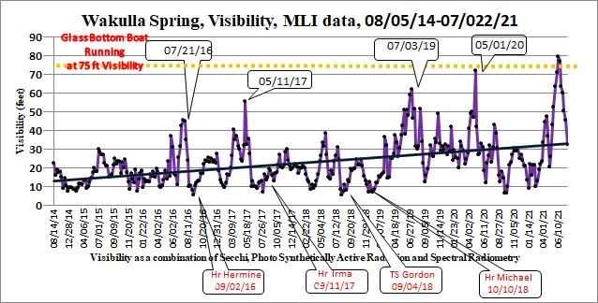
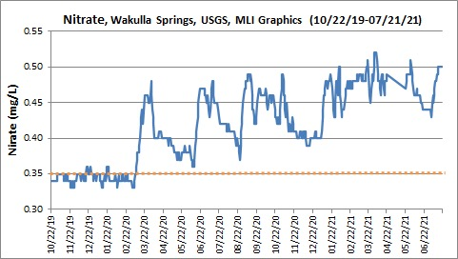

Appendix E

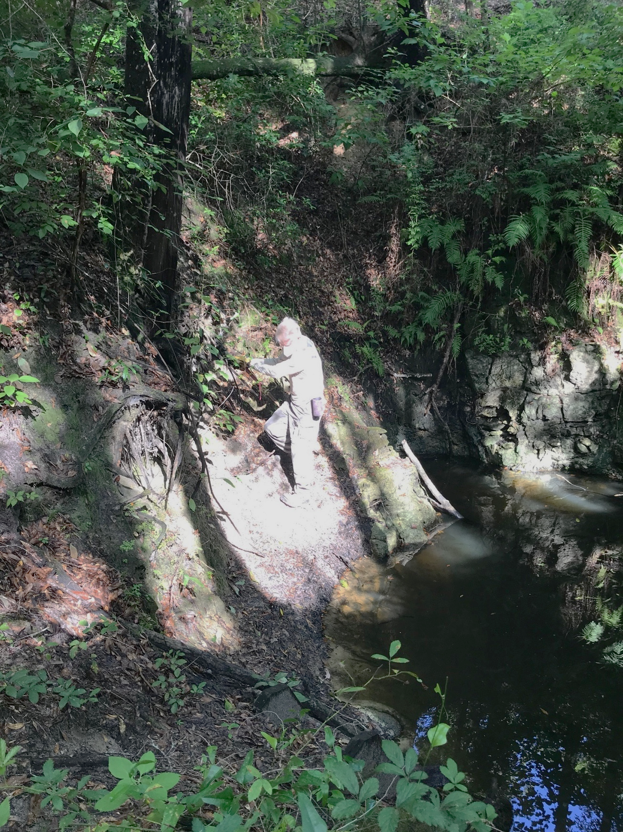
Sent from my iPhone

Appendix F
Barrios Basin Map

