Wakulla Springs Alliance
8-21-15 Board Meeting Minutes

The Wakulla Springs Alliance held a Board meeting on August 21, 2015 at the Renaissance Center. The draft agenda and list of participants can be found in Appendices A and B. Review the action items underlined below for your commitments and actions you can help with. This report is based on the secretary’s notes and does not capture everything or exactly what was said.

Opening

Chairman Sean McGlynn welcomed everyone, reviewed the meeting agenda and everyone introduced themselves. The minutes of the last three meetings and the treasurer’s report (Appendix C) was presented and approved.

Wakulla Springs Water Quality Restoration

Rob Spencer and David Podgorski presented an overview of their past current and proposed research and how their work can contribute to our goals for Wakulla Springs. Rob Spencer is a professor in the Department of Earth, Ocean, and Atmospheric Science at FSU. David Podgorski (National High Magnetic Field Laboratory at FSU. Their proposal in appendix D highlights their research and what they are seeking funding for related to Wakulla Springs. At the end of the meeting there was a discussion of the value of this research and how it can be funded. Everyone recognized that this is a great opportunity to get needed cutting-edge research that can help document the chemical and biological processes impacting the Spring and identify the sources responsible for different pollutants. The Friends of Wakulla Springs was interested in the proposal but have committed all of their money to archeological studies. Tom Taylor agreed to contact Rodney DeHan to see if the assets from the now dissolved Hydrology Consortium. Howard Kessler offered to raise additional money if needed.

Parks in peril – Jim Stevenson:

Tour includes Lake Munson and there is a utility building in Cascades where PCBs leaked into Lake Munson. There is a DOH fish advisory but no signs to tell fishermen. 4 agencies said another one should do it. A good Samaritan fabricated a sign that came down. The County has agreed to put up a permanent sign. Cleanup is not possible because of cost.

Citizen opposition has won on threats at Cherokee, and on bottled water, campground, and diving in the past.
DEP is dismantling the State Parks System. Volunteers are 1/3 of park work force. Positions are continually being cut. DEP is pushing multiple-use (consumptive uses) including hunting, logging, grazing, etc.). A new group was formed for Paynes Prairie and for Myakka River. Ron Piasecki is with FL Friends of State Parks which is asking all CSOs to contact legislators. Bald point may be addressed soon. DEP has a $675,000 contract with a forest firm to determine the potential for logging on state parks starting with the Cross-Florida Greenway. Tom Swihart, Rob Williams and Jim Stevenson to see if this is “insipient agency policy” and whether a letter can be sent. Also look to see if the bonding for parks specified use that can be challenged.

Wakulla Springs Alliance Tax Exempt Status – Howard Kessler

A motion was approved paying $200 in sales tax to buy equipment for one of the License Plate Grants. To get a sales tax exemption WSA must have IRS designation as a 501c3 non-profit corporation. Debbie Lightsey moved, Tom Swihart 2nd a motion authorizing $400 for the application and the motion passed unanimous. Tom Taylor will initiate the process.

Diving Issues: Emerald, Spit Sink, Sally Ward, Position Letter – Cal Jamison

Cal presented a binder with the diving records and needs help reviewing it. It shows that the that dive groups have not followed the requirements. The access point has been degraded dramatically. Roots have been exposed and cut. Cal and Sean have before and after pictures. Sean will work with Cal to write a letter. They will apply in September to renew their permit. Tom Taylor moved and Bob D seconded a motion to send a letter to the DEP Secretary and Park Director that passed unanimously.

Highway 319 Widening Update – Bob Deyle

Bob D sent a request to April the DOT project manager. Bob will follow-up with her on the request for more geo-technical analysis.

BMAP and Septic Tank Update – Debbie Lightsey

There is a Wakulla Springs BMAP meeting 8-31-15, 2-4 pm Room 609 Blair Stone and everyone is encouraged to attend. We need to get a reporter to meeting. We have made comments in the past with no response yet. The FL Springs Council legal committee will meet in October and Rob Williams will push for a legal challenge to the BMAP. There have been three BMAPs for springs. The Lower Santa Fe River and Springs BMAP in 2012 used the “sufficiency of effort” standard and did not provide an allocation of responsibility for actions. The Wekiva BMAP never finalized an awful final draft so it can’t be challenged. Wakulla may be an excellent test case. Allocations must be fair and equitable. Tallahassee residents have already paid $225 million for improvements to the wastewater treatment facilities. Leon County did a septic system survey recently. We need to ask Sustainable Tallahassee to support action on the septic tank issue. Leon County uses the DOH legislation as an excuse, which expires Dec 31, 2015. DEP wants BMAP before this expires. [Note, post meeting research reveals that legislative language hidden in an appropriations bill may extend the restrictions indefinitely.]

Appendix A

Wakulla Springs Alliance
8-21-15 Board Meeting Agenda
9:00 Opening
Welcome and meeting agenda review
Introductions
Secretary Minutes (will not be present)
Treasurer Report

9:15 Wakulla Springs Water Quality Restoration – Rob Spencer and David Podgorski, an overview of some of the methods, how they can be useful for our goals at Wakulla Springs and how they have been used in some past work

10:00 Parks in peril – Jim Stevenson:

10:30 Wakulla County and the current status of BP money – Howard Kessler

11:00 Break

11:15 What’s new (about 5 minutes each)
o Diving Issues: Emerald, Spit Sink, Sally Ward, Position Letter – Cal Jamison
o Highway 319 Widening Update – Albert Gregory and Bob Deyle
o License Plate Grant Updates – Bob Deyle
o Land Acquisition – Albert Gregory and Bob Deyle
o BMAP and Septic Tank Update – Debbie Lightsey
o Legislative Report – Rob Williams and Charles Pattison
o Springshed Updates – Cal Jamison and Seán McGlynn
o Karst Lake Updates – John Outland and Seán McGlynn
o Toxic Algae – Bob Deyle and Seán McGlynn

11:50 Other Business

12:00 Adjourn

Rob Spencer is a professor in the Department of Earth, Ocean, and Atmospheric Science at FSU, just brought on board this past year. He is passionate about Wakulla Spring and being close to Wakulla Spring was an important factor in choosing FSU.
Rob Spencer (Earth, Ocean & Atmospheric Science, Florida State University)
David Podgorski (National High Magnetic Field Laboratory, Florida State University).
Research by Dr. Rob Spence:
http://www.spencerbiogeochem.org/
http://www.spencerbiogeochem.org/research/organic-matter-method-development/

Appendix B

Board, Advisors and Guests
* Indicates 6-19-15 Participants

Board Members

Bob Deyle *
Albert Gregory
Cal Jamison *
Howard Kessler *
Todd Kincaid
Debbie Lightsey *
Sean McGlynn *
Charles Pattison *
Jim Stevenson *
Tom Swihart *
Tom Taylor *
Rob Williams *

WSA Advisors

Anthony Gaudio
Pam Hall
Julie Harrington
Bob Henderson *
Bob Knight
Pam McVety
Dan Pennington
Bob Thompson *

Guests
Rob Spencer Speaker
David Podgorski Speaker
Audrine Finnerty *
Mark Heidecker *
Bill Howell *
Ron Piasecki *

Appendix C

Wakulla Springs Alliance

Treasurer’s Report for meeting: August 21, 2015

Checking Balance of statement ending July 31, 2015: $2,866.59

Activity this month on statement ending June 30, 2015:
None *

Current Balance $2,866.59

* The Wakulla Springs Alliance has received a donation of $1681.09 that is not reflected on this report.

Wakulla Springs Water Quality Restoration

Mission

Karst landscapes such as the Woodville Karst Plain enable surface water to enter
underground conduits through characteristic sinkholes and be transported for great
distances before re-emerging at springheads (e.g., Wakulla Springs). Surface-derived
water will carry organic molecules and anthropogenic pollutants with it, which can be
used to determine its source. Dissolved organic matter (DOM) in particular offers us a
unique window into the molecular messages held within the water as it moves through the karst landscape. This can be seen as simply as in the color of the water, through to as
complex as the individual molecular formula of tens of thousands of organic molecules
within the water as both give us insights into the source of the DOM. Karst aquifers are
some of the most susceptible systems to contamination due to their hydrological
connectivity between surface and subsurface waters.

The aquamarine tint and crystal clear water quality that was once the defining feature of
the “mysterious waters” of Wakulla Springs where visitors could view the remains of
mastodons resting on the basin’s steep sandy slopes has been replaced by tea-stained and
green water which now impedes the breathtaking views that once attracted visitors from
near and far. The tea-stained color is characteristic of terrestrial inputs such as lignin and
tannin that are derived from plants, while the green color is characteristic of algal blooms
that are a result of anthropogenic-derived influxes of nutrients, both inorganic (e.g.
nitrate) and organic (e.g. urea derived from sewage and septic systems).

We propose a long-term collaborative project that combines the resources, expertise, and
state of the art analytical technology from the FSU Department of Earth, Ocean and
Atmospheric Sciences, Florida Geological Survey/Department of Environmental
Protection, and the National High Magnetic Field Laboratory. The goal of this project
will be to comprehensively assess sources of organic pollution to Wakulla Springs and
thus to allow restoration of the mysterious waters of Wakulla Springs back to their
natural spender so the gasps of visitors moved by the spring’s abyss can once again be
heard daily instead of a few rare days a year. The project will have two initial phases
designed to identify and then track natural and anthropogenic contaminants back to the
source. Phase I will establish a temporal baseline of the changes and composition of the
pollutants by sampling conduits B, C, D, K and conjunctions A/D and A/K, and the
springhead at regular intervals (every two weeks) and after major rain events over the
period of one year. The scope of the project will broaden in phase II to include the
collection of water samples from the major sinks that are known to feed conduits that
lead to Wakulla Springs.

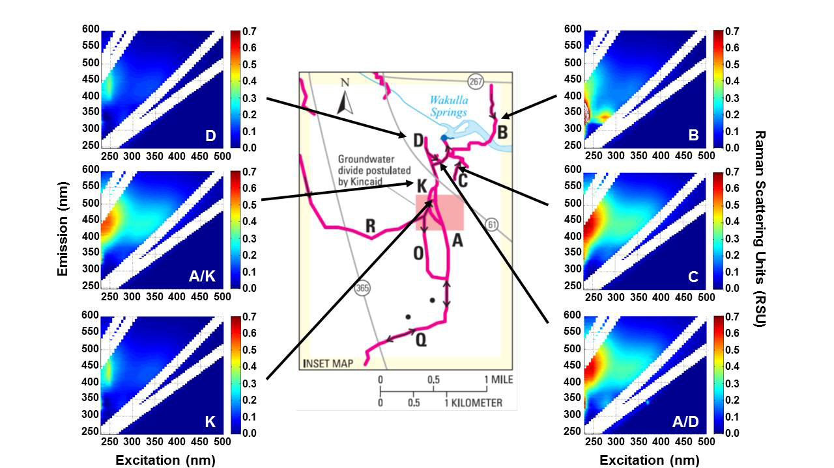
Figure 1. EEMs spectra of CDOM in waters collected from Wakulla Springs conduits B,
C, D, K, and the conjunctions of A/D and A/K.

Analytical Characterization of Pollutants

We will combine dissolved organic carbon (DOC) data and state-of-the-art analytical
characterization techniques with measurements of regional precipitation, flow rates, and
water level in the springs to track the pollution back to the sources. The two state-of-the-art
analytical techniques that we will employ are fluorescence excitation-emission matrix
spectroscopy (EEMs) and ultra-high resolution Fourier transform ion cyclotron resonance
mass spectrometry (FT-ICR MS).

EEMs is an optical spectroscopy method that measures the excitation and emission
wavelengths of compounds that absorb light. The fluorescence of different wavelengths /
regions provide detailed information regarding the composition and source of DOM.
Figure 1 shows EEMs spectra of water collected from conduits B, C, D, K, and the
conjunctions of A/D and A/K on June 23, 2015. Samples A/K, A/D and C show
fluorescent signatures of regions associated with terrestrially-derived DOM. The weak
fluorescence signatures from D and K may be indicative of more of a pristine background
signal. Sample B shows a unique region of intense fluorescence, which is associated with
nitrogen-containing organic compounds, which may come from the spray field or another
source of sewage such as diffuse septic system inputs. Past studies have successfully used
this technique to assess sewage inputs from diffuse sources such as leaking septic
systems with great success. These optically derived measurements can be made quickly
and as the project continues fluorometers may be installed to make high temporal
resolution measurements in-situ.

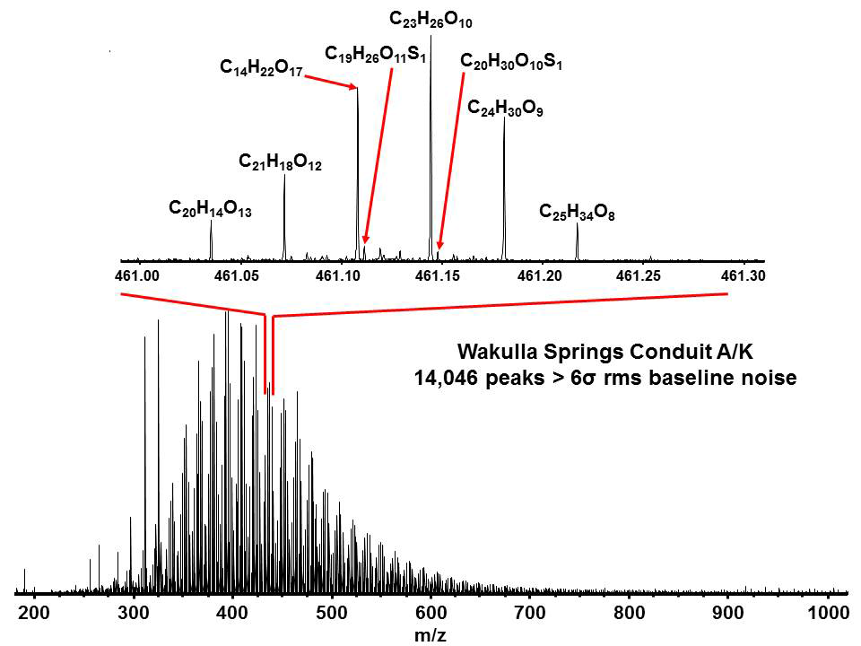

Figure 2. Broadband (-) ESI FT-ICR mass spectrum of DOM extracted from water
collected at the junction of Wakulla Springs conduits A and K (bottom) and a 0.3 Da
mass-expanded window at m/z 461 showing the molecular formulas assigned to a select
group of peaks. Individual molecular formulas can be assigned to all 14,046 peaks in the
mass spectrum.

Recent advances in analytical chemistry have brought advanced mass spectrometry
techniques such as Fourier transform ion cyclotron resonance mass spectrometry
(FTICR-MS) to the environmental sciences to characterize highly complex organic
mixtures such as those found in natural waters. The extreme mass accuracy and precision
of FTICR-MS allows the determination of molecular formulae for thousands of organic
compounds, which is a major advance for the characterization of organic matter in natural
waters and the molecular messages contained within. Figure 2 shows a broadband FTICR
mass spectrum of DOM extracted from the water sampled at the conjunction of
conduits A and K. We were able to identify >14,000 species in this single sample over an
800 Da mass range (m/z 200-800). The inset of Figure 2 shows all of the peaks in a single
0.3 Da mass range with the molecular formulas shown for a few select signals. However,
molecular formulas can be assigned to all of the signals in that window, even the small
ones near the base line.

After formulas are assigned they can be classified based on elemental composition. The
compound classes identified for the molecular formulas assigned in each sample are
depicted in Figure 3. DOM extracted from the conjunctions of conduits A/D and A/K
show a higher percentage of polyphenols (e.g., tea-colored tannins) Conduits A/D, A/K,
and K also show a relatively high percentage of condensed aromatics, a potential
indicator that they could originate from wildfire impacted areas.

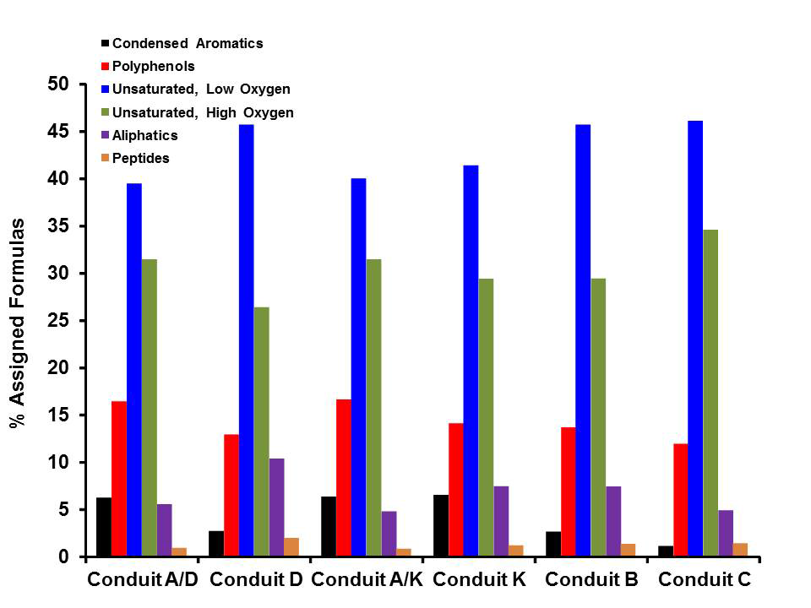
Figure 3. Bar graph of the compound classes as a percentage of the total number of
molecular formulas identified by FT-ICR MS in the DOM extracted from water samples
collected from conduits B, C, D, K, and the conjunctions of A/D and A/K.

The source of both natural and anthropogenic pollution will ultimately be determined
through statistical analysis of data collected from a large number of samples collected
over the course of one year from the six conduits and the spring outflow and then
eventually from many sites over the course of years. Figure 4 shows an example on one
type of statistical analysis that can be applied to show differences/similarities between the
elemental compositions of different samples. Here, the number of samples (n) is only
equal to six, which is not ideal for statistical analysis and means that results may be more
random. However, once many samples are collected (n = 100s), this type of analysis can
reliably show similarities between the elemental composition of samples collected from
different locations to enable us to identify the source of pollution. Similar analyses are
performed with EEMs data called parallel factor analysis (PARAFAC) (not shown). The
combination of these two powerful analytical techniques will lead us to track down the
source of contamination that pollutes Wakulla Springs so we can restore the Springs back
to their pristine condition.

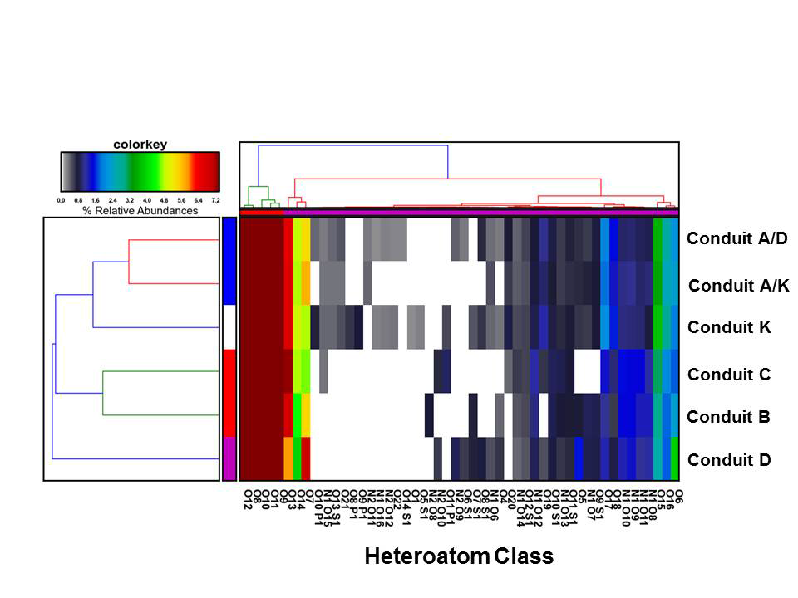
Figure 4. Hierarchical cluster analysis of the heteroatoms classes identified by FT-ICR
MS in the DOM extracted from water samples collected from conduits B, C, D, K, and
the conjunctions of A/D and A/K.

Principal Investigators:

Dr. Robert Spencer Dr. David Podgorski
Earth, Ocean & Atmospheric Science National High Magnetic Field Laboratory
Florida State University Florida State University
303 Oceanography Building 1800 East Paul Dirac Drive
Tallahassee, FL 32306 Tallahassee, FL 32310
Phone: +1-850-645-0955 Phone: +1-850-645-0795
E-mail: rgspencer@fsu.edu E-mail: podgorski@magnet.fsu.edu
Postdoctoral Research Scientist: Graduate Student (MSc)
Dr. François Guillemette Ms. Casey Luzius
Earth, Ocean & Atmospheric Science Earth, Ocean & Atmospheric Science
Florida State University Florida State University
427A Oceanography Building Oceanography Building
Tallahassee, FL 32306 Tallahassee, FL 32306
Phone: +1-850-645-7296 Phone: +1-850-555-5555
E-mail: fguillemette@fsu.edu E-mail: crl11g@my.fsu.edu

Funding Request:
Through this proposal we seek funding from the Wakulla Springs Alliance to support a water
quality project through the Department of Earth, Ocean & Atmospheric Science at Florida State
University. In this request we ask for support of $8,439.00 from the Wakulla Springs Alliance.
Thank you for your consideration of this proposal.

