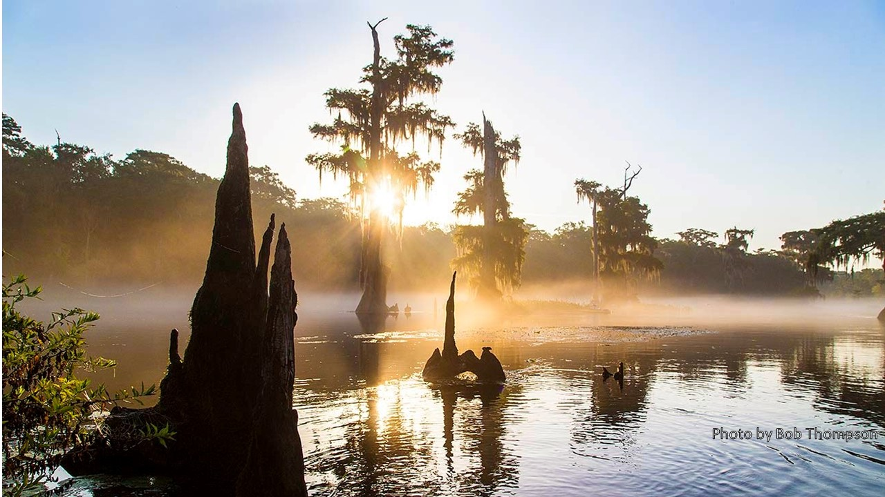
Wakulla Springs Alliance
WSA Meeting Minutes
Friday, September 25, 2020

WMD Presentations on Minimum Flows and Levels

James Sutton - Interactions between Wakulla Springs and Spring Creek
(The PowerPoint with maps and tables is on the WSA website)

• Showed map of Wakulla Spring, Spring Creek Springs Group, and major swallets. Lost Creek Sink connected to both Wakulla Spring and Spring Creek Springs Group.
• Conceptual reversal diagrams show normal flow, reversal and surface water inflow.
• Period of Record Evaluation shows discharge and specific conductance showing peak events over time.
• Reversals and Head Gradients shows reversals and specific conductivity at Wakulla Spring
• A table of SCSG Reversal Events shows the days of reversals and elevated specific conductivity at Wakulla Spring.
• A graph of Event #3 shows the lag time between elevated specific conductivity at SCSG and elevated specific conductivity at Wakulla Spring during a reversal. There was a rainfall event that ended the reversal, higher Wakulla Springs conductance and return to normal conditions.
• Graph of average Wakulla Spring discharge has increased 176% from 2004 to 2019.
• A graph of sea level rise, Wakulla Spring discharges and gage heights shows a correlation to discharges.
• Summary, multiple factors affect discharge at Wakulla Springs including reversals and sea level rise.
Q&A
Q - What are the drivers of the changes?
A - WMD has not looked at long-term weather patterns or changes in large-scale ocean currents in the Gulf of Mexico. It seems like a long period of drought may change heads in the aquifer which leads to a reversal of head gradient. This is also influenced by an increase in the equivalent freshwater head at the coast.
Q - We lost species on the Apalachicola Forest as ponds dried because the aquifer levels lowered in the 1990s. We also had problems with dark water in Wakulla Springs. Do you have data in the 1990s? We used to have 250 days of clear water.
A – This presentation does not look at dark water at Wakulla Spring nor does the period of record go back that far. The USGS Springs Creek Springs Group station was installed in 2007. We did not look at color or where it is coming from.
Q – What is behind the declining river stage with the discharge going up?
A – We have had high discharge that scoured the depth and width of channels that lowers the stage levels increases the discharge levels. The herbicide treatments of hydrilla reduced the damming effect. Removal caused scouring, which increased velocity, scouring and flows. There are places scoured out to the limestone. Many plants were removed.
Q – Where is the river stage measured? Are there other cross sections of the river?
A – It is at the boat maintenance launch. We have stage data from 1987. We did channel elevation surveys when the MFL process started and resurveyed post Hurricane Michael. There also is a USGS monitoring station at Shadeville Road bridge.
Q – It may be important to know the elevation of the limestone.
Q – Look at the information on the water coming from Georgia. Consider the relationship between surface and ground water.
Q – There was another invasive plant, elodea before hydrilla back to the 1980s.
Q – Have you looked at how changes in groundwater velocity in the upper groundwater contribution area has affected Floridan aquifer heads? The impact of withdrawal of 30 MGD by the city is about 10% of the flow.
A – Withdrawals are less than 30 MGD. A large portion of this water is returned to the aquifer at the City of Tallahassee spray field. Net withdrawals are less than 5% of the average spring flow.
A – City net 12 MGD withdrawal. City of Tallahassee withdrawals have not changed during the past 20 years, so are not the driver of the recent changes we are seeing. Per capita usage and total water use for the City are down.
Q – Do we have data on Georgia withdrawals?
A – Yes, there is some data available. We can bring that next time.

Kathleen Coates Presentation
(The PowerPoints are on the website: Use of Surface and Groundwater Models
in MFL Development and Implementation and Groundwater Flow Models )

• This is a presentation on the development of the Minimum Flow and Level, MFL for Wakulla and Sally Ward Springs and models used.
• MFLs are focused on determining the limit beyond which further withdrawals will cause significant harm.
• Steps for setting the MFL diagram shows how data is developed and used.
• The peer-review process is coming up later in the fall, which will make recommendations for modifications to the MFL technical assessment.
• If current flows are below the proposed MFL, a recovery strategy will be developed. If flows are projected to fall below the proposed MFL during the next 20 years, a prevention strategy will be developed.
• A groundwater flow model can be used to quantify the benefits of projects or measures that are part of a prevention or a recovery strategy.
• The MFL must be adopted by rule. If a recovery or prevention strategy is needed, it must be developed at the same time the MFL rule is adopted.
• As new permits come in the model can be used to evaluate the effects of withdrawals.
• The WMD website has a MFL Work Plan submitted by the consultants. This included an option for developing an “integrated model” that combines surface and groundwater models.
• We installed 70 monitoring sites which collect a range of data that are used to develop hydrologic models. As part of MFL development process, the District will address 10 water resource values and metrics.
• Surface water hydraulic (transects, stage, fish, manatee, etc.) and hydrodynamic (flow, stage, temperature, salinity, etc.) models are used. Hydrodynamic models are for evaluating estuarine and thermal (for manatees) habitat.
• The Eastern District groundwater model can be used to assess need for a prevention strategy and to evaluate the withdrawal impacts associated with new water use permits.
• Other springs in FL have had historical reductions in flows. Wakulla Spring has flow increases. They are using a conservative approach and using actual flows.
• The hydraulic model addresses the relation between discharges and stages/flow relationships.
Q&A
Q – The process diagram has new steps for evaluate impact of withdrawals after the MFL. Will we see a run of the model before the MFL is set? Will the model be evaluated in the peer review?
A – The model may be used to determine the need for a prevention strategy, evaluating the benefit of prevention strategy components, and then evaluating permits after the MFL is set. We will evaluate 20-year withdrawal projections. The model will also be used in the every 5-year Water Supply Assessment, which spans over a 20-year planning horizon. The existing withdrawals are considered in the existing calculations. The evaluation of a need for a prevention strategy will all happen this fall before the rulemaking. The model will be calibrated in two or more weeks. This may be before the peer review. However, because the groundwater flow model is not used to determine the minimum flow, it is not part of the peer review.
Q – Current flow rates are changing. Do we have more historic information to better understand longer term changes. How are you going to handle the changes without a change in withdrawals? How do we understand the variance? Has the biological minimum changed?
A – The reference time period for the MFL is from October 2004 to 2019. Wakulla Springs has changed over time more than many other springs. The surface water model has captured changes in the river channel. This is a steady state model. For the groundwater flow model, we have a wet, dry and average year models.
Q – The model looks at flow at Wakulla Spring. Long-term rainfall hasn’t changed. This doesn’t consider Spring Creek. Now this is a new thing. The water quality has changed.
A – The USGS Spring Creek station was not installed until 2007. The ground water model does not simulate the conduit connections. The main question for MFL development is about the flow in the river.
Q – What about dark water. Discharge is a function of the quantity of surface and ground water. Some of the color is tannic and green, which is a new source from sinking lakes.
A – Dark water was noted by Edward Ball long ago. Reverses have happened in the past. It may be occurring more frequent now. Reverses are caused by several factors and generally occur during periods of low rainfall. The frequency of reversals appears to be exacerbated by the long-term sea level rise and scouring/ stage changes in the upper Wakulla River. Pumpage by the City of Tallahassee has remained fairly constant for the past 20 years and is the not cause of recent changes observed in the Wakulla Spring system.

Leon County Comprehensive Wastewater Facilities Plan Update

- We were told the answers to our questions will come in part 5 of the contract.
- WSA has a draft letter by Bob Deyle, Pam Hall and Anthony Gaudio. See draft letter in Appendix D.
- This is a well presented letter. We need to make follow-up contacts with county commissioners rather than invite them to contact us. Theresa Heiker & Charles Woo will be cc’d.
- Terry Ryan made motion to approve, which passed unanimously.

Monthly status report - Cal Jamison

- Thursday morning Wakulla Springs had 4.8’ visibility. The stage gauge was a foot higher than normal. This shows the lag time between rain on the Apalachicola National Forest and higher levels at Wakulla Springs.
- Route 319 widening holding ponds and sinkholes are holding water. I am worried that Jump Creek is dammed off and that this may cause flooding.

Other news

- Bob saw the stage at the highest level. The gators basking places are flooded.
- Debbie’s Lake Hiawatha has come up 30’ in her yard and 1 ½ feet higher after Hurricane Sally. Highest in 6-10 years. It is very dark.
- Dan Pennington is stepping down from the WSA Board.
- WSA meetings are published on the Friends of Wakulla Springs site.
- Oct 23 meeting Mark Heidecker will talk about TAPP and stormwater quality
- Oct 28 and 30 Ferrell track tours at 9:00 AM in 10 private vehicles. We have 6 signed up for each day now. Contact Bob Deyle if you want to go.

WSA Regular Board Meeting

Secretary report: August 28 minutes - Gail Fishman

- Jim Davis and Calvin Jamison made and seconded the motion to approve the minutes, that was approved unanimously.

Treasurer report: July 2020 - Jim Davis

- Received $500 contribution plus another $50. Total $2880.18
- Legal fee from Robert Rivas’s firm, Sachs, Sax and Caplan, was $1085.62; Rivas didn’t charge us for ½ his time. $1000 from WSA and $85.62 from Bob. Doug Barr and Bob made $500 donations to cover the cost.
- Cal Jamison made a motion to approve the Treasurer’s report, seconded by Debbie Lightsey, that was passed unanimously.

Settlement agreement status report – Bob Deyle

- Bob got a call from Robert Rivis reporting that he talked to Sean’s attorney and there is an agreement with the settlement agreement with a non-disparagement clause. Rivis will work with Sean’s attorney on the wording. The Executive Committee will review and signoff on the final agreement.
- Doug Barr has recommended that WSA send a thank you letter to Robert Rivis.

General liability insurance - Bob Deyle

- We will go back to the Earl Bacon agent after the matter with Sean is settled.
- We may need to resubmit the application at that time given this incident

Formal review of forthcoming Wakulla Spring/Sally Ward Spring MFL

- We have had several reports and presentations from the WMD.
- There will be public comments in January.
- The Board will submit collective comments from its members rather than assign a committee to review the draft MFL.
- Doug Barr requested a copy of the draft that goes to the peer review committee.

WSA conduct guidelines

- At various times there have been concerns about communications between members and with others directly, by email and in WSA meetings.
- Tom Taylor will draft guidelines to be discussed at the October meeting.

Appendix A

Agenda WSA Board - Revised
Friday, September 25, 2020
11:40 am – 12:00 pm, via Zoom

11:40 Board business meeting
- Secretary report: August 28 minutes - Gail Fishman
- Treasurer report: July 2020 - Jim Davis
- Settlement agreement status report – Bob Deyle
- General liability insurance - Bob Deyle
- Formal review of forthcoming Wakulla Spring/Sally Ward Spring MFL

Appendix B
9-25-20 WSA Board Meeting Participants
* indicates those present

Officers
Robert E. Deyle, Chair *
Douglas E. Barr, Vice-Chair *
Gail Fishman, Secretary *
Jim Davis, Treasurer *

Directors
Albert Gregory
Cal Jamison *
Howard Kessler *
Debbie Lightsey *
Terry Ryan *
Lindsay Stevens *
Jim A. Stevenson *
Tom Taylor *

Guests
Madeleine Carr*
Kathleen Coates *
Sophie Wacongne *
Amy Conyers*
Sandy Cook*
Scott Dyer *
Anthony Gaudio *
Grant Gelhardt*
Andreas Hagberg *
Pamela Hall*
Maddy Hart*
Mark Heidecker*
Carlos Herd*
Chuck Hess *
Roger Holdener*
Mitra Khadka *
Clint Kromhout *
Mary Beth Litrico *
Cynthia Paulson*
Johnny Richardson*
James Sutton*
Meredith Tanguay*
Paul Thurman *
Ming Ye *
Meredith Hart(?)*
Susan Poplin(?)*
Nurge*

Appendix C

