**WSA Board Meeting Minutes**

September 30, 2022

**Sep. 30, 2022, Board Meeting Highlights**

* Gwendolyn Waldorf is WSA’s 4th life member.
* We need to keep responding to challenges as they arise AND develop and implement strategies that will enhance the health of Wakulla Springs. Do we want a workshop.
* Don’t reinvent the wheel. Use Bob Knight’s book [Saving Florida’s Springs](https://floridaspringsinstitute.org/product/saving-floridas-springs/), the [Waste Water Treatment Facilities Plan](https://cms.leoncountyfl.gov/waterresource/Protecting-and-Preserving-Our-Water-Quality/Primary-Springs-Protection-Zone/Wastewater-Treatment-Facilities-Plan-2021), WWTFP, [Basin Management Action Plan](https://floridadep.gov/dear/water-quality-restoration/documents/upper-wakulla-river-and-wakulla-springs-basin-management-0), BMAP, [Stormwater plans](https://www.talgov.com/you/stormwater). We need an update on these things at a future meeting.
* We need people to step up and do things. Suggest changes to the [WSA Strategic Plan](https://docs.google.com/document/d/1fUeXuM0DL0eHWG_7K4_FEyePC0RbdZUPEfAow7iPEs4/edit#heading=h.uvcv1ixdbju9) and indicate what you are willing to do.
* Brian Luipani made a motion to draft letter of support for the English Property (See Appendix D) Florida Forever application, seconded by Lindsay Stevens, which passed unanimously.
* After Hurricane Ian Spring creek reversed and this increases salinity at Wakulla Springs. Wakulla Springs stopped flowing on Sep 29.
* Bob Deyle made a motion to send a request for a presentation to Anna Padilla Stormwater Management Coordinator, Tony Park, Director of Public Works and Vince Long, County Administrator, which passed unanimously.
* WSA meeting October 28, 9:00 AM on Zoom: <https://fsu.zoom.us/j/97207430086>

**Opening**

* Welcome and introductions – Howard Kessler
* Agenda review and approval – Howard Kessler

**Announcements from Bob Deyle**

* Gwendolyn Waldorf is WSA’s 4th life member.
* Attend the Big Bend Environmental Forum, BBEF, on Oct 13 for local elections at city hall, 5:00 greet and meet, 6:00 forum.
* Debbie Lightsey sent a piece on environmental issues to the candidates.

**Approval of Minutes**– Tom Taylor

* Tom Taylor made the motion to approve, seconded by Howard Kessler, which passed unanimously.

**Approval of Financial Report** – Jim Davis

* Bob Deyle made the motion to approve, seconded by Albert Gregory, which passed unanimously.

**Recommendation for workshop to address how we can actively work to**

**Save Wakulla Springs –** Howard Kessler

* We need to keep responding to challenges as they arise AND develop and implement strategies that will enhance the health of Wakulla Springs. We may want to have a workshop on this.
* Don’t reinvent the wheel. Use Bob Knight’s book [Saving Florida’s Springs](https://floridaspringsinstitute.org/product/saving-floridas-springs/) for $16. Have Bob Knight come and work with us.
* We are reactive and we have things to build on, like the [Waste Water Treatment Facilities Plan](https://cms.leoncountyfl.gov/waterresource/Protecting-and-Preserving-Our-Water-Quality/Primary-Springs-Protection-Zone/Wastewater-Treatment-Facilities-Plan-2021), WWTFP, [Basin Management Action Plan](https://floridadep.gov/dear/water-quality-restoration/documents/upper-wakulla-river-and-wakulla-springs-basin-management-0), BMAP, [Stormwater plans](https://www.talgov.com/you/stormwater). We need an update on these things at a future meeting.
* Tom Taylor provided an overview of the WSA Strategic Plan and encouraged everyone to submit needed updates.
* We need people to step up and do things. Use our strategic plan and revise the plan using Bob Knights book and other plans.
* How would we answer a candidate who asks what they should do? We need a 1 to 2-page answer. Have simple broad objectives that officials and the public can easily understand. We have a brochure and a website with this that can be given to candidates. Howard has copies of the brochure if anyone wants them. Bob Deyle has brochures that will be put in candidates’ hands.
* We may need a small group

**Presentation on the Fish Farm**- Bob Deyle

* They have not made any progress on the structure. There are a lot of cinder blocks and other materials.
* They have a for sale sign for 4.25 acres that they may be selling to raise money to complete the project.

**Request for members for Nominating Comm**. – Howard Kessler

* We need to elect the committee at the next meeting
* Brian Luipini, Howard Kessler and Mike Keys volunteered for the committee
* Rob Williams made a motion to accept these three as a nominating committee, seconded by Albert Gregory, which passed unanimously.

**Discussion/vote- Florida Forever proposal for English property** - Brian Lupiani

* Brian Lupiani and Mark Okasako provided a description (See Appendix E) of the 770-acre property, (10k units plus commercial), Save the English Park group’s activities and a summary of the effort to nominate this property for acquisition by Florida Forever (See Appendix D). Hope to submit application by Oct 31st
* We would like to create a park.
* Q - Albert asks if this would be a stand-alone project or a boundary amendment. A – Has to be stand alone because just value exceeds amendment threshold.
* Steven Martin joined the meeting
* No management obligations associated with being a co-applicant
* Lindsay Stevens – Does not think this is a great FF landscape scale project. Not likely to score very well.
* Osaka says they know it’s a longshot. Have some advisors who are familiar with the process. Are extending the area south to connect with Apalachicola National Forest.
* Debbie Lightsey thinks the configuration is difficult because it does not include the entire property parcel – would require subdividing the PUD.
* Mark O says owner is not opposing.
* Brian says we won’t know until we try. Save the English Forest is planning to go forward with the application.
* Howard K asks if there is any downside to WSA supporting this
* Rob Williams says we have a big interest in getting FF to acquire the existing priority projects already identified for Wakulla Springs. Suggests that’s where our effort and credibility ought to be invested. $5 million spent on this property would be $5 million not available for those higher priority properties. However, it’s likely to never get funded.
* Jim Stevenson says we do have some interest in all properties within the springshed being developed in the right way
* Brian agrees – The development will affect the water supply and Wakulla Spring.
* No motion made to support the proposal that WSA be a co-applicant
* Mark O asks if WSA would instead submit a letter of support.
* Lindsay says a letter of support would be more appropriate than signing on as a co-applicant
* Albert thinks caution is warranted against being a co-sponsor. He thinks it’s a worthwhile project, but not one likely to succeed with FF. Is there a $2 million parcel within the footprint of this land that could comprise a meaningful management unit that could be pursued as a boundary amendment?
* Is there a $2 m part of this land that could be a manageable unit. A – There is a ravine with a spring and spring run. It is unique in Tallahassee. This would probably not be developable.
* Mark Okasako says the ravine in the north portion could qualify for this. It has a spring head and spring run. Available property to buffer that would be limited.
* Albert – Maybe could get English folks to donate that land for a park and or sign onto a conservation easement.
* Brian Luipani made a motion to draft letter of support for the FF application, seconded by Lindsay Stevens, which passed unanimously.
* Rob Williams asks about LAVA classification of the site
* Debbie guesses that it is not likely to be highest vulnerability. Says there are existing city regulations protecting ravines, May not be developable.
* Mark Okasako will provide examples. Howard Kessler will draft the letter with input from Lindsay Stevens.

**Springshed and river update**– Cal Jamison

* Wednesday survey included the Springs Watch survey.
* 17.8’ visibility which is fairly dark.
* The staff gauge dropped to 4.8’ which is low.
* Spring Creek reversed and this increases salinity at Wakulla Springs.
* There is a lot of flux at St. Marks and Mashes Sands because the water was sucked out by hurricane Ian.
* Wildlife survey revealed yellow crowned night herons and others.
* The water is back.
* Wakulla Springs stopped flowing on Sep 29. The flow is still down but recovering.

**Cave exploration updates** – Chris Werner and Andreas Hagberg - No updates.

**Merits of having a permanent chairperson**– Rob Williams

* Rob says based on his experience as interim this is not desirable long term. There is a learning curve to just the logistics and procedures. By the time you get the hang of it it’s somebody else’s term. More importantly effective organizations need leadership with a longer-term commitment in a position to be a motivator.

**Announcements (5-10 minutes)**

* BBEF is October 13 at 6:00 pm; meet and great starts at 5:15 pm
* Harley Means presentation on caves and potential pollution.
* The Wakulla County Planning Department has hired a consultant to prepare the assessment for amending the county’s spring protection ordinance. Clean Water Wakulla is monitoring this effort.
* Wakulla County Administrator, David Edwards, is open to having input after the consultant does their work, including a presentation by Florida Geological Survey Director, Harley Means, that has been proposed by Clean Water Wakulla.
* Q - What is the status of the WWTFP? A – We have frequently asked to be notified of public input opportunities. The comment period came and went without any notification to us. The report needs to be reviewed. We may want to ask for a presentation.
* This will come before it goes to the elected officials for adoption. This is a forgotten project that has a big potential impact.
* Anna Padilla is the contact person. She attended past WSA meetings.
* Bob Deyle made a motion to send a request for a presentation to Anna Padilla Stormwater Management Coordinator, Tony Park, Director of Public Works and Vince Long, County Administrator, which passed unanimously. [More comment opportunities have since been announced. Comments due October 28.]

**Upcoming meetings and events**

* WSA Board Meeting October 28 9-11am
* Nominating Committee – Board Members and Officers for October meeting

Zoom Recording <https://fsu.zoom.us/rec/share/13jn92kf-MnBvat7PqmigHC1-XycrQ3OFvX_c3FbTOk7AzIkHXgjDXoFfAxZMICi.MfAbFfLFj1RoorYj>

Appendix A

September Board Meeting Final Agenda

September 30, 2022

9:00 am to 11:00 pm

**Opening**

·      Welcome and introductions – Howard Kessler (10 minutes)

·      Agenda review and approval – Howard Kessler (5 minutes)

**Approval of Minutes**– Tom Taylor (5 minutes)

**Approval of Financial Report** – Jim Davis (5-minutes)

**Recommendation for workshop to address how we can actively work to**

**Save Wakulla Springs –** Howard Kessler to introduce (20-minutes)

**Presentation** – Report regarding the Fish Farm- Bob Deyle (5-minutes)

(Questions and answers 5-minutes)

Request for members for Nominating Comm. – Howard Kessler (5 minutes)

**Discussion/vote- Florida Forever proposal regarding English property** - Brian Lupiani

(5 minutes presentation) 5-minute discussion/vote)

**Springshed and river update**– (Cal Jamison 5-10 minutes)

**Cave exploration updates** – Chris Werner and Andreas Hagberg (5-minutes)

**Merits of having a permanent chairperson**– Rob Williams (10-minutes) (5-minutes questions)

**Announcements (5-10 minutes)**

**Upcoming meetings and events**

October 28 9-11am

Nominating Committee – Board Members and Officers for October meeting

**Adjourn**

Appendix B

**9-30-22 WAKULLA SPRINGS Board Meeting Participants**

**\* Indicates those present**

Officers

Howard Kessler, Chair *  
Robert E. Deyle, Vice-Chair *  
Tom Taylor, Secretary *   
Jim Davis, Treasurer

Directors

Gail Fishman *  
Rob Gelhardt

Albert Gregory *

Andreas Hagberg *

Cal Jamison *  
Robert Williams *

Mike Keys *

Debbie Lightsey *

Brian Luipani *

Lindsay Stevens *

Members and Guests

Jim Dunbar *

Anthony Gaudio *

Chad Hanson *

Mark Heidecker *

Chuck Hess *

SN Martin

Mark Okasako *

Jim Stevenson *

Paul Thurman *

Sophie Wacongne-Spear *

Appendix C

|  |  |
| --- | --- |
| **WAKULLA SPRINGS ALLIANCE** |  |
| **FINANCIAL REPORT** |  |
| **FOR THE 8 MONTHS ENDED AUGUST 31, 2022** |  |
|  |  |
| **INCOME** |  |
| Donations | $ |
| Memberships | 4,855.00 |
|  | 4,855.00 |
|  |  |
| **EXPENSES** |  |
| Awards | 118.20 |
| Florida Corporate Annual Report | 61.25 |
| Big Bend Environmental Forum | 100.00 |
| PayPal Fees | 195.70 |
| Earl Bacon Agency - Insurance | 1,097.00 |
|  | 1,572.15 |
|  |  |
| **SURPLUS/(DEFICIT)** | 3,282.85 |
|  |  |
| **BANK BALANCE - 12/31/2021** | 5,412.79 |
| **PAYPAL BALANCE - 12/31/2021** | 454.17 |
| **TOTAL - 12/31/2021** | 5,866.96 |
|  |  |
| **BANK BALANCE - 8/31/2022** | 8,815.38 |
| **PAYPAL BALANCE- 8/31/2022** | 334.43 |
| **TOTAL 8/31/2022** | **$9,149.81** |

**Appendix D**

**English Property Map**

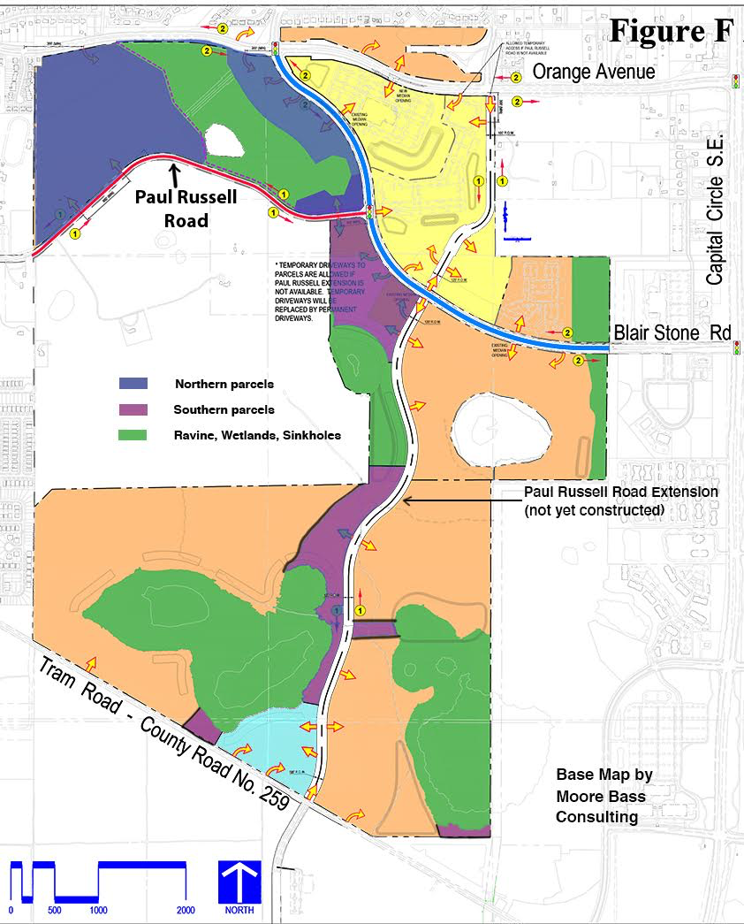

**Appendix E**

**English Property Additional item and links**

Information below provided by Mark Okasako and Brian Lupiani

The property in question is owned by the English Family. About 770 acres has been rezoned as a PUD.  The boundaries are Orange Ave on the north, Tram Road on the south, just east of Rickards High on the west, and west of the Southwood Publix on the east.  The plan is to have this as mixed residential (about 10,000 units) and commercial/offices.

Objective is to have a portion of this preserved as a nature park.  This would provide existing wildlife with some habitat and give some modest mitigation for stormwater runoff from the developed areas.  The shape of the park provides a corridor for wildlife from south to north of the PUD and allows access to the Indianhead Acres and Blairstone Forest neighborhoods, which essentially extends the corridor north to St. Augustine Road (just south of the Apalachee

Parkway).

The process of completing an application for a Florida Forever new Project is happening.  In addition to the wildlife habitat/corridor and stormwater arguments, the application will be mentioned in several other items. Much of the PUD is south of the Cody Scarp, there are several karst features we would like to protect.  This also means that direct access to the Floridan Aquifer is more likely here and increases the chances of stormwater carrying pollutants (fertilizers, insecticides, etc.) entering the Aquifer and being carried south to places like Wakulla Springs.

There have been two archaeological surveys done (in a limited area) and the most recent one recommended an additional more comprehensive survey be done.  In the northern portion (north of Paul Russell Road, south of Orange Ave, west of Blair Stone Road, and east of Rickards High), there is a ravine which has a unique feature not found anywhere else in Tallahassee (and probably Leon County).  This is a spring head/run.  We would like this to be protected.  There is a good chance that this ravine and some other areas in the south are habitat for some endangered species (a certain species of salamander for example). The attached map shows the property and the areas we would like to preserve.

The ask of Wakulla Springs Alliance is to be a co-applicant on our application. This is not the same as the manager of the property.  Florida Forever clearly states that the manager has to be either a local government (e.g., City of Tallahassee or Leon County) or state agency (e.g., Florida Forest Service).  We are in the process of getting the City (Parks and Rec) as the manager. First, Florida Forever will hold a webinar for new applicants next Wednesday, Oct 5, at 2:00 PM. Unfortunately, it’s 5 days after the WSA meeting, but for what it’s worth if anyone is interested, they can register here: <https://register.gotowebinar.com/register/3686039490145094413>

In the meantime, if anyone wants more info about FL Forever and the application process here are two links they can use: [Florida Forever | Florida Department of Environmental Protection](https://floridadep.gov/lands/environmental-services/content/florida-forever) and [Florida Forever Application and Process Overview | Florida Department of Environmental Protection](https://floridadep.gov/lands/lands/content/florida-forever-application-and-process-overview)