Agenda, Wakulla Springs Alliance Board Meeting,

**April 25, 2025**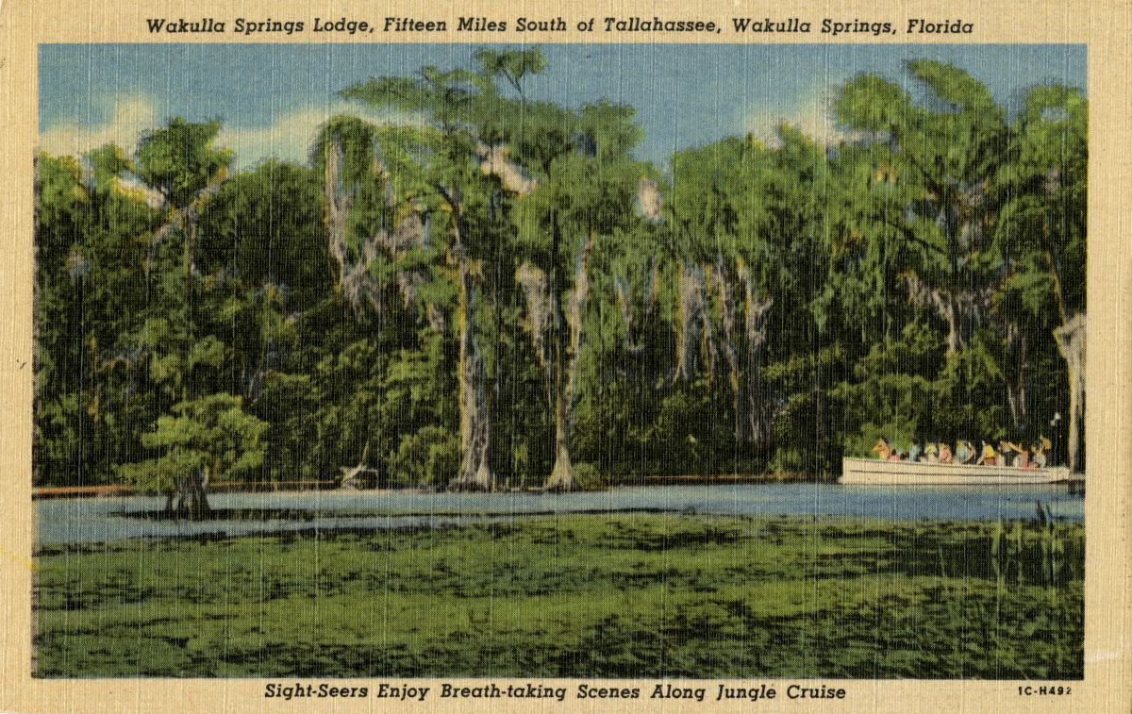

Date: Friday, **April 25, 2025**

Time: 09:00 AM – 11:00 AM

Location of Meeting **Zoom Only**

Zoom link [https://us06web.zoom.us/j/89786667803](https://webmail.centurylink.net/app/Utilities/gateway_url.asp?umsgid=%7B7ca5f517-7842-46e4-a9d1-f67c24b31ec4%7D&uurl=https%3A//us06web.zoom.us/j/89786667803)

Board of Directors Meeting

**9:00    Opening WSA Board**

**Welcome and introductions** – Chad Hanson, Chair

**Agenda review** – Chad Hanson, Chair

**9:10 Financial report**– Anthony Gaudio **[attached] -** 5 min

[approved unanimously]

**9.15  Minutes of March 28, 2024, Board meeting**- Brian Lupiani **[attached] -** 5 min

[approved unanimously]

**9:20  Update on UUPI (Underground Utilities & Public Infrastructure) - Industrial land use (including a fueling station) planned on 95 acres at the corner of CCSW and Orange Avenue W. Intersection (**Renee Murray) - 15 min

[summary report of last meeting with City shared with group, no discussion]

**9:35 Status of Land Swap for SW Ga Oil property Report (**Renee Murray) - 10 Min

[no update provided or action taken]

**9:45 Wakulla Springs Basin Management Action Plan update – discussion and draft letter** (FDEP / Chad /Anthony) - 25 mins

**[**Board approved sending letter to DEP with revisions provide by and approved by the Executive Committee, letter sent May 2]

**10:10 Wakulla Springs Lab – Outreach and Education** – (Kellie Keys/FSU Comms students) - 30 mins

[Kellie provided an overview of the FSU Communications Digital Media Program’s project on Wakulla Springs. About twelve students are producing education video/documentaries targeting school age children to describe the connectivity of the sinks, tunnels and springs in the basin. Products will be finalized later this summer and will be shared.

**10:40 Springshed and river update (**Cal Jamison) - 15 Min [no update – Cal not available]

**10:55 Other Topics: 5 Min**,

1. May 23, 2025, Board Meeting WSA Board meeting Zoom only.
   1. Presentations or topics for discussion (FSU Wakulla Springs Research / FL Legislative Session, other?)
2. Education/Outreach coordinator for arranging presenters
3. Upcoming meetings / events
   1. County / City Commission meetings
4. Announcements

**11:00 Adjourn**