**Wakulla Springs Alliance**

**Minutes of Board of Directors Meeting**

**Friday, August 23, 2024**

9:00 AM – 11:00 AM

Location: Zoom Only

Zoom link <https://us06web.zoom.us/j/89786667803>

Recording (with transcript!) available at

<https://us06web.zoom.us/rec/share/XE4j_ckiUg6Vehn7p3O11uFPH4XJuqWPX8QhOfyIrKfomyM-PqVmECg39jj1gG95.eu4HXfKKiQXFBNRv?iet=U1dkIfrcnUsP70DFKC4IagT65MFZbBatnQdYwbF4omk.AG.wF21tq27Y6b72bgMDpuCyu-0htf6Xx-uWVydF61vE5ACPNs80_WyQHLHuNCTwXlMK_MoZ8Cs_cg-IRIIBNAkISiQ3aIn_88kIMn730Lh7YTCvEAZL8jc4tFsvHUcgP3p.Qoxb0-iIvZD4bPWP0WP6WQ.dbt7m7koDryy3n7o>

Passcode: h%Dj3*C=

**Thanks to Tom Taylor for writing the minutes this month!**

**9:07(?) Meeting called to order** by Anthony Gaudio (00:32 in recording)

**9:08    Opening WSA Board**

**Welcome and introductions** – Anthony Gaudio (Appendix B)

**Agenda review** – Anthony Gaudio (Appendix A)

Gil Damon will talk about the proposed changes to state parks.

**9:10  Financial report**- Jim Davis (Appendix C)

Brian **moved to accept the report**; seconded by Albert & **passed without opposition.**

**9:11  Minutes of June 26, 2024 WSA Board meeting** - Brian Lupiani (Appendix E)

Albert **moved to accept the minutes**; seconded by Gail & **passed without opposition.**

**9:13 Proposal to “develop” State Parks**  - Gil Damon

The State is attempting to add golf courses, disc golf courses, pickleball courts, and 350-room “lodges” to a handful of state parks.

The plans have generated much opposition, including from GOP legislators.

The plans may come up for a vote at a meeting of DEP’s Acquisitions and Restoration Council on September 12.

Gil will send info to Anthony, who will pass it along to our email list.

Gil put this link in the chat: <https://www.downriverproject.org/parks>

**9:15 FSUCML Wakulla Springs Research Grant** - Kellie Keys, Joel Trexler (00:40)

Joel Trexler, Director of The FSU Coastal Marine Lab, and Kellie Keys, Research Faculty FSU School of Communication, spoke on the $750,000 State funded Wakulla Springs research grant awarded to FSUCML, and its design and objectives, for both primary research and Communication and outreach.

* FSU school of Communications and the Marine Lab
* Kelly took legislators on a tour of Wakulla Springs who liked the idea and
* Joel did a legislative budget request.
* School will 1) start Wakulla Springs tours, 2) do communications research on environmental education and produce a paper and 3) create a video for middle school science students with more videos in the future for high school and others
* The Marine Lab will 1) review research 2) met with FL Geological Survey and NWFWMD, 3) address priority data and research needs include groundwater currents, nutrient input, productivity of the ecosystem, Phosphorus impacts, etc.
* We want to present requests for further funding from the legislator.
* Working with Chris Werner and the Wakulla Karst Plane project
* Josh Breihaupt looking at carbon and nutrient and impacts downstream
* Shauna Manning at FIU will analyze DNA to trace water sources.
* There is a plan for water sampling with Chris Werner that will look at the impact of sea water. It will help distinguish between salt, rain and older ground water.
* Will sample up to 4 times of the year and capture unique events.
* Explore tropic states and how they are impacted. Josh will look at the organic carbon and nitrogen, nitrates, phosphorus (by type)
* Wakulla Springs micro-biome, environmental DNA will use new technologies. There may be thousands of markers that can be used as tracers. There may be meta-analysis like what is being done in health research. FSU Medical School has new equipment. This will help us to study many kinds of life.
* Q. Where does conductivity data sampled. A. From the end of the boat dock. BMAP analysis will benefit from this work.
* Q. How are the resources divided between 3 groups and each will each have allocated resources to each task. We will have lower costs because of the Med School equipment.
* Q. Many people need to understand the where the water in the springs comes from through translating the science information.
* C. The monthly surveys sample at 7 points on the river.
* C. FSU did DNA analysis of algae that tracked back to Lake Jackson and other lakes. A. Bob Deyle did a report on work by FAMU that was not peer reviewed. It was a good study and we have new technology. Cal took them on a tour.
* C. Let us know how WSA can help advocate for more funding.

**10:07 Status of Land Swap for SW Ga Oil property** - Renee Murray (01:32)

* We met with Conservation FL on July 24 and made a recommendation on the site plan for the land swap. It included a provision for acre for acre swap.
* Renee got an email saying there will be a new site plan next week; she expects it’ll be a few weeks.
* There are negotiations with St. Joe.
* Thanks to Renee and the group!
* We need to focus on the use of the conservation land that will be grasslands for water improvement not more pine trees.
* Q. Who will manage it? A. That is yet to be determined and we will have a voice in that.

**10:10 Big Bend Environmental Forum** - Brian Lupiani

* It was on August 6 with 50+ attendees and candidates.
* October 17 will be the forum for the November election at Public Library. (Brian will be out of town and unable to table the WSA table.)
* The ignorance of the candidates was shocking
* WSA can contact all of the commissioners individually.
* Recordings of the Big Bend Environmental Forum are on facebook at<https://www.facebook.com/BigBendEF/videos>

**10:20 Update on Wakulla County Board of County Commission Springs Protection Ordinance Workshops** - Kellie Keys, WCBOCC Liaison with Wakulla environmental groups for workshops for Springs Protection and Drinking Water Ordinances (01:47)

* There is not a date set
* There is more work needed on the document
* We may get some things accomplished. The County is considering expanding the springs protection zone and restricting withdrawals in some areas.
* Officials are starting to understand the environment better and we can make meetings with them. Most have little knowledge.
* We may want to have a slide show to present at commission meetings, then one-on-ones.
* Debbie talked about how she was helped by Helge Swanson when she started. Talk about the role of land use and the environment. Bob Deyle can help with this. We must keep it simple.
* Tom Taylor wants to be involved.

**10:30 WSA Strategy Session for Springs Protection Ordinance** - Anna Garner

Anna wasn’t present. Anthony will get the strategy group together.

**10:35 DEP Water Quality Grant applications** - Tom Taylor (01:58)

Applications were due by July 15. Mitch Holmes at DEP reported that these are the final applications:

Tallahassee – no applications

Leon – Woodville sewering and additional septic tank upgrade subsidies

Wakulla – Extending transmission lines for disposal at the golf course and a gravity sewer in Panacea

This is a major opportunity to advance many components of the [WSA’s Strategic Plan](https://docs.google.com/document/d/1fUeXuM0DL0eHWG_7K4_FEyePC0RbdZUPEfAow7iPEs4/edit?usp=sharing)

**10:40 Spring shed and river update -**Cal Jamison (02:02)

* Last week in July and first in August we had 75’ visibility.
* After the hurricane it went down to 40 then 29’ of visibility.
* Historically July visibility has been higher
* Nitrates are .45 and hasn’t varied lately. The TMDL is .35
* Manatees have been in the swimming area.
* Cal and Chris Werner looked at the sampling sites including the Wakulla Environmental Institute swirl.
* Albert Winn needed volunteers to clear the trail to the swirl.
* The sampling team has taken officials out and is open to more, one at a time.
* Anyone is welcome to join us on Thursdays at 8:30 for breakfast at Savannah’s with the tour at 10:00

**10:55 Other Topics and Announcements** (02:17)

* September 27, Zoom
* October 25, meeting in person? Where?
* The Friends of the **Red Hills Community Cemetery are** having a Volunteer Meet up 8/25 4-6PM Abundance wellness Center 325 John Knox Rd Unit T
* Fl Springs Council October 19 in St. Pete. It is free and has great workshops with lunch.

**Upcoming meetings and events**– 4th Friday of the month

Reservations have been made for use of the conference room at the Renaissance Center for every month in 2024 Formats and locations yet to be determined for those dates from 08:45 - 12:30:

**11:00 Adjourn** moved by Brian, seconded by Cal, no opposition (02:25)

APPENDIX A

Agenda, Wakulla Springs Alliance April Board Meeting, 8/23/2024**[See Attached Doc]** 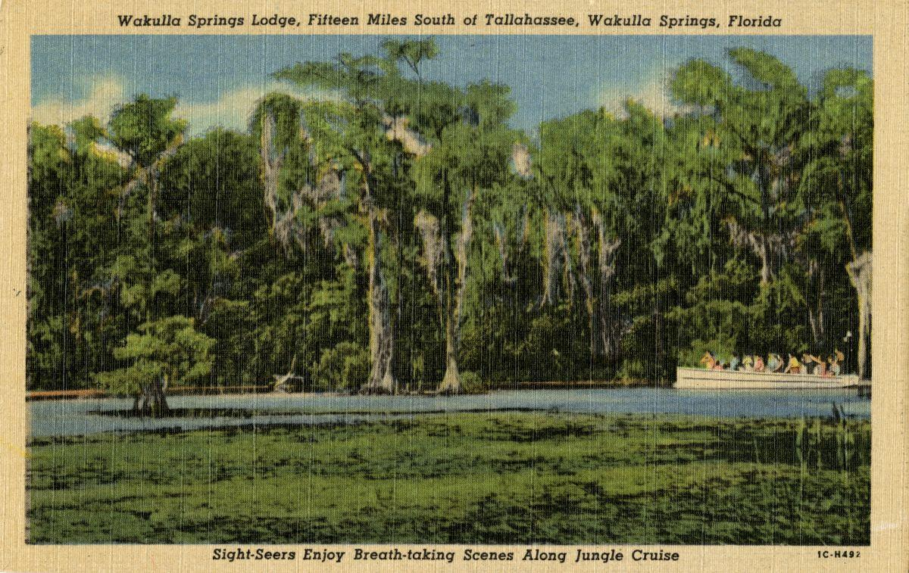

Date: Friday, August 23, 2024

Time: 09:00 AM – 11:00 AM

Location of Meeting Zoom Only

Zoom link <https://us06web.zoom.us/j/89786667803>

Board of Directors Meeting

**9:10    Opening WSA Board**

•       **Welcome and introductions** – Anthony Gaudio

•       **Agenda review** – Anthony Gaudio

**9:20 Financial report**- Jim Davis **[attached] 5 min**

**9.25 Minutes of June 26, 2024 WSA Board meeting**- Brian Lupiani **[attached] 5 min**

**9:30 $750k FSUCML Grant** Joel Trexler, Director of The FSU Coastal Marine Lab, and Kellie Keys, Research Faculty FSU School of Communication, will give a presentation on the $750,000 State funded Wakulla Springs research grant awarded to FSUCML, and its design and objectives, for both primary research and Communication and outreach. **20 Min**

**9:50 Q&A on $750k FSUCML Grant 10 Min**

**10:00 WSA Status of Land Swap for SW Ga Oil property Report** Renne Murray

From Adam Bass Conservation FL update concerning site plan and Saint Joe Paper Company issues. $3.7 Mil approved in budget. **10 Min**

**10:10 Big Bend Environmental Forum BBEF 8/6** Brian Lupiani WSA representative **5 Min**

**10:15 Update Wakulla County Board of County Commission Springs Protection Ordinance Workshops** Kellie KeysWCBOCC Liasson For Workshops with Wakulla Environmental Groups for Springs protection and Drinking Water Ordinance Workshops **10 Min**

**10:25 WSA Strategy Session for Springs Protection Ordinance** A Gaudio, Anna Garner Last Summer WSA and other Environmental Groups submitted a Citizens Springs Protection Ordinance. WSA’s plan for input to workshop **20 Mn**

**10:45** The **DEP Water Quality Grant applications** Tom Taylor **5 Min** Applications were due by July 15. Mitch Holmes at DEP reported that these are the final applications:

Tallahassee – no applications

Leon – Woodville sewering and additional septic tank upgrade subsidies

Wakulla – Extending transmission lines for disposal at the golf course and a gravity sewer in Panacea

This is a major opportunity to advance many components of the [WSA’s Strategic Plan](https://docs.google.com/document/d/1fUeXuM0DL0eHWG_7K4_FEyePC0RbdZUPEfAow7iPEs4/edit?usp=sharing)

**10:50 Springshed and river update -**Cal Jamison **10 Min**

**11:00 Other Topics: 5 Min**

1. September 27, Zoom
2. October 25, meeting in person? Where?
3. The Friends of the **Red Hills Community Cemetery are** having a Volunteer Meet up 8/25 4-6PM Abundance wellness Center 325 John Knox Rd Unit T
4. Announcements

**Upcoming meetings and events**– 4th Friday of the month

Reservations have been made for use of the conference room at the Renaissance Center for every month in 2024 Formats and locations yet to be determined for those dates from 08:45 - 12:30:

**11:05 Adjourn**

APPENDIX B

**August 23, 2024, WAKULLA SPRINGS ALLIANCE**

**Board Meeting Participants**

Zoom-only meeting

Officers

Anthony Gaudio, Chair

Chad Hanson, Vice-Chair

Brian Lupiani, Secretary

Directors

Gail Fishman

Rob Gelhardt

Albert Gregory

Cal Jamison

Mike Keys

Debbie Lightsey

Renee Murray

Tom Taylor

Members and Guests

Gil Damon, Downriver Project

Mark Heidecker, City of Tallahassee

Kellie Keys, Wakulla Co. Soil & Water Cons District / Liaison btwn Co and Env groups

Johnny Richardson, Leon Co. Public Works

Paul Thurman, NW Florida Water Management District

Sophie Wacongne-Speer, Friends of Lake Jackson

Joel Trexler, FSU Marine Lab Director

Joshua Breithaupt, FSU Marine Lab

Directors Not In Attendance: Jim Davis, Bob Deyle, Howard Kessler, Lindsay Stevens

APPENDIX C

| **WAKULLA SPRINGS ALLIANCE** |  |
| --- | --- |
| **FINANCIAL REPORT** |  |
| **FOR THE 7 MONTHS ENDED JULY 31, 2024** |  |
|  |  |
| **INCOME** |  |
| Donations | $ - |
| Memberships | 1,030.00 |
|  | 1,030.00 |
|  |  |
| **EXPENSES** |  |
| Data Processing Related | - |
| Printing | - |
| Florida Corporate Annual Report | 61.25 |
| Big Bend Environmental Forum | 100.00 |
| PayPal Fees | 66.21 |
| Earl Bacon Agency - Insurance | 1,138.50 |
|  | 1,365.96 |
|  |  |
| **SURPLUS/(DEFICIT)** | (335.96) |
|  |  |
| **BANK BALANCE - 12/31/2023** | 9,409.26 |
| **PAYPAL BALANCE - 12/31/2023** | 1,574.71 |
| **TOTAL - 12/31/2023** | 10,983.97 |
|  |  |
| **BANK BALANCE - 7/31/2024** | 8,509.59 |
| **PAYPAL BALANCE -7/31/2024** | 2,138.42 |
| **TOTAL 7/31/2024** | **$ 10,648.01** |

APPENDIX D

Visibility Chart August 2024

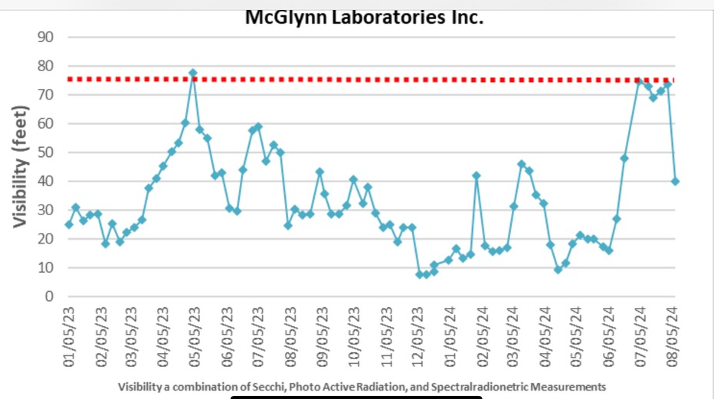

APPENDIX E

**Wakulla Springs Alliance**

**Board of Directors Meeting**

**Friday, June 28, 2024**

9:00 AM – 11:00 AM

Location: Zoom Only

Zoom link <https://us06web.zoom.us/j/89786667803>

Recording (with transcript!) available at

<https://us06web.zoom.us/rec/share/9fK2Zv9ESiiBNp9VtVCTsbtFgxqs3QgATl8Fm5KWkjHt0SgbXlhYdVg2K22Ux3lm.ArG8o1SSB2c0sxP1>

Passcode: mY!qbY!7

Thanks as always to Tom Taylor for his thorough notes!

**9:03 Meeting called to order** by Anthony Gaudio (00:41 in recording)

**9:05    Opening WSA Board**

**Welcome and introductions** – Anthony Gaudio (Appendix B)

**Agenda review** – Anthony Gaudio (Appendix A)

Sophie Wacongne-Spear will talk about the Big Bend Environmental Forum after Cal’s Spring shed update.

**9:07  Financial report**- Jim Davis (Appendix C)

Albert **moved to accept the report**; seconded by Brian & **passed without opposition.**

**9.09  Minutes of May 24, 2024 WSA Board meeting** - Brian Lupiani

Albert **moved to accept the minutes**; seconded by Brian & **passed without opposition.**

**9:10 WSA Status of Land Swap for SW Ga Oil property Report** - Renee Murray

The Governor has signed the $3.7 million appropriation and the funding will be available on July 1. The WSA working group will reach out to Conservation Florida (CF) after the week of July 4 to get an update on their next steps, and try to get a site plan from SW Georgia Oil. We’ve had no communication with them since we submitted our recommendations back at the end of April. The appropriation approval should initiate conversation among the stakeholders.

In response to a question from Grant, Renee said her understanding is that the Division of State Lands will be involved in the purchase process. Gil said that was confirmed. Renee said that stewardship of the property would be the responsibility of CF.

Anthony said that the biggest sticking point at the last meeting with the lawyers was a site plan that covered 30 acres and included an old age home, a strip mall, a hardware store, etc. Albert stated that according to Adam Bass of CF, the Division of State Lands has to approve any site plan.

**9:20 Update on Wakulla County Board of County Commission Springs Protection Ordinance Workshops** - Kellie Keys, WCBOCC Liaison with Wakulla environmental groups for workshops for Springs Protection and Drinking Water Ordinances (00:59)

Wakulla County held a tree protection workshop; one proposal that might go forward is to require developers to set aside 5% of their property, with the option to get it back by saving individual trees on individual lots.

Kellie thinks the county might consider banning the commercial withdrawal of large amounts of water within the (PFAs?).

She’s going to talk to the County’s landscaper about NOT using fertilizer on County property from June to September. (No way the Commissioners would go for a countywide ban on fertilizer.)

Kellie thinks we shouldn’t push for legally defined setbacks, because even if they were 500 feet it wouldn’t be a very strong level of protection from regulated substances and petroleum spills. Instead there should be language requiring that everything that comes before the Planning and County commissions fully consider all the karst features.

Regarding extra regulations for gas stations, Somer Pell (Asst County Admin of Community Development) thinks it’ll be preempted by the State, but Kellie thinks it wouldn’t hurt to push for it locally, to raise awareness if nothing else.  
  
As to expanding the Springs Protection zone, she talked to Ryan Smart of the Florida Springs Council (FSC) and people at 1000 Friends of Florida and the way the County's willing to go for the expansion is if we treat the Crawfordville Town plan separately, even though the Crawfordville Town plan is within the priority focus area, the County is willing to consider expanding the Springs Protection zone.

There have been no Springs Protection Ordinance workshops. Kellie hopes to talk to Somer about it soon. Kellie thinks there need to be 2 workshops: one for items that most everyone agrees on, and one for more contentious items.

**9:28 WSA Strategy Session for Springs Protection Ordinance**  (01:07)

Ana Garner agreed that workshops are a good idea, as is removing the Crawfordville Town Plan from the Springs Protection zone expansion.

Anthony suggested forming a Springs Protection Workshop workgroup to work with Kellie.

Kellie said it wouldn’t be a good idea to bring a huge crowd to the first workshop. She hopes the first will be in July and the second in August.

Chad volunteered to be on the workgroup and says we shouldn’t cede the issue of the Crawfordville Town Plan until we see what, if any, impacts expanding the Springs Protection zone will actually have in the Town Plan area.

Tom, Renee, and Anthony volunteered to be on the workgroup. Chad will set up the initial meeting.

**9:45 FSU Wakulla Springs Research $750K Grant** - Kellie Keys (01:25)

$500K is going to the FSU Marine Lab for scientific research on Wakulla Springs mitigation. Dr Joel Trexler, Marine Lab Director, has the ultimate say & decision on that research. $250K is for the FSU Dept of Communication to work on outreach and education, but also communication research regarding the best type of messaging to reach people effectively. They’ll also produce a video, hopefully by December, that will be available free of charge for schools to use regarding springs education. It’s not recurring funding but the hope is that it will be.

**9:55 DEP Water Quality Grant applications** - Tom Taylor (Appendix D) (01:35)

Applications are due by July 15.  
Tom reviewed the projects submitted so far by the City of Tallahassee, Leon County, and Wakulla County. There was some discussion as to whether Leon County’s Woodville sewer extension might be a negative for Wakulla Springs in the long run by encouraging more development. Anna Padilla said that Leon County was committed to the Woodville sewer extension.  
Tom **moved to send a letter of support to each of the 3 governmental entities supporting their projects,** and volunteered to draft the letter for review by the Executive Committee; seconded by Brian and **passed without opposition**.

**10:10 Spring shed and river update -**Cal Jamison (01:52)

Still 5 inches over normal rainfall.

Amazing visibility: last month it was 22 feet and the water was very dark with tannin, the next week visibility shot up to 40 feet, the next 44, and yesterday it was 52 feet. The tannin is gone and the water is very clear, but it has a very green tint to it. This is a great time to visit the Spring.

The quarterly Submerged Aquatic Vegetation (SAV) survey was done this month and the dominant plants are the grasses, the vallisneria (eel grass), and the Sagittaria. And Hydrilla. There’s a lot of algae too. The Sagittaria is blooming.

The hydrilla is nearly topped out in some areas where the water is too shallow for the manatees to graze.

Nitrates are around .47 or .48 after being at .45 for some time.

Cal also mentioned that he heard from a landowner whose neighbor claimed to have a project ready to go, near the volunteer fire department on Crawfordville Road and Pixie Circle. The project would include a 16 pump gas station, with several multifamily apartments or townhouses on an adjoining 19 acres. Cal checked with the planning department and they hadn’t heard of any such project and no permits had been pulled. But Cal said the owner may be working with an engineering firm and the project could pop up sooner or later.  
  
Cal also found out, via Meta AI, that NOAA predicts that in the next 10 years, Wakulla County’s sea level rise could be 2 to 4 inches - which would have a tremendous impact on the water quality at Wakulla Springs. NOAA has an interactive map showing sea level rise at   
[Coast.noaa.gov/slr/](http://coast.noaa.gov/slr/)

Anthony attended the Florida Springs Council’s (FSC) BMAP update. The only spring that had an improvement since 2018 was Wakulla Springs, but it’s still significantly above the .35 goal, over .4. The FSC website has the BMAP update information.

**10:30 Big Bend Environmental Forum** (02:11)

Sophie reminded us that the Big Bend Environmental Forum (BBEF) was organizing for this year’s forums (one before the August primary and one before the November general election) and that WSA is one of the member organizations. She diplomatically pointed out that we need to pay our dues to continue as a member, have a table at the events, and submit questions for consideration. She requested that we have a representative come to the organizing meetings,

Brian **moved that WSA become a continuing member of the BBEF so that each election cycle that we get billed and pay the $100 until further notice.** Seconded by Cal and **passed without opposition.** Brian volunteered to be the WSA representative at the BBEF meetings, to collect and pass along WSA’s suggested questions, and to do the tabling at the forums.

**10:45 Concrete batch plant on St Marks River** (02:25)

Gil reported that someone wants to buy the old asphalt plant property along the St Marks, which is now a Brownfield site, from the city and put in a concrete batch plant to manufacture large, pre-stressed concrete structures for bridges, etc., 25 to 50 feet in length. They’ll likely send them downriver by barge. Gil isn’t asking for WSA as an organization to get involved, but hopes someone might be interested in helping the Downriver Project look into it.

**10:55 Other Topics and Announcements** (02:37)

1. July 26 WSA meeting is canceled

2. August 23 meeting will be Zoom only

3. Anthony will check on the availability of a site in Wakulla for an in-person meeting on October 25

4. Cal, Kellie, and David Shepard were elected without opposition to the Wakulla County Soil and Water Conservation District. There are still 2 seats open to any Wakulla County resident

**11:00 Adjourn** moved by Cal, seconded by Albert, no opposition (02:42)

APPENDIX A

Agenda, Wakulla Springs Alliance April Board Meeting, 6/28/2024**[See Attached Doc]** 

Date: Friday, June 28, 2024

Time: 09:00 AM – 11:00 PM

Location of Meeting Zoom Only

Zoom link <https://us06web.zoom.us/j/89786667803>

Board of Directors Meeting

**9:10    Opening WSA Board**

•       **Welcome and introductions** – Anthony Gaudio

•       **Agenda review** – Anthony Gaudio

**9:20 Financial report**- Jim Davis **[attached] 5 min**

**9.25 Minutes of May 24, 2024 WSA Board meeting**- Brian Lupiani **[attached] 5 min**

**9:30 WSA Status of Land Swap for SW Ga Oil property Report** Renne Murray

**10 Min** Adam Bass Conservation Fl update . $3.7 Mil approved in budget.

**9:40 Update Wakulla County Board of County Commission Springs Protection Ordinance Workshops** Kellie KeysWCBOCC Liasson For Workshops with Wakulla Environmental Groups for Springs protection and Drinking Water Ordinance Workshops **10 Min**

**9:50 WSA Strategy Session for Springs Protection Ordinance** A Gaudio, Anna Garner Last Summer WSA and other Environmental Groups submitted a Citizens Springs Protection Ordinance. WSA’s plan for input to workshop **20 Mn**

**10:10 FSU Wakulla Springs Research $750K Grant** Kellie KeysReport **10 Min**

**10:20**The **DEP Water Quality Grant applications** are due by July 15 (see below). This is a major opportunity to advance many components of the [WSA’s Strategic Plan](https://docs.google.com/document/d/1fUeXuM0DL0eHWG_7K4_FEyePC0RbdZUPEfAow7iPEs4/edit?usp=sharing). At our June 28 WSA Board Meeting, we will discuss if WSA can apply for or support grants from this or other sources.  <https://docs.google.com/document/d/1fUeXuM0DL0eHWG_7K4_FEyePC0RbdZUPEfAow7iPEs4/edit?usp=sharing> 30 Min

**30 Min**

* We would like our partners to list their current and possible applications in this [Google Doc](https://docs.google.com/document/d/13mZH3HmDr3Gi3LZxLDZHif2iA8T6r4voFVcV0SU1slo/edit?usp=sharing) or by return email.
* Wakulla Springs Alliance, Friends of Wakulla Springs, City of Tallahassee, Leon County, Wakulla County, Leon Soil and Water District, Wakulla Soil and Water District, FAMU, FSU
* Others

**10:50 Spring shed and river update -**Cal Jamison **10 Min**

**11:00 Other Topics: 5 Min**

1. July 26 WSA meeting, cancel? or Format Zoom or in person?
2. August 23 meeting in person? Where?
3. Announcements

**Upcoming meetings and events**– 4th Friday of the month

Reservations have been made for use of the conference room at the Renaissance Center for every month in 2024 Formats and locations yet to be determined for those dates from 08:45 - 12:30:

**11:05 Adjourn**

APPENDIX B

**June 28, 2024 WAKULLA SPRINGS ALLIANCE**

**Board Meeting Participants**

Zoom-only meeting

Officers

Anthony Gaudio, Chair

Chad Hanson, Vice-Chair

Brian Lupiani, Secretary

Directors

Albert Gregory

Cal Jamison

Mike Keys

Renee Murray

Tom Taylor

Members and Guests

Gil Damon, Downriver Project

Sue Damon

Ana Garner, Citizens’ Springs Protection Ordinance committee

Grant Gelhardt, Sierra Club

Scott Hannahs

Mark Heidecker, City of Tallahassee

Kellie Keys, Wakulla Co. Soil & Water Cons District / Liaison btwn Co and Env groups

Anna Padilla, Leon Co. Public Works

Johnny Richardson, Leon Co. Public Works

Paul Thurman, NW Florida Water Management District

Sophie Wacongne-Spear, Friends of Lake Jackson

Edgar Wade, Leon Co. Public Works

Directors Not In Attendance:, Jim Davis, Bob Deyle, Gail Fishman, Rob Gelhardt, Howard Kessler, Debbie Lightsey, Lindsay Stevens  
  
NOTE: Don Axelrad resigned from the WSA Board of Directors prior to this meeting.

APPENDIX C

| **WAKULLA SPRINGS ALLIANCE** |  |
| --- | --- |
| **FINANCIAL REPORT** |  |
| **FOR THE 5 MONTHS ENDED MAY 31, 2024** |  |
|  |  |
| **INCOME** |  |
| Donations | $ - |
| Memberships | 1,030.00 |
|  | 1,030.00 |
|  |  |
| **EXPENSES** |  |
| Data Processing Related | - |
| Printing | - |
| Florida Corporate Annual Report | 61.25 |
| Big Bend Environmental Forum | - |
| PayPal Fees | 64.10 |
| Earl Bacon Agency - Insurance | 1,138.50 |
|  | 1,263.85 |
|  |  |
| **SURPLUS/(DEFICIT)** | (233.85) |
|  |  |
| **BANK BALANCE - 12/31/2023** | 9,709.26 |
| **PAYPAL BALANCE - 12/31/2023** | 1,574.71 |
| **TOTAL - 12/31/2023** | 11,283.97 |
|  |  |
| **BANK BALANCE - 5/31/2024** | 8,912.02 |
| **PAYPAL BALANCE -5/31/2024** | 2,138.10 |
| **TOTAL 5/31/2024** | **$ 11,050.12** |

APPENDIX D

Wakulla Springs Alliance

Friends of Wakulla Springs

City of Tallahassee

* [West Drainage Ditch at Mission Road Erosion Mitigation Project](https://nam04.safelinks.protection.outlook.com/?url=https%3A%2F%2Fgo.boarddocs.com%2Ffla%2Ftalgov%2FBoard.nsf%2Fgoto%3Fopen%26id%3DD5AHY34AB6EA&data=05%7C02%7Cttaylor%40fsu.edu%7C0b0ea5618e8b4b32c70308dc960a9a24%7Ca36450ebdb0642a78d1b026719f701e3%7C0%7C0%7C638550219484160697%7CUnknown%7CTWFpbGZsb3d8eyJWIjoiMC4wLjAwMDAiLCJQIjoiV2luMzIiLCJBTiI6Ik1haWwiLCJXVCI6Mn0%3D%7C0%7C%7C%7C&sdata=H7nYc%2BraJSnWrHxkBXIHiVyD6%2FRK2unu87Una0QqkF0%3D&reserved=0) $750,000 + match = 1,500,000
* [Think About Personal Pollution (TAPP)](https://nam04.safelinks.protection.outlook.com/?url=https%3A%2F%2Fgo.boarddocs.com%2Ffla%2Ftalgov%2FBoard.nsf%2Fgoto%3Fopen%26id%3DD5AJ4H4B4877&data=05%7C02%7Cttaylor%40fsu.edu%7C0b0ea5618e8b4b32c70308dc960a9a24%7Ca36450ebdb0642a78d1b026719f701e3%7C0%7C0%7C638550219484177469%7CUnknown%7CTWFpbGZsb3d8eyJWIjoiMC4wLjAwMDAiLCJQIjoiV2luMzIiLCJBTiI6Ik1haWwiLCJXVCI6Mn0%3D%7C0%7C%7C%7C&sdata=XKSI6cqDreUldKwb6Jz45V%2B4pgaazCOgc8uKdE4jRtQ%3D&reserved=0) $150,000 + match= $300,000
* 1-2 Treatment Plant upgrades may be applied for.
* *City of Tallahassee Southside Triangle Sanitary Sewer Construction Project $1,752,207*

Leon County

* Leon County intends to apply for a FDEP Water Quality Improvement Grant for $10 million for the Woodville Sewer System Project, pending Board approval. The County previously applied for Springs Restoration Grant Program funding for the Woodville Sewer project this fiscal year through the Northwest Florida Water Management District Water Quality Grant Program.
* Pam Hall and Anthony studied this and there were very few potential connections that would boast development and not have a net benefit.
* LC is committed to this and this grant may make it happen sooner. This is for a second phase. This will convert about 1000 properties to sewer.
* *Leon County Northeast Lake Munson Sewer System Project $2,947,735*

Wakulla County

* Public Access Reuse, piping graywater from Otter Creek WWTF to the golf course
* *Wakulla County Alexander Lift Station and Force Main Construction Project $3,209,336*
* *13 Wakulla County School Board Wakulla Middle School Sewage Treatment Plant Decommissioning $580,800*
* *Wakulla County Crawfordville East Septic-to-Sewer Project $1,980,275*

NWFWMD

* They will make some applications

Leon Soil and Water District

Wakulla Soil and Water District

FAMU

FSU

Others