**Wakulla Springs Alliance**

**Board of Directors Meeting**

Friday, August 25, 2023

9:00 AM – 11:30 AM

Location: Zoom Only

Recording available at

<https://fsu.zoom.us/rec/share/sVgDDvmsZY3Tg5k1sRvfbWC_AX9KbYh3CfhfX8z0uNW-OQoWJ2lR-BrNI43Fn1Rj.Ma_AYuxlnAgelbsu>

**9:05   Meeting called to order** by Anthony Gaudio

**Welcome and introductions** – Anthony

Lynn Artz pointed out that WSA’s proposal to expand the WS Protection Area will be voted on at the next WC Charter Review Commission meeting, Sept 19 6:00 PM at the WC Community Center.

**Agenda review** – Anthony

**9:10   Financial report**- Jim Davis (Appendix C)

Howard Kessler **moved to accept the report**; seconded by Albert Gregory and **passed without opposition.**

**9:13   Minutes of July 28, 2023 meeting**-  Brian Lupiani

Howard Kessler **moved to accept the minutes**; seconded by Albert Gregory and **passed without opposition.**

**9:14   Approval of Edited Minutes of June 23, 2023 meeting**-  Brian Lupiani

Brian Lupiani **moved to accept the minutes**; seconded by Albert Gregory and **passed without opposition.**

**9:15   Report on the 08/07/23 Wakulla County Board of County Commission Meeting and lack of action on Citizens Springs Protection Ordinance** –Mike Keys

Video recording of meeting on YouTube:

[Wakulla County BOCC Meeting 8-7-2023](https://www.youtube.com/watch?v=IfwbTANXaAg&t=3s)

* There was a meeting on a comprehensive plan amendment and zoning change for a gas station at Highways 267 and 319.
* 300-400 citizens showed up. Many were hot and couldn’t hear outside. There were not reasonable accommodations for participation.
* The hearing was tabled and Ralph Thomas said work was in progress to have the State of Florida consider buying the property.
* There was extensive coverage and support.

Anthony: This was a significant success for many partners and Wakulla Springs.

**9:25   Report on the 08/21/23 Wakulla County Board of County Commission Meeting** - Chad Hansen

Video recording of meeting on YouTube:

[Wakulla County BOCC Meeting 8-21-2023](https://www.youtube.com/watch?v=p4NAAc9I2GI&t=1s)

* Following the 8/07 County Commission meeting, the Wakulla County Planning Commission approved Chad’s motion to recommend that the County Commission hold a workshop to review the Springs Protection Ordinance.
* The motion passed to recommend a workshop, without specifying participants.
* At the 8/21 County Commission meeting, the BoCC voted for the workshop.
* We need to get hydrogeologists and other experts there.
* Gas stations are allowable uses in Commercial Zones. Chuck Hess made a motion that WC make gas stations a conditional use.
* Another option is state legislation for funding acquisition with WC matching funds.
* Lynn suggested sending suggestions for the workshop. Lynn suggested expanding the springs protection zone.
* Lindsey questioned whether there is still comp plan language regarding gas stations. It could support Chuck Hess’s proposal.
* We need to have someone there to address preemption.
* A Springs Protection ordinance could include expanding the SP Zone, septic systems, etc.
* Chad doubts much appetite for expanding topics. They may consider expanding the zone to the BMAP area. We do need to address setbacks from caves.
* There are other issues like water bottling, an industrial park and other pollutants.
* Current commissioners may be primaried by development interests.
* We may address “water budget” in the BMAP process.

**9:50   Approval of Letter to WCBoCC requesting WSA’s involvement in the design, participation, and invitees to series of workshops on developing a Springs and Drinking Water Protection Ordinance** - Anthony

* Anthony presented a draft letter which includes some suggestions of specific people that should be involved in the workshop.
* Lynn Artz will work on the letter. She agreed that we should request Richard Grosso. His letter to BoCC made a difference. He said WC would not be sued by GA Gas
* Gil posted in the chat this link to an article about Grosso: <https://floridapolitics.com/archives/627402-sierra-club-lawyer-threatens-lawsuit-over-wakulla-gas-station-plan/>
* Bob Deyle said we might better suggest the FL Springs Council board member who was their attorney for the recent BMAP challenges.
* We could list groups not names.
* Name people at DEP and WMD who can answer questions in the letter. We don’t just want the WC consultants. We should get commitment from DEP first. If DEP is asked by the county they’ll participate.

**10:10 Motion**: **Authorize Anthony to create a team to write a letter to the Wakulla County BoCC expressing WSA’s positions and recommendations for the workshops on developing a Springs and Drinking Water Protection Ordinance.** Motion made by Brian, seconded by Mike, **passed without opposition.** It’s understood that the team will consist of Anthony, Chad, and Mike. Lynn and Bob Deyle will review the letter.

**10:15 Next Steps for WSA for State Acquisition of property** - Albert Gregory

One option is FL Forever, Amend FL Springs Protection Project to include this site or a new project could be completed.

* FL Community Trust could purchase this.
* WC could seek a legislative appropriation for purchase by WC.
* Sine Murray with TPL said that larger projects are more competitive for FL Forever and FCT. Connectivity to the Wakulla Protection Project would be key. You need someone to manage it. Work with the BoCC on a long-term vision.
* Anthony said that Ryan Smart suggested that FL Forever won’t work in the short-term.
* A visitor or welcome center could be a possibility if the WC acquires it. It could promote WS and other environmental activities.
* The welcome center would cost too much for operation. A northern county recreation area would have strong support. It would require acquiring more land from St. Joe.
* Fl Forever may be a possibility if it is connected to other St. Joe land. An amendment is easier than a new FL Forever project. There are springs and caves that connect to the Wakulla Springs Protection Zone. This would help with legislation.
* The USFS or the WMD could manage it.
* GA Gas and St. Joe would need to be willing sellers.
* Getting a boundary amendment could be a good place to start.
* There is currently a welcome center near Panacea, with environmental awareness, run by volunteers. A recreation area could have a lot of fertilizer.
* Grant Gelhardt showed a map with the FL Forever properties. This could be an extension of the St. Joe, WS Area or others.
* Sierra or WSA could request the extension with a letter from the property owners saying they will consider an offer. TPL or another non-profit may be a better applicant.
* The Revel track was purchased by the WMD and managed by WC.
* Getting a FL Forever amendment could take a long time. Legislative appropriation would be quicker.
* Albert Gregory, Lindsey Stevens, Cal Jamison, Anthony Gaudio, Grant Gelhardt and Mike Keys will work on this.
* Be sure to find out what WC is doing before we do anything.

**10:57 Fundraising Report: The Great Wakulla Gas Station Battle of 2023**.

* Down River Project was the Fiscal Agent; Anthony managed this.
* $10,240 raised, $5,630 spent, 15% Admin Fee,
* Balance for next steps $3,000.
* There were nearly 100 donors, average donation was about $80.

**11:00 Spring shed and river update** - Cal Jamison (see Appendix D)

* Visibility continues to drop, due to rainfall and some flow from Spring Creek
* Good comeback in apple snail population
* Maria Wilhelmy, ranger and Observation Team boat driver, has moved to Seattle
* No word yet on a new park manager
* A woman with the FL Wild Mammal Association has volunteered to help with any kind of legal research that we need done. Chad knows here and will talk to her.

**11:08 Other Topics**

* The WSA September meeting will be in-person only at the WC Community Center at 318 Shadeville Rd. Moira Homann, DEP, will give a presentation on BMAP.
* Oct, Nov/Dec meetings format may be Zoom, in-person or hybrid.
* Chad: there was a request for the planning department to talk about WC development plans; Summer Pell(?) will not be available in the near future.
* Anthony: Mark Heidecker will present a report in Jan or Feb on Lake Jackson.
* Cal: Andreas Hagberg is undergoing treatment for stage 4 lung cancer

**Upcoming meetings and events**– 4th Friday of the month

September 22 in person only location WC Community Center 318 Shadeville Rd. Crawfordville, 32327,

Currently, reservations have been made for use of the conference room at the Renaissance Center for the following dates in 2023 from 08:45 - 12:30:

October 27 TBD, December 1 TBD (conference room not available November 17th TBD)

**11:22 Adjourn** moved by Cal, seconded by Brian, no opposition

[Thanks to Tom Taylor for writing the majority of these Minutes.]

Appendix A

Wakulla Springs Alliance August Board Meeting Agenda

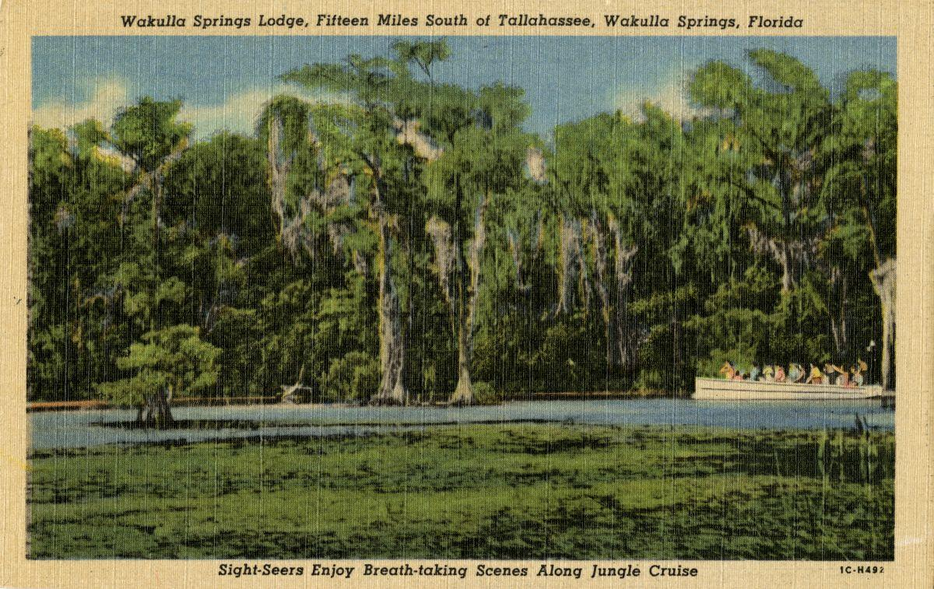

Date: Friday, August 25, 2023

Time: 09:00 AM – 11:00 PM

Location: Zoom Only

Zoom link: <https://fsu.zoom.us/j/97207430086>

Board of Directors Meeting

**9:00    Opening**

•       **Welcome and introductions** – Anthony Gaudio

•       **Agenda review** – A Gaudio

**9:10 Financial report**- Jim Davis **[attached] 5 min**

**9.15 Minutes of July 28, 2023, WSA Board meeting Plus Approval of edited June 23 Board minutes**- Brian Lupiani **[attached] 5 min**

**9:20 Report on the 08/07/23 Wakulla County Board of County Commission Meeting Mtg.** Mike Keys

**20 Min**

**9:40 Report on the 08/21/23 Wakulla County Board of County Commission Meeting Mtg.** Chad Hansen Establishment of Ordinance Workshops and amending commercial zoning regulations to require gas stations to get approval for "conditional use “**20 Min.**

**10:00 Approval of Letter to WCBOC Crequesting WSA’s involvement in the design, participation, and invitees to series of workshops on developing a Springs and Drinking Water Protection Ordinance** A Gaudio **(see attached) 10 min.**

**10:10 Next Steps for WSA for State Acquisition of property** Albert Gregory **(See attached Sine Murray, Trust for Public Lands) 30 Min**

**10:40**  **Fundraising Report: The Great Wakulla Gas Station Battle of 2023**. Down River Project Fiscal Agent A Gaudio 10 Min

$10,240 raised, $5,630 spent, 15% Admin Fee, Balance for next steps $3,001

**10:50   Spring shed and river update -**Cal Jamison **10 Min**

**11:00 Other Topics: 5 Min**

1. Oct, Nov, Dec meeting format (Zoom, In Person, Hybrid)
2. Others?

**Upcoming meetings and events**– 4th Friday of the month

August 25 Zoom only, September 22 in person only location Wakulla County Community Center 318 Shadeville Rd. Crawfordville, 32327,

Currently, reservations have been made for use of the conference room at the Renaissance Center for the following dates in 2023 from 08:45 - 12:30:

October 27 TBD, December 1 TBD (conference room not available November 17th TBD)

11:05 **Adjourn**

Appendix B

**08-25-23 WAKULLA SPRINGS ALLIANCE Board Meeting Participants**

Zoom-only meeting

Officers

Anthony Gaudio Chair

Michael Keys Vice-Chair

Brian Lupiani, Secretary

Directors

Bob Deyle   
Rob Gelhardt

Albert Gregory

Chad Hansen

Cal Jamison   
Howard Kessler

Lindsay Stevens

Tom Taylor

Members and Guests

Lynn Artz

Kathleen Coates

Dave Damon

Gil Damon

Sue Damon

Chloe Dougherty

Grant Gelhardt

Mark Heidecker

Chuck Hess

Sine Murray

Peter Salco

Jim Stevenson

Paul Thurman

Sophie Wacongne-Spear

Chris Werner

Directors Not In Attendance:, Jim Davis, Gail Fishman, Debbie Lightsey

Appendix C

|  |  |
| --- | --- |
| **WAKULLA SPRINGS ALLIANCE** |  |
| **FINANCIAL REPORT** |  |
| **FOR THE 7 MONTHS ENDED JULY 31, 2023** |  |
|  |  |
| **INCOME** |  |
| **Donations** | $ - |
| Memberships | 650.00 |
|  | 650.00 |
|  |  |
| **EXPENSES** |  |
| Awards | - |
| Florida Corporate Annual Report | - |
| Big Bend Environmental Forum | - |
| PayPal Fees | 19.58 |
| Earl Bacon Agency - Insurance | 1,132.78 |
|  | 1,152.36 |
|  |  |
| **SURPLUS/(DEFICIT)** | (502.36) |
|  |  |
| **BANK BALANCE - 12/31/2022** | 9,299.81 |
| **PAYPAL BALANCE - 12/31/2022** | 643.61 |
| **TOTAL - 12/31/2022** | 9,943.42 |
|  |  |
| **BANK BALANCE -7/31/2023** | 9,427.07 |
| **PAYPAL BALANCE-7/31/2023** | 13.99 |
| **TOTAL 7/31/2023** | **$ 9,441.06** |
|  |  |

Appendix D

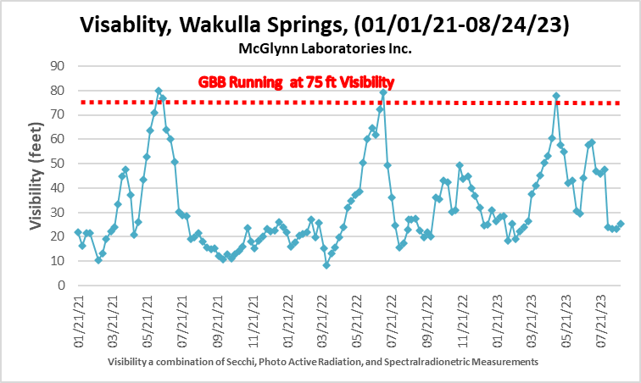

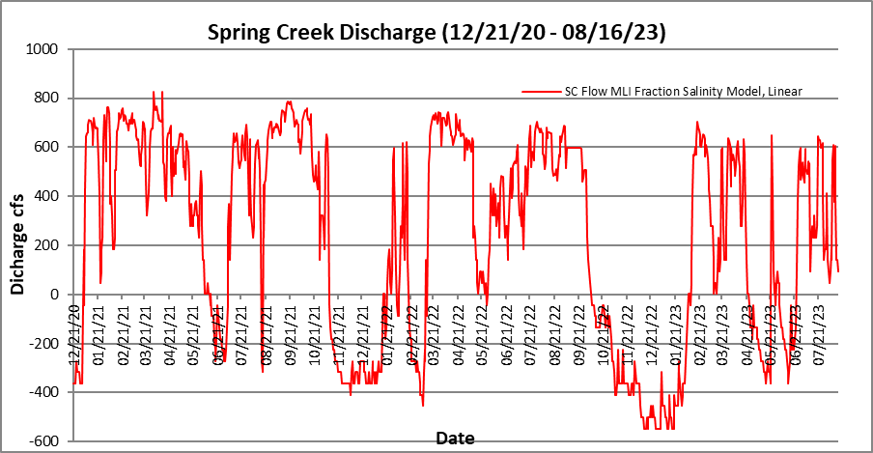

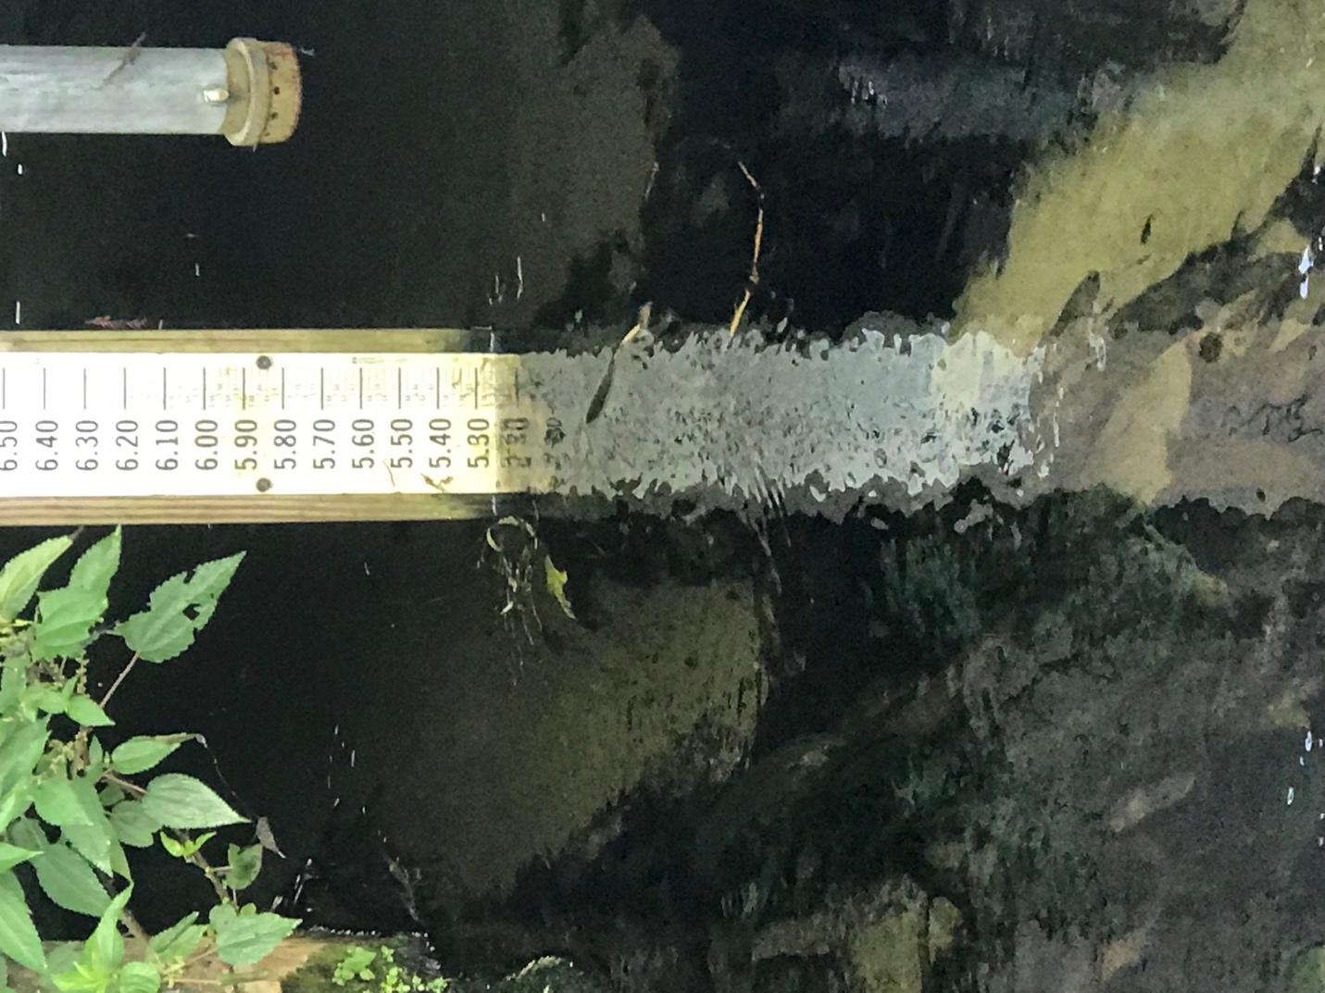

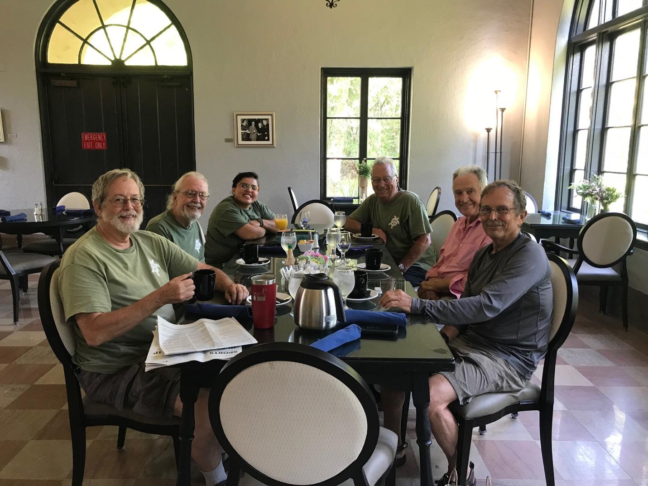

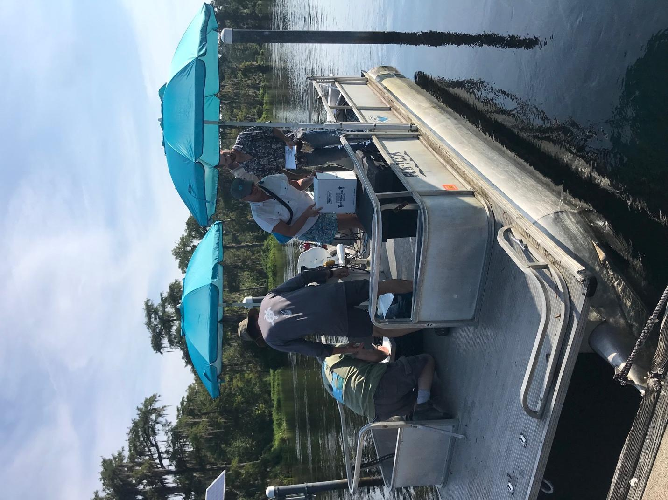

Sent from my iPhone