**Note: Appendices D, E, and G are not yet included in this document**

**The narrative and attendance list ARE complete**

**Wakulla Springs Alliance**

**Board of Directors Meeting**

Friday, December 1, 2023

9:00 AM – 11:00 AM

Location: Zoom Only

Recording (with transcript!) available at

<https://us06web.zoom.us/rec/share/AvE-tgy8OrxU5CfKoOHGKzuV2211FISse94twYist6wyrnemEvdl15DBVKmZQAVj.hCg0nMiHbvu8Q00q>

Passcode: Q&j2nWY2

**9:05 Meeting called to order** by Anthony Gaudio

**Welcome and introductions** – Anthony

**Agenda review** – Anthony

**9:10 Financial report** - Jim Davis (Appendix C)

Albert Gregory **moved to accept the report**; seconded by Brian Lupiani and **passed without opposition.**

**9:11 Minutes of October 27, 2023 meeting** - Brian Lupiani

Albert Gregory **moved to accept the minutes**; seconded by Tom Taylor and **passed without opposition.**

**9:13 Special Considerations for Gas Stations in Commercial Zoning**

**Workgroup -** Anthony (Appendix D)

Executive Committee plus Chad Hanson and Debbie Lightsey crafted a letter to WCBOCC to address this issue. There was no discussion or vote.

**9:16 WSA Status of Land Swap for SW Ga Oil property Report -** Albert

Gregory

Adam Bass of Conservation Florida needs site plan from SW GA Oil.

So far, indications are that House, Senate, and Gov support the purchase, but there's a lot of money being requested for projects in this area.

Anthony said that there are still some issues to be resolved between SW GA Oil and Conservation Florida such as above-ground vs below-ground tanks, etc.

Cal said that a Wakulla Soil & Water Conservation District (WSWCD) supervisor spoke with Sue Duggar, who owns the land on the SE corner of the intersection where the existing gas station is. The lease for that gas station is up in 2 years. Cal suggests that since it’ll take about that long for SW GA Oil to put up a new station, perhaps they’d be interested in getting a lease on (or buying) the existing one. Anthony asked Albert to pass the information on to Adam Bass.

**9:25 Workgroup Report to Restate WSA Ecological Restoration Goal –** Cal Jamison, Brian Lupiani, Jim Stevenson, Chad Hanson

Lindsay Stevens is arranging for a TNC (The Nature Conservancy) member to give a presentation on ecological  resilience  at our January meeting. The work group will get going from there.

For reference, the current goal as stated on the WSA website is:

“The Wakulla Springs Alliance goal for the ecological restoration of the Wakulla Spring and River is to restore the aquatic flora and fauna and water clarity to its condition at state acquisition in 1986. This includes the same relative abundance and diversity of aquatic plants, fishes, reptiles, and birds inhabiting the spring and river within the state park.”

**9:30 WSA becoming a member of the Wakulla County Economic Development Council Cost $75** **15 min**– Anthony (Appendix E)

[Wakulla Economic Development Council (wakullaedc.com)](https://www.wakullaedc.com/)

Anthony is recommending that WSA join the WC Economic Development Council, noting the EDC’s emphasis on WC’s desirable environment and natural attractions. We should be able to show that environmental protections are good for the economy and that WSA is not the enemy.  
He’s received a generally negative reaction from the EDC’s director (Beth Cicchetti?) and President John Shuff, saying that we don’t share the same goals. (Shuff is on the WC Charter Review Committee and doesn’t want any more regulations - maybe thinking for example of WSA’s efforts to put in the Charter the expansion of the WS Protection Zone.)

But Anthony thinks it’s still worth a try. Albert, Chad, and Mike express their support. Anthony has invited Ms Cicchetti to our meeting.

Anthony and Mike will draft a letter to go along with our EDC membership request and present it at our next meeting, when we’ll vote on applying.

**9:45 Spring shed and river update** - Cal Jamison (Appendix F)

WS is full of manatees! Yesterday the park biologist Patty Wilbur and Ranger Raquel counted 36 in the spring basin and a short distance downriver. In other news, the specific conductance has been on the rise, possibly indicating that Spring Creek has reversed enough to send salt water up. Also the water height has been increasing from a little below 5 feet above sea level to a few inches above. We don’t know why. Nitrates are staying around .40; the goal is .35.

The photo in Appendix F is of the new tour boat “Great Blue Heron” at its dedication ceremony, which was well attended (about 60 people) by the Friends of WS, FL State Parks Foundation, DEP, and some legislators.

It’s a hybrid boat, using an electric motor but with a gas motor available if more power is needed going upriver. It was bought with funds from license plate sales.

The WS Water Observation Group did a dye trace study, injecting at Meeting House Sink. The dye showed up at WS, Northside Springs, and No Name Springs. It did not show up at Indian Springs, Sherlock Springs, or Sally Ward Spring. A followup dye trace will be done early in 2024 after a permit is acquired - which shouldn’t be a problem. The purpose of the trace was to identify water routes that divers haven’t been able to get through. It was funded by the Friends of WS and the Wakulla Soil & Water Conservation District.

**10:00 Expansion of Springs Protection Zone** – Lynn Artz (Appendix G) WSA to promote petition campaign to put on the ballot

Lynn talked to WC Supervisor of Elections Joe Morgan and believes her proposed timeline of gathering signatures from February through June is correct. The deadline for presenting the proposal to the WCBoCC is August 16, for a public hearing on September 3. She asks WSA to be the sponsoring organization.

Anthony says the WSA would need to create a work group today, the draft ordinance would need to be written (Chad?) (and a choice made between the 2 options WSA presented to the WC Charter Review Committee), and then a specific request with a specific dollar amount and a written ordinance would need to be presented to WSA to consider and vote on it.

**10:25 Motion**: **Create a work group to examine and report back whether or not WSA should be a sponsor of the [Springs Protection Zone expansion] initiative; to bring back a draft petition; determine the cost of the petition drive and the cost of a campaign, and if the petition is successful determine if a PAC is needed, if our bylaws allow it, and what the impact would be on our nonprofit status. The work group will consist of Anthony, Chad, Lynn, and Mike.** Motion made by Brian, seconded by Tom, **passed without opposition.** There were at least nine votes in favor.

**10:30 Update Wakulla County Board of County Commission Actions** - Kellie Keys

Kellie believes that there is support on the WCBoCC to follow through and actually hold public workshops for a Springs Protection and Drinking Water Ordinance. She suggests that we proceed with a very soft touch and avoid confrontation.

**10:45 Motion**: **Create a work group to coordinate WSA’s efforts to have WC hold the workshops. The work group will consist of Anthony, Chad, and Kellie.** Motion made by Brian, seconded by Albert, **passed without opposition.**

Cal and Kellie noted that they both serve on the Wakulla Soil and Water Conservation District and need to alert to possible Sunshine Law conflicts.

So far there aren’t any, as Cal is not in the workshop work group with Kellie, and Kellie will normally not attend WSA Board meetings.

**10:50 WSA Board Member Nominating Committee Report** -Albert Gregory & Tom Taylor

Bylaws allow us to have up to 15 people on the Board; we currently have 14.

Of the 7 whose terms are ending, all but Mike would like to stay on, though most said they’d be willing to step aside for new blood and broadening the representation of people on the Board.

Anthony noted that several Board members are continually not attending Board meetings and he’ll be contacting them. Also, Board members should be sure to update/renew their membership.

Cal said that the Apalachee Land Conservancy, a nonprofit that monitors conservation easements, is also looking to increase their board membership.

**10:55 Upcoming meetings and events**

January 26, zoom only. February 23, format TBA.

**11:00 Adjourn** moved by Cal, seconded by Albert, no opposition

Appendix A

**Agenda, Wakulla Springs Alliance April Board Meeting,**

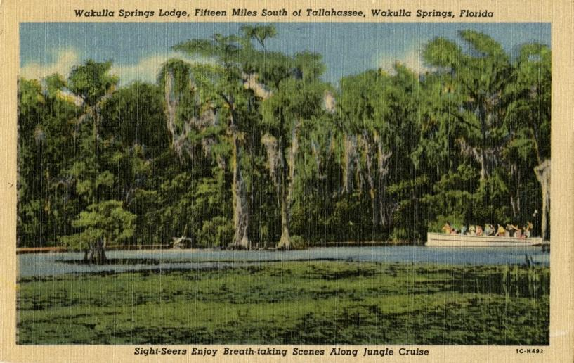

Date: Friday, December 1, 2023

Time: 09:00 AM – 11:00 PM

Location of Meeting Zoom Only

Zoom link <https://us06web.zoom.us/j/89786667803>

**9:00    Opening**

∙       **Welcome and introductions** – Anthony Gaudio

∙       **Agenda review** – Anthony Gaudio

**9:10 Financial report**- Jim Davis **[attached] 5 min**

**9.15 Minutes of October 27, 2023 WSA Board meeting**- Brian Lupiani **[attached] 5 min**

**9:20 Special Considerations for Gas Stations in Commercial Zoning Workgroup -** A Gaudio **10 Min** Executive Committee plus Chad Hanson and Debbie Lightsey crafted a letter to WCBOCC to Address this issue **[attached]**

**9:30 WSA Status of Land Swap for SW Ga Oil property Report** Albert Gregory

**15 Min** Adam Bass needs site plan from SW GA Oil

**9:45 Workgroup Report to Restate WSA Ecological Restoration Goal 10 min –** Cal Jamison, Brian, Jim Stevenson, Chad H. – Lindsey Stevenson has arraigned for a TNC (The Nature Conservancy) member to give a presentation on ecological  resilience  at our January meeting

From WSA Website “The Wakulla Springs Alliance goal for the ecological restoration of the Wakulla Spring and River is to restore the aquatic flora and fauna and water clarity to its condition at state acquisition in 1986. This includes the same relative abundance and diversity of aquatic plants, fishes, reptiles, and birds inhabiting the spring and river within the state park.”

**9:55 Update Wakulla County Board of County Commission Actions** Mike Keys **10 Min**

Springs protection and Drinking Water Ordinance Workshops

**10:05 WSA becoming a member of the Wakulla County Economic Development Council Cost $75** **15 min**– A Gaudio Discussion and Vote [Wakulla Economic Development Council (wakullaedc.com)](https://www.wakullaedc.com/)

**10:20 Expansion of Springs Protection Zone** – **10 Min** Lynn Artz WSA to promote petition campaign to put on the ballot

**10:30 Spring shed and river update -**Cal Jamison **10 Min**

**10:40 WSA Board Member Nominating Committee Report –10 min** Albert Gregory & Tom Taylor- In preparation for the annual meeting elections on January 26, 2024. 15 Maximum Members Seven Elected in 2023 **(See Attached WSA By-Laws Article VI)** Seven 2 Yr. Terms Expiring- Gregory, Davis, Lupiani, Lightsey, Fishman, Kessler, Keys,

**10:50 Other Topics: 10 Min**

1. Membership reminders starting Nov 1 for 2024 with membership drive request to affiliate non-members – 16 Renewals or new members to date
2. January26 & February 23 WSA meeting Formats?
3. Announcements

**Upcoming meetings and events**– 4th Friday of the month

Reservations have been made for use of the conference room at the Renaissance Center for every month in 2024 Formats and locations yet to be determined for those dates from 08:45 - 12:30:

**11:00 Adjourn**

Appendix B

**12-1-23 WAKULLA SPRINGS ALLIANCE Board Meeting Participants**

Zoom-only meeting

Officers

Anthony Gaudio Chair

Michael Keys Vice-Chair

Brian Lupiani, Secretary

Directors

Gail Fishman   
Rob Gelhardt

Albert Gregory

Chad Hanson

Cal Jamison

Lindsay Stevens

Tom Taylor

Members and Guests

Lynn Artz

Meta Calder

Kellie Keys

Paul Thurman

Sophie Wacongne-Spear

Elizabeth ?

Directors Not In Attendance: Jim Davis, Bob Deyle, Howard Kessler, Debbie Lightsey

Appendix C

|  |  |
| --- | --- |
| **WAKULLA SPRINGS ALLIANCE** |  |
| **FINANCIAL REPORT** |  |
| **FOR THE 10 MONTHS ENDED OCTOBER 31, 2013** |  |
|  |  |
| **INCOME** |  |
| Donations | $ - |
| Memberships | 1,400.00 |
|  | 1,400.00 |
|  |  |
| **EXPENSES** |  |
| Data Processing Related | 272.81 |
| Printing | 17.24 |
| Florida Corporate Annual Report | 61.25 |
| Big Bend Environmental Forum | - |
| PayPal Fees | 35.58 |
| Earl Bacon Agency - Insurance | 1,132.78 |
|  | 1,519.66 |
|  |  |
| **SURPLUS/(DEFICIT)** | (119.66) |
|  |  |
| **BANK BALANCE - 12/31/2022** | 9,299.81 |
| **PAYPAL BALANCE - 12/31/2022** | 643.61 |
| **TOTAL - 12/31/2022** | 9,943.42 |
|  |  |
| **BANK BALANCE -10/31/2023** | 9,404.26 |
| **PAYPAL BALANCE-10/31/2023** | 419.50 |
| **TOTAL 10/31/2023** | **$ 9,823.76** |
|  |  |
|  |  |
| **NOTE: Annual Membership dues collection** |  |
| **for the upcoming year started in November** |  |

Appendix D

Letter to WCBoCC re special consideration will be copied here

Appendix E

WC Economic Development Council strategic plan document will be copied here

Appendix F

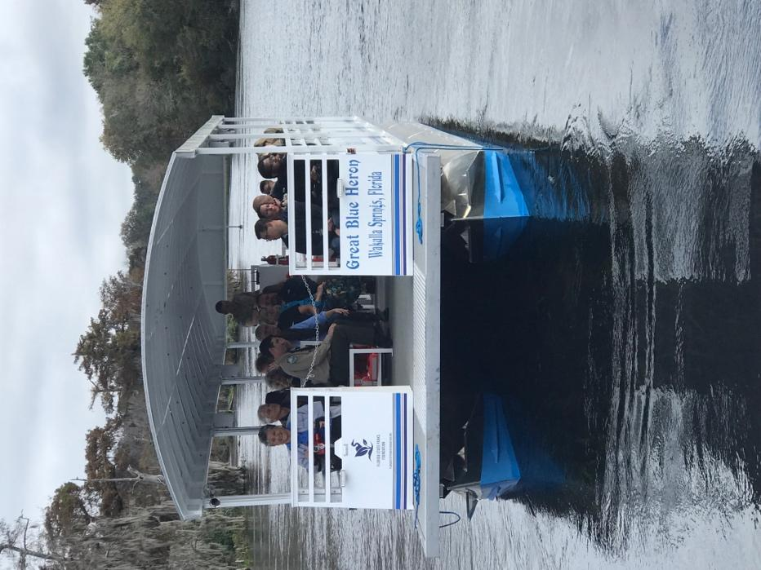

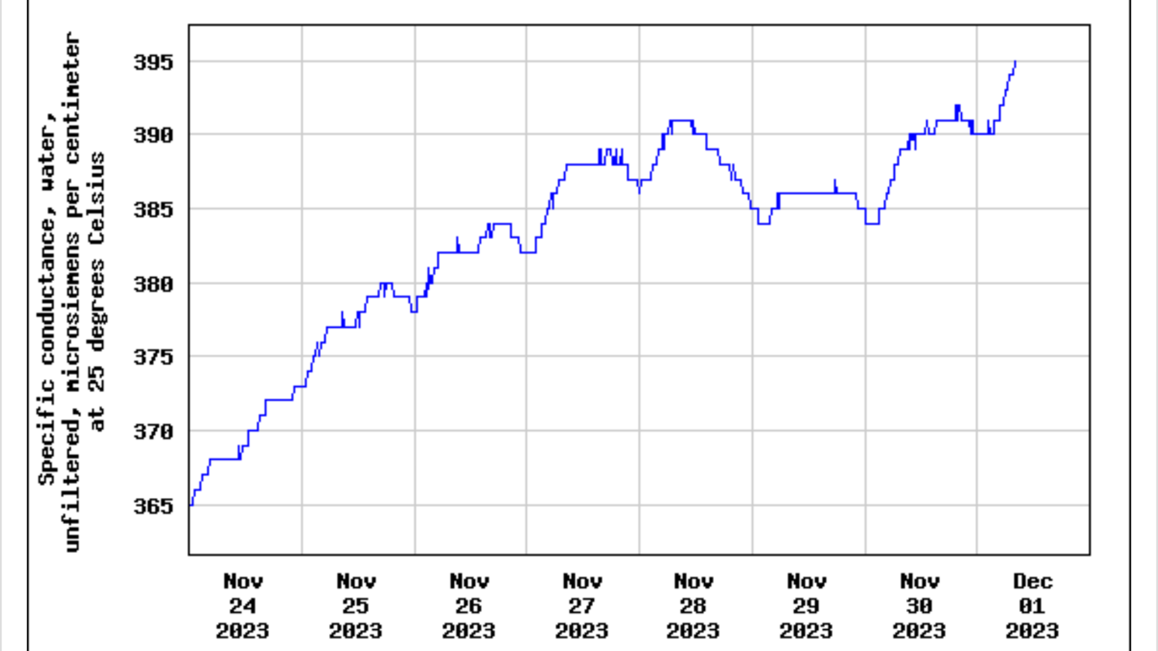

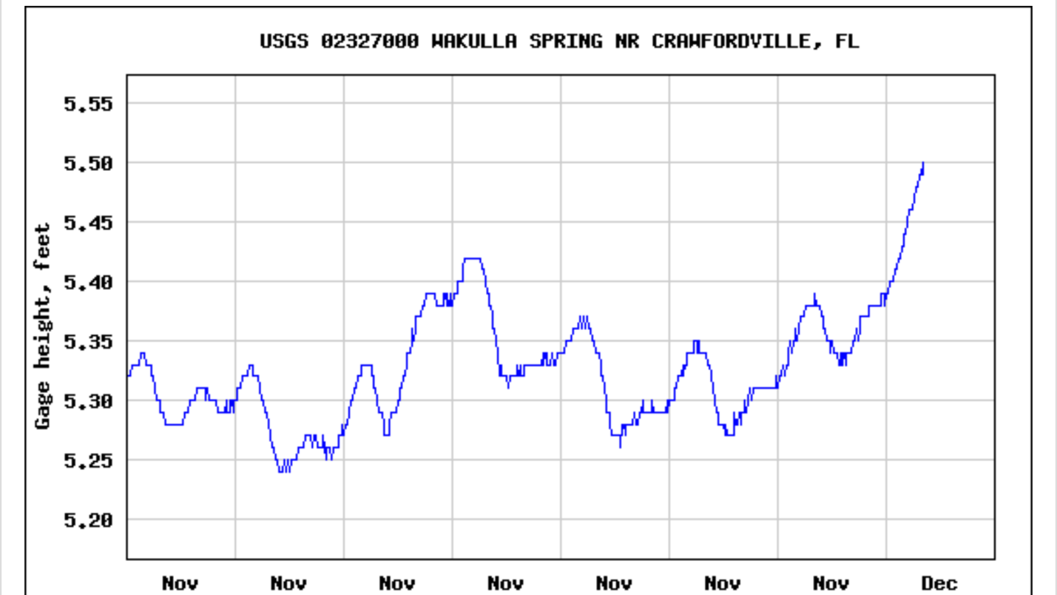

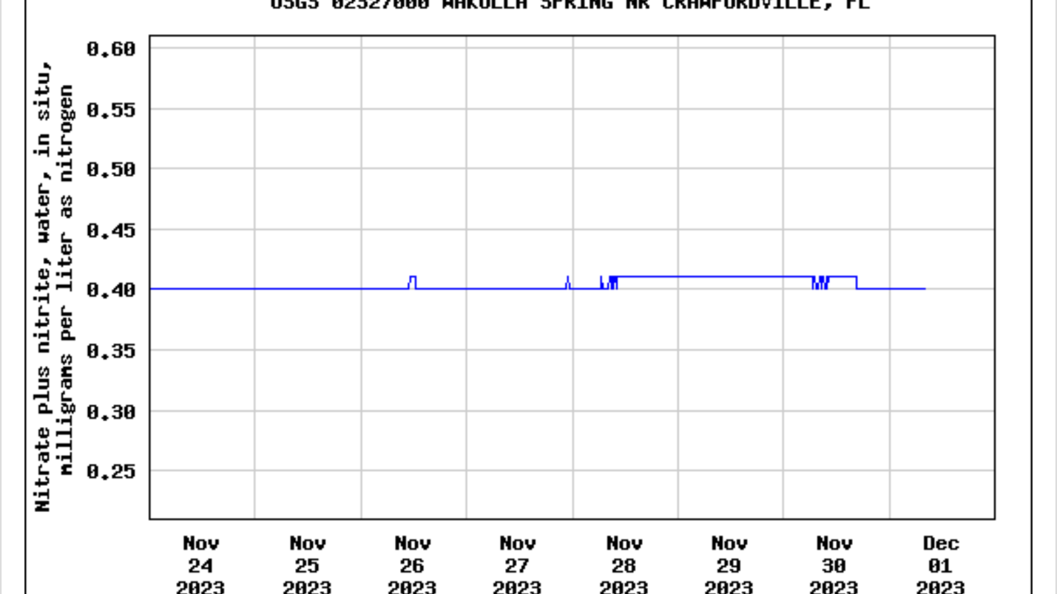

Sent from my iPhone

Appendix G

Emails from Lynn Artz re WC Charter petition campaign will be copied here