**Wakulla Springs Alliance**

**Board of Directors Meeting**

Friday, August 22, 2025

9:00 AM – 11:00 AM

Location: Zoom Only

Zoom link <https://us06web.zoom.us/j/89786667803>

Recording (with transcript!) available at

<https://us06web.zoom.us/rec/share/tpn64v_aXzaOfNP873E7N676S7nZWjB5x-HRP8R8KaahfcJ5U7zPpbFDFTqomCM4.65RPoV029bzbWhYF?startTime=1755865934000>

Passcode: 2Kk+bmJA

(Meeting begins about 30 minutes into the recording)

**9:02 Meeting called to order** by Chad Hanson

**Welcome and introductions** – Appendix E, attendance

**Agenda review** – Chad

Anthony will discuss in “Other Topics”, the Lake Munson Action Plan meeting on Tuesday August 26, 6:00 PM at the Woodville Community Center.

**9:05 Financial Report** - Anthony Gaudio (Appendix C)

Brian Lupiani **moved to accept the financial report**; seconded by Renee Murray and **passed without opposition.**

**9:10 Minutes of June 27, 2025 meeting** - Tom Taylor/Brian Lupiani

Anthony Gaudio **moved to accept the minutes**; seconded by Howard Kessler and **passed without opposition.**

**Minutes of July 10, 2025 Executive Committee meeting to approve WSA signing onto the FSC’s letter requesting delay in BMAP implementation** Brian Lupiani

Howard **moved to accept the minutes**; seconded by Anthony and **passed without opposition.**

**9:15 Florida Springs Council challenge to BMAPs –** Ryan Smart

Ryan stated that the letter requesting extensions on 11 BMAPS was sent over a month ago, and there has been no response from DEP. There are four entities requesting an extension for Wakulla Springs: FSC, WSA, Save the Manatee Club, and Tallahassee Regional Environmental Group (TREG). After about 15 minutes of discussion:

Anthony moved that the Executive Committee be authorized to determine 1) whether or not WSA should petition the DEP to challenge the Wakulla Springs BMAP, 2) whether to financially support the efforts of the FSC to challenge other BMAPS, and 3) have a spending limit of $1,000.

Howard seconded Anthony’s motion and it **passed without opposition.**

**9:30 Land Swap for SW Ga Oil property -** Renee Murray (0:58 in recording)

Renee said that (Elsa?) told her that everything is still on track; they’re working through deed restrictions and the zoning change, which hasn’t been filed yet,

**9:35 Spring Education and Outreach -** Chad / Renee

Chad said he, Renee, and Kelly Keys have been looking for education & outreach opportunities in coordination with FSU, the Wakulla Environmental Institute, etc. WEI is having some educational events coming up. Renee said that Chris Werner will be speaking there on Sept 13. Chris, who had just joined the meeting, said he’ll be speaking on the geology and hydrology of the Woodville Karst Plain - what is known and what is unknown. They’re looking for someone to follow his presentation with a talk about how people can get involved.   
  
Lynn said that Kelly is going to lead a tour from Tallahassee to WS State Park on October 16 for the Wakulla County Garden Club, which filed up quickly. Kelly also wants to do springs tours targeting county officials, staff, commissioners, etc.  
  
Renee said that according to Kelly, FSU’s marine institute has funding for its Wakulla Springs project through the end of this calendar year but no further. Kelly has no funding, but the Friends is sponsoring nearly $14,000 to help with outreach, education, and internship. Chris said they didn’t get funded for this fiscal year, but have some carryover funds available to wrap up compiling and reporting data.

**9:45 Springshed and river update** - Cal Jamison

Sally Ward Spring flow appears to be tannic. Wakulla River has been higher than normal for about the last year - yesterday it was 5.6 feet above sea level - and the flow is very strong. For a long time the height stayed close to 5 feet, and we don’t have a good reason for the increased height. Also, a year ago the flow was about 600 cubic feet per second, but now it’s about 1,000 and has been that way for awhile. It doesn’t appear to be rain-driven.   
  
Submerged vegetation is coming back in quite a few places. It’s reaching its peak time, so we expect to see more hydrilla.

Chloe and Cal were contacted about a proposed land swap between Wakulla County for some lowlands near the Wakulla sewage treatment plant, to trade to the National Forest for some forest land north of Crawfordville. The county has been trying to find a place for a park to serve residents of the northern part of the county. But it literally would take an act of Congress to make the swap, so when anything might happen is unknown. This afternoon, Cal and Chloe are going to meet with the citizen who contacted them.

**10:00 Hydrologic Conditions of Wakulla Spring and Spring Creek -** Paul Thurman, NW FL Water Management District (1:25 in recording)

NOTE: A link to Paul Thurman’s PowerPoint presentation will be inserted here.

**10:45 League of Environmental Educators in Florida (LEEF**) - Lynn / Chad <https://www.leef-florida.org> (2:10 in recording)

Annual conference will be held in Wakulla County March 27-29, 2026

Lori Nicholson at (St Marks Wildlife?) Refuge is very active in LEEF

They’re looking for sponsors, presenters, & field trips. Kelly Keys will be giving a

presentation and leading a field trip, and Julie Harrington has suggested that the

Friends will probably sponsor.

Cal said that the subject came before the Soil & Water Conservation District

and it’s considering sponsoring local schoolteachers. Chad suggested that that

might be the best way for WSA to help out. He’ll contact Lori and report back.

**10:55 Other Topics**  (2:20 in recording)

1. Anthony discussed the Lake Munson Action Plan meeting on Tuesday,

August 26, 6:00 PM at the Woodville Community Center.

2. Lynn reminded that the FSC is having a live online event to talk about the BMAPs   
 next Wednesday.

3. Lynn said that she’s working on citizen ballot initiatives for next November to

expand the springs protection zone.

4. Cal said that he knew of nothing going on with the Woodville fish farm, although  
 the permit should have expired.

5. Anthony and Chad said we should acquaint ourselves with the candidates who

are starting to turn up for next year’s elections.

6. Cal said the Friends’ annual car show would be November 8th and would feature

the car that was removed from Donahue’s sink earlier this year.

7. Next WSA Board meeting will be September 26, 2025. Zoom only.

**11:05 Adjourn**

## NOTE: According to our Zoom AI overlord, these are our Next Steps

1. Executive Committee: Determine whether WSA will petition to challenge the Wakulla Springs BMAP or financially support Florida Springs Council's efforts to challenge other BMAPs.

2. Ryan: Organize a virtual meeting with representatives from Wakulla Springs Alliance, TREG, Florida Springs Council, and Save the Manatee Club to discuss potential BMAP challenges.

3. Chad: Send Ryan the email addresses of the WSA executive committee members.

4. Ryan: Drop a link in the chat for the FSC webinar on BMAPs scheduled for Wednesday at 6:30 PM.

5. Cal: Attend the Lake Munson Action Plan meeting on Tuesday at 6 PM at the Woodville Community Center.

6. Cal: Meet with a citizen regarding the proposed land swap between Wakulla County and National Forest.

7. Cal: Report findings from the land swap property visit at next month's meeting.

8. Cal: Provide an update next month on the potential karst window sinkhole and unaccounted water feature discovered on the land swap property.

9. Cal: Keep Chad informed about the land swap situation for potential action.

10. Renee: Continue monitoring and following up on the land swap progress with Shalsa.

11. Chad: Coordinate with Renee, Kelly, and Mary for the September 13th event at Wakulla Environmental Institute, including finding a speaker to discuss public participation opportunities.

12. WSA representatives: Coordinate with Wakulla Environmental Institute about participating in the September 13th event where Chris Warner will be presenting.

13. Chad: Reach out to Kelly about getting on the agenda for next month's meeting to provide updates on her activities.

14. Chad: Follow up with Joel and Kelly about potential updates on their research projects and funding needs.

15. Chad: Share meeting highlights and notes after the meeting next week.

16. Cal: Include Anthony on future communications when sending materials for meetings.

17. Cal: Provide Anthony with the conductivity data graph from Sean McGlynn's weekly sampling at Wakulla Springs.

18. Chad: Share Paul's PowerPoint presentation on the Alliance website.

19. Chad: Contact Lori Nicholson about sponsorship options for the LEAF conference, particularly regarding sponsoring local teachers to attend, and report back at the next meeting.

20. Lynn: Convene a meeting in September with key people to discuss citizen-initiated petitions, including one to expand the Wakulla Springs protection zone.

21. Chad: Add discussion about election candidate outreach to the next meeting agenda.

22. Water Management District: Replace the sensor for continuous discharge measurements at Wakulla Spring.

23. Paul Thurman: Replace the velocity meter in Wakulla Spring and restart collecting real-time continuous spring discharge data within the next 2-3 months.

24. Northwest Florida Water Management District: Continue manual discharge measurements at Wakulla, Sally Ward, St. Mark's River Rise, and other springs in the district.

25. Northwest Florida Water Management District: Continue monitoring and investigating the dynamics between Wakulla Spring flows, water quality, and Spring Creek reversals.

26. Northwest Florida Water Management District: Develop vegetation restoration projects for Wakulla Spring in the next 1-2 years

Appendix A

Agenda, Wakulla Springs Alliance Board Meeting,

**August 22, 2025**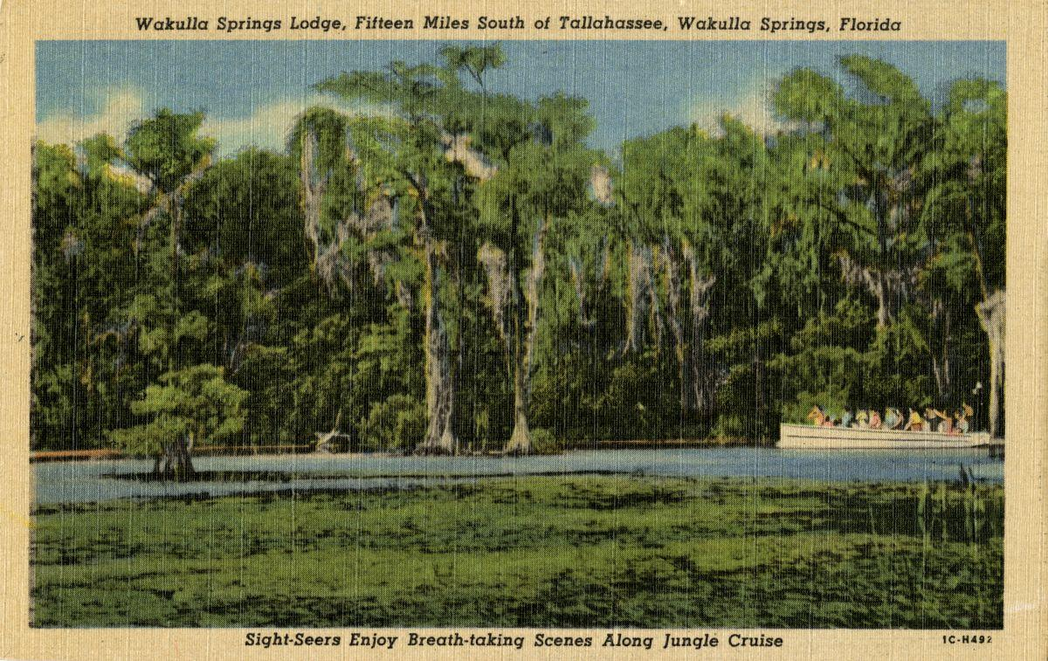

Date: Friday, **August 22, 2025**

Time: 09:00 AM – 11:00 AM

Location of Meeting **Zoom Only**

Zoom link [https://us06web.zoom.us/j/89786667803](https://webmail.centurylink.net/app/Utilities/gateway_url.asp?umsgid=%7B7ca5f517-7842-46e4-a9d1-f67c24b31ec4%7D&uurl=https%3A//us06web.zoom.us/j/89786667803)

Board of Directors Meeting

**9:00    Opening WSA Board**

**Welcome and introductions** – Chad Hanson, Chair

**Agenda review** – Chad Hanson, Chair

**9:10 Financial report**– Anthony Gaudio **[attached] -** 5 min

**9.15  Minutes of June 27, 2025 Board meeting**- Tom Taylor/Brian Lupiani **[attached] -** 5min

**9:20 Florida Springs Council challenge to BMAPs –** Chad / Anthony / Tom / Ryan Smart [10 min]

**9:30 Status of Land Swap for SW Ga Oil property Report -** Renee Murray [5 Min]

**9:35 Spring Education and Outreach -** Chad / Renee [10 mins]

**9:45 Springshed and river update (**Cal Jamison) - 15 Min

**10:00 Hydrologic Conditions of Wakulla Spring and Spring Creek -** (Paul Thurman, NW FL Water Management District) - 30 mins

**10:45 *League of Environmental Educators in Florida* (LEEF**) will be held in Wakulla County March 27-29, 2026 (Lynn Artz/Chad) – looking for sponsors [https://www.leef-florida.org/page-1816](https://webmail.centurylink.net/app/Utilities/gateway_url.asp?umsgid=%7B99346318-f5b8-4e63-bdc9-c0ce7c91ec46%7D&uurl=https%3A//www.leef-florida.org/page-1816)

**10:55 Other Topics: 5 Min**,

1. September 26, 2025, Board Meeting WSA Board meeting Zoom only.
   1. Presentations? Discussions?
2. Education/Outreach events
3. Upcoming meetings / events
   1. County / City Commission meetings
4. Announcements

**11:00 Adjourn**

Post meeting executive action

**WSA Executive Committee Sept 08, 2025 email vote**

The WSA Executive Committee* voted by email on September 08. The purpose of the vote was to decide if WSA should sign on to 1000 Friends of Florida’s letter to legislators requesting changes to HB 180.

The Executive Committee voted unanimously to add WSA to 1000 Friends of Florida’s letter. The email thread and the text of the Friends’ letter are below.

Brian Lupiani, WSA Secretary

850-273-10328

* Chad Hanson, Chair

Tom Taylor, Vice-Chair

Anthony Gaudio, Treasurer

Brian Lupiani, Secretary

Appendix B

**8-22-25 WAKULLA SPRINGS ALLIANCE**

**Board Meeting Participants**

Zoom-only meeting

Officers

Chad Hanson, Chair

Tom Taylor, Vice-Chair

Anthony Gaudio, Treasurer

Brian Lupiani, Secretary

Directors

Cal Jamison

Johnathan Kelly (“Royal - Luxury RE Marketing”)

Howard Kessler

Renee Murray

Members and Guests

Lynn Artz

Kathleen Coates, NWFWMD

Sue Damon

Mark Heidecker, City of Tallahassee

“M B Lupo”

Johnny Richardson, Leon County

Ryan Smart, Florida Springs Council

Paul Thurman, NWFWMD

Chloe Broker, Friends of Wakulla Springs Board

Caryn Crabb-Nelson, FDACS

Sophie Wacongne-Speer

Edgar Wade, Leon County

Chris Werner, WKPP

Directors Not In Attendance: Jim Davis, Bob Deyle, Albert Gregory, Debbie Lightsey, Peter Scalco, Beau Simon

Appendix C

|  |  |  |
| --- | --- | --- |
| **WAKULLA SPRINGS ALLIANCE** |  |  |
| **ANNUAL FINANCIAL REPORT** |  |  |
| **FOR THE Month ENDED July 31, 2025** |  |  |
|  |  |  |
| **INCOME** |  |  |
| **Donations** | 500.00 | Scott Hannahs |
| Memberships | 15.00 |  |
| **Interest Earned June + July** | 47.53 |  |
| **Total Income** | **562.53** |  |
| **EXPENSES** |  |  |
| Paypal Fees | 1.01 |  |
| **Total Expense** | **1.01** |  |
|  |  |  |
| **SURPLUS/(DEFICIT)** | **561.52** |  |
|  |  |  |
| **BANK BALANCE - Envision Credit Union 7/31/25** |  |  |
| **Checking Account** | 418.05 |  |
| **Sterling Account** | 5,667.19 |  |
| **Membership Account** | 5.00 |  |
| **CD Matures 1/24/26 4.17%** | 5,085.15 | Renewed 7/24/25 |
|  |  |  |
| **BANK BALANCE - 7/31/25** | 11,175.39 |  |
| **PAYPAL BALANCE 7/31/25** | 13.99 |  |
| **TOTAL - 1/31/2025** | **$ 11,189.38** |  |
|  |  |  |
| **BANK BALANCE - May 31, 2025** | 10,627.86 |  |
| **PAYPAL BALANCE May 31, 2025** | - |  |
| **TOTAL 5/31/2025** | **$ 10,627.86** |  |
|  |  |  |
| **June + July Surplus** | **561.52** |  |
|  |  |  |