**Wakulla Springs Alliance**

**Board of Directors Meeting**

Friday, February 23, 2024

9:00 AM – 11:00 AM

Location: Zoom Only

Zoom link <https://us06web.zoom.us/j/89786667803>

Recording (with transcript!) available at

<https://us06web.zoom.us/rec/share/if0OZyb_aAIkgRgLdfdeHcm17HHu1FmMy8FAebxcuOkFVcnSrDuA6pyIkDhpWu5S.D_kUFmppCsqNsFn8?iet=kbo6eQc3GIhGpvqOjAULEU2_vJF0Jr1-5geZBF4zYws.AG.3uKu5fMY1sq0p5Hv1ju-ODH3fJa0FzitEG8HKigK6-4vWtEC2p0i5LXa43nojgPRawrO5VXgOnZ-g73egw0-lKYWkQSw2Cnpjb329PfviSB2WDO-HGqpNiGS0nEYfK7E.PJILlymXrMhDuX_xYljFgg.UWMwGpN2v2WDqLpI>

Passcode: !3+sNH&V

**9:03 Meeting called to order** by Anthony Gaudio

**Welcome and introductions** – Anthony

**Agenda review** – Anthony

**9:06 Financial report** - Jim Davis (Appendix C)

Brian Lupiani **moved to accept the report**; seconded by Albert Gregory and **passed without opposition.**

**9:08 Minutes of January 26, 2024 meetings (Annual general meeting and Board meeting)** - Brian Lupiani

Albert Gregory **moved to accept the minutes**; seconded by Brian Lupiani and **passed without opposition.**

**9:10 Special Considerations for Gas Stations in Commercial Zoning Workgroup Update -** Chad Hanson

Anthony delivered Chad’s report that nothing is currently going on.

**9:12 Status of Land Swap for SW Ga Oil property Report -** Renee Murray

The legislative session has made it difficult to connect with Conservation Florida, but Renee did have a conversation with Adam Bass, who indicated that SW Georgia Oil is interested and wants to speak with the local coalition. Conservation FL also believes that the funding in the state budget will be adequate.

**9:15 Spring shed and river update -**Cal Jamison

Cal told the saga of The Great Water Sample Bottle Rescue of 2024.

Water visibility remains below 20 feet. There are plenty of fish, in particular bream and bass, and dozens of manatees.

The park has 4 new tour boats in use daily. One has both gas & electric motors while the others are all gas - though the new motors are very efficient and much quieter than those on the old boats.

WKKP is searching for sinkholes between Wakulla Springs and Spring Creek but so far haven’t found any that provide access to the cavern system.  
Water levels at Wakulla Springs had been well over 5 feet for weeks but are now dropping quite a bit. We expect a likely Spring Creek reversal.

Anthony received a request from Valerie Mendez of the 4H IFAS program in Leon County about starting a Watershed Wonders spring break camp. Cal spoke with WSSP manager Lance, who is very interested in restoring all of the science programs that the Park used to do.

**9:25** Anthony and Anna Padilla are working on a problem arising from a Leon

County ordinance’s impact on the expansion (by the Legislature) of the Springs Protection Zone to most of the county.

**9:30 Proposed Addition to WSA website regarding Ecological Restoration**

Bob Deyle described how he’s working with Bob Thompson to make the weekly wildlife survey info available through the WSA website and Facebook page.

**9:35** “**The Nature Conservancy’s Approach to Establishing Ecological**

**Restoration Goals**.” **–** Intro by Bob Deyle, Presented byChris Bergh on ecological resilience and goal setting to help WSA reconsider its target

goal in this regard.

From WSA Website “The Wakulla Springs Alliance goal for the ecological

restoration of the Wakulla Spring and River is to restore the aquatic flora and fauna and water clarity to its condition at state acquisition in 1986. This includes the same relative abundance and diversity of aquatic plants, fishes, reptiles, and birds inhabiting the spring and river within the state park.”

Thanks to Tom Taylor for these notes:

* The WS Management plan and BMAP do not have biological goals
* We need an ecological restoration goal.
* TNC has conservation by design framework
* Need goals, measurable objectives, situation analysis (storytelling, different perspectives, leverage points, data confidence = description of conditions (# & diagrams), shared understanding), theory of change (diagram: funding, partners, pilot projects > short & long-term outcomes > impacts), and last, monitoring, evaluation and learning
* Managing for climate resilience, e.g., reefs in the FL Keys.
* Resilience involves resistance, tolerance, recovery and adaption.
* In October Bob Deyle, Chad Hanson, Brian Lupiani, Jim Stevenson, Cal Jamison agreed to look at restoration goals. We can use Chris’s approach to proceed with this. Donald Axelrad, Anthony Gaudio and Kathleen Coates will attend the first meeting. They will report to the March meeting.
* There are Conservation facilitators who can help.
* Make goals with climate change in mind and identify implications on Spring Creek and Wakulla Springs.
* There are projections for the amount and timing of rainfalls and sea level rise.
* There will need to be periodic reviews of restoration goals.
* Uncertainty leads to adaptive ecosystem management strategies, e.g., will bull rushes survive and is this important. Which plants survive with salinity and darkness changes?
* NOAH has scenario models. We can test hypotheses. We may have different species in the future.
* Sean McGlynn has measures of salinity which will change everything. We may not have options.

**10:10** **Q&A & Discussion Ecological Restoration Target**

A Workgroup was set up in October to rewrite the WSA’s Ecological Restoration Goal. The group consisted of Cal Jamison, Jim Stevenson, Chad Hansen, and Brian Lupiani. Bob Deyle will schedule and begin the first meeting of the Group, and Anthony Gaudio, Kathleen Coates, and Don Axelrad will join in that meeting.

**10:30  Update Wakulla County Board of County Commission Springs**

**Protection Ordinance Workshops -** Kellie Keys

Kellie was not present but Anthony said the Wakulla County Commission has asked her to be the liaison for workshops with Wakulla environmental groups.

**10:33  Don Axelrad Lectures on Environmental Issues**

Don will be presenting a series of six Thursday evening lectures at Temple Israel beginning next Thursday (February 29) at 6:00 PM. Information and registration for the lectures is at <https://www.templeisraeltlh.org/form/environmental-health-registration.html>

**10:37  Ryan Smart letter to Legislature’s Budget Conference committee**

**concerning funding for Florida Forever, etc.** - Anthony Gaudio

Ryan gave Anthony a 3-page letter during this meeting and requested that WSA indicate its support by 4:00 today.

Tom Taylor **moved to empower the Executive Committee review the letter and decide whether to sign onto it or not;** seconded by Gail Fishman and **passed without opposition.**

**[Note:** Immediately following the Board meeting, it was decided to sign on to Ryan’s letter.**]**

**10:40 WSA becoming a member of the Wakulla County Economic**

**Development Council** – Anthony

Anthony has applied for WSA membership in the WCEDC; no reply yet

March 22 WSA meeting Format will be Zoom only

**10:45 Adjourn** moved by Gail, seconded by Cal, no opposition

Appendix A

Agenda, Wakulla Springs Alliance April Board Meeting, 2/23/2024**[See Attached Doc]** 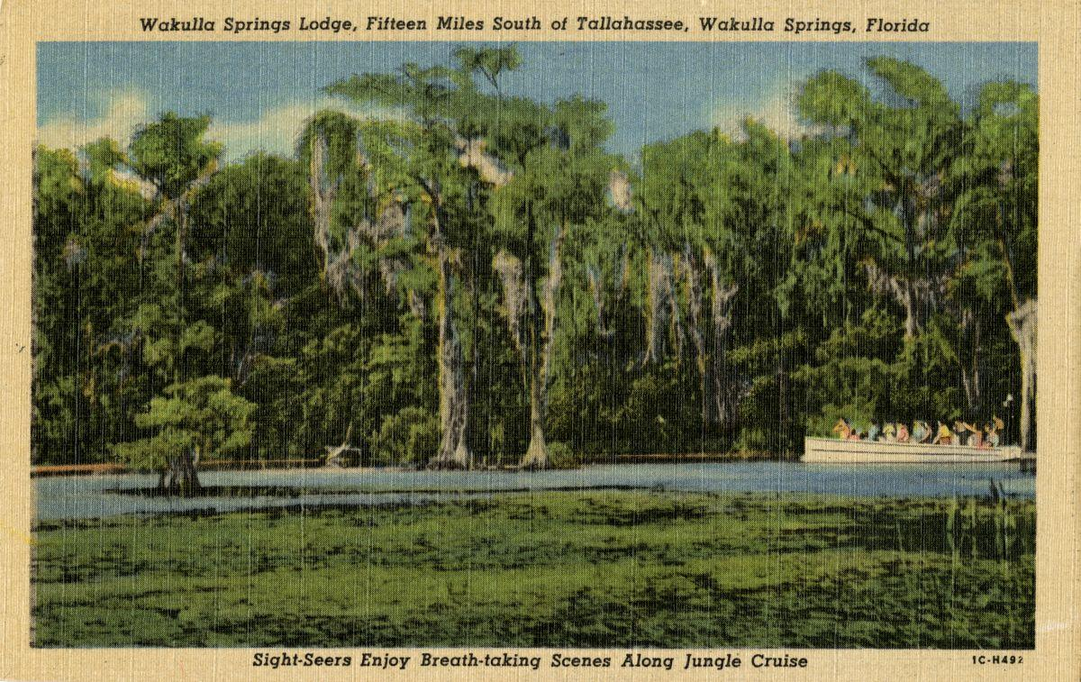

Date: Friday, February 23, 2024

Time: 09:00 AM – 11:00 PM

Location of Meeting Zoom Only

Zoom link <https://us06web.zoom.us/j/89786667803>

Board of Directors Meeting

**9:10    Opening WSA Board**

∙       **Welcome and introductions** – Anthony Gaudio

∙       **Agenda review** – Anthony Gaudio

**9:20 Financial report**- Jim Davis **[attached] 5 min**

**9.25 Minutes of January 26, 2023 WSA Board meeting**- Brian Lupiani **[attached] 5 min**

**9:25 Special Considerations for Gas Stations in Commercial Zoning Workgroup Update-** A Gaudio **10 Min** Chad hanson

**9:35 WSA Status of Land Swap for SW Ga Oil property Report** Renne Murray

**10 Min** Adam Bass update

**9:45** “**The Nature Conservancy’s Approach to Establishing Ecological Restoration Goals**.”**30 min –** Introduction by Bob Deyle, Presentation byChris Bergh on ecological resilience and goal setting to help WSA reconsider its target goa in this regard. WSA Workgroup Brian Lupiani, Cal Jamison, Jim Stevenson, Chad Hansen.

From WSA Website “The Wakulla Springs Alliance goal for the ecological restoration of the Wakulla Spring and River is to restore the aquatic flora and fauna and water clarity to its condition at state acquisition in 1986. This includes the same relative abundance and diversity of aquatic plants, fishes, reptiles, and birds inhabiting the spring and river within the state park.”

**10:15 Q&A & Discussion Ecological Restoration Target 15 min**

**10:30 Proposed Addition to our Website concerning Ecological Restoration 5 Min –** Bob Deyle – Vote by Board

**10:35 Update Wakulla County Board of County Commission Springs Protection Ordinance Workshops** Kellie KeysWCBOCC Liasson For Workshops with Wakulla Environmental Groups **10 Min**

Springs protection and Drinking Water Ordinance Workshops

**10:45 Spring shed and river update -**Cal Jamison **10 Min**

**11:55 Other Topics: 10 Min**

1. March 22 WSA meeting Format
2. Announcements

**Upcoming meetings and events**– 4th Friday of the month

Reservations have been made for use of the conference room at the Renaissance Center for every month in 2024 Formats and locations yet to be determined for those dates from 08:45 - 12:30:

**11:00 Adjourn**

Appendix B

**2-23-24 WAKULLA SPRINGS ALLIANCE**

**Board Meeting Participants**

Zoom-only meeting

Officers

Anthony Gaudio, Chair

Chad Hanson, Vice-Chair

Brian Lupiani, Secretary

Directors

Don Axelrod

Bob Deyle

Gail FishmanRob Gelhardt

Albert Gregory

Cal Jamison

Renee Murray

Lindsay Stevens

Tom Taylor

Members and Guests

Chris Bergh, The Nature Conservancy

Kathleen Coates, NWFWMD

Mark Heidecker, City of Tallahassee

Chuck Hess, Wakulla County Commissioner

Anna Padilla, Leon Co. Public Works

Johnny Richardson, Leon Co. Public Works

Sophie Wacongne-Spear

Edgar Wade, Leon Co. Public Works

“Elizabeth”

Directors Not In Attendance: Jim Davis, Howard Kessler, Michael Keys, Debbie Lightsey Appendix C

|  |  |
| --- | --- |
| **WAKULLA SPRINGS ALLIANCE** |  |
| **FINANCIAL REPORT** |  |
| **FOR THE 1 MONTH ENDED JANUARY 31, 2024** |  |
|  |  |
| **INCOME** |  |
| Donations | $ |
| Memberships | 610.00 |
|  | 610.00 |
|  |  |
| **EXPENSES** |  |
| Data Processing Related | - |
| Printing | - |
| Florida Corporate Annual Report | - |
| Big Bend Environmental Forum | - |
| PayPal Fees | 18.68 |
| Earl Bacon Agency - Insurance | - |
|  | 18.68 |
|  |  |
| **SURPLUS/(DEFICIT)** | 591.32 |
|  |  |
| **BANK BALANCE - 12/31/2023** | 9,709.26 |
| **PAYPAL BALANCE - 12/31/2023** | 1,574.71 |
| **TOTAL - 12/31/2023** | 11,283.97 |
|  |  |
| **BANK BALANCE - 1/31/2024** | 9,909.26 |
| **PAYPAL BALANCE - 1/31/2024** | 1,966.03 |
| **TOTAL 1/31/2024** | **$ 11,875.29** |

