**Wakulla Springs Alliance**

**Annual General Membership Meeting**

Friday, January 26, 2024

9:00 AM – 9:20 AM

Location: Zoom Only

Zoom link <https://us06web.zoom.us/j/89786667803>

Recording (with transcript!) available at

<https://us06web.zoom.us/rec/share/cBKPufN8Ughog8FU2j8cVSetiNEUrjIEv9mGx119FXMS-gcJUDBAvawSpWk9xXnQ.PeGbQcS4m9DYWIhP?iet=rIZgUxfm-1Q68XGLV_zA-w39JYa9hESEwEwInckGL_A.AG.X44MCUiiMce1zZ_jj3Mer1nyLT6fGOWIgGI6LPCAZpRh3gtVh_iyZ-48IM6-JduIITZfzOYEzUsZ_Gg39Rwsd89Zco0oTyUJ3oHClwMVGuzvlEDyquIEHnKGqXcQsOWe.83IjBPuWmVI9d-eXnndsIg.oBQzxvrXo4jSHa57>

Passcode: cy2#%5nG

(Meeting begins about 30 minutes into the recording)

**9:00   Opening of WSA Annual Meeting**

**Welcome and introductions** – Anthony

**One shy of Quorum (15 members)**

**9:09 WSA Board Member Nominating Committee Report –** Albert Gregory & Tom Taylor- In preparation for the annual meeting elections on January 26, 2024. 15 Maximum Members Seven Elected in 2023 **(See WSA By-Laws Article VI)** 2024 Nominees 2 Yr. Terms Expiring 2026- Albert Gregory, Jim Davis, Brian Lupiani, Debbie Lightsey, Gail Fishman, Howard Kessler (Current board Members), Don Axelrad, Renee Muray, (Nominated new Board Members).   
  
There were no nominations from the floor.

**9:13 Quorum established** (Gail joined the meeting)

**9:16 Vote to accept the Nominating Committee’s slate - passed without opposition**

**9:20 WSA Annual Financial report** - Jim Davis (Appendix D)

Brian Lupiani **moved to accept the report**; seconded by Gail Fishman and **passed without opposition.**

**9:20 Adjourn**

**Wakulla Springs Alliance**

**Board of Directors Meeting**

Friday, January 26, 2024

9:25 AM – 11:30 AM

Location: Zoom Only

Zoom link <https://us06web.zoom.us/j/89786667803>

Recording (with transcript!) available at

<https://us06web.zoom.us/rec/share/cBKPufN8Ughog8FU2j8cVSetiNEUrjIEv9mGx119FXMS-gcJUDBAvawSpWk9xXnQ.PeGbQcS4m9DYWIhP?iet=rIZgUxfm-1Q68XGLV_zA-w39JYa9hESEwEwInckGL_A.AG.X44MCUiiMce1zZ_jj3Mer1nyLT6fGOWIgGI6LPCAZpRh3gtVh_iyZ-48IM6-JduIITZfzOYEzUsZ_Gg39Rwsd89Zco0oTyUJ3oHClwMVGuzvlEDyquIEHnKGqXcQsOWe.83IjBPuWmVI9d-eXnndsIg.oBQzxvrXo4jSHa57>

Passcode: cy2#%5nG

(Meeting begins about 48 minutes into the recording)

**9:20 Meeting called to order** by Anthony Gaudio

**Agenda review** – Anthony

**9:20 Minutes of December 1, 2023 meeting** - Brian Lupiani

Gail **moved to accept the minutes**; seconded by Albert and **passed without opposition.**

**9:22 Nominating Committee Executive Committee Nominations.**  WSA Officers nominees Anthony Gaudio Chair, Vice Chair Chad Hansen. Secretary Brian Lupiani, Treasurer Jim Davis. There were no nominations from the floor.

**Vote to accept the Nominating Committee’s slate of Officers - passed without opposition.**

**9:25 Special Considerations for Gas Stations in Commercial Zoning Workgroup -** Executive Committee plus Chad Hanson and Debbie Lightsey

Nothing to report

**9:25 WSA Status of Land Swap for SW Ga Oil property Report** Albert Gregory

Adam Bass update - nothing new. Maybe something after next Tuesday call with Adam.

Mike Keys - Kellie says Ryan Smart (FL Springs Council) says the current budget item $ (Shoaf request) in both houses is well below the $3.8 million request for the Chip’s Hole property.

**9:30 Update Wakulla County Board of County Comm Actions -** Mike Keys

No action on Springs protection and Drinking Water Ordinance Workshops;

Kellie remains optimistic

**9:35 Spring shed and river update -**Cal Jamison

Hybrid Boat at Park

Visibility still low; tannic/rain

Invertebrates, fish, certain plants doing well though nitrates are still high  
Casey says FL Geol Survey wants to remove everything (cables, meters, tubing)

Cal & Anthony to talk after mtg to determine WSA action

**9:50 Bio-Char Presentation – Bud Chiles** Bio-Char is a replacement for fossil fuel and livestock manure fertilizers to promote CO2 reduction and ground water protection. **YouTube Video link**: [An ancient soil-enriching technique could help decarbonise modern griculture | FT Food Revolution - YouTube](https://www.youtube.com/watch?v=IR0BXeNdhQs)

**10:10 Q&A on Bio-Char**

**10:30 WSA becoming a member of the Wakulla County Economic Development Council; Cost $75** – A Gaudio Discussion and Vote [Wakulla Economic Development Council (wakullaedc.com)](https://www.wakullaedc.com/)

**10:40 Albert moved that WSA apply to join the EDC; with periodic reports to the Board; and evaluate the result after a year**; seconded by Tom and **passed without opposition.**

**10:50 Expansion of Springs Protection Zone** **Workgroup Report** – Chad Hansen WSA to promote petition campaign to put on the WC 2024 ballot

Not moving forward in this election cycle.

**~~(11:10~~**: **Work group to coordinate WSA’s efforts to have WC hold the workshops Report.** Covered at 9:30 in Wakulla County Commission update)

**10:52 Other Topics / Announcements:**

1. Membership - we currently have 43 paid members; only 16 showed up for today’s annual meeting.
2. February 23, 2024 WSA Board meeting will be Zoom only; hope to have

Lindsay Stevens or another Nature Conservancy speaker talking about changing WSA’s environmental goals.

Also, please look at Florida Specifier article about FDEP $4.942 mil For Golf Course Rapid Infiltration Basin System (RIBS) wastewater system

1. Gil Damon: Downriver Project will likely be launching this summer a Wakulla Springs coloring book based on one published in 1990 by Julie Hanway (Gil’s aunt).

Gil also expressed concern about the County’s intention to eventually increase the Golf Course RIBS capacity to 2 million gallons per day.

1. Renee: WS Park ranger Jackie Turner is retiring; she’s been a long-time fixture at the Park and her late husband Joe Glissen was the initial plaintiff in the lawsuit that led to getting Tallahassee’s sewer treatment system upgraded.

[Jackie’s retirement party will be Sat, Feb 24.]

**11:12 Adjourn** Tom, 2nd by Gail, passed without opposition

Appendix A

Agenda, Wakulla Springs Alliance April Board Meeting, 1/26/2024**[See Attached Docs]** 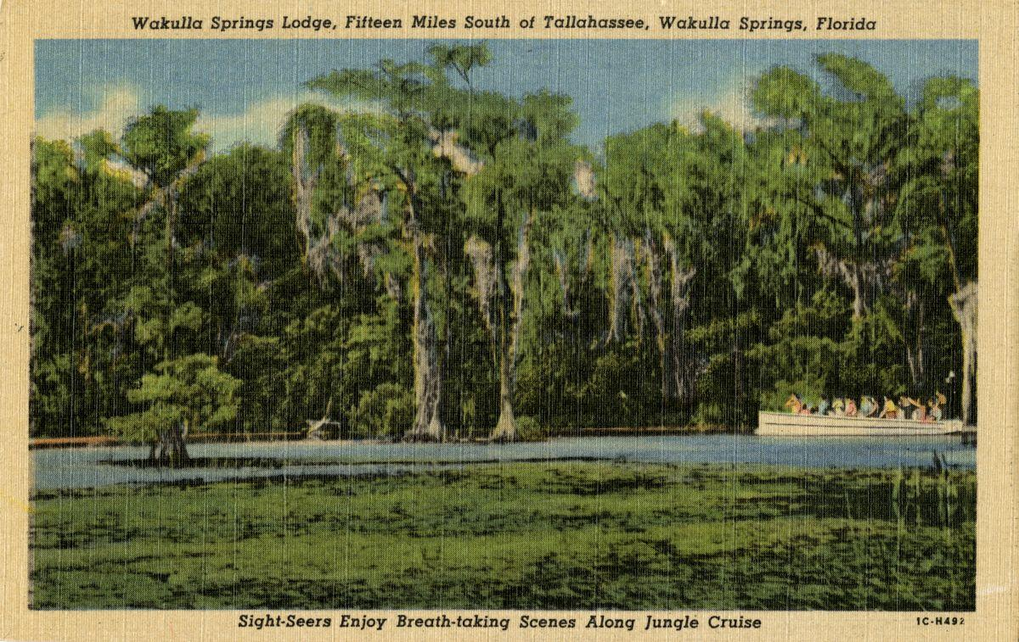

Date: Friday, January 26, 2024

Time: 09:00 AM – 11:00 PM

Location of Meeting Zoom Only

Zoom link <https://us06web.zoom.us/j/89786667803>

**2024 WSA Annual Meeting**- convened

**9:00   Opening of WSA annual Meeting and determination of Quorum (20 members) by Secretary**

**9:05 WSA Board Member Nominating Committee Report –15 min** Albert Gregory & Tom Taylor- In preparation for the annual meeting elections on January 26, 2024. 15 Maximum Members Seven Elected in 2023 **(See Attached WSA By-Laws Article VI)** 2024 Nominees 2 Yr. Terms Expiring 2026- Albert Gregory, Jim Davis, Brian Lupiani, Debbie Lightsey, Gail Fishman, Howard Kessler (Current board Members), Don Axelrad, Renee Muray, (Nominated new Board Members **See attached background docs for Axelrad & Murray)**

. Nominations from the floor and Vote by members in good standing to approve nominees and nominations from the membership.

**9:20 WSA Annual Financial report**- Jim Davis **[attached] 5 min**

**Board of Directors Meeting**

**9:25    Opening WSA Board**

∙       **Welcome and introductions** – Anthony Gaudio

∙       **Agenda review** – Anthony Gaudio

**9.30 Minutes of December 1, 2023 WSA Board meeting**- Brian Lupiani **[attached] 5 min**

**9:35 Nominating Committee Executive Committee Nominations. 5 min** WSA Officers nominees Anthony Gaudio Chair, Vice Chair Chad Hansen. Secretary Brian Lupiani, Treasurer Jim Davis. Nominations from the floor and vote on Nominees by Board

**9:40 Special Considerations for Gas Stations in Commercial Zoning Workgroup -** A Gaudio **10 Min** Executive Committee plus Chad Hanson and Debbie Lightsey

**9:50 WSA Status of Land Swap for SW Ga Oil property Report** Albert Gregory

**10 Min** Adam Bass update

**10:00 Bio-Char Presentation – Bud Chiles 20min** Will discuss how Bio-Char is a replacement for fossil fuel and livestock manure fertilizers to promote CO2 reduction and ground water protection. **U Tube Video link**. [An ancient soil-enriching technique could help decarbonise modern griculture | FT Food Revolution - YouTube](https://www.youtube.com/watch?v=IR0BXeNdhQs)

**10:20 Q&A on Bio-Char 5 min**

**10:25 Update Wakulla County Board of County Commission Actions** Mike Keys **10 Min**

Springs protection and Drinking Water Ordinance Workshops

**10:35 WSA becoming a member of the Wakulla County Economic Development Council Cost $75** 15 **min**– A Gaudio Discussion and Vote [Wakulla Economic Development Council (wakullaedc.com)](https://www.wakullaedc.com/)

**10:50 Expansion of Springs Protection Zone** **Workgroup Report**– **10 Min** Chad Hansen WSA to promote petition campaign to put on the WC 2024 ballot

**11:00 Spring shed and river update -**Cal Jamison **10 Min** Hybrid Boat at Park **[attached]**

**11:10**: **Work group to coordinate WSA’s efforts to have WC hold the workshops Report.** Kelie Keys to report **10 min**

**11:20 Other Topics: 10 Min**

1. Membership second reminder for 2024, sent 1/24/24 with membership drive request to affiliate non-members – All memberships received after Nov1,2023, will be considered for 2024
2. February 23, 2024 WSA meeting Format?
3. FDEP $4.942mil For Golf Course RIBS wastewater system **[attached]**

**Upcoming meetings and events**– 4th Friday of the month in 2024, Formats and locations yet to be determined for those dates from 08:45 - 12:30:

**11:30 Adjourn**

Appendix B

**1-26-24 WAKULLA SPRINGS ALLIANCE**

**Annual General Membership Meeting Participants**

Zoom-only meeting

Officers

Anthony Gaudio, Chair

Michael Keys, Vice-Chair

Brian Lupiani, Secretary

Directors

Bob Deyle

Gail Fishman   
Rob Gelhardt

Albert Gregory

Chad Hanson

Cal Jamison

Tom Taylor

Members and Guests

Don Axelrad

Linda Chaisson

Grant Gelhardt, Florida Sierra Club

Mark Heidecker

Renee Murray

Johnny Richardson, Leon Co. Public Works

Jim Stevenson, Florida Springs Council, WSA Emeritus

Sophie Wacongne-Spear

Edgar Wade, Leon Co. Public Works

“Elizabeth”

Directors Not In Attendance: Jim Davis, Howard Kessler, Debbie Lightsey, Lindsay Stevens

Appendix C

**1-26-24 WAKULLA SPRINGS ALLIANCE Board Meeting Participants**

Zoom-only meeting

Officers

Anthony Gaudio, Chair

Chad Hanson, Vice-Chair

Brian Lupiani, Secretary

Directors

Don Axelrad

Bob Deyle

Gail Fishman   
Rob Gelhardt

Albert Gregory

Cal Jamison

Michael Keys

Renee Murray

Tom Taylor

Members and Guests

Linda Chaisson

Bud Chiles

Gil Damon

Grant Gelhardt, Florida Sierra Club

Mark Heidecker

Johnny Richardson, Leon Co. Public Works

Jim Stevenson, Florida Springs Council, WSA Emeritus

Sophie Wacongne-Spear

Edgar Wade, Leon Co. Public Works

“Elizabeth”

Directors Not In Attendance: Jim Davis, Howard Kessler, Debbie Lightsey, Lindsay Stevens

Appendix D

|  |  |
| --- | --- |
| **WAKULLA SPRINGS ALLIANCE** |  |
| **FINANCIAL REPORT** |  |
| **FOR THE YEAR ENDED DECEMBER 31, 2023** |  |
|  |  |
| **INCOME** |  |
| Donations | $ - |
| Memberships | 2905.00 |
|  | 2905.00 |
|  |  |
| **EXPENSES** |  |
| Data Processing Related | 272.81 |
| Printing | 17.24 |
| Florida Corporate Annual Report | 61.25 |
| Big Bend Environmental Forum | - |
| PayPal Fees | 80.37 |
| Earl Bacon Agency - Insurance | 1,132.78 |
|  | 1,564.45 |
|  |  |
| **SURPLUS/(DEFICIT)** | 1340.55 |
|  |  |
| **BANK BALANCE - 12/31/2022** | 9,299.81 |
| **PAYPAL BALANCE - 12/31/2022** | 643.61 |
| **TOTAL - 12/31/2022** | 9,943.42 |
|  |  |
| **BANK BALANCE -12/31/2023** | 9,709.26 |
| **PAYPAL BALANCE-12/31/2023** | 1,574.71. |
| **TOTAL 12/31/2023** | **$ 11,283.97** |
|  |  |
|  |  |
| **NOTE: Annual Membership dues collection** |  |
| **for the upcoming year started in November** |  |