**Wakulla Springs Alliance**

**Board of Directors Meeting**

Friday, March 22, 2024

9:00 AM – 11:00 AM

Location: Zoom Only

Zoom link <https://us06web.zoom.us/j/89786667803>

Recording (with transcript!) available at

<https://us06web.zoom.us/rec/component-page?action=viewdetailpage&sharelevel=meeting&useWhichPasswd=meeting&clusterId=us06&componentName=need-password&meetingId=IfcGBbBB_C1DRHov99mtIwpu9EFJQuBw0YCQ5rxUGS3aXFE8L88yPk2Jhe2_HV_4.MleSRuL8JFigOwko&originRequestUrl=https%3A%2F%2Fus06web.zoom.us%2Frec%2Fshare%2FJMB6ziIGsFKEdedCi9N9sBE8wcqHsSqSMDDw0zMJzPYA10ipd83vj4s8tVTkyB_Y.uuFZ5zTKd1oatOvI%3Fiet%3DvV716j6S-uhYy6jeY11O16Nxwlv4AOU1HaTOY-aMGFo.AG.hx_HWMKR0OKhcMNww1WF3qgRDo4xFx3okL5UWLoBUM8f72sxYP2BvL0tIgFlQeITaTiiY21j-41IurPgk4I3QZu4Nso1GSIK0_uKGbrf_5dUfSANkmJfzPFQHM9joPGY.D8xRc4CnBK_A-3E7otu_lw.14peuAixj_4qqCeV>

Passcode: 6jcmn.x7

**9:03 Meeting called to order** by Anthony Gaudio (at 00:29:20 in recording), a quorum of Board members being present.

**Welcome and introductions** – Anthony

**Agenda review** – Anthony

**9:06 Minutes of February 23, 2024 WSA Board meeting** - Brian Lupiani

Albert Gregory **moved to accept the minutes**; seconded by Brian Lupiani and **passed without opposition.**

**9:08 Financial report** - Jim Davis (Appendix C)

Brian Lupiani **moved to accept the report**; seconded by Debbie Lightsey and **passed without opposition.**

**9:10 Proposal to Change WSA Ecological Restoration Goal –** Bob Deyle, Proposal to change the WSA Ecological Restoration Goal as proposed by the WSA Workgroup (Bob Deyle, Brian Lupiani, Cal Jamison, Jim Stevenson, Chad Hanson, and Anthony Gaudio ex-officio).

**Current, from** WSA Website: “The Wakulla Springs Alliance goal for the ecological restoration of the Wakulla Spring and River is to restore the aquatic flora and fauna and water clarity to its condition at state acquisition in 1986. This includes the same relative abundance and diversity of aquatic plants, fishes, reptiles, and birds inhabiting the spring and river within the state park.”

**Workgroup’s proposal:** “The Wakulla Springs Alliance goal for managing the Wakulla Spring and River is to enhance and maintain an ecosystem that is resilient to the impacts of natural and human-caused disturbances.”

NOTE: The proposed change is a report from a committee, which is considered a motion and does not require a second if voted on as proposed. However, after a bit of group editing, the language was changed to the following and voted on using the motion-and-second procedure.

**Revised proposal:** “The Wakulla Springs Alliance promotes and supports managing the Wakulla Spring basin to enhance and maintain the Wakulla Spring and River ecosystem so that it is resilient to the impacts of natural and human-caused disturbances.”

**9:40** Bob Deyle **moved to adopt the revised proposed language**; seconded by Debbie Lightsey and **passed without opposition.**

**9:45 Q&A & Discussion Ecological Restoration Target Action Steps**

Anthony proposes that a workgroup be created to develop action steps needed to fulfill our ecological restoration goal/purpose; the steps will become part of WSA’s strategic plan.

Initially, the workgroup will consist of Bob Deyle, Gail Fishman, Chad Hanson, Tom Taylor, and Anthony Gaudio ex-officio. Tom will set up the first meeting. The target for making a presentation is the May 24 Board meeting.

**9:55 Special Considerations for Gas Stations in Commercial Zoning Workgroup Update** - Chad Hanson

9:50 Chad posted in chat:

“Special considerations for gas stations is already approved and finalized by the WC BOCC. Gas station proposals (i.e., site plans) are now required to go to the Planning Commission for approval for a "Conditional Use". There is expected to be a Wawa gas station proposal (just north of Walmart on 319) at the April 8 Planning Commission meeting but I do not have specific details or documents at this time. Chuck Hess may be able to fill in any additional details.”

Renee: “Thanks Chad, we still have the issue of what tools the Planning Commission can use for the "consideration" Do you have any additional information on this concern?”

Chad replied that he hadn’t been provided any further info yet. He thinks there’ll be requirements for the applicant to look into connections to cave systems and karst features on the property, but he’s not aware of any standards at this point.

Chuck Hess said the special consideration process doesn’t require more information, but cave systems are supposed to be added to the file used by the planning commission.

**10:00 WSA Status of Land Swap for SW GA Oil property Report** -Renee

Murray

There was a meeting yesterday with SW Georgia Oil CEO, attorneys, and a civil engineer. Renee, Albert, Anthony and Mike were there along with Gil Damon, Tom Greenhouse(?) and Adam Bass from Conservation FL. It was civil and respectful. SW GA wants to use underground tanks, we’re pushing for above. They said they’ll do what we want. We’ll see. Mike pointed out that SW GA’s lawyer essentially said that if they do above ground tanks and anything goes wrong, it’s our fault.

SW GA didn’t provide any paperwork or supporting documentation. Renee felt that some of the information they provided was misleading at best. Another meeting is scheduled for April 12.   
  
Adam Bass requested that our organizations send a letter to the Governor in support of the allocation of funds for the land swap.

**10:15** Tom Taylor **moved that the Executive Committee send a letter to the Governor** to approve the allocation, and ask other groups if they want to sign on to it. Albert will draft the letter. seconded by Brian Lupiani and **passed without opposition.**

**10:20  Update on Wakulla County BoCC Springs Protection Ordinance Workshops** - Kellie Keys,WCBOCC Liaison For Workshops with Wakulla Environmental Groups for Springs protection and Drinking Water Ordinance Workshops

Kellie’s traveling so Mike presented her update. The County Administrator requested that we work together ahead of the workshop to craft the ordinance, using Kellie as a liaison between the County and the environmental groups so that by the time of a workshop we have all parties in general agreement.

(So then what’s the purpose of the workshop if it’s not to craft the ordinance?)

County Admin Dave Edwards seems to understand there’s a need for an updated ordinance, but sees the conflict in springs protection versus higher density, particularly Crawfordville.

After about 30 minutes of discussion, Anthony proposed that Kellie along with Anna Garner and the rest of the committee that drew up the Citizens’ Ordinance review it and modify it as they see fit, to use as a starting point with the County. We can request that they make a presentation to us in April or May.

**10:55 Spring shed and river update -**Cal Jamison

Water depth at the tour boat dock had been over 5 feet (above sea level) for months. It didn’t seem to be driven by rainfall, and has now dropped below 5 feet. Visibility has been variable; we’re now at about 40 feet. There were 2 very high spikes in total color in November and December, the darkest Sean has ever recorded, and there’s no explanation yet. Nitrates are at about.46; the BMAP goal is .35.

WKPP is still looking for openings between Wakulla Spring and Spring Creek. They’re taking advantage of the clear water to do extensive mapping of the Sullivan Saint(?) cave system as well as Sherlock Springs (formerly Indian Springs).

**11:05 Other Topics:**

1. **April 26 WSA Board meeting** Zoom - BMAP update with Moira Homan
2. **May 24 WSA Board meeting** Zoom - Strategic plan with Tom and Gail
3. **Bob Thompson offers to post weekly wildlife data and photos on WSA website**
4. Announcements

Cal - TLH History Festival tomorrow at Kleman Plaza, Friends of WS will have a table

Albert - SW GA Oil attorney Charles Gardner just sent an email to the group that met yesterday saying they will do above ground storage tanks.

**11:10 Adjourn** moved by Brian, seconded by Gail, no opposition

Appendix A

Agenda, Wakulla Springs Alliance April Board Meeting, 3/22/2024**[See Attached Doc]** 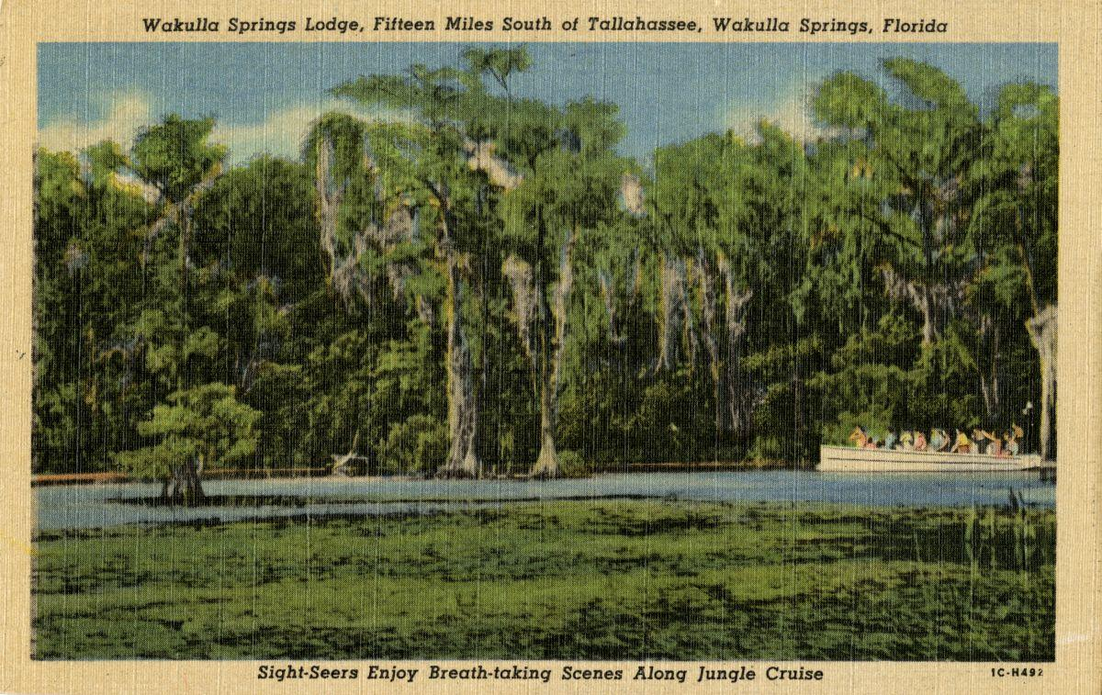

Date: Friday, March 22, 2024

Time: 09:00 AM – 11:00 PM

Location of Meeting Zoom Only

Zoom link <https://us06web.zoom.us/j/89786667803>

Board of Directors Meeting

**9:10    Opening WSA Board**

•       **Welcome and introductions** – Anthony Gaudio

•       **Agenda review** – Anthony Gaudio

**9:20 Financial report**- Jim Davis **[attached] 5 min**

**9.25 Minutes of February 23, 2024 WSA Board meeting**- Brian Lupiani **[attached] 5 min**

**9:25 Special Considerations for Gas Stations in Commercial Zoning Workgroup Update 10 Min** Chad Hanson

**9:35 WSA Status of Land Swap for SW Ga Oil property Report** Renne Murray

**10 Min** Adam Bass Conservation Fl update

**9:45 Proposal to Change WSA Ecological Restoration Goal. 20 min –**Bob Deyle, Proposal to change the WSA Ecological Restoration Goal as proposed by the WSA Workgroup Bob Deyle, Brian Lupiani, Cal Jamison, Jim Stevenson, Chad Hansen.

**From** WSA Website “The Wakulla Springs Alliance goal for the ecological restoration of the Wakulla Spring and River is to restore the aquatic flora and fauna and water clarity to its condition at state acquisition in 1986. This includes the same relative abundance and diversity of aquatic plants, fishes, reptiles, and birds inhabiting the spring and river within the state park.”

**To:** The Wakulla Springs Alliance goal for managing the Wakulla Spring and River is to enhance and maintain an ecosystem that is resilient to the impacts of natural and human-caused disturbances.

**10:05 Proposed Change to our Website concerning Ecological Restoration 5 Min –** Bob Deyle – Vote by Board

**10:10 Q&A & Discussion Ecological Restoration Target Action Steps 25min**

After taking action on the proposal, discussion of possible objectives and actions. That the workgroup agreed are some possible objectives and associated actions. Here are a few examples that were discussed:

·        Attain the nitrate TMDL

·        Restore native SAV populations

o   Collaborate with the NWFWMD etc. to assess potential restoration initiatives

**10:35 Update Wakulla County Board of County Commission Springs Protection Ordinance Workshops** Kellie KeysWCBOCC Liasson For Workshops with Wakulla Environmental Groups for Springs protection and Drinking Water Ordinance Workshops **10 Min**

**10:45 Spring shed and river update -**Cal Jamison **10 Min**

**10:55 Other Topics: 5 Min**

1. April 26 WSA meeting Format Zoom with BMAP update with Moira Homan
2. **Bob Thompson offers to post weekly wildlife data and photos on WSA website**
3. Announcements

**Upcoming meetings and events**– 4th Friday of the month

Reservations have been made for use of the conference room at the Renaissance Center for every month in 2024 Formats and locations yet to be determined for those dates from 08:45 - 12:30:

**11:00 Adjourn**

Appendix B

**March 22, 2024 WAKULLA SPRINGS ALLIANCE**

**Board Meeting Participants**

Zoom-only meeting

Officers

Anthony Gaudio, Chair

Chad Hanson, Vice-Chair

Brian Lupiani, Secretary

Directors

Don Axelrad

Jim Davis

Bob Deyle

Gail Fishman

Albert Gregory

Cal Jamison

Mike Keys

Debbie Lightsey

Renee Murray

Lindsay Stevens

Tom Taylor

Members and Guests

Kathleen Coates, NWFWMD

Mark Heidecker, City of Tallahassee

Chuck Hess, Wakulla County Commissioner

Tom Jacobs, Sierra Club

Anna Padilla, Leon Co. Public Works

“Elizabeth”

“toothmanw”

Directors Not In Attendance: Rob Gelhardt, Howard Kessler

Appendix C

|  |  |  |
| --- | --- | --- |
| **WAKULLA SPRINGS ALLIANCE** |  |  |
| **FINANCIAL REPORT** |  |  |
| **FOR THE 2 MONTHS ENDED FEBRUARY 29, 2024** |  |  |
|  |  |  |
| **INCOME** |  |  |
| Donations | $ - |  |
| Memberships | 735.00 |  |
|  | 735.00 |  |
|  |  |  |
| **EXPENSES** |  |  |
| Data Processing Related | - |  |
| Printing | - |  |
| Florida Corporate Annual Report | - |  |
| Big Bend Environmental Forum | - |  |
| PayPal Fees | 33.04 |  |
| Earl Bacon Agency - Insurance | - |  |
|  | 33.04 |  |
|  |  |  |
| **SURPLUS/(DEFICIT)** | 701.96 |  |
|  |  |  |
| **BANK BALANCE - 12/31/2023** | 9,709.26 |  |
| **PAYPAL BALANCE - 12/31/2023** | 1,574.71 |  |
| **TOTAL - 12/31/2023** | 11,283.97 |  |
|  |  |  |
| **BANK BALANCE - 2/29/2024** | 9,909.26 |  |
| **PAYPAL BALANCE - 2/29/2024** | 2,076.67 |  |
| **TOTAL 2/29/2024** | **$ 11,985.93** |  |
|  |  |  |