**Wakulla Springs Alliance**

**Board of Directors Meeting**

**Friday, May 24, 2024**

9:00 AM – 11:00 AM

Location: Zoom Only

Zoom link <https://us06web.zoom.us/j/89786667803>

Recording (with transcript!) available at

<https://us06web.zoom.us/rec/share/Ba6FRrYHicQq8qqOZDFDfbifxx6wZUT6F6n1jVgK77eTEUdqlKBN3x2m3nyp1Cjm.vxmDf_rHVIKW_Pzi>

Passcode: V9zYY!S4

Thanks as always to Tom Taylor for his thorough notes!

**9:06 Meeting called to order** by Anthony Gaudio (at 00:51 in recording)

**Welcome and introductions** – Anthony

**Agenda review** – Anthony

**9:08 Financial report** - Jim Davis (Appendix C)

Tom **moved to accept the report**; seconded by Don and **passed without opposition.**

**9:10 Minutes of March 22, 2024 WSA Board meeting** - Brian Lupiani

Renee **moved to accept the minutes**; seconded by Brian and **passed without opposition.**

**9:12  WSA Status of Land Swap for SW Ga Oil property Report** - Renee Murray

(00:57)

Our working group sent our recommendation to SW Georgia Oil in April but

they haven’t responded.

We also haven’t heard anything from Conservation FL about Gov DeSantis signing the appropriation. Renee and the group will consider the next steps.

**9:15 Update of WSA Strategic Plan** – Tom Taylor & Gail Fishman (01:00)

WSA Strategic Plan Update with interactive discussion

<https://docs.google.com/document/d/1fUeXuM0DL0eHWG_7K4_FEyePC0RbdZUPEfAow7iPEs4/edit?usp=sharing>

* Tom Taylor provided an overview of the strategic plan.
* The group discussed, identified leads/supporters and began to prioritize goals
* The top priority was Goal 5, Public Education and Advocacy. There were suggested next steps and Anthony Gaudio will convene a group to refine the strategy that will be considered at a future WSA meeting.
* Suggestions and volunteers are indicated in **bold** in the [WSA Strategic Plan Google Doc](https://docs.google.com/document/d/1fUeXuM0DL0eHWG_7K4_FEyePC0RbdZUPEfAow7iPEs4/edit?usp=sharing)
* Everyone was encouraged to provide more input on the goals and actions, including volunteering to lead or support activities.

(9:30ish Gail joined the meeting)

In Chat at 01:38 in the recording, Mark posted:

“<https://www.youtube.com/watch?v=WwIjXJ4RIaA>

That's the latest springs related PSA but all of our PSAs are here: <https://tappwater.org/videos>”

**10:00  Special Considerations for Gas Stations in Commercial Zoning Workgroup Update** - Chad Hanson (01:45)

* There are 2 gas stations going in. One is at Mack’s Meats, near the corner of Shadeville and Spring Creek, It’s right near the cave system. It was approved before the conditional use ordinance went into effect. They had the zoning required.
* There were emails about this.
* There will be a site plan review that may be an opportunity to get changes but not challenge the location.
* The other station has karst windows to an unmapped cave system and is connected to the aquifer. Near E. Ivan / Posey and Wakulla Arran traffic circle.

(10:00ish Debbie joined the meeting)

**10:10 Update Wakulla County Board of County Commission Springs Protection Ordinance Workshops** - Kellie Keys (01:53)

* Kellie Keys is theWCBOCC Liaison For Workshops with Wakulla Environmental Groups for Springs Protection and Drinking Water Ordinance Workshops provided the report.
* Workshop date not set, possibly in July
* We keep looking for some agreement even if we don’t get everything we want.
* Staff has become more aware of the cave system and the dynamics of the aquifer and springs.
* We want to have goals ready
* Somer Pell has separated the tree and spring ordinances. She understands that ground cover is important for springs but it’s too much to put in one ordinance. (There’ll be a workshop on the tree ordinance in June - the 13th, Kellie thinks.
* The boundaries for the springs’ protection zone need to be expanded. It could complicate the Crawfordville town plan which can have separate provisions. One possibility would be to expand the zone but leave Crawfordville out of it to allow for higher density where it makes sense, like to encourage the use of sewer.

In Chat at 02:02 in the recording, Chad posted:

“Wakulla springs protection zone currently with the Crawfordville Town center (ie Urban Core) area shown in PFA#2”

* Gas station regulations have been pre-empted by the state. Gas stations are now conditional uses.

In Chat at 02:06 in the recording, Renee posted:

“Kelly, I thought that the county can require additional requirements for Wakulla springs protection zone for gas stations. If a developer wants a gas station in a defined protection zone, they know that addental requirements would be required.”

* We could have conditional use requirements for other hazardous wastes like oil change place and drycleaners.
* Zones could be rewritten to give more protection.
* We could ban water withdrawal for commercial use elsewhere.
* We may get provisions “considering” cave systems.
* BOCC supports a fertilizer education campaign but not a ban. May ban on public land in the summer, rainy months.
* We can do a resolution of concern about micro plastics.
* Wastewater disposal needs to be considered so we have recharge of cleaned water.
* Q – Why the thought that there will a problem with the PFA in town plan?   
  A – We need to look at the language of the PFA and town plan. Chuck Hess can ask David Edwards where the problem is. We need to put new housing on sewer.

In Chat at 02:10 in the recording, Debbie posted:

“There are other ancillary problems that come with additional density....stormwater runoff, fertilizer, tree removal, etc”

* C – We can ask staff about the problem and change the SPA ordinance to address the concerns.
* C - The quantity issue should address the whole BMAP area, not just the SPA.
* C - There is an issue of buffers for cave systems nearby.
* C – The BOCC can create guidelines for gas stations regarding caves that the planning commission can weigh in a way that does not trigger state pre-emption. A – There can be provisions with prohibitions at the county level.
* C – The WSA drafted a proposed ordinance that can be refined by the working group.

A – We need to consider the feasibility of passage. The state may object and BOCC may be opposed.

* C – We can have revised recommendations that are doable. Have realistic goals.
* C – The workshop can clarify what the state and BOCC input.

Renee will contact Anna Garner to reconvene the workgroup for the July workshop. Debbie Lightsey will join the group and help with editing. Chad Hanson will join too, and they’ll work with Kellie.

**10:40 Spring shed and river update -**Cal Jamison (02:27)

* Rainfall is 10” over normal at the TLH airport.
* All streams’ flows and swamps are high.
* Secchi reading (visibility) at the spring boil was 20’ 6” yesterday
* Water is dark, some manatees and a gator in the swimming and dock area.
* Nitrate levels about .45.
* There is a for sale sign near Mill and Lost creeks confluence. There is a residence and 23 acres for $90000

**10:45 Other Topics** (02:33)

There will be a memorial / celebration of life for Katy McGlynn tomorrow, May 25 at 12:00 at the Wakulla Springs Lodge

Jun - Aug 2024 WSA meetings will be Zoom only (Renaissance Center conference room is still reserved every month through December)

**10:52 Adjourn** moved by Brian, seconded by Debbie, no opposition (02:37)

APPENDIX A

Agenda, Wakulla Springs Alliance April Board Meeting,

5/24/2024 **[See Attached Doc]** 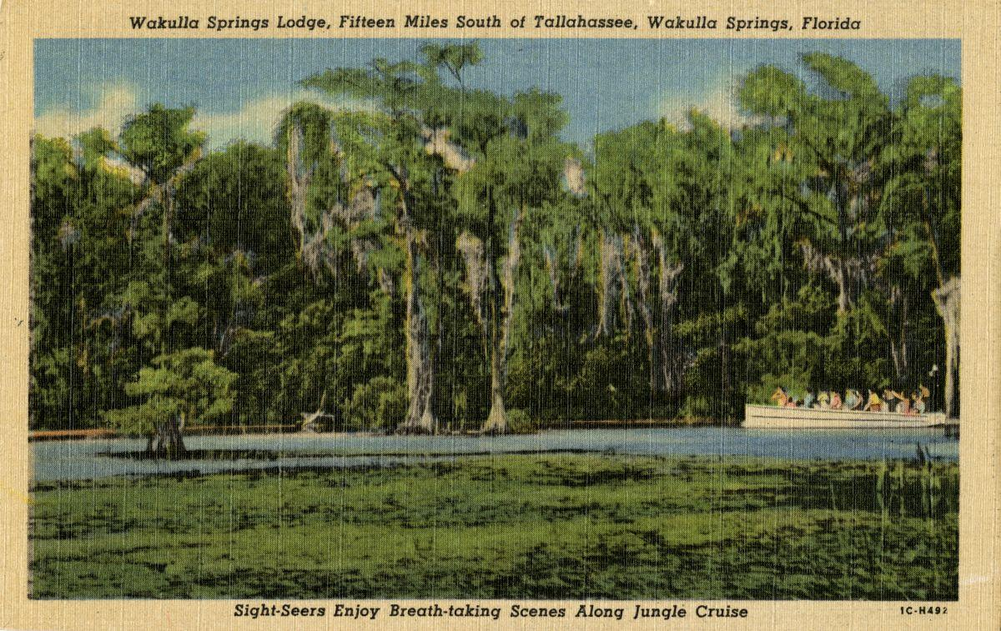

Date: Friday, May 24, 2024

Time: 09:00 AM – 11:00 PM

Location of Meeting Zoom Only

Zoom link <https://us06web.zoom.us/j/89786667803>

Board of Directors Meeting

**9:10    Opening WSA Board**

•       **Welcome and introductions** – Anthony Gaudio

•       **Agenda review** – Anthony Gaudio

**9:20 Financial report**- Jim Davis **[attached] 5 min**

**9.25 Minutes of April 26, 2024 WSA Board meeting**- Brian Lupiani **[attached] 5 min**

**9:30 WSA Status of Land Swap for SW Ga Oil property Report** Renne Murray

**10 Min** Adam Bass Conservation Fl update

**9:40 Update of WSA Strategic Plan – Tom Taylor & Gail Fishman 30 Min** WSA Strategic Plan Update with interactive discussion

<https://docs.google.com/document/d/1fUeXuM0DL0eHWG_7K4_FEyePC0RbdZUPEfAow7iPEs4/edit?usp=sharing>

* Discuss, identify leads/supporters and prioritize goals
* Review and prioritize actions, suggest next steps and responsibilities for the priority goal.
* Request more input on the rest of the goals.

**10:10 Special Considerations for Gas Stations in Commercial Zoning Workgroup Update 10 Min**

**10:20 Update Wakulla County Board of County Commission Springs Protection Ordinance Workshops** Kellie KeysWCBOCC Liasson For Workshops with Wakulla Environmental Groups for Springs protection and Drinking Water Ordinance Workshops **10 Min**

**10:30 Spring shed and river update -**Cal Jamison **10 Min**

**10:40 Other Topics: 5 Min**

1. June 28 WSA meeting Format Zoom or in person?
2. Announcements

**Upcoming meetings and events**– 4th Friday of the month

Reservations have been made for use of the conference room at the Renaissance Center for every month in 2024 Formats and locations yet to be determined for those dates from 08:45 - 12:30:

**10:45Adjourn**

APPENDIX B

**May 24, 2024 WAKULLA SPRINGS ALLIANCE**

**Board Meeting Participants**

Zoom-only meeting

Officers

Anthony Gaudio, Chair

Chad Hanson, Vice-Chair

Brian Lupiani, Secretary

Directors

Don Axelrad

Gail Fishman

Cal Jamison

Mike Keys

Debbie Lightsey

Renee Murray

Tom Taylor

Members and Guests

Sue Damon

Mark Heidecker, City of Tallahassee

Chuck Hess, Wakulla County BoCC

Kellie Keys, Wakulla Co. Soil & Water Cons District / Liaison btwn Co and Env groups

Edgar Wade, Leon Co. Public Works

Directors Not In Attendance:, Jim Davis, Bob Deyle, Rob Gelhardt, Albert Gregory, Howard Kessler, Lindsay Stevens

APPENDIX C

|  |  |
| --- | --- |
| **WAKULLA SPRINGS ALLIANCE** |  |
| **FINANCIAL REPORT** |  |
| **FOR THE 4 MONTHS ENDED APRIL 30, 2024** |  |
|  |  |
| **INCOME** |  |
| **Donations** | $ - |
| Memberships | 855.00 |
|  | 855.00 |
|  |  |
| **EXPENSES** |  |
| Data Processing Related | - |
| Printing | - |
| Florida Corporate Annual Report | 61.25 |
| Big Bend Environmental Forum | - |
| PayPal Fees | 52.49 |
| Earl Bacon Agency - Insurance | 1,138.50 |
|  | 1,252.24 |
|  |  |
| **SURPLUS/(DEFICIT)** | (397.24) |
|  |  |
| **BANK BALANCE - 12/31/2023** | 9,709.26 |
| **PAYPAL BALANCE - 12/31/2023** | 1,574.71 |
| **TOTAL - 12/31/2023** | 11,283.97 |
|  |  |
| **BANK BALANCE - 4/30/2024** | 10,847.93 |
| **PAYPAL BALANCE -4/30/2024** | 38.80 |
| **TOTAL 4/30/2024** | **$ 10,886.73** |
|  |  |
|  |  |