**Wakulla Springs Alliance**

**Minutes of Board of Directors Meeting**

**Friday, November 22, 2024**

9:00 AM – 11:00 AM

Location: **Zoom Only**

Zoom link <https://us06web.zoom.us/j/89786667803>

Recording (with transcript - and now with Summary and Smart Chapters!) available at

<https://mail.yahoo.com/d/search/keyword=gaudio/messages/AMTtDjsf0VETZ0C1RQnfWHqlM7o?reason=invalid_cred#:~:text=Passcode%3A%200!gUBwsB-,Watch%20now,-Recording%20Summary>

Passcode: 0!gUBwsB

**9:05 Meeting called to order** by Anthony Gaudio (00:43 in recording)

**Welcome and introductions** – Anthony Gaudio (Appendix B, attendance)

**Agenda review and changes** – Anthony Gaudio (Appendix A)

**9:10 Financial report**- Jim Davis (Appendix C)

**Gail Fishman moved to accept the report**; seconded by **Bob Deyle** and **passed without opposition.**

**9:12 Minutes of October 2024 WSA Board meeting** - Brian Lupiani (Appendix E)

**Renee Murray moved to approve the minutes**; seconded by **Gail Fishman** and **passed without opposition.**

**9:13 Bob Deyle Presentation the WSSP wildlife survey data title Crayfish Predator Dynamics in an Evolving Detrital Food Web: The Upper Wakulla River Ecosystem 2012-2024** (00:50 in recording)

Thanks to Tom Taylor for these notes on Bob’s presentation:

* History of hydrilla management, mechanical, 2002 herbicides and manatees.
* Herbicides killed SAV and matts swept away SAV too.
* Algae grew back faster.
* This altered the food web.
* This changed habitat. 1967 show eel grass.
* 2013-2024 SAV trends over 7 transects show stable levels of Algae, bare sediment, hydrilla and Vallisneria. Sagittaria is increasing.
* Critter count 2000 to 2012 and 2012-2022 has been decreasing. 2022-2024 has been stable.
* A table showed species levels by hydrilla management periods.
* Pie-Billed Grebe counts went down in 2023-2024. This may be related to die-off of the bulrush matts and plants in the area around the boat dock.
* Bulrush island was from dredging in 2016. Most of the bulrushes are gone now. It may be from salinity spikes.
* There was a die-off of knot weed and water hemlock in May 2021 and May 2022. This was happening down the river. It was only in the Wakulla river and may be from a discharge of herbicides.
* The species that have increased include hooded merganser, alligator, cormorant, yellow-crowned night heron, cattle egret and white ibis. There are fewer bass, gar and other fish.
* Cormorants feed in a larger area and have a large nesting area down river.
* White Ibis numbers up in 2024.
* Hooded Merganser eat crayfish are here in the winter.
* A graph showed the numbers of species that feed on crayfish and statistics that confirm the correlation.
* The change from eel grass to algae may affect crayfish. Crayfish affected by 2012 herbicide and oxygen levels from dying vegetation.
* Policy needs? A We need more fish. Cal reports seeing more fish. Bob saw more snails last week.
* What about a fish survey? Bob discussed this with Dana Bryant. FWC could do this using the baseline from the past.
* There was a recent fish survey of a variety of species. Cal has observed that fish are coming back because of habitat that has come back. There are more macroinvertebrate’s and a small plant that provide habitats for the micro invertebrates. There is a slight increase in water levels.
* BMAP impact? Higher nitrate level increases algae. The SAV and critter levels may be more about recovery from herbicides.

**10:15  WSA Strategy Session for Springs Protection Ordinance** - Chad Hansen

(01:53 in recording)

Nothing to update except that Kellie Keys has met with the 2 new Wakulla

County Commissioners, **Valerie Russell** and **Josh Lawhorn**.

Chad plans to set up WSA meetings with the commissioners after Thanksgiving.

**10:20 Nominating Committee Report** - Albert Gregory, Brian, & Anthony

(Appendix D) (01:57 in recording)

Still need 2 more Board Members and Chair and Secretary volunteers. Anthony agrees to Treasurer and Chad Vice-Chair. Tom is a potential Sect if no one steps up.

**10:23 Update Wakulla County Board of County Commission Springs Protection**

**Ordinance Workshops** - Kellie Keys,WCBOCC Liaison For Workshops with

Wakulla Environmental Groups for Springs protection and Drinking Water

Ordinance Workshops (02:00 in recording)

Nothing to update (Kellie not present). On hold until WSA reps meet with new County Commissioners Valerie Russell and Josh Lawhorn.

**10:24 WSA Status of Land Swap for SW Ga Oil property Report** - Renne Murray

Nothing to update, until the new year.

**10:25 Springshed and river update -**Cal Jamison (02:02 in recording)

A 1977 Datsun 200SX was extracted from Donahue sinkhole after 40+ years.

Cal made a YouTube video: <https://www.youtube.com/watch?v=7OM9j9LpYE4>

This aired on WTXL TV: <https://www.wtxl.com/crawfordville/decades-old-car-removed-from-sinkhole-to-protect-wakulla-springs>

WTXL’s Kenzie Krueger also had this report on the water observation team:

<https://www.wtxl.com/news/local-news/researchers-test-water-quality-at-wakulla-springs>

At Wakulla Spring, visibility was up to nearly 80 feet, which was quite rare, before the hurricane. Since then, it’s topped out at less than 30.

Plenty of manatees, including young ones.

Last month a few Board members went on the water observation tour to measure visibility, dissolved oxygen and other data.

**10:50 Other Topics**

1. January 24, 2025 Board Meeting WSA Board meeting Zoom only, No December meeting. Election of Officers and induction of new members
2. Dues notices have been sent to current members and WSA Affiliates for 2025 Dues. All dues received after Nov 1 of 2024 count towards 2025. Only dues paying members can vote in elections.
3. Announcements

**10:55 Adjourn** (02:31 in recording)

Brian made the motion to adjourn, seconded by Cal and passed without

opposition.

NOTE: According to our AI overlord at Zoom, these are our Next Steps

**1. Chad to organize a call with Kelly, Renee, and Anthony to regroup on outreach to new commissioners.**

**2. Chad to reach out to new commissioners Valerie Russell and Josh Lawhorn.**

**3. Anthony to send out another notice to members about updating their membership for 2025.**

**4. Nominating committee to continue seeking 2 more board members.**

**5. Board members to consider potential candidates for the chair position.**

**6. Bob to reach out to Albert about potentially serving as chair again.**

**7. Cal to follow up with Lance (park manager) about potentially displaying the removed car near the Admin Building at Wakulla Springs.**

**8. Cal to follow up with Sergeant McLeod about the car's VIN number.**

**9. Friends of Wakulla Springs to work with 850 Media Productions on creating a documentary about the car removal and water quality.**

**10. Board members to update their membership for 2025 via the website.**

**11. Anthony to prepare for the January 24th board meeting, including elections and induction of new members.**

**12. Cal to continue monitoring and reporting on spring and river conditions.**

**13. Board to consider ideas for future fish and crayfish surveys in the river.**

**14. Members to review the WTXL news videos about the car removal and water testing shared in the chat.**

APPENDIX A

Agenda, Wakulla Springs Alliance Board Meeting,

November 22, 2024 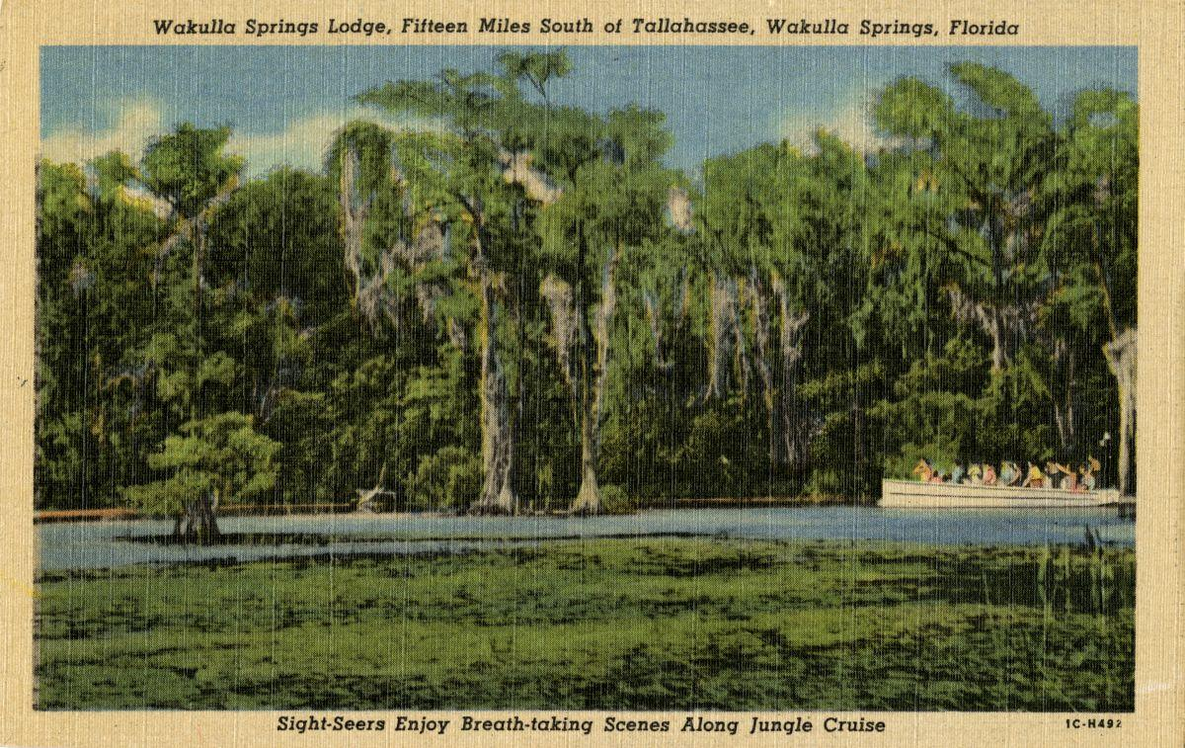

Date: Friday, **November 22 , 2024**

Time: 09:00 AM – 11:00 AM

Location of Meeting **Zoom Only**

Zoom link <https://us06web.zoom.us/j/89786667803>

Board of Directors Meeting

**9:00    Opening WSA Board**

•       **Welcome and introductions** – Anthony Gaudio

•       **Agenda review** – Anthony Gaudio

**9:10 Financial report**- Jim Davis **[attached] 5 min**

**9.15 Minutes of October 25, 2024 WSA Board meeting**- Brian Lupiani **[attached] 5 min**

9:20 **Bob Deyle** Presentation the WSSP wildlife survey data **title Crayfish Predator Dynamics in an Evolving Detrital Food Web: The Upper Wakulla River Ecosystem 2012-2024**

**Q&A 30 min**

**9:50 WSA Strategy Session for Springs Protection Ordinance** Chad Hansen, Last Summer WSA and other Environmental Groups submitted a Citizens Springs Protection Ordinance. WSA’s plan for input to workshop **20 Min**

**10:10 Nominating Committee Report Albert Gregory, Brian, & Anthony. 10 Min Still need 2 more Board Members and Chair and Secretary volunteers. Gaudio agrees to Treasurer and Hansen Vice-Chair**

**10:20 Update Wakulla County Board of County Commission Springs Protection Ordinance Workshops** Kellie KeysWCBOCC Liasson For Workshops with Wakulla Environmental Groups for Springs protection and Drinking Water Ordinance Workshops **10**

**10:30 WSA Status of Land Swap for SW Ga Oil property Report** Renne Murray

From Adam Bass Conservation FL update concerning site plan and Saint Joe Paper Company issues. $3.7 Mil approved in budget. **10 Min**

**10:40 Springshed and river update -**Cal Jamison **15 Min**

**10:55 Other Topics: 5 Min**,

1. January 24, 2025 Board Meeting WSA Board meeting Zoom only, No December meeting. Election of Officers induction of new members
2. Dues notices have been sent to current members and WSA Affiliates for 2025 Dues. All dues received after Nov 1 of 2024 count towards 2025. Only dues paying members can vote in elections.
3. Announcements

**Upcoming meetings and events**– 4th Friday of the month

Reservations have been made for use of the conference room at the Renaissance Center for every month in 2024 Formats and locations yet to be determined for those dates from 08:45 - 12:30:

**10:55 Adjourn**

APPENDIX B

**November 22, 2024, WAKULLA SPRINGS ALLIANCE**

**Board Meeting Participants**

Zoom Only meeting

Officers

Anthony Gaudio, Chair

Chad Hanson, Vice Chair

Brian Lupiani, Secretary

Directors

Bob Deyle

Gail Fishman

Cal Jamison

Renee Murray

Tom Taylor

Members and Guests

Bentley

Big Bend Coastal Conservancy

Jim Crozier

Dave Dubose

Tom Jacobs, Sierra Club

Harris Krasner

Anna Padilla, Leon County

Tony Murray

Johnny Richardson

Courtney Schoen

Paul Thurman

Joel Trexler, FSU Marine Lab

Sophie Wacongne-Speer, Friends of Lake Jackson

Edgar Wade, Leon County

Directors Not In Attendance: Jim Davis, Rob Gelhardt, Albert Gregory, Howard Kessler, Mike Keys, Debbie Lightsey, Lindsay Stevens

APPENDIX C

|  |  |
| --- | --- |
| **WAKULLA SPRINGS ALLIANCE** |  |
| **FINANCIAL REPORT** |  |
| **FOR THE 10 MONTHS ENDED OCTOBER 31, 2024** |  |
|  |  |
| **INCOME** |  |
| **Donations** | $ - |
| Memberships | 1,170.00 |
|  | 1,170.00 |
|  |  |
| **EXPENSES** |  |
| Sponorship | 200.00 |
| Meeting Costs | 150.00 |
| Florida Corporate Annual Report | 61.25 |
| Big Bend Environmental Forum | 100.00 |
| Fees | 184.98 |
| Earl Bacon Agency - Insurance | 1,138.50 |
|  | 1,834.73 |
|  |  |
| **SURPLUS/(DEFICIT)** | (664.73) |
|  |  |
| **BANK BALANCE - 12/31/2023** | 9,409.26 |
| **PAYPAL BALANCE - 12/31/2023** | 1,574.71 |
| **TOTAL - 12/31/2023** | 10,983.97 |
|  |  |
| **BANK BALANCE -10/31/2024** | 10,319.24 |
| **PAYPAL BALANCE 10/31/2024** | - |
| **TOTAL 10/31/2024** | **$ 10,319.24** |

APPENDIX D

Nominating Committee Board Terms 2024

|  |  |  |  |  |  |  |  |  |
| --- | --- | --- | --- | --- | --- | --- | --- | --- |
|  |  | Elected |  |  |  |  | Agrees to Continue |  |
|  |  | 2022 | 2023 | 2024 |  |  | 2025 |  |
| Anthony Gaudio | agaudio49@gmail.com |  | x |  | 2335 Grassroots Way TLH 32311 | 850-528-6350 | Yes | 1 |
| Bob Deyle | rdeyle@fsu.edu |  | x |  | 2394 Carefree Cove TLH 32308 | 850-443-6657 | yes | 2 |
| Brian Lupiani | brianlupiani@yahoo.com | x |  |  | 607 McDaniel St, TLH 32303 | 850-273-1028 |  |  |
| Cal Jamison | caljamison@msn.com |  | x |  | 465 Park Dr Crawfordvile 32327 | 850-509-4814 | yes | 3 |
| Chad Hanson | chad.hanson@embarqmail.com |  | x |  |  | 850-491-4754 | yes | 4 |
| Debbie Lightsey | deblite2016@gmail.com | x |  | x | 2340 Cypress Cove Dr. TLH 32310 | 850-567-7160 |  |  |
| Gail Fishman | grtener@gmail.com | x |  | x | 1507 Kolopakin Nene, TLH 32301 | 850-545-6196 |  |  |
| Howard Kessler | annhow@embarqmail.com | x |  | x | 408 Plantation Rd. TLH 32303 | 850-597-3856 |  |  |
| Jim Davis | jim@jimdaviscpa.com | x |  | x | 1733 Old Plank Rd. Crawfordville 32327 | 850-445-5878 |  |  |
| Lindsay Stevens | lindsay.stevens@TNC.ORG |  | x |  | 3122 Mahan Dr Ste 801 box 239 32308-2502 | 850-408-8286 | no |  |
| Rob Gelhardt | rob@gelhardt.com; |  | x |  | 902 Brookwood Drive, TLH 32308 | 850-877-6185 | no |  |
| Tom Taylor | ttaylor@fsu.edu |  | x |  | 1053 Myers Park Dr. TLH 32301 | 850-933-9444 | yes | 5 |
| Renee Murray | murrayclan87@gmail.com |  |  | x | 87 Walker Creek Dr Crawfordville 32327 | 850-524-1955 |  |  |
| Donald Axelrad | daxe@comcast.net |  |  | x | resigned |  |  |  |
|  |  |  |  |  |  |  |  |  |
| Peter Salco |  |  |  |  |  |  | ? |  |
| **Beau Simon** | (954)-515-7284 |  |  |  | balexandersimon@gmail.com |  | yes | 6 |

APPENDIX E

Minutes of Oct 25 WSA Board meeting, approved at Nov 22 meeting

**Wakulla Springs Alliance**

**Minutes of Board of Directors Meeting**

**Friday, October 25, 2024**

9:00 AM – 11:00 AM

Location: **In-person Only**

**Wakulla County Community Center**

**317 Shadeville Road 32327**

**Thanks to Tom Taylor for writing these minutes!**

**Meeting called to order** by Anthony Gaudio

**Opening WSA Board**

**Welcome and introductions** – Anthony Gaudio (Appendix B, attendance)

**Agenda review and changes** – Anthony Gaudio (Appendix A)

**Financial report**- Jim Davis (Appendix C)

**Brian Lupiani moved to accept the report**; seconded by Bob Deyle and **passed without opposition.**

**Minutes of September 2024 (postponed to Oct 4) WSA Board meeting** -

Brian Lupiani (Appendix D)

**Bob Deyle moved to approve the minutes**; seconded by Brian and **passed without opposition.**

**Anna Padilla update Leon County Comprehensive Wastewater Management**

**Plan implementation**

* Plan submitted to DEP.
* Phases 2 and 3 will be done in the next 10 years.
* The BMAP is based on the projected N reductions not the actual ones.
* The recent levels are .4 to .45 recently.
* Contractor still completing files on properties in county and recommended technologies. People can go online and see what is recommended for their properties.
* Have upgrade subsidies for upgrading up to $7000. Wakulla is paying $8000. We can do 300 and have had 350 applications.
* State is enforcing upgrades.
* There are 2 installers doing most of these and a total of 5.
* They are worried about INRB systems failing. Homeowners needed education about properly using the systems. They are trying to do more education.
* The systems with liners and micro-dosing have to be approved and none have been installed or tested.
* ATU or NF245 systems require regular inspections and maintenance.
* People are choosing the INRB because of the cost $800 out of pocket and other are $4-5000. LC just recommends seeing the DOH website.
* LC paid $13000 for INRB.
* A separate $1.5 m upgrade program and they are extending testing on them. Anthony will check on the status.
* We can ask Kelly Keys and FSU to include more monitoring of systems that have been installed. It would be up to the homeowners. DEP used to do the monitoring for the performance-based systems. DEP monitored 8 sites and only 3 were not compromised by user error.
* Performance-based systems have only worked when there were RME
* They were doing 2 being tested. It is designed for 400 gpd and one had 1000 gpd and other very low. People resisted being monitored.
* The county could provide incentives for monitoring. Monitoring can avoid wasting money on systems that don’t work.
* Property buyers need to be notified of (???)

**WSA Strategy Session for Springs Protection Ordinance -** Renee Murray

Last Summer WSA and other Environmental Groups submitted a Citizens Springs Protection Ordinance. WSA’s plan for input to workshop

* Renee, Kelly and Chad met and everything is on hold until the new commission is installed.
* There will be an educational effort with new commissioners and then workshops and advocacy for the ordinance. The sampling group may take commissioners out. Other emissaries can meet with them.
* Need to have an incremental approach to actions to protect the spring and drinking water wells.

**WSA Status of Land Swap for SW Ga Oil property Report -** Renne Murray

From Adam Bass Conservation FL update concerning site plan and Saint Joe Paper Company issues. $3.7 Mil approved in budget.

* The sale may be the first of the year. Conservation FL will purchase from St Joe for $3.4 m. Conservation FL will get their fee and title.
* This doesn’t include the 7 acre that will be a swap for up to 35 acres across Hwy 267. SW GA could have a retirement home and commercial center.
* There is a question of above or below ground tanks and distance from the cave system.
* Renee said that they need to get back to us with a revised proposal.

**Big Bend Environmental Forum BBEF 8/6** - Brian Lupiani WSA representative

* Brian and Tom Taylor were there and had a table with Sophie and Friends of Lake Jackson.
* It was disappointing how uninformed some of the candidates were.
* We need to do a better job of educating them in the future.

**Springshed and river update -**Cal Jamison

* The end of September the clarity was near 80’ then the hurricane came and it was 9’ the next week it was 13’ and then more.
* 10-12 manatees followed the sampling boat around
* Anyone is invited to go on a tour after the meeting.
* Leg appropriation of $500,000 to FSU. Cal is doing additional monitoring for this.
* FOWS is having a Cars and Karst show coming up. Cal has identified a sink with a car in it and is working with a wrecking company and dive team, including Frank. They will use balloons to help get it up. The newspaper and channel 27 may cover it. It will be at the car show.
* Rich Abrams bought the Sherlock Spring property (formerly Camp Indian Springs) and supports sampling and joint projects. He plans to donate it to the State when he dies. He has a venue for weddings and events. He is not using the cabins. The water quality is very good.

**Kill the Drill**

* Downriver Project is following the oil drilling in the Apalachicola basin and mobilized massive letter writing.
* Riverkeepers has filed an administrative hearing appeal.
* Riverkeepers, Sierra and others are building pressure on DEP.
* Website “Kill the Drill” has a banner with 15+ organizations that support this. We are looking for more supporters and giving out yard signs. We have an email list of 32,000.
* Brian made a motion to join in opposing drilling in the Apalachicola basin. It was seconded and passed without opposition.

**Other Topics:**

* November 22 WSA Board meeting Zoom only,
* We need a nominating committee for chair, vice-chair, secretary and treasurer. Albert, Anthony and Brian will be on the nominating committee.
* Bob Deyle will have an update on the wildlife status in January.
* Albert Gregory asked for an early morning boat ride. Cal Jamison will talk to the park manager.

**Upcoming meetings and events**– 4th Friday of the month

Reservations have been made for use of the conference room at the Renaissance Center for every month in 2024 Format, location, and date are yet to be determined for the December meeting.

**Adjourn**

Brian made the motion to adjourn, seconded by Renee and passed without

opposition.

APPENDIX A

Agenda, Wakulla Springs Alliance Board Meeting,

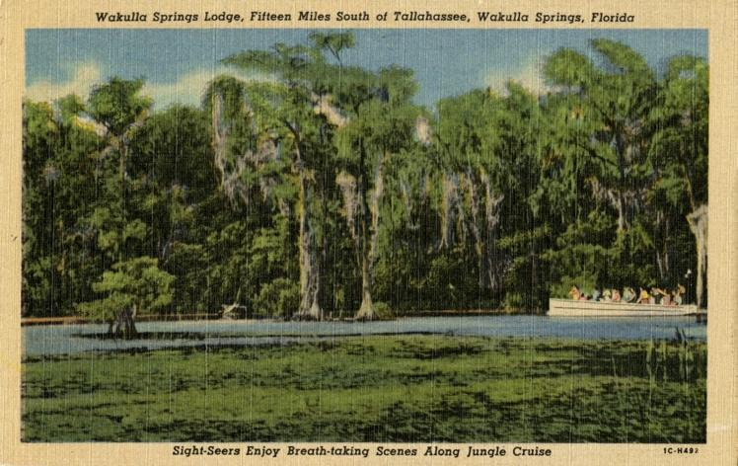

Date: Friday, **October 25 2024,**

Time: 09:00 AM – 11:00 AM

Location of Meeting **In Person Only**

**Wakulla County Community Center**

**317 Shadeville Road 32327**

**9:00    Opening WSA Board**

•       **Welcome and introductions** – Anthony Gaudio

•       **Agenda review** – Anthony Gaudio

**9:10Financial report**- Jim Davis **[attached] 5 min**

**9.15 Minutes of October 4, 2024, WSA Board meeting**- Brian Lupiani **[attached] 5 min**

**9:20 Anna Padilla update Leon County Comprehensive Wastewater Management Plan implementation 20 Min, Q&A 10 min**

**9:50 WSA Strategy Session for Springs Protection Ordinance** Chad Hansen, Last Summer WSA and other Environmental Groups submitted a Citizens Springs Protection Ordinance. WSA’s plan for input to workshop **20 Min**

**10:10 Update Wakulla County Board of County Commission Springs Protection Ordinance Workshops** Kellie KeysWCBOCC Liasson For Workshops with Wakulla Environmental Groups for Springs protection and Drinking Water Ordinance Workshops **10**

**10:20 WSA Status of Land Swap for SW Ga Oil property Report** Renne Murray

From Adam Bass Conservation FL update concerning site plan and Saint Joe Paper Company issues. $3.7 Mil approved in budget. **10 Min**

**10:30 Big Bend Environmental Forum BBEF 8/6** Brian Lupiani WSA representative **10 Min**

**10:40 Springshed and river update -**Cal Jamison **10 Min**

**10:50 Other Topics: 5 Min**,

1. November 22 WSA Board meeting Zoom only,
2. Announcements

**Upcoming meetings and events**– 4th Friday of the month

Reservations have been made for use of the conference room at the Renaissance Center for every month in 2024 Formats and locations yet to be determined for those dates from 08:45 - 12:30:

**10:55 Adjourn**

APPENDIX B

**October 25, 2024, WAKULLA SPRINGS ALLIANCE**

**Board Meeting Participants**

In-person Only meeting

Officers

Anthony Gaudio, Chair

Brian Lupiani, Secretary

Directors

Bob Deyle

Cal Jamison

Albert Gregory

Renee Murray

Tom Taylor

Members and Guests

Gil Damon, Downriver Project

Sophie Wacongne-Speer, Friends of Lake Jackson

Edgar Wade, Leon County

Chris Brown

Tom Jacobs

Wayne Toothman, Leon County

Anna Padilla, Leon County

Directors Not In Attendance: Jim Davis, Rob Gelhardt, Chad Hanson, Howard Kessler, Mike Keys, Debbie Lightsey, Lindsay Stevens

APPENDIX C

|  |  |  |
| --- | --- | --- |
| **WAKULLA SPRINGS ALLIANCE** |  |  |
| **FINANCIAL REPORT** |  |  |
| **FOR THE 9 MONTHS ENDED SEPTEMBER 30, 2024** |  |  |
|  |  |  |
| **INCOME** |  |  |
| **Donations** | $ - |  |
| Memberships | 1,130.00 |  |
|  | 1,130.00 |  |
|  |  |  |
| **EXPENSES** |  |  |
| Sponsorship | 200.00 |  |
| Printing | - |  |
| Florida Corporate Annual Report | 61.25 |  |
| Big Bend Environmental Forum | 100.00 |  |
| PayPal Fees | 66.21 |  |
| Earl Bacon Agency - Insurance | 1,138.50 |  |
|  | 1,565.96 |  |
|  |  |  |
| **SURPLUS/(DEFICIT)** | (435.96) |  |
|  |  |  |
| **BANK BALANCE - 12/31/2023** | 9,409.26 |  |
| **PAYPAL BALANCE - 12/31/2023** | 1,574.71 |  |
| **TOTAL - 12/31/2023** | 10,983.97 |  |
|  |  |  |
| **BANK BALANCE -9/30/2024** | 10,548.01 |  |
| **PAYPAL BALANCE -9/30/2024** | - |  |
| **TOTAL 9/30/2024** | **$ 10,548.01** |  |
|  |  |  |

APPENDIX D

[Minutes of October 4, 2024 WSA Board meeting, approved at Oct 25 meeting]