**Wakulla Springs Alliance**

**Minutes of Board of Directors Meeting**

**Friday, October 25, 2024**

9:00 AM – 11:00 AM

Location: **In-person Only**

**Wakulla County Community Center**

**317 Shadeville Road 32327**

**Thanks to Tom Taylor for writing these minutes!**

**Meeting called to order** by Anthony Gaudio

**Opening WSA Board**

**Welcome and introductions** – Anthony Gaudio (Appendix B, attendance)

**Agenda review and changes** – Anthony Gaudio (Appendix A)

**Financial report**- Jim Davis (Appendix C)

**Brian Lupiani moved to accept the report**; seconded by Bob Deyle and **passed without opposition.**

**Minutes of September 2024 (postponed to Oct 4) WSA Board meeting** -

Brian Lupiani (Appendix D)

**Bob Deyle moved to approve the minutes**; seconded by Brian and **passed without opposition.**

**Anna Padilla update Leon County Comprehensive Wastewater Management**

**Plan implementation**

* Plan submitted to DEP.
* Phases 2 and 3 will be done in the next 10 years.
* The BMAP is based on the projected N reductions not the actual ones.
* The recent levels are .4 to .45 recently.
* Contractor still completing files on properties in county and recommended technologies. People can go online and see what is recommended for their properties.
* Have upgrade subsidies for upgrading up to $7000. Wakulla is paying $8000. We can do 300 and have had 350 applications.
* State is enforcing upgrades.
* There are 2 installers doing most of these and a total of 5.
* They are worried about INRB systems failing. Homeowners needed education about properly using the systems. They are trying to do more education.
* The systems with liners and micro-dosing have to be approved and none have been installed or tested.
* ATU or NF245 systems require regular inspections and maintenance.
* People are choosing the INRB because of the cost $800 out of pocket and other are $4-5000. LC just recommends seeing the DOH website.
* LC paid $13000 for INRB.
* A separate $1.5 m upgrade program and they are extending testing on them. Anthony will check on the status.
* We can ask Kelly Keys and FSU to include more monitoring of systems that have been installed. It would be up to the homeowners. DEP used to do the monitoring for the performance-based systems. DEP monitored 8 sites and only 3 were not compromised by user error.
* Performance-based systems have only worked when there were RME
* They were doing 2 being tested. It is designed for 400 gpd and one had 1000 gpd and other very low. People resisted being monitored.
* The county could provide incentives for monitoring. Monitoring can avoid wasting money on systems that don’t work.
* Property buyers need to be notified of (???)

**WSA Strategy Session for Springs Protection Ordinance -** Renee Murray

Last Summer WSA and other Environmental Groups submitted a Citizens Springs Protection Ordinance. WSA’s plan for input to workshop

* Renee, Kelly and Chad met and everything is on hold until the new commission is installed.
* There will be an educational effort with new commissioners and then workshops and advocacy for the ordinance. The sampling group may take commissioners out. Other emissaries can meet with them.
* Need to have an incremental approach to actions to protect the spring and drinking water wells.

**WSA Status of Land Swap for SW Ga Oil property Report -** Renne Murray

From Adam Bass Conservation FL update concerning site plan and Saint Joe Paper Company issues. $3.7 Mil approved in budget.

* The sale may be the first of the year. Conservation FL will purchase from St Joe for $3.4 m. Conservation FL will get their fee and title.
* This doesn’t include the 7 acre that will be a swap for up to 35 acres across Hwy 267. SW GA could have a retirement home and commercial center.
* There is a question of above or below ground tanks and distance from the cave system.
* Renee said that they need to get back to us with a revised proposal.

**Big Bend Environmental Forum BBEF 8/6** - Brian Lupiani WSA representative

* Brian and Tom Taylor were there and had a table with Sophie and Friends of Lake Jackson.
* It was disappointing how uninformed some of the candidates were.
* We need to do a better job of educating them in the future.

**Springshed and river update -**Cal Jamison

* The end of September the clarity was near 80’ then the hurricane came and it was 9’ the next week it was 13’ and then more.
* 10-12 manatees followed the sampling boat around
* Anyone is invited to go on a tour after the meeting.
* Leg appropriation of $500,000 to FSU. Cal is doing additional monitoring for this.
* FOWS is having a Cars and Karst show coming up. Cal has identified a sink with a car in it and is working with a wrecking company and dive team, including Frank. They will use balloons to help get it up. The newspaper and channel 27 may cover it. It will be at the car show.
* Rich Abrams bought the Sherlock Spring property (formerly Camp Indian Springs) and supports sampling and joint projects. He plans to donate it to the State when he dies. He has a venue for weddings and events. He is not using the cabins. The water quality is very good.

**Kill the Drill**

* Downriver Project is following the oil drilling in the Apalachicola basin and mobilized massive letter writing.
* Riverkeepers has filed an administrative hearing appeal.
* Riverkeepers, Sierra and others are building pressure on DEP.
* Website “Kill the Drill” has a banner with 15+ organizations that support this. We are looking for more supporters and giving out yard signs. We have an email list of 32,000.
* Brian made a motion to join in opposing drilling in the Apalachicola basin. It was seconded and passed without opposition.

**Other Topics:**

* November 22 WSA Board meeting Zoom only,
* We need a nominating committee for chair, vice-chair, secretary and treasurer. Albert, Anthony and Brian will be on the nominating committee.
* Bob Deyle will have an update on the wildlife status in January.
* Albert Gregory asked for an early morning boat ride. Cal Jamison will talk to the park manager.

**Upcoming meetings and events**– 4th Friday of the month

Reservations have been made for use of the conference room at the Renaissance Center for every month in 2024 Format, location, and date are yet to be determined for the December meeting.

**Adjourn**

Brian made the motion to adjourn, seconded by Renee and passed without

opposition.

APPENDIX A

Agenda, Wakulla Springs Alliance Board Meeting,

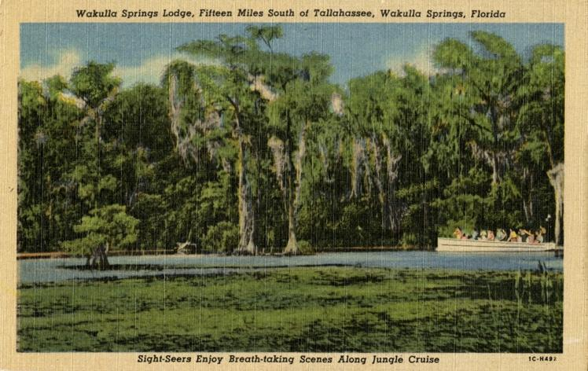

Date: Friday, **October 25 2024,**

Time: 09:00 AM – 11:00 AM

Location of Meeting **In Person Only**

**Wakulla County Community Center**

**317 Shadeville Road 32327**

**9:00    Opening WSA Board**

•       **Welcome and introductions** – Anthony Gaudio

•       **Agenda review** – Anthony Gaudio

**9:10Financial report**- Jim Davis **[attached] 5 min**

**9.15 Minutes of October 4, 2024, WSA Board meeting**- Brian Lupiani **[attached] 5 min**

**9:20 Anna Padilla update Leon County Comprehensive Wastewater Management Plan implementation 20 Min, Q&A 10 min**

**9:50 WSA Strategy Session for Springs Protection Ordinance** Chad Hansen, Last Summer WSA and other Environmental Groups submitted a Citizens Springs Protection Ordinance. WSA’s plan for input to workshop **20 Min**

**10:10 Update Wakulla County Board of County Commission Springs Protection Ordinance Workshops** Kellie KeysWCBOCC Liasson For Workshops with Wakulla Environmental Groups for Springs protection and Drinking Water Ordinance Workshops **10**

**10:20 WSA Status of Land Swap for SW Ga Oil property Report** Renne Murray

From Adam Bass Conservation FL update concerning site plan and Saint Joe Paper Company issues. $3.7 Mil approved in budget. **10 Min**

**10:30 Big Bend Environmental Forum BBEF 8/6** Brian Lupiani WSA representative **10 Min**

**10:40 Springshed and river update -**Cal Jamison **10 Min**

**10:50 Other Topics: 5 Min**,

1. November 22 WSA Board meeting Zoom only,
2. Announcements

**Upcoming meetings and events**– 4th Friday of the month

Reservations have been made for use of the conference room at the Renaissance Center for every month in 2024 Formats and locations yet to be determined for those dates from 08:45 - 12:30:

**10:55 Adjourn**

APPENDIX B

**October 25, 2024, WAKULLA SPRINGS ALLIANCE**

**Board Meeting Participants**

In-person Only meeting

Officers

Anthony Gaudio, Chair

Brian Lupiani, Secretary

Directors

Bob Deyle

Cal Jamison

Albert Gregory

Renee Murray

Tom Taylor

Members and Guests

Gil Damon, Downriver Project

Sophie Wacongne-Speer, Friends of Lake Jackson

Edgar Wade, Leon County

Chris Brown

Tom Jacobs

Wayne Toothman, Leon County

Anna Padilla, Leon County

Directors Not In Attendance: Jim Davis, Rob Gelhardt, Chad Hanson, Howard Kessler, Mike Keys, Debbie Lightsey, Lindsay Stevens

APPENDIX C

|  |  |  |
| --- | --- | --- |
| **WAKULLA SPRINGS ALLIANCE** |  |  |
| **FINANCIAL REPORT** |  |  |
| **FOR THE 9 MONTHS ENDED SEPTEMBER 30, 2024** |  |  |
|  |  |  |
| **INCOME** |  |  |
| **Donations** | $ - |  |
| Memberships | 1,130.00 |  |
|  | 1,130.00 |  |
|  |  |  |
| **EXPENSES** |  |  |
| Sponsorship | 200.00 |  |
| Printing | - |  |
| Florida Corporate Annual Report | 61.25 |  |
| Big Bend Environmental Forum | 100.00 |  |
| PayPal Fees | 66.21 |  |
| Earl Bacon Agency - Insurance | 1,138.50 |  |
|  | 1,565.96 |  |
|  |  |  |
| **SURPLUS/(DEFICIT)** | (435.96) |  |
|  |  |  |
| **BANK BALANCE - 12/31/2023** | 9,409.26 |  |
| **PAYPAL BALANCE - 12/31/2023** | 1,574.71 |  |
| **TOTAL - 12/31/2023** | 10,983.97 |  |
|  |  |  |
| **BANK BALANCE -9/30/2024** | 10,548.01 |  |
| **PAYPAL BALANCE -9/30/2024** | - |  |
| **TOTAL 9/30/2024** | **$ 10,548.01** |  |
|  |  |  |

APPENDIX D

Minutes of Oct 4 WSA Board meeting, approved at Oct 25 meeting

**Wakulla Springs Alliance**

**Minutes of Board of Directors Meeting**

**Friday, October 4, 2024**

(Rescheduled from September 27)

9:00 AM – 11:00 AM

Location: Zoom Only

Zoom link <https://us06web.zoom.us/j/89786667803>

Recording (with transcript - and now with Summary and Smart Chapters!) available at

<https://us06web.zoom.us/rec/share/HAe6ELnzNWAOOvPBzolDyGcDhNhPGd1dwY9FwXcuDyKo9MFBSbLnsHM4XQGY364O.vOZdgbGHmlMuLrzu?iet=3GPfiZogZtOk7j9mQA-1_YvVK69pL1ZxrdUXYAJpNj8.AG.vrc52gJzPA_7j5CxeamhZnN3kRdZDPbNe4M4SA60i0xMqQW4h7CK9vWmRJU8PbDo3eqSUzDUgijF-9IsFUgRdm5kcg9WEvJgPF52B65ZgU2i_CyC5DgbJ_gWaIgAsfIC.mqOIxfyZalvYt_QVsZg81Q.myakaCAULsjrzfsk>

Passcode: YALp4Ea*

**Thanks as always to Tom Taylor for help with the minutes!**

**9:03 Meeting called to order** by Anthony Gaudio (00:33 in recording)

**9:03 Opening WSA Board**

**Welcome and introductions** – Anthony Gaudio (Appendix B)

**Agenda review and changes** – Anthony Gaudio (Appendix A)

1. The Strategy Session for the Ordinance Workshops will immediately follow the Update on the Workshops.
2. Chad has an item about a request from the Wakulla Environmental Institute that will be taken up at the end of the meeting

**9:08 Update on Wakulla County Board of County Commission Springs Protection Ordinance Workshops** - Kellie Keys, WCBOCC Liaison with Wakulla envir groups for workshops for Springs Protection and Drinking Water Ordinances

Kellie pointed out that even after the County Commission approves a new ordinance, it will take months for review and approval by various State and County offices.

The Wakulla County Commission had voted to have a workshop on October 7 but it was canceled due to the storm. Kellie hopes that on the 7th they will reschedule the workshop for the 21st (probably at 3:00). When they do hold their workshop, they’ll likely hold off on any substantive decisions until the newly elected Commission takes office in November. But Kellie believes they can move forward on some items like telling the County communication office to post educational information about fertilizer and pesticides, and passing a non-binding resolution recognizing the growing concern about microplastics and forever chemicals in the water.

**9:12 WSA Strategy Session for Springs Protection Ordinance** - Chad Hanson, Anna Garner

Chad, Kellie, and Renee have been writing a document with a number of code

/ordinance changes for the County to consider. They envision a series of two or more workshops to make the effort more manageable. Issues may include water bottling and water extraction, depending on the State’s preemption. The group intends to come back at WSA’s October meeting or the following one with more specific language. Expanding the Spring Protection Zone will be considered.

Anthony said Anna Garner should be contacted and included if she wants to be involved. Anthony wants to be included in the discussion and possibly more involved. Tom wants in also, and Bob would like to be kept in the loop and contribute if he can.

Renee said since there’ll be a few new County Commissioners* we need to inform them about Wakulla Springs: take them on a tour boat ride, explain where the water comes from and goes, etc., prior to the workshops.  
  
* Valerie Russell is replacing Mike Kemp, and Josh Lahan is replacing Chuck Hess. Anthony will reach out to Ms Russell; Kellie has had contact with Mr Lahan, so she and Anthony will “triangulate” on reaching out to him.

Kellie asked if anyone could provide educational information on fertilizers and pesticides (like bullet points, not a long text) for communications students to use in developing the public awareness campaign for the Wakulla County website. During discussion (at this point in the meeting and also after the report on the SW GA Oil land swap, when Anthony saw that Mark Heidecker had joined the meeting) it was pointed out that Leon County and Tallahassee have a fertilizer ordinance and Tallahassee has the TAPP (Think About Personal Pollution)* program. Mark Heidecker offered to send links, and stated that education is essential. Bob mentioned that Alachua County has a more stringent fertilizer ordinance than Tallahassee and so should have good PR material. *<https://tappwater.org/>

**9:25  Financial report**- Jim Davis (Appendix C) (00:54)

**No report this month due to storm. Few changes since last month; no vote taken.**

**9:26  Minutes of August 23, 2024 WSA Board meeting** - Brian Lupiani (Appendix E)

**Chad moved to accept the minutes**; seconded by Renee &/or Brian and **passed without opposition.**

Brian noted that the minutes now include the approved minutes of the prior month.

**9:30 The DEP Great Outdoors Initiative to Increase Public Access, Recreation**

**and Lodging at Florida State Parks** - Grant Gelhardt, Ryan Smart

Coordinated efforts by environmental groups to prevent the implementation of this initiative

Grant apparently missed the notice that this meeting had been postponed; he logged in last week but isn’t here today.

Gil Damon said he’s not as deeply involved as last month when he discussed the proposal, but he knows that DEP pulled it back, possibly to try again next year. Gil thinks that a scaled-back plan with pickleball and disc golf may be the result. And although the plan that became public involved 9 parks, 19 were apparently targeted for “improvements”, including Maclay Gardens.

Anthony said the Florida Springs Council is mobilized for the issue.

Bob said a Facebook group had been created: Florida State Park Guardians.

**9:35 Status of Land Swap for SW Ga Oil property** - Renee Murray (01:02)

Renee said Adam Bass of Conservation FL texted her about 3 weeks ago saying that he expected to have a “final” (final that they’ll present to us) site plan from SW GA Oil within a week, but she’s heard nothing since. She reached out to him earlier this week, but no response yet. They (Cons FL?) are pushing to have the land purchase with St Joe well on its way by the first of the year. Conservation FL is the lead on the land purchase.

**9:40 BMAP Update** - Tom Taylor report on DEP BMAP update for Wakulla Springs held on Sept. 23, 2024 (01:06)

* There was a PPT and small group discussion. See the synopsis.
* People shared and discussed information.
* There has been a lot of progress on the charts.
* It shows Wakulla has achieved 100% of goals. Chad said this is misleading because there is still a lot to do to meet the 15 years goals and that they have not factored in new development or loss of trees.
* They are accepting comments with final draft in spring and adoption in the summer.
* Growth is improperly addressed in the BMAP based on the assumption that this will be addressed by all new development being on sewer or advanced treatment septic systems. Treatment is not 100% reduction; growth also means increased nitrogen loading due to increased use of fertilizer.
* FSC lawsuits addressed this. We need to ask Ryan Smart about this.
* BMAPs have limited value.
* Q - Does the BMAP address withdrawal? A – No. This is addressed by Minimum Flows and Levels by the NWFWMD. The flows are higher, possibly because of Spring Creek reversals. Load not concentration is key. The TMDL is a measure of concentration, not load.
* Concentrations at the spring are not being reduced.
* Wakulla County is doing monitoring that needs to be considered.

**Tom made a motion that Anthony convene a committee to draft comments, before the next WSA Board meeting, on the BMAP update to submit on behalf of WSA. Bob seconded**, and **the motion passed without opposition.**

Anthony, Cal, Chad, and Tom will serve on the committee.

**9:55 Big Bend Environmental Forum (BBEF)** - Brian Lupiani WSA rep (01:25)

The forum for the November election will be Oct 17 at the Public Library. Brian will be out of town at the Springs Summit and unable to table the WSA table. Anthony and Tom will crew the table. Setup is at 4:45, meet and greet with the candidates at 5:15, and the forum runs from 6:00 to 8:00.

**10:00 Sponsorship of FL Springs Council Oct 19 Springs Summit** - Brian Lupiani   
 Approval of $200 expenditure for sponsorship.

Brian said that he’s going to attend, though not as a representative for WSA. He **moved that WSA spend $200 to be a non-profit sponsor of the Summit.** **Cal seconded**, and during discussion **Chad suggested amending** the motion to say that **Brian would be a representative of WSA and be reimbursed up to $100 for his expenses.** Brian agreed that it was a (very) friendly amendment and Cal accepted it as well. **The motion passed without opposition.**

Bob suggested that Brian by the WSA’s representative to the FL Springs Council if they still have regular meetings. Brian agreed to do it unless someone more qualified was interested.

**10:10** Approval of new logo (see Attachment 1)

Coincident with WSA sponsorship of the FSC Springs Summit, we can submit a logo to be printed on the event’s t-shirts (and possibly other recognition). Attachment 1 is a proposed logo created by Anthony’s daughter Carrie Gaudio. Cal was concerned about the center of the design being a bit busy, and also asked what the big hurry was about. Discussion led to an almost-consensus that the logo could be tweaked before final approval, but due to the deadline for the Springs Summit the current design could be approved as a temporary logo.

**Renee moved that we adopt the current design as our logo. Brian seconded**, and during discussion **Anthony suggested a friendly amendment** to say that **we accept the logo with a change so that the large central swoop doesn’t look like a “J”.** Renee and Brian accepted that change. After more discussion, Anthony restated the motion: **Accept this design as a temporary logo, with changing the color of the thing that looks like a “J”. A proposed final design will be presented at the October meeting.**  **The motion passed 6 - 1.**

**10:15 Spring shed and river update -**Cal Jamison (01:45)

* Before hurricane, visibility was 80’ for several weeks rather than 5’ to 7’
* The flow has really increased and the color is really dark now.
* The water level increased over 6 feet. The concentration is reduced because of the flow.
* The nitrogen is over 4.5 which is higher than what the BMAP is reporting.
* Good wildlife counts this week.
* Sinkhole survey found a car and Cal is working on getting the Ford Galaxy 500 out. The Sheriff may help get it out as an exercise. A diver will help assess the situation.

**10:25 Wakulla Environmental Institute Water Quality Monitoring** (01:57)

Tallahassee State College’s Wakulla Environmental Institute is submitting a proposal for an EPA water quality program. They’re asking us to submit a letter of support for it. **Chad moved that WSA endorse the WEI initiative and send a letter of support. Brian seconded**, and **the motion passed without opposition.**

**10:30 Other Topics and Announcements** (02:03)

**October 25 meeting will be in person** at The Wakulla Springs Park Administration Offices Meeting Room

*“At the recently held meeting of the International Geological Congress in Busan, South Korea, it was announced that Wakulla Spring was chosen by the International Union of Geological Sciences to be included in the “Second 100 International Geological Heritage Sites”.  This is a really big deal.  Some of the other designated sites in the U.S. include Yosemite Valley, Devil’s Tower, and the Great Salt Lake.  Wakulla Spring is in pretty good company.”* From Harley Means (See Attachments 2, 3, and 4).

**Upcoming meetings and events**– 4th Friday of the month

Reservations have been made for use of the conference room at the Renaissance Center for every month in 2024. Formats, locations, and dates are yet to be determined for this year’s remaining meetings.

**10:36 Adjourn** moved by Brian, seconded by Cal, no opposition (02:06)

ATTACHMENT 1

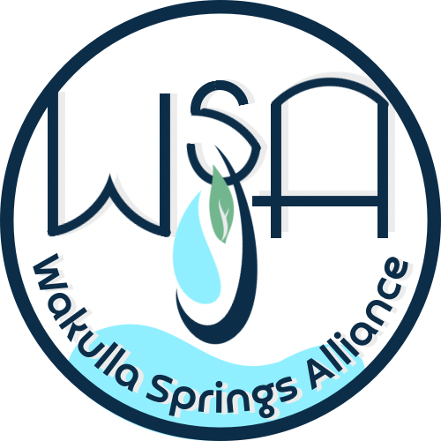

ATTACHMENT 2



**The International Union of Geological Sciences (IUGS) announced the list of The Second 100 IUGS Geological Heritage Sites at the 37th International Geological Congress (IGC) in Busan, Republic of Korea.**

**The announcement was made by IUGS President John Ludden, Stanley Finney, IUGS Secretary General, and Asier Hilario chair of the International Commission on Geoheritage on August 27th during an special event of the 37th International Geological Congress.**

**More than 700 experts from 80 nations and 16 international organizations participated in this global endeavor, which consolidates the recognition of geological heritage by the IUGS.**

**More information:** [**www.iugs-geoheritage.org**](http://www.iugs-geoheritage.org)(available from August 26)

The announcement of the Second 100 IUGS Geological Heritage Sites was one of the main events of the second day of the 37th International Geological Congress (IGC). IGC is the main conference related to Earth Sciences, it is sponsored by and is the scientific forum of the IUGS. Every four years the IGC brings together an important part of the geological community from all over the world.

The announcement of the Second 100 IUGS Geological Heritage Sites consolidates this global initiative that started with the announcement of “The First 100” during the IUGS 60th anniversary event in 2022 in Zumaia (Basque Coast, Spain). The main goal of this collaborative program led by the IUGS is to give the highest recognition to those sites that are essential for the geological sciences.

The Second 100 IUGS Geological Heritage Sites, as with the First 100, receive IUGS recognition because they are the highest scientific value. They are the world’s best demonstrations of geologic features and processes. They are the sites of fabulous discoveries of the Earth and its history. They are sites that served to develop the science of geology. They are located worldwide, and they are geologically diverse. Recognition and visibility of the “Second 100” by IUGS can lead to their further appreciation, to their use as educational resources, and, most importantly, to their preservation.

The final selection of the “Second 100” was ratified by the IUGS Executive Committee on February 21, 2024. The Second 100 Geological Heritage Sites are distributed in 53 countries and represent nine disciplines. The list of the “Second 100” is attached.

“The Second 100” as well as the “First 100” are attractively illustrated and described in a coffee table book than can be downloaded and purchased on the website of the International Commission on Geoheritage. [www.iugs-geoheritage.org](http://www.iugs-geoheritage.org).

In Busan, Republic of Korea

2024. August 27th

The International Union of Geological Sciences

Contact for more information:

**Dr. Asier Hilario** / flysch@gipuzkoa.eus

Chair – IUGS International Commission on Geoheritage

APPENDIX A

Agenda, Wakulla Springs Alliance September Board Meeting, Rescheduled, October 4 2024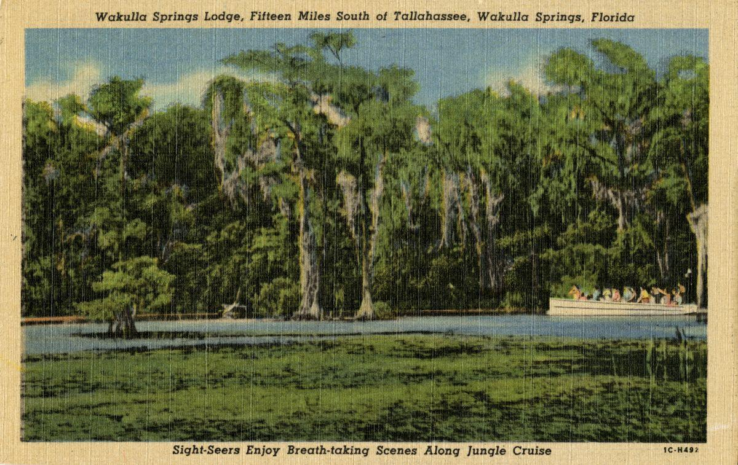

Date: Friday, **Rescheduled October 4 2024,** Originally September 27

Time: 09:00 AM – 11:00 AM

Location of Meeting Zoom Only

Zoom link <https://us06web.zoom.us/j/89786667803>

Board of Directors Meeting

**9:00    Opening WSA Board**

•       **Welcome and introductions** – Anthony Gaudio

•       **Agenda review** – Anthony Gaudio

**9:10 Update Wakulla County Board of County Commission Springs Protection Ordinance Workshops** Kellie KeysWCBOCC Liason For Workshops with Wakulla Environmental Groups for Springs protection and Drinking Water Ordinance Workshops **10**

**9:20 Financial report**- Jim Davis **[No Change from August Storm related delay} 5 min**

**9.25 Minutes of June 26, 2024 WSA Board meeting**- Brian Lupiani **[attached] 5 min**

**9:30 The DEP Great Outdoors Initiative to Increase Public Access, Recreation and Lodging at Florida State** Parks Grant Gelhardt, Ryan Smart Coordinated efforts by environmental groups to prevent the implementation of this initiative **20 Min**

**9:50 WSA Strategy Session for Springs Protection Ordinance** Chad Hansen, Anna Garner Last Summer WSA and other Environmental Groups submitted a Citizens Springs Protection Ordinance. WSA’s plan for input to workshop **20 Min**

**10:10 WSA Status of Land Swap for SW Ga Oil property Report** Renne Murray

From Adam Bass Conservation FL update concerning site plan and Saint Joe Paper Company issues. $3.7 Mil approved in budget. **10 Min**

**10:20 BMAP Update** Tom Taylor report on DEP BMAP update for Wakulla Springs held on Sept. 23, 2024 t. **10 Min**

**10:30 Big Bend Environmental Forum BBEF 8/6** Brian Lupiani WSA representative **10 Min**

**10:40 Sponsorship of Florida springs Council October 9 Springs Summit** Brian Lupiani $200 approval plus approval of new logo (see attached) **5 Min**

**10:45 Springshed and river update -**Cal Jamison **10 Min**

**10:55 Other Topics: 5 Min**,

1. October 25, **meeting in person** at The Wakulla Springs Park Administration Offices Meeting Room
2. ***At the recently held meeting of the International Geological Congress in Busan, South Korea, it was announced that Wakulla Spring was chosen by the International Union of Geological Sciences to be included in the “Second 100 International Geological Heritage Sites”.  This is a really big deal.  Some of the other designated sites in the U.S. include Yosemite Valley, Devi’s Tower, and the Great Salt Lake.  Wakulla Spring is in pretty good company. From Harley Means (See Attached)***
3. Announcements

**Upcoming meetings and events**– 4th Friday of the month

Reservations have been made for use of the conference room at the Renaissance Center for every month in 2024 Formats and locations yet to be determined for those dates from 08:45 - 12:30:

**11:00Adjourn**

APPENDIX B

**October 4, 2024, WAKULLA SPRINGS ALLIANCE**

(Rescheduled from September 27)

**Board Meeting Participants**

Zoom-only meeting

Officers

Anthony Gaudio, Chair

Chad Hanson, Vice-Chair

Brian Lupiani, Secretary

Directors

Bob Deyle

Gail Fishman

Cal Jamison

Mike Keys

Renee Murray

Tom Taylor

Members and Guests

Gil Damon, Downriver Project

Sue Damon

Mark Heidecker, City of Tallahassee

Kellie Keys, Wakulla Co. Soil & Water Cons District / Liaison btwn Co and Env groups

Sophie Wacongne-Speer, Friends of Lake Jackson

Edgar Wade, Leon County

Directors Not In Attendance: Jim Davis, Rob Gelhardt, Albert Gregory, Howard Kessler, Debbie Lightsey, Lindsay Stevens

APPENDIX C

No Financial Report this month; few changes since last month’s report.

APPENDIX D

Visibilty Chart September 2024

[Chart was actually not included in Minutes]

APPENDIX E

[Minutes of August 23, 2024 WSA Board meeting, approved at Oct 4 meeting]