**Wakulla Springs Alliance**

**Minutes of Board of Directors Meeting**

**Friday, October 4, 2024**

(Rescheduled from September 27)

9:00 AM – 11:00 AM

Location: Zoom Only

Zoom link <https://us06web.zoom.us/j/89786667803>

Recording (with transcript - and now with Summary and Smart Chapters!) available at

<https://us06web.zoom.us/rec/share/HAe6ELnzNWAOOvPBzolDyGcDhNhPGd1dwY9FwXcuDyKo9MFBSbLnsHM4XQGY364O.vOZdgbGHmlMuLrzu?iet=3GPfiZogZtOk7j9mQA-1_YvVK69pL1ZxrdUXYAJpNj8.AG.vrc52gJzPA_7j5CxeamhZnN3kRdZDPbNe4M4SA60i0xMqQW4h7CK9vWmRJU8PbDo3eqSUzDUgijF-9IsFUgRdm5kcg9WEvJgPF52B65ZgU2i_CyC5DgbJ_gWaIgAsfIC.mqOIxfyZalvYt_QVsZg81Q.myakaCAULsjrzfsk>

Passcode: YALp4Ea*

**Thanks as always to Tom Taylor for help with the minutes!**

**9:03 Meeting called to order** by Anthony Gaudio (00:33 in recording)

**9:03 Opening WSA Board**

**Welcome and introductions** – Anthony Gaudio (Appendix B)

**Agenda review and changes** – Anthony Gaudio (Appendix A)

1. The Strategy Session for the Ordinance Workshops will immediately follow the Update on the Workshops.
2. Chad has an item about a request from the Wakulla Environmental Institute that will be taken up at the end of the meeting

**9:08 Update on Wakulla County Board of County Commission Springs Protection Ordinance Workshops** - Kellie Keys, WCBOCC Liaison with Wakulla envir groups for workshops for Springs Protection and Drinking Water Ordinances

Kellie pointed out that even after the County Commission approves a new ordinance, it will take months for review and approval by various State and County offices.

The Wakulla County Commission had voted to have a workshop on October 7 but it was canceled due to the storm. Kellie hopes that on the 7th they will reschedule the workshop for the 21st (probably at 3:00). When they do hold their workshop, they’ll likely hold off on any substantive decisions until the newly elected Commission takes office in November. But Kellie believes they can move forward on some items like telling the County communication office to post educational information about fertilizer and pesticides, and passing a non-binding resolution recognizing the growing concern about microplastics and forever chemicals in the water.

**9:12 WSA Strategy Session for Springs Protection Ordinance** - Chad Hanson, Anna Garner

Chad, Kellie, and Renee have been writing a document with a number of code

/ordinance changes for the County to consider. They envision a series of two or more workshops to make the effort more manageable. Issues may include water bottling and water extraction, depending on the State’s preemption. The group intends to come back at WSA’s October meeting or the following one with more specific language. Expanding the Spring Protection Zone will be considered.

Anthony said Anna Garner should be contacted and included if she wants to be involved. Anthony wants to be included in the discussion and possibly more involved. Tom wants in also, and Bob would like to be kept in the loop and contribute if he can.

Renee said since there’ll be a few new County Commissioners* we need to inform them about Wakulla Springs: take them on a tour boat ride, explain where the water comes from and goes, etc., prior to the workshops.  
  
* Valerie Russell is replacing Mike Kemp, and Josh Lahan is replacing Chuck Hess. Anthony will reach out to Ms Russell; Kellie has had contact with Mr Lahan, so she and Anthony will “triangulate” on reaching out to him.

Kellie asked if anyone could provide educational information on fertilizers and pesticides (like bullet points, not a long text) for communications students to use in developing the public awareness campaign for the Wakulla County website. During discussion (at this point in the meeting and also after the report on the SW GA Oil land swap, when Anthony saw that Mark Heidecker had joined the meeting) it was pointed out that Leon County and Tallahassee have a fertilizer ordinance and Tallahassee has the TAPP (Think About Personal Pollution)* program. Mark Heidecker offered to send links, and stated that education is essential. Bob mentioned that Alachua County has a more stringent fertilizer ordinance than Tallahassee and so should have good PR material. *<https://tappwater.org/>

**9:25  Financial report**- Jim Davis (Appendix C) (00:54)

**No report this month due to storm. Few changes since last month; no vote taken.**

**9:26  Minutes of August 23, 2024 WSA Board meeting** - Brian Lupiani (Appendix E)

**Chad moved to accept the minutes**; seconded by Renee &/or Brian and **passed without opposition.**

Brian noted that the minutes now include the approved minutes of the prior month.

**9:30 The DEP Great Outdoors Initiative to Increase Public Access, Recreation**

**and Lodging at Florida State Parks** - Grant Gelhardt, Ryan Smart

Coordinated efforts by environmental groups to prevent the implementation of this initiative

Grant apparently missed the notice that this meeting had been postponed; he logged in last week but isn’t here today.

Gil Damon said he’s not as deeply involved as last month when he discussed the proposal, but he knows that DEP pulled it back, possibly to try again next year. Gil thinks that a scaled-back plan with pickleball and disc golf may be the result. And although the plan that became public involved 9 parks, 19 were apparently targeted for “improvements”, including Maclay Gardens.

Anthony said the Florida Springs Council is mobilized for the issue.

Bob said a Facebook group had been created: Florida State Park Guardians.

**9:35 Status of Land Swap for SW Ga Oil property** - Renee Murray (01:02)

Renee said Adam Bass of Conservation FL texted her about 3 weeks ago saying that he expected to have a “final” (final that they’ll present to us) site plan from SW GA Oil within a week, but she’s heard nothing since. She reached out to him earlier this week, but no response yet. They (Cons FL?) are pushing to have the land purchase with St Joe well on its way by the first of the year. Conservation FL is the lead on the land purchase.

**9:40 BMAP Update** - Tom Taylor report on DEP BMAP update for Wakulla Springs held on Sept. 23, 2024 (01:06)

* There was a PPT and small group discussion. See the synopsis.
* People shared and discussed information.
* There has been a lot of progress on the charts.
* It shows Wakulla has achieved 100% of goals. Chad said this is misleading because there is still a lot to do to meet the 15 years goals and that they have not factored in new development or loss of trees.
* They are accepting comments with final draft in spring and adoption in the summer.
* Growth is improperly addressed in the BMAP based on the assumption that this will be addressed by all new development being on sewer or advanced treatment septic systems. Treatment is not 100% reduction; growth also means increased nitrogen loading due to increased use of fertilizer.
* FSC lawsuits addressed this. We need to ask Ryan Smart about this.
* BMAPs have limited value.
* Q - Does the BMAP address withdrawal? A – No. This is addressed by Minimum Flows and Levels by the NWFWMD. The flows are higher, possibly because of Spring Creek reversals. Load not concentration is key. The TMDL is a measure of concentration, not load.
* Concentrations at the spring are not being reduced.
* Wakulla County is doing monitoring that needs to be considered.

**Tom made a motion that Anthony convene a committee to draft comments, before the next WSA Board meeting, on the BMAP update to submit on behalf of WSA. Bob seconded**, and **the motion passed without opposition.**

Anthony, Cal, Chad, and Tom will serve on the committee.

**9:55 Big Bend Environmental Forum (BBEF)** - Brian Lupiani WSA rep (01:25)

The forum for the November election will be Oct 17 at the Public Library. Brian will be out of town at the Springs Summit and unable to table the WSA table. Anthony and Tom will crew the table. Setup is at 4:45, meet and greet with the candidates at 5:15, and the forum runs from 6:00 to 8:00.

**10:00 Sponsorship of FL Springs Council Oct 19 Springs Summit** - Brian Lupiani   
 Approval of $200 expenditure for sponsorship.

Brian said that he’s going to attend, though not as a representative for WSA. He **moved that WSA spend $200 to be a non-profit sponsor of the Summit.** **Cal seconded**, and during discussion **Chad suggested amending** the motion to say that **Brian would be a representative of WSA and be reimbursed up to $100 for his expenses.** Brian agreed that it was a (very) friendly amendment and Cal accepted it as well. **The motion passed without opposition.**

Bob suggested that Brian by the WSA’s representative to the FL Springs Council if they still have regular meetings. Brian agreed to do it unless someone more qualified was interested.

**10:10** Approval of new logo (see Attachment 1)

Coincident with WSA sponsorship of the FSC Springs Summit, we can submit a logo to be printed on the event’s t-shirts (and possibly other recognition). Attachment 1 is a proposed logo created by Anthony’s daughter Carrie Gaudio. Cal was concerned about the center of the design being a bit busy, and also asked what the big hurry was about. Discussion led to an almost-consensus that the logo could be tweaked before final approval, but due to the deadline for the Springs Summit the current design could be approved as a temporary logo.

**Renee moved that we adopt the current design as our logo. Brian seconded**, and during discussion **Anthony suggested a friendly amendment** to say that **we accept the logo with a change so that the large central swoop doesn’t look like a “J”.** Renee and Brian accepted that change. After more discussion, Anthony restated the motion: **Accept this design as a temporary logo, with changing the color of the thing that looks like a “J”. A proposed final design will be presented at the October meeting.**  **The motion passed 6 - 1.**

**10:15 Spring shed and river update -**Cal Jamison (01:45)

* Before hurricane, visibility was 80’ for several weeks rather than 5’ to 7’
* The flow has really increased and the color is really dark now.
* The water level increased over 6 feet. The concentration is reduced because of the flow.
* The nitrogen is over 4.5 which is higher than what the BMAP is reporting.
* Good wildlife counts this week.
* Sinkhole survey found a car and Cal is working on getting the Ford Galaxy 500 out. The Sheriff may help get it out as an exercise. A diver will help assess the situation.

**10:25 Wakulla Environmental Institute Water Quality Monitoring** (01:57)

Tallahassee State College’s Wakulla Environmental Institute is submitting a proposal for an EPA water quality program. They’re asking us to submit a letter of support for it. **Chad moved that WSA endorse the WEI initiative and send a letter of support. Brian seconded**, and **the motion passed without opposition.**

**10:30 Other Topics and Announcements** (02:03)

**October 25 meeting will be in person** at The Wakulla Springs Park Administration Offices Meeting Room

*“At the recently held meeting of the International Geological Congress in Busan, South Korea, it was announced that Wakulla Spring was chosen by the International Union of Geological Sciences to be included in the “Second 100 International Geological Heritage Sites”.  This is a really big deal.  Some of the other designated sites in the U.S. include Yosemite Valley, Devil’s Tower, and the Great Salt Lake.  Wakulla Spring is in pretty good company.”* From Harley Means (See Attachments 2, 3, and 4).

**Upcoming meetings and events**– 4th Friday of the month

Reservations have been made for use of the conference room at the Renaissance Center for every month in 2024. Formats, locations, and dates are yet to be determined for this year’s remaining meetings.

**10:36 Adjourn** moved by Brian, seconded by Cal, no opposition (02:06)

ATTACHMENT 1

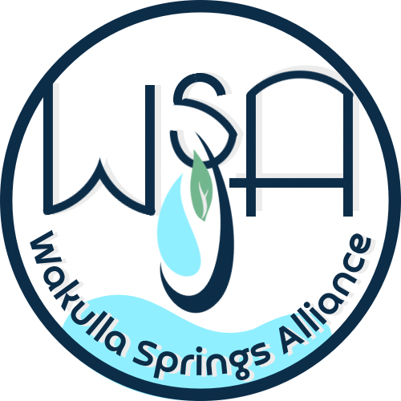

ATTACHMENT 2



**The International Union of Geological Sciences (IUGS) announced the list of The Second 100 IUGS Geological Heritage Sites at the 37th International Geological Congress (IGC) in Busan, Republic of Korea.**

**The announcement was made by IUGS President John Ludden, Stanley Finney, IUGS Secretary General, and Asier Hilario chair of the International Commission on Geoheritage on August 27th during an special event of the 37th International Geological Congress.**

**More than 700 experts from 80 nations and 16 international organizations participated in this global endeavor, which consolidates the recognition of geological heritage by the IUGS.**

**More information:** [**www.iugs-geoheritage.org**](http://www.iugs-geoheritage.org)(available from August 26)

The announcement of the Second 100 IUGS Geological Heritage Sites was one of the main events of the second day of the 37th International Geological Congress (IGC). IGC is the main conference related to Earth Sciences, it is sponsored by and is the scientific forum of the IUGS. Every four years the IGC brings together an important part of the geological community from all over the world.

The announcement of the Second 100 IUGS Geological Heritage Sites consolidates this global initiative that started with the announcement of “The First 100” during the IUGS 60th anniversary event in 2022 in Zumaia (Basque Coast, Spain). The main goal of this collaborative program led by the IUGS is to give the highest recognition to those sites that are essential for the geological sciences.

The Second 100 IUGS Geological Heritage Sites, as with the First 100, receive IUGS recognition because they are the highest scientific value. They are the world’s best demonstrations of geologic features and processes. They are the sites of fabulous discoveries of the Earth and its history. They are sites that served to develop the science of geology. They are located worldwide, and they are geologically diverse. Recognition and visibility of the “Second 100” by IUGS can lead to their further appreciation, to their use as educational resources, and, most importantly, to their preservation.

The final selection of the “Second 100” was ratified by the IUGS Executive Committee on February 21, 2024. The Second 100 Geological Heritage Sites are distributed in 53 countries and represent nine disciplines. The list of the “Second 100” is attached.

“The Second 100” as well as the “First 100” are attractively illustrated and described in a coffee table book than can be downloaded and purchased on the website of the International Commission on Geoheritage. [www.iugs-geoheritage.org](http://www.iugs-geoheritage.org).

In Busan, Republic of Korea

2024. August 27th

The International Union of Geological Sciences

Contact for more information:

**Dr. Asier Hilario** / flysch@gipuzkoa.eus

Chair – IUGS International Commission on Geoheritage

ATTACHMENT 3

ATTACHMENT 4

APPENDIX A

Agenda, Wakulla Springs Alliance September Board Meeting, Rescheduled, October 4 2024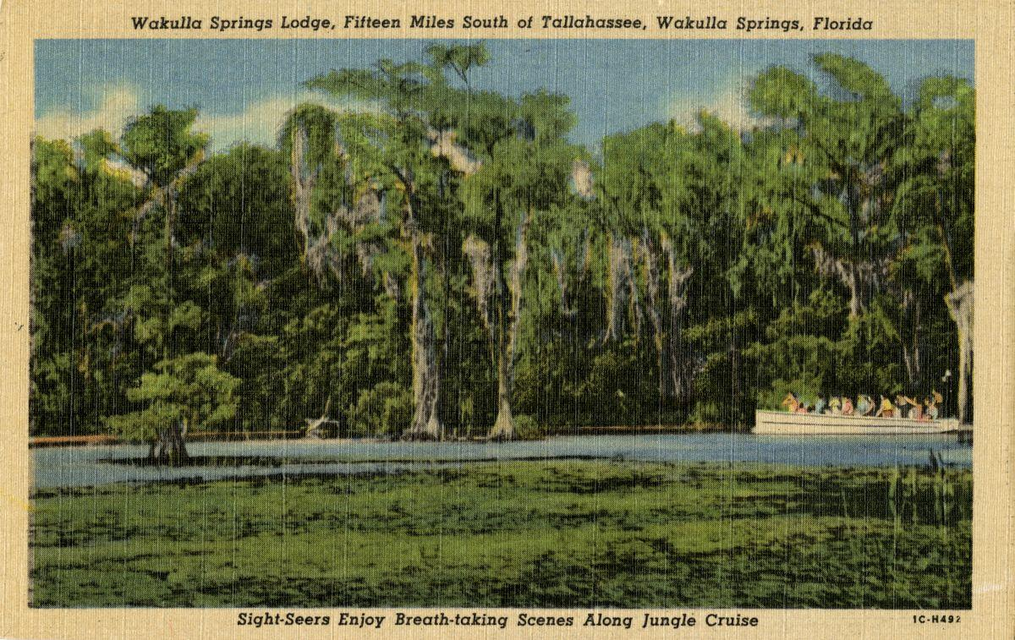

Date: Friday, **Rescheduled October 4 2024,** Originally September 27

Time: 09:00 AM – 11:00 AM

Location of Meeting Zoom Only

Zoom link <https://us06web.zoom.us/j/89786667803>

Board of Directors Meeting

**9:00    Opening WSA Board**

•       **Welcome and introductions** – Anthony Gaudio

•       **Agenda review** – Anthony Gaudio

**9:10 Update Wakulla County Board of County Commission Springs Protection Ordinance Workshops** Kellie KeysWCBOCC Liason For Workshops with Wakulla Environmental Groups for Springs protection and Drinking Water Ordinance Workshops **10**

**9:20 Financial report**- Jim Davis **[No Change from August Storm related delay} 5 min**

**9.25 Minutes of June 26, 2024 WSA Board meeting**- Brian Lupiani **[attached] 5 min**

**9:30 The DEP Great Outdoors Initiative to Increase Public Access, Recreation and Lodging at Florida State** Parks Grant Gelhardt, Ryan Smart Coordinated efforts by environmental groups to prevent the implementation of this initiative **20 Min**

**9:50 WSA Strategy Session for Springs Protection Ordinance** Chad Hansen, Anna Garner Last Summer WSA and other Environmental Groups submitted a Citizens Springs Protection Ordinance. WSA’s plan for input to workshop **20 Min**

**10:10 WSA Status of Land Swap for SW Ga Oil property Report** Renne Murray

From Adam Bass Conservation FL update concerning site plan and Saint Joe Paper Company issues. $3.7 Mil approved in budget. **10 Min**

**10:20 BMAP Update** Tom Taylor report on DEP BMAP update for Wakulla Springs held on Sept. 23, 2024 t. **10 Min**

**10:30 Big Bend Environmental Forum BBEF 8/6** Brian Lupiani WSA representative **10 Min**

**10:40 Sponsorship of Florida springs Council October 9 Springs Summit** Brian Lupiani $200 approval plus approval of new logo (see attached) **5 Min**

**10:45 Springshed and river update -**Cal Jamison **10 Min**

**10:55 Other Topics: 5 Min**,

1. October 25, **meeting in person** at The Wakulla Springs Park Administration Offices Meeting Room
2. ***At the recently held meeting of the International Geological Congress in Busan, South Korea, it was announced that Wakulla Spring was chosen by the International Union of Geological Sciences to be included in the “Second 100 International Geological Heritage Sites”.  This is a really big deal.  Some of the other designated sites in the U.S. include Yosemite Valley, Devi’s Tower, and the Great Salt Lake.  Wakulla Spring is in pretty good company. From Harley Means (See Attached)***
3. Announcements

**Upcoming meetings and events**– 4th Friday of the month

Reservations have been made for use of the conference room at the Renaissance Center for every month in 2024 Formats and locations yet to be determined for those dates from 08:45 - 12:30:

**11:00Adjourn**

APPENDIX B

**October 4, 2024, WAKULLA SPRINGS ALLIANCE**

(Rescheduled from September 27)

**Board Meeting Participants**

Zoom-only meeting

Officers

Anthony Gaudio, Chair

Chad Hanson, Vice-Chair

Brian Lupiani, Secretary

Directors

Bob Deyle

Gail Fishman

Cal Jamison

Mike Keys

Renee Murray

Tom Taylor

Members and Guests

Gil Damon, Downriver Project

Sue Damon

Mark Heidecker, City of Tallahassee

Kellie Keys, Wakulla Co. Soil & Water Cons District / Liaison btwn Co and Env groups

Sophie Wacongne-Speer, Friends of Lake Jackson

Edgar Wade, Leon County

Directors Not In Attendance: Jim Davis, Rob Gelhardt, Albert Gregory, Howard Kessler, Debbie Lightsey, Lindsay Stevens

APPENDIX C

No Financial Report this month; few changes since last month’s report.

APPENDIX D

Visibility Chart September 2024

APPENDIX E

**Wakulla Springs Alliance**

**Minutes of Board of Directors Meeting**

**Friday, August 23, 2024**

9:00 AM – 11:00 AM

Location: Zoom Only

Zoom link <https://us06web.zoom.us/j/89786667803>

Recording (with transcript!) available at

<https://us06web.zoom.us/rec/share/XE4j_ckiUg6Vehn7p3O11uFPH4XJuqWPX8QhOfyIrKfomyM-PqVmECg39jj1gG95.eu4HXfKKiQXFBNRv?iet=U1dkIfrcnUsP70DFKC4IagT65MFZbBatnQdYwbF4omk.AG.wF21tq27Y6b72bgMDpuCyu-0htf6Xx-uWVydF61vE5ACPNs80_WyQHLHuNCTwXlMK_MoZ8Cs_cg-IRIIBNAkISiQ3aIn_88kIMn730Lh7YTCvEAZL8jc4tFsvHUcgP3p.Qoxb0-iIvZD4bPWP0WP6WQ.dbt7m7koDryy3n7o>

Passcode: h%Dj3*C=

**Thanks to Tom Taylor for writing the minutes this month!**

**9:07(?) Meeting called to order** by Anthony Gaudio (00:32 in recording)

**9:08    Opening WSA Board**

**Welcome and introductions** – Anthony Gaudio (Appendix B)

**Agenda review** – Anthony Gaudio (Appendix A)

Gil Damon will talk about the proposed changes to state parks.

**9:10  Financial report**- Jim Davis (Appendix C)

Brian **moved to accept the report**; seconded by Albert & **passed without opposition.**

**9:11  Minutes of June 26, 2024 WSA Board meeting** - Brian Lupiani (Appendix E)

Albert **moved to accept the minutes**; seconded by Gail & **passed without opposition.**

**9:13 Proposal to “develop” State Parks**  - Gil Damon

The State is attempting to add golf courses, disc golf courses, pickleball courts, and 350-room “lodges” to a handful of state parks.

The plans have generated much opposition, including from GOP legislators.

The plans may come up for a vote at a meeting of DEP’s Acquisitions and Restoration Council on September 12.

Gil will send info to Anthony, who will pass it along to our email list.

Gil put this link in the chat: <https://www.downriverproject.org/parks>

**9:15 FSUCML Wakulla Springs Research Grant** - Kellie Keys, Joel Trexler (00:40)

Joel Trexler, Director of The FSU Coastal Marine Lab, and Kellie Keys, Research Faculty FSU School of Communication, spoke on the $750,000 State funded Wakulla Springs research grant awarded to FSUCML, and its design and objectives, for both primary research and Communication and outreach.

* FSU school of Communications and the Marine Lab
* Kelly took legislators on a tour of Wakulla Springs who liked the idea and
* Joel did a legislative budget request.
* School will 1) start Wakulla Springs tours, 2) do communications research on environmental education and produce a paper and 3) create a video for middle school science students with more videos in the future for high school and others
* The Marine Lab will 1) review research 2) met with FL Geological Survey and NWFWMD, 3) address priority data and research needs include groundwater currents, nutrient input, productivity of the ecosystem, Phosphorus impacts, etc.
* We want to present requests for further funding from the legislator.
* Working with Chris Werner and the Wakulla Karst Plane project
* Josh Breihaupt looking at carbon and nutrient and impacts downstream
* Shauna Manning at FIU will analyze DNA to trace water sources.
* There is a plan for water sampling with Chris Werner that will look at the impact of sea water. It will help distinguish between salt, rain and older ground water.
* Will sample up to 4 times of the year and capture unique events.
* Explore tropic states and how they are impacted. Josh will look at the organic carbon and nitrogen, nitrates, phosphorus (by type)
* Wakulla Springs micro-biome, environmental DNA will use new technologies. There may be thousands of markers that can be used as tracers. There may be meta-analysis like what is being done in health research. FSU Medical School has new equipment. This will help us to study many kinds of life.
* Q. Where does conductivity data sampled. A. From the end of the boat dock. BMAP analysis will benefit from this work.
* Q. How are the resources divided between 3 groups and each will each have allocated resources to each task. We will have lower costs because of the Med School equipment.
* Q. Many people need to understand the where the water in the springs comes from through translating the science information.
* C. The monthly surveys sample at 7 points on the river.
* C. FSU did DNA analysis of algae that tracked back to Lake Jackson and other lakes. A. Bob Deyle did a report on work by FAMU that was not peer reviewed. It was a good study and we have new technology. Cal took them on a tour.
* C. Let us know how WSA can help advocate for more funding.

**10:07 Status of Land Swap for SW Ga Oil property** - Renee Murray (01:32)

* We met with Conservation FL on July 24 and made a recommendation on the site plan for the land swap. It included a provision for acre for acre swap.
* Renee got an email saying there will be a new site plan next week; she expects it’ll be a few weeks.
* There are negotiations with St. Joe.
* Thanks to Renee and the group!
* We need to focus on the use of the conservation land that will be grasslands for water improvement not more pine trees.
* Q. Who will manage it? A. That is yet to be determined and we will have a voice in that.

**10:10 Big Bend Environmental Forum** - Brian Lupiani

* It was on August 6 with 50+ attendees and candidates.
* October 17 will be the forum for the November election at Public Library. (Brian will be out of town and unable to table the WSA table.)
* The ignorance of the candidates was shocking
* WSA can contact all of the commissioners individually.
* Recordings of the Big Bend Environmental Forum are on facebook at<https://www.facebook.com/BigBendEF/videos>

**10:20 Update on Wakulla County Board of County Commission Springs Protection Ordinance Workshops** - Kellie Keys, WCBOCC Liaison with Wakulla environmental groups for workshops for Springs Protection and Drinking Water Ordinances (01:47)

* There is not a date set
* There is more work needed on the document
* We may get some things accomplished. The County is considering expanding the springs protection zone and restricting withdrawals in some areas.
* Officials are starting to understand the environment better and we can make meetings with them. Most have little knowledge.
* We may want to have a slide show to present at commission meetings, then one-on-ones.
* Debbie talked about how she was helped by Helge Swanson when she started. Talk about the role of land use and the environment. Bob Deyle can help with this. We must keep it simple.
* Tom Taylor wants to be involved.

**10:30 WSA Strategy Session for Springs Protection Ordinance** - Anna Garner

Anna wasn’t present. Anthony will get the strategy group together.

**10:35 DEP Water Quality Grant applications** - Tom Taylor (01:58)

Applications were due by July 15. Mitch Holmes at DEP reported that these are the final applications:

Tallahassee – no applications

Leon – Woodville sewering and additional septic tank upgrade subsidies

Wakulla – Extending transmission lines for disposal at the golf course and a gravity sewer in Panacea

This is a major opportunity to advance many components of the [WSA’s Strategic Plan](https://docs.google.com/document/d/1fUeXuM0DL0eHWG_7K4_FEyePC0RbdZUPEfAow7iPEs4/edit?usp=sharing)

**10:40 Spring shed and river update -**Cal Jamison (02:02)

* Last week in July and first in August we had 75’ visibility.
* After the hurricane it went down to 40 then 29’ of visibility.
* Historically July visibility has been higher
* Nitrates are .45 and hasn’t varied lately. The TMDL is .35
* Manatees have been in the swimming area.
* Cal and Chris Werner looked at the sampling sites including the Wakulla Environmental Institute swirl.
* Albert Winn needed volunteers to clear the trail to the swirl.
* The sampling team has taken officials out and is open to more, one at a time.
* Anyone is welcome to join us on Thursdays at 8:30 for breakfast at Savannah’s with the tour at 10:00

**10:55 Other Topics and Announcements** (02:17)

* September 27, Zoom
* October 25, meeting in person? Where?
* The Friends of the **Red Hills Community Cemetery are** having a Volunteer Meet up 8/25 4-6PM Abundance wellness Center 325 John Knox Rd Unit T
* Fl Springs Council October 19 in St. Pete. It is free and has great workshops with lunch.

**Upcoming meetings and events**– 4th Friday of the month

Reservations have been made for use of the conference room at the Renaissance Center for every month in 2024 Formats and locations yet to be determined for those dates from 08:45 - 12:30:

**11:00 Adjourn** moved by Brian, seconded by Cal, no opposition (02:25)

APPENDIX A

Agenda, Wakulla Springs Alliance April Board Meeting, 8/23/2024**[See Attached Doc]** 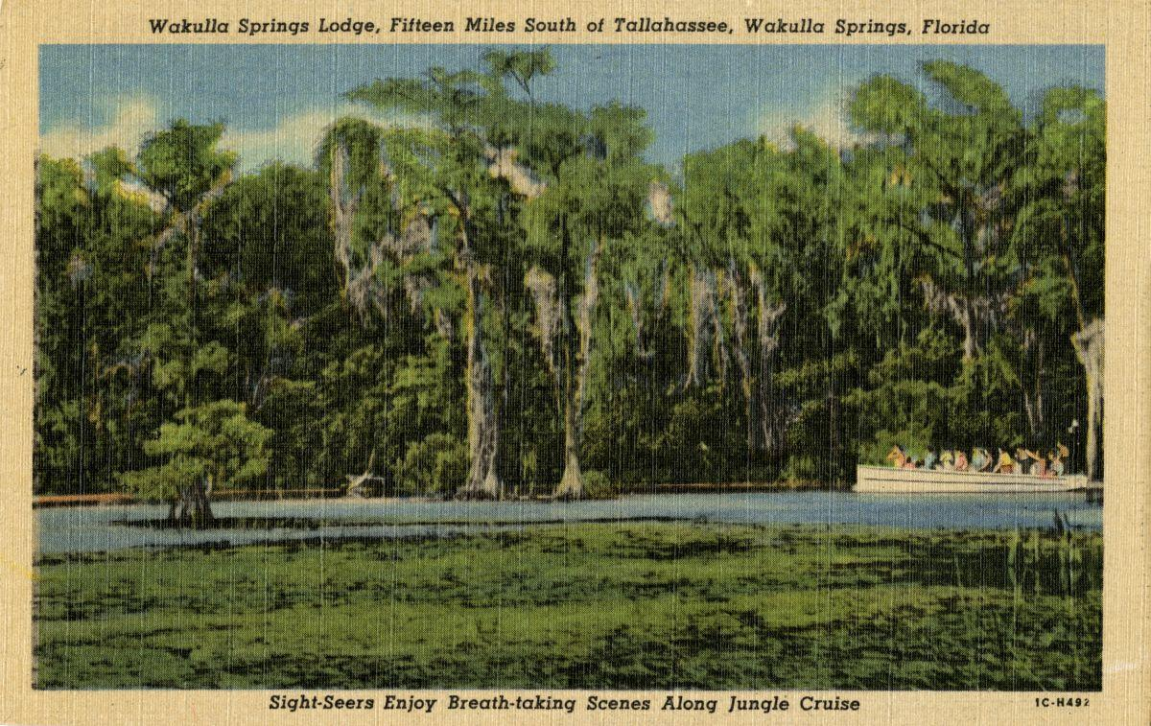

Date: Friday, August 23, 2024

Time: 09:00 AM – 11:00 AM

Location of Meeting Zoom Only

Zoom link <https://us06web.zoom.us/j/89786667803>

Board of Directors Meeting

**9:10    Opening WSA Board**

•       **Welcome and introductions** – Anthony Gaudio

•       **Agenda review** – Anthony Gaudio

**9:20 Financial report**- Jim Davis **[attached] 5 min**

**9.25 Minutes of June 26, 2024 WSA Board meeting**- Brian Lupiani **[attached] 5 min**

**9:30 $750k FSUCML Grant** Joel Trexler, Director of The FSU Coastal Marine Lab, and Kellie Keys, Research Faculty FSU School of Communication, will give a presentation on the $750,000 State funded Wakulla Springs research grant awarded to FSUCML, and its design and objectives, for both primary research and Communication and outreach. **20 Min**

**9:50 Q&A on $750k FSUCML Grant 10 Min**

**10:00 WSA Status of Land Swap for SW Ga Oil property Report** Renne Murray

From Adam Bass Conservation FL update concerning site plan and Saint Joe Paper Company issues. $3.7 Mil approved in budget. **10 Min**

**10:10 Big Bend Environmental Forum BBEF 8/6** Brian Lupiani WSA representative **5 Min**

**10:15 Update Wakulla County Board of County Commission Springs Protection Ordinance Workshops** Kellie KeysWCBOCC Liasson For Workshops with Wakulla Environmental Groups for Springs protection and Drinking Water Ordinance Workshops **10 Min**

**10:25 WSA Strategy Session for Springs Protection Ordinance** A Gaudio, Anna Garner Last Summer WSA and other Environmental Groups submitted a Citizens Springs Protection Ordinance. WSA’s plan for input to workshop **20 Mn**

**10:45** The **DEP Water Quality Grant applications** Tom Taylor **5 Min** Applications were due by July 15. Mitch Holmes at DEP reported that these are the final applications:

Tallahassee – no applications

Leon – Woodville sewering and additional septic tank upgrade subsidies

Wakulla – Extending transmission lines for disposal at the golf course and a gravity sewer in Panacea

This is a major opportunity to advance many components of the [WSA’s Strategic Plan](https://docs.google.com/document/d/1fUeXuM0DL0eHWG_7K4_FEyePC0RbdZUPEfAow7iPEs4/edit?usp=sharing)

**10:50 Springshed and river update -**Cal Jamison **10 Min**

**11:00 Other Topics: 5 Min**

1. September 27, Zoom
2. October 25, meeting in person? Where?
3. The Friends of the **Red Hills Community Cemetery are** having a Volunteer Meet up 8/25 4-6PM Abundance wellness Center 325 John Knox Rd Unit T
4. Announcements

**Upcoming meetings and events**– 4th Friday of the month

Reservations have been made for use of the conference room at the Renaissance Center for every month in 2024 Formats and locations yet to be determined for those dates from 08:45 - 12:30:

**11:05 Adjourn**

APPENDIX B

**August 23, 2024, WAKULLA SPRINGS ALLIANCE**

**Board Meeting Participants**

Zoom-only meeting

Officers

Anthony Gaudio, Chair

Chad Hanson, Vice-Chair

Brian Lupiani, Secretary

Directors

Gail Fishman

Rob Gelhardt

Albert Gregory

Cal Jamison

Mike Keys

Debbie Lightsey

Renee Murray

Tom Taylor

Members and Guests

Gil Damon, Downriver Project

Mark Heidecker, City of Tallahassee

Kellie Keys, Wakulla Co. Soil & Water Cons District / Liaison btwn Co and Env groups

Johnny Richardson, Leon Co. Public Works

Paul Thurman, NW Florida Water Management District

Sophie Wacongne-Speer, Friends of Lake Jackson

Joel Trexler, FSU Marine Lab Director

Joshua Breithaupt, FSU Marine Lab

Directors Not In Attendance: Jim Davis, Bob Deyle, Howard Kessler, Lindsay Stevens

APPENDIX C

|  |  |
| --- | --- |
| **WAKULLA SPRINGS ALLIANCE** |  |
| **FINANCIAL REPORT** |  |
| **FOR THE 7 MONTHS ENDED JULY 31, 2024** |  |
|  |  |
| **INCOME** |  |
| Donations | $ - |
| Memberships | 1,030.00 |
|  | 1,030.00 |
|  |  |
| **EXPENSES** |  |
| Data Processing Related | - |
| Printing | - |
| Florida Corporate Annual Report | 61.25 |
| Big Bend Environmental Forum | 100.00 |
| PayPal Fees | 66.21 |
| Earl Bacon Agency - Insurance | 1,138.50 |
|  | 1,365.96 |
|  |  |
| **SURPLUS/(DEFICIT)** | (335.96) |
|  |  |
| **BANK BALANCE - 12/31/2023** | 9,409.26 |
| **PAYPAL BALANCE - 12/31/2023** | 1,574.71 |
| **TOTAL - 12/31/2023** | 10,983.97 |
|  |  |
| **BANK BALANCE - 7/31/2024** | 8,509.59 |
| **PAYPAL BALANCE -7/31/2024** | 2,138.42 |
| **TOTAL 7/31/2024** | **$ 10,648.01** |

APPENDIX D

Visibility Chart August 2024

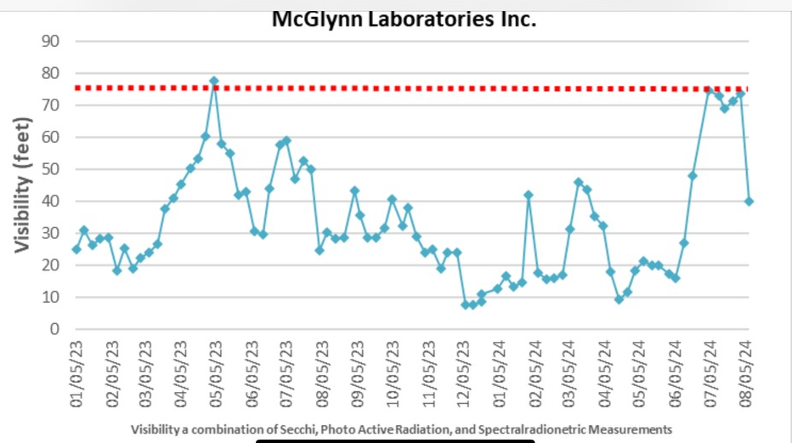

APPENDIX E

[Minutes of June 28, 2024 WSA Board Meeting]