**Wakulla Springs Alliance**

**Board of Directors Meeting**

Friday, October 27, 2023

9:00 AM – 11:30 AM

Location: 435 N. Macomb Street, 2nd Floor Renaissance Center

Hybrid meeting: In-person and Zoom (Recording available through Bob Deyle)

**9:08   Meeting called to order** by Anthony Gaudio

**Welcome and introductions** – Anthony Gaudio

**Agenda review** – Gaudio

**9:10   Financial report**- Jim Davis (Appendix C)

Albert Gregory **moved to accept the report**; seconded by Cal Jamison and **passed without opposition.**

**9:12   Minutes of June 23, 2023 meeting**-  Brian Lupiani

Albert **moved to accept the minutes**; seconded by Jim Stevenson and **passed without opposition.**

**9:20 Discussion of WSA’ s Stated goal for the ecological restoration of WS** Bob Deyle (PowerPoint).

From WSA Website “The Wakulla Springs Alliance goal for the ecological restoration of the Wakulla Spring and River is to restore the aquatic flora and fauna and water clarity to its condition at state acquisition in 1986. This includes the same relative abundance and diversity of aquatic plants, fishes, reptiles, and birds inhabiting the spring and river within the state park.”

1986 is not a good reference point. Pam Hall’s “Goal of the BMAP” written in 2015 would be a better guideline for what WSA’s ecological restoration goal should be.

Anthony proposed that we establish a working group to restate WSA’s goal for ecological restoration, and identify problems and specify action steps to resolve them. Jim Stevenson noted that Bob Knight’s book “Saving Florida’s Springs: A Prescription for Springs Health” lays out what needs to be done.

**10:10 Motion**: **Authorize Anthony to create a working group to**

1. **Restate WSA’s goal for ecological restoration, and**
2. **Identify roadblocks to restoration and specify action steps to resolve them.** Motion made by Bob Deyle, seconded by Tom Taylor and **passed without opposition.** Cal Jamison, Jim Stevenson, and Brian Lupiani volunteered to be on the working group.

**10:15 Update Wakulla County Board of County Commission Actions** Mike Keys

Special Considerations for Gas Stations in Commercial Zoning

Springs protection and Drinking Water Ordinance Workshops

**10:25 Motion**: **Authorize the Executive Committee and others to draft a letter to the Wakulla County BoCC regarding the lack of progress on the Springs and Drinking Water Protection Ordinance workshops and supporting a moratorium on gas station related zoning approvals until the updated “special consideration” language is in effect.** Motion made by Brian, seconded by Bob, **passed without opposition.**

It’s understood that, in addition to the Executive Committee, Chad Hanson and Debbie Lightsey will help with the letter.

**10:30 WSA Status of Land Swap for SW Ga Oil property Report** - Albert

Adam Bass of Conservation Florida is working on it

**10:40 Benjamin Dimmitt landscape photographer** - Jeff Chanton

Dimmitt’s book "An Unflinching Look: Our Changing Climate" documents over 30 years the effects of water withdrawal & rising sea level on the spring-dominated coastline around the Chassahowitzka River. Jeff and his wife, Sue Cerulean, have invited Dimmer to include Tallahassee on his book tour. They are requesting WSA’s support in publicizing and co-sponsoring the event. They’re not requesting any financial support from WSA, only our help with publicity. The event is expected to take place in January or early February 2024.

There was no formal endorsement, but the consensus was that we should help, for instance by sending an announcement of the event to our email list.

**10:45** **Spring shed and river update** - Cal Jamison (Appendix D)

Visibility has been dropping lately; water is very green.

The water level is up.

**11:00 Formation of WSA Board Member Nominating Committee** – Anthony (See WSA By-Laws Article VI)

* 3 Member Volunteers needed to Be Appointed by Board in preparation for the annual meeting elections on January 26, 2024
* 15 Maximum Members
* Seven Elected in 2023
* Seven 2 Yr. Terms Expiring- Gregory, Davis, Lupiani, Lightsey, Fishman, Kessler, Keys,

Albert Gregory and Tom Taylor will serve on the Nominating Committee, and Anthony will recruit a member not on the Board to join them.

**11:05 Other Topics**

* WSA becoming a member of the Wakulla County Economic Development Council Cost $75 – Anthony

Discussion and Vote postponed until a later meeting

* WSA Membership reminders starting Nov 1 for 2024 with membership drive request to affiliate non-members
* Sea & Shoreline research FDEP permit for invasive removal and SAV Restoration on the Wakulla River – Bob Deyle

Lynn Artz said that a citizens proposal for the 2024 general election to expand the Wakulla Springs Protection Zone. There’s a deadline (not sure when) for submitting the 7000 signatures required to put it on the ballot. They need to be collected within a 6-month time frame; Lynn suggests Feb - June. The WSA won’t write the ordinance, but individuals can. Bob suggests Renee Murray and Ana Garner.

Cal stated that the Wakulla County Soil and Water Conservation District needs one more person to serve as a Supervisor; must be a Wakulla County resident.

He also noted that the Wakulla Springs Basin signs need repair or replacement.

**Upcoming meetings and events**– 4th Friday of the month

* 4th Friday conflicts with holidays in Nov and Dec, so we’ll meet on

December 1, Zoom only

* Currently, reservations have been made for use of the conference room at the Renaissance Center from 8:45 - 12:30 for every month in 2024
* Formats and locations TBD for those Meetings.
* Jan 26, 2024 will be our Annual Membership Meeting; format TBD.

**11:27 Adjourn** moved by Cal, seconded by Albert, no opposition

Appendix A

10/27/2023 Wakulla Springs Alliance Board Meeting Agenda, 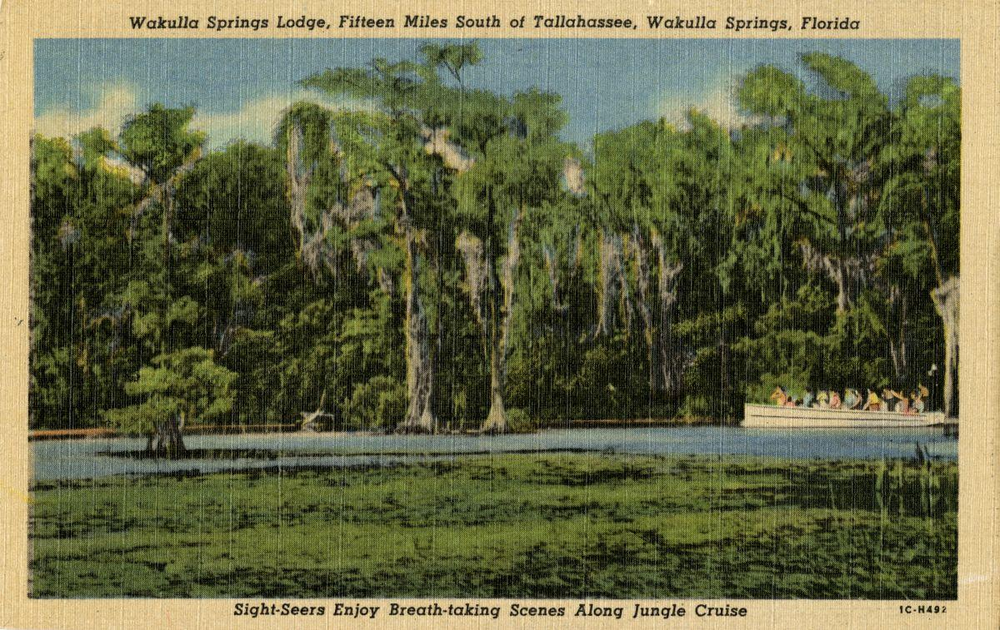

Date: Friday, October 27, 2023

Time: 09:00 AM – 11:00 PM

Location: 435 N. Macomb Street, 2nd Floor Renaissance Center

Hybrid meeting In-Person/Zoom

Zoom link: <https://fsu.zoom.us/j/97207430086>

Board of Directors Meeting

**9:00    Opening**

∙       **Welcome and introductions** – Anthony Gaudio

∙       **Agenda review** – Anthony Gaudio

**9:10 Financial report**- Jim Davis **[attached] 5 min**

**9.15 Minutes of September 22, 2023 WSA Board meeting**- Brian Lupiani **[attached] 5 min**

**9.20 Discussion WSA’ s Stated goal for the ecological restoration of WS** Bob Deyle (**PowerPoint). -** A review of historic disturbances to the Wakulla Springs ecosystem and long- term trends in animal abundance and diversity. **30 Min**

From WSA Website “The Wakulla Springs Alliance goal for the ecological restoration of the Wakulla Spring and River is to restore the aquatic flora and fauna and water clarity to its condition at state acquisition in 1986. This includes the same relative abundance and diversity of aquatic plants, fishes, reptiles, and birds inhabiting the spring and river within the state park.”

**9:50 Update Wakulla County Board of County Commission Actions** Mike Keys **20 Min**

Special Considerations for Gas Stations in Commercial Zoning

Springs protection and Drinking Water Ordinance Workshops

**10:10 WSA Status of Land Swap for SW Ga Oil property Report** Albert Gregory

**10 Min**

**10:20** **Benjamin Dimmitt landscape photographer** Jeff Chanton, to discuss the book, "An Unflinching Look, Our Changing Climate." which documents over 30 plus years the effects of water withdrawal and rising sea level on the spring-dominated coastline around the Chassahowitzka River. (Photos to be shared by Jeff) **10 Min**

**-10:30 Spring shed and river update -** Cal Jamison **10 Min**

**10:40 Formation of WSA Board Member Nominating Committee – 3 Member Volunteers needed to Be Appointed by Board** Anthony Gaudio- In preparation for the annual meeting elections on January 26, 2024. 15 Maximum Members Seven Elected in 2023 **(See Attached WSA By-Laws Article VI)** Seven 2 Yr. Terms Expiring- Gregory, Davis, Lupiani, Lightsey, Fishman, Kessler, Keys, **10 Min**

**10:50 Other Topics: 15 Min**

1. WSA becoming a member of the Wakulla County Economic Development Council Cost $75 – A Gaudio Discussion and Vote
2. Sea & Shoreline research FDEP permit for invasive removal and SAV Restoration on the Wakulla River – Bob Deyle
3. WSA Mtg style for December 1 Zoom, only, Room not available
4. WSA Membership reminders starting Nov 1 for 2024 with membership drive request to affiliate non-members

**Upcoming meetings and events** – 4th Friday of the month

December 1 Zoom Only (4th Friday conflict with be The Nov/Dec mtg. Thanksgiving) Reservations have been made for use of the conference room at the Renaissance Center from 08:45 - 12:30 for every month in 2024. Formats and locations TBD for those Meetings. Jan 26, 2024 will be our Annual Membership Meeting Formats TBD.

**11:05 Adjourn**

Appendix B

**10-27-23 WAKULLA SPRINGS ALLIANCE Board Meeting Participants**

In Person and Zoom

* Indicates those physically present

Officers

Anthony Gaudio Chair *

Michael Keys Vice-Chair

Brian Lupiani, Secretary *

Directors

Bob Deyle *

Gail Fishman *  
Albert Gregory *

Chad Hanson

Cal Jamison *

Debbie Lightsey

Lindsay Stevens

Tom Taylor *

Members and Guests

Lynn Artz

Colleen Castille

Jeff Chanton

Kathleen Coates, NWFWMD

Gil Damon

WestiJo DeHaven-Smith

Mark Heidecker, City of Tallahassee

Chuck Hess, WCBoCC *

Liza McFadden

Johnny Richardson

Jim Stevenson *

Paul Thurman

Sophie Wacongne-Spear *

Directors Not In Attendance: Jim Davis, Rob Gelhardt, Howard Kessler

Appendix C

|  |  |
| --- | --- |
| **WAKULLA SPRINGS ALLIANCE** |  |
| **FINANCIAL REPORT** |  |
| **FOR THE 9 MONTHS ENDED SEPTEMBER 30, 2013** |  |
|  |  |
| **INCOME** |  |
| Donations | $ |
| Memberships | 1,400.00 |
|  | 1,400.00 |
|  |  |
| **EXPENSES** |  |
| Awards |  |
| Printing | 17.24 |
| Florida Corporate Annual Report | 61.25 |
| Big Bend Environmental Forum | - |
| PayPal Fees | 35.58 |
| Earl Bacon Agency - Insurance | 1,132.78 |
|  | 1,246.85 |
|  |  |
| **SURPLUS/(DEFICIT)** | 153.15 |
|  |  |
| **BANK BALANCE - 12/31/2022** | 9,299.81 |
| **PAYPAL BALANCE - 12/31/2022** | 643.61 |
| **TOTAL - 12/31/2022** | 9,943.42 |
|  |  |
| **BANK BALANCE -9/30/2023** | 9,677.07 |
| **PAYPAL BALANCE-9/30/2023** | 419.50 |
| **TOTAL 9/30/2023** | **$ 10,096.57** |

Appendix D

