**Wakulla Springs Alliance**

**Board of Directors Meeting**

Friday, September 22, 2023

9:00 AM – 11:30 AM

Location: Wakulla County Community Center

318 Shadeville Rd. Crawfordville, 32327

No Zoom; in Person Only (No recording was made)

**9:05   Meeting called to order** by Albert Gregory

**Welcome and introductions** – Albert

**Agenda review** – Albert

**NOTE: A majority of the Board was never present during the meeting, so a quorum was not established.**

**9:10   Financial report**- Jim Davis (Appendix C)

Recent efforts by WSA have brought in $1,400 of membership dues and donations

Cal Jamison **moved to accept the report**; seconded by Chad Hanson and **passed without opposition.**

**9:12   Minutes of August 25, 2023 meeting**-  Brian Lupiani

Chad **moved to accept the minutes**; seconded by Brian and **passed without opposition.**

**9:15 Presentation on Lake Munson Drawdown –** Anna Padilla, Leon County Stormwater Management Coordinator(See Appendix D)

**9:50 Q&A**

**10:00  Update Wakulla County Board of County Commission Actions since**

**08/07 Mtg** - Albert

* At the Oct 9 Planning Commission meeting, Chad will propose that gas stations require special consideration and a separate vote for approval beyond typical commercial zone uses.
* No word on any action taken by Wakulla County to arrange the Water Protection Ordinance Workshops. Chad suggests following up on WSA’s letter to the BoCC about the workshops.

**10:10  WSA State Acquisition of property Workgroup Report** - Albert

See Appendix E

**10:25 Legislation (SB106) that links SUN (Shared-Use Nonmotorized) Trails and Wildlife Corridors especially as it relates to Wakulla Springs** - Dale Allen Pres. Florida Greenways & Trails Foundation

Proposed paved Trail connection from the Tallahassee--St. Marks Rail Trail to Wakulla Springs State Park.

**10:45   Spring shed and river update -**Cal

* Streams and swallets are still flowing providing tannic water
* A big plug of tannic water is expected to reach the Spring soon, though it might not be very visible.
* Thursday’s Secchi visibilty was 41 feet
* Last week we had the highest chlorophyll ever recorded at the Spring
* Apple Snail eggs are plentiful but we haven’t seen many adult snails
* We’re now seeing manatees year-round, including a number of calves
* There are 100s of mullets.
* Collecting water samples for UF and FAMU
* PFAFs have been detected in the Spring
* Spring Creek in flux with reversals. Some saltwater gets to Wakulla Springs.
* The fish count has come up with bass and pan fish.
* Eel Grass and Sagittaria are coming back, where we planted it and everywhere, with the critters coming back - the whole ecosystem seems to be coming back
* Spring water is consistently green, even when it’s “clear.” Nutrient levels are high

**10:55 Other Topics:**

**1. Report on WC Charter Review Commission** - Chad

* Chad thinks the Review Commission is hesitant to put anything on the ballot
* Our proposal to expand the SPA was rejected for inclusion in the charter amendment
* We may want to ask for a Wakulla Springs plan
* We could propose a right to clean water statement in the charter
* Clean water polls positively

**2. WSA becoming a member of the Wakulla County Economic**

**Development Council** – Anthony

Postponed until next meeting

**3. Sea & Shoreline research FDEP permit for invasive removal and**

**SAV Restoration on the Wakulla River** – Bob Deyle

**4. WSA Mtg style for October 27 & December 1:** Zoom, Hybrid, In-person?

* It is nice to do hybrid meetings with zoom recordings for the secretary
* It is nice to be together in person. Have these periodically in Wakulla County
* (Someone) won’t use zoom for security reasons
* Do it at Wakulla Springs for a swim or boat ride
* Give Chad Hanson program suggestions

**5. Watch for opening ceremony of the Debbie Lightsey Nature Park**.

It is part of the Wakulla Springs Basin and there are water quality, bike/hike trails and habitat corridor benefits.

**Upcoming meetings and events**– 4th Friday of the month

* Currently, reservations have been made for use of the conference room at the Renaissance Center for the following dates in 2023 from 8:45 - 12:30:
* October 27, December 1 (conference room not available Nov 17,TBD)

**11:15 Adjourn** moved by Brian, seconded by Cal, no opposition

Appendix A

Agenda, Wakulla Springs Alliance September Board Meeting, 09/22/2023**[See Attached Doc]** 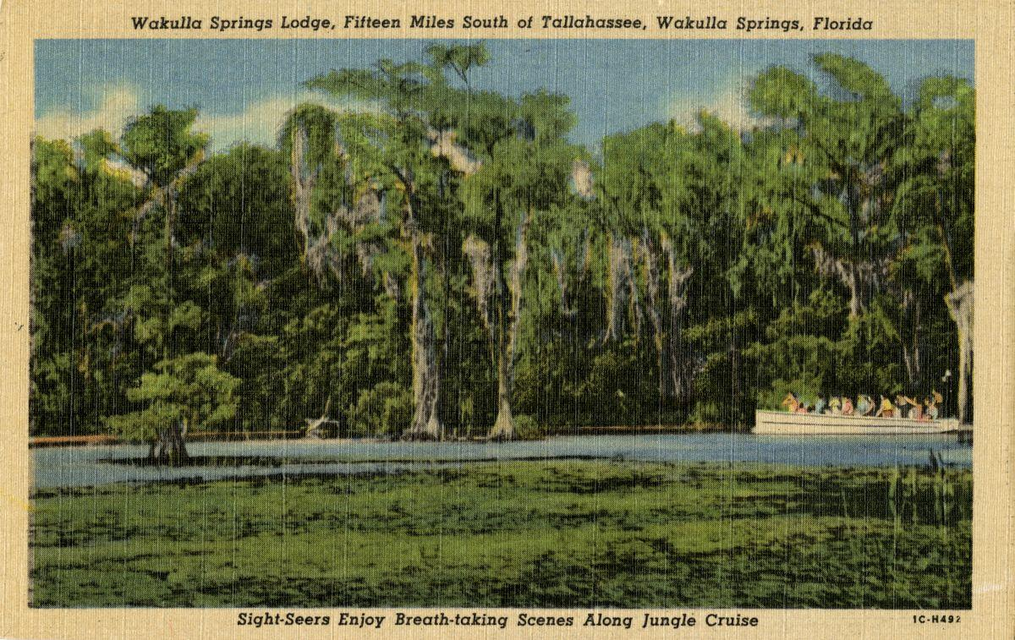

Date: Friday, September 22, 2023

Time: 09:00 AM – 11:00 PM

Location: Wakulla County Community Center 318 Shadeville Rd. Crawfordville, 32327,

No Zoom in Person Only

Board of Directors Meeting

**9:00    Opening**

∙       **Welcome and introductions** – Albert Gregory

∙       **Agenda review** – Albert Gregory

**9:10 Financial report**- Jim Davis **[attached] 5 min**

Recent efforts by WSA have brought in $1,400 of membership dues and donations

**9.15 Minutes of August 25, 2023 WSA Board meeting**- Brian Lupiani **[attached] 5 min**

**9:20 Presentation Lake Munson Drawdown – Anna Padilla Leon County Stormwater Management Co-Ordinator 20 Min (See Attached)**

**9:40 Q&A 10 Min\**

**9:50 Update Wakulla County Board of County Commission Actions since 8/7 Mtg.** Albert Gregory **20 Min**

Special Considerations for Gas Stations in Commercial Zoning

Springs protection and Drinking Water Ordinance Workshops

**10:10  WSA State Acquisition of property Workgroup Report** Albert Gregory

**10 Min**

**10:20**  **Legislation (SB106) that links SUN Trails and Wildlife Corridors especially as it relates to Wakulla Springs.**Dale Allen Pres. Florida Greenways & Trails Foundation Proposed paved Trail connection from the Tallahassee--St. Marks Rail Trail to Wakulla Springs State Park.

**10 min**

**10:30   Spring shed and river update -**Cal Jamison **10 Min**

**10:40 Other Topics: 15 Min**

1. WSA becoming a member of the Wakulla County Economic Development Council – A Gaudio For next meeting
2. Report WC Charter Review Commission _ Chad Hansen
3. Sea & Shoreline research FDEP permit for invasive removal and SAV Restoration on the Wakulla River – Bob Deyle
4. WSA Mtg style for October 27 & December 1Zoom, Hybrid, In-person?

**Upcoming meetings and events**– 4th Friday of the month

September 22 in person only location

Currently, reservations have been made for use of the conference room at the Renaissance Center for the following dates in 2023 from 08:45 - 12:30:

October 27 TBD, December 1 TBD (conference room not available November 17th TBD)

**10:55 Adjourn**

Appendix B

**09-22-23 WAKULLA SPRINGS ALLIANCE Board Meeting Participants**

In-person-only meeting

Officers

Brian Lupiani, Secretary

Directors

Albert Gregory

Chad Hanson

Cal Jamison

Debbie Lightsey  
Tom Taylor

Members and Guests

Dale Allen

Dave Coffee

Marty Coffee

Gil Damon

WestiJo DeHaven-Smith

Chloe Dougherty

Chuck Hess

Anna Padilla, Leon County

Wayne Toothman, Leon County

Sophie Wacongne-Spear

Edgar Wade, Leon County

Wyatt Hendricks, Friends of Lake Munson vice chair

Ann Hendricks, Friends of Lake Munson

Directors Not In Attendance: Anthony Gaudio, Michael Keys, Jim Davis, Bob Deyle

Gail Fishman, Rob Gelhardt, Howard Kessler, Lindsay Stevens

Appendix C

|  |  |  |
| --- | --- | --- |
| **WAKULLA SPRINGS ALLIANCE** |  |  |
| **FINANCIAL REPORT** |  |  |
| **FOR THE 8 MONTHS ENDED AUGUST 31, 2023** |  |  |
|  |  |  |
| **INCOME** |  |  |
| **Donations** | $ - |  |
| Memberships | 1,400.00 |  |
|  | 1,400.00 |  |
|  |  |  |
| **EXPENSES** |  |  |
| Awards | - |  |
| Printing | 17.24 |  |
| Florida Corporate Annual Report | 61.25 |  |
| Big Bend Environmental Forum | - |  |
| PayPal Fees | 35.58 |  |
| Earl Bacon Agency - Insurance | 1,132.78 |  |
|  | 1,246.85 |  |
|  |  |  |
| **SURPLUS/(DEFICIT)** | 153.15 |  |
|  |  |  |
| **BANK BALANCE - 12/31/2022** | 9,299.81 |  |
| **PAYPAL BALANCE - 12/31/2022** | 643.61 |  |
| **TOTAL - 12/31/2022** | 9,943.42 |  |
|  |  |  |
| **BANK BALANCE -8/31/2023** | 9,677.07 |  |
| **PAYPAL BALANCE-8/31/2023** | 419.50 |  |
| **TOTAL 8/31/2023** | **$ 10,096.57** |  |

Appendix D

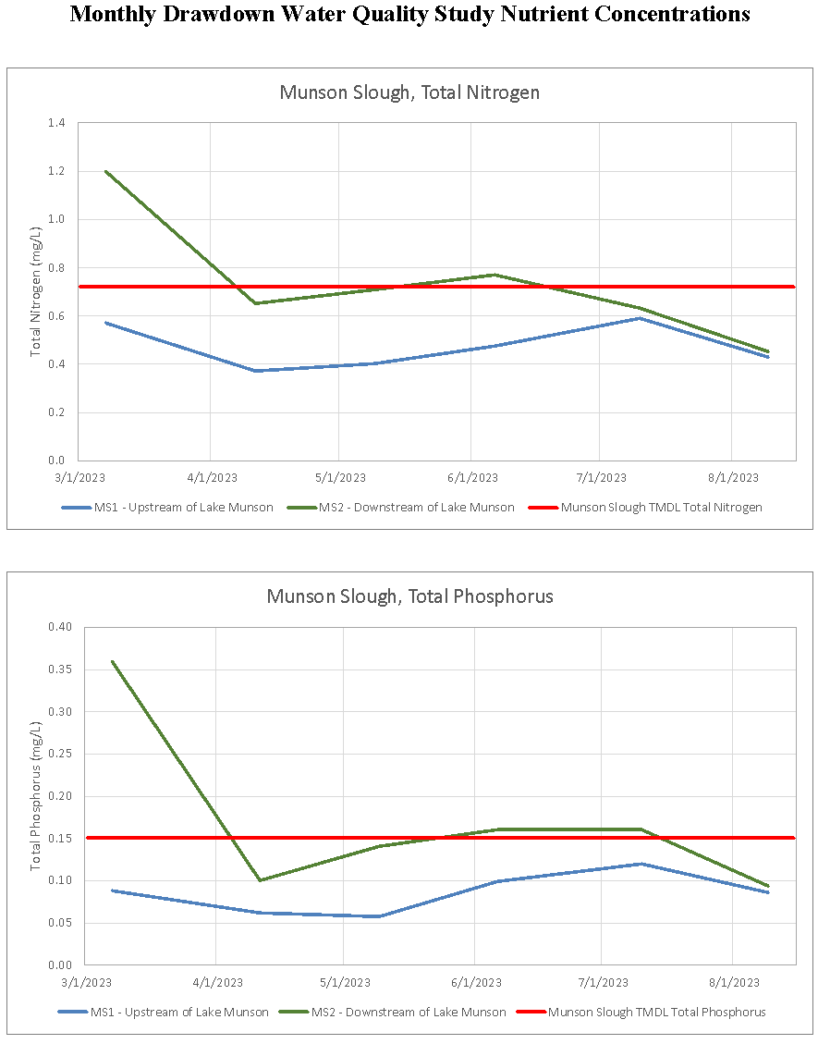

Appendix E

Grant Gelhardt’s Meeting Notes

