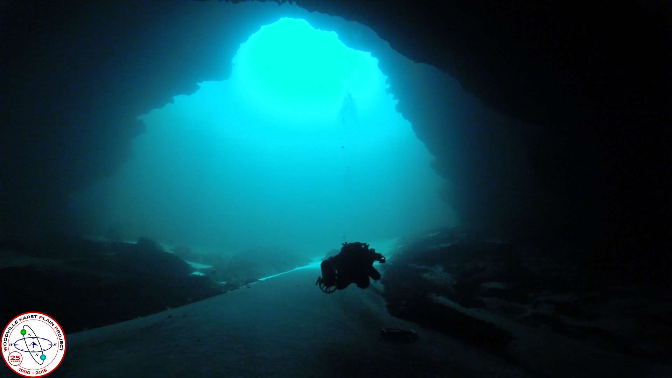

Wakulla Springs Alliance

**Agenda, Friday, March 23, 2018**

**9 am to 12 pm**

**9 am to 12 pm, Renaissance Center**

**435 N. Macomb Street, 2nd Floor Conference Room**

**WSA March Board Meeting Minutes**

**9:00 Opening**

Welcome and meeting agenda review (Seán McGlynn)

Introductions (Board)

Secretary Minutes (Bart Bibler, new secretary / Tom Taylor, past secretary)

Treasurer Report(Jim Davis, new treasurer / Bob Henderson, past treasurer)

Since the Meeting Minutes and Treasurer’s Report were just provided, they will not be approved until next month’s meeting.

Tom Taylor discussed the Strategic Planning efforts that we conducted in 2017. Some folks on the Issue committees have left. He asked to revive where each group left off, asked for interest in joining. Tom will take the lead in prompting the Committee chairs to move their planning efforts forward. Chuck Hess will join the Land Acquisition Issues group, and Doug Barr the Ecosystem Restoration Issues group.

**9:15 Saving Wakulla Springs** – Bart Bibler

Bart Bibler gave a presentation on his new business, Wakulla Springs Protection, which will help protect Wakulla Springs and promote the non-profits and businesses that are striving to protect Wakulla Springs. (Attached is the PowerPoint Presentation. The business website will launch on Thursday, April 26).

**9:45 Park Update**–Jim Stevenson

New Park Manager is Amy Conyers; who has experience with other Florida Springs. A new video has been produced on Florida Springs, that Jim Stevenson will provide for distribution.

[**https://florida.pbslearningmedia.org/resource/9fec0d90-49d3-4f11-a91d-f824fddbc757/clean-water-clear-water-exploring-the-floridan-aquifer/#.WrWL1JPwaRY**](https://florida.pbslearningmedia.org/resource/9fec0d90-49d3-4f11-a91d-f824fddbc757/clean-water-clear-water-exploring-the-floridan-aquifer/#.WrWL1JPwaRY)

**10:00 What’s New**

* Legislative Update – Vivian Young

Springs Protection funding by the Florida Legislature - $50 million. This will go through the WMDs for project selection and implementation. Jim asked Brett Cyphers of NWFWMD for an annual update on how the NWFWMD funds get spent. He said he’d be glad to provide that, as well as holdiong a meeting to provide an earlier and more complete update. Doug Barr asked about project nitrogen loading reduction forecasts as part of project selection, and followup monitoring to ensure that the forecast nitrogen reduction is achieved.

* Grant Update – Seán McGlynn

License plate grants are a work in progress with the next grant starting in June. An educational grant for implementing the BMAP is being applied for Ch. 319 funds from FDEP and will be through the Park Service as the WSA was not eligable. We are also looking at possible spring protection grants from the WMD for planting Submerged Aquatic Vegetation and removing *Lyngbya* in Wakulla Springs. We are also looking at possible Spring protection grants from the WMD for decreasing salt water intrusion at Spring Creek, which is affecting Wakulla Springs.

* Helicopter Flyovers at Wakulla Spring–Jim Stevenson

We’re on hold. The Wakulla Springs State Park boat crew is recording the times and info about helicopter flyovers.

* Big Bend Environmental Forum – Jim Stevenson

Big Bend Environmental Forum (BBEF) – WSA will renew its membership. They are an important organization that helps to clarify political candidate positions, especially on environmental issues. Jim usually gets a surge in Wakulla Springs Overland Tours by candidates prior to the BBEF. Good opportunity for partnerships, and getting more participation in the WSA.

* Dye Study Update – Seán McGlynn

We are still planning another Lake Lafayette dye study to take place after we get permission to dive in Indian Springs. Some surprises in the routes that the groundwater flow is going, through Sallie Ward springs (see attached update).

* Springshed Updates– Cal Jamison

Spring Creek has not flowed since October 2017, but has just started flowing again. Chuck Hess pointed out how the freshwater flow in Spring Creek is crucial to the survival of the oysters in Wakulla County.

* Land use in vulnerable areas of the Wakulla Springs Springshed – Gail Fishman

Two meetings that may impact Wakulla Springs land use:

1. COT Urban Forest Master Plan meetings; survey.
2. Meeting regarding the upcoming Wakulla County Bike Trail along Hwy 98.

Johnny Richardson discussed the nitrogen uptake of different types of trees, and will share the scientific papers with Gail so that these considerations will be part of what trees are planted, and consequences of cutting down trees.

* Camp Indian Springs – sold – Chuck Hess

Rich Adams is the purchaser. Suppose to be reopening it as a kids camp. Gail suggested that this would be a good time for someone from the Ecosystem Restoration Issues group to approach him to discuss his vision for the property. Sean is trying to get permission to dive on the property as part of the dye study.

* Website and Social Media, Updates – Tom Taylor
  + Wildlife Cam Update

Tom and Bart discussed the website, it’s strengths and limitations. There will be further discussion by the WSA about enhancements and website management, as part of our strategic planning.

**11:30 Wakulla Springs BMAP / OSTDS update** – Bart Bibler and Seán McGlynn

Jim Stevenson emphasized that the lakes with sinks are a part of the nitrogen problems of Wakulla Springs, and need nutrient improvements. Tom Taylor suggested that we may need a mediation meeting with FDEP once the draft BMAP is released.

**11:45 Items from the floor**

Jim – we need more folks at our WSA meetings. Each Board member should try to bring in another participant. Tom Taylor said that there will be a proposal for recruitment or membership by the next WSA meeting.

**12:00 Adjourn**