Wakulla Springs Alliance
5-19-17 Minutes and Action Items
WSA Action Info

This section provides information on what you and others can do to support research-based actions to enhance water quality and quantity in Wakulla Springs and the water/springshed and improve related environmental, economic and social systems. Efforts by all, produce results!

Background
- Wakulla Springs Information
- WSA Purpose and Plans
- WSA Action Resources

Upcoming Events
- Everyone is encouraged to attend the June 13 Intergovernmental Agency meeting at 3:00 in the City Commission Chamber. Agenda with consider this proposal and when and how to fund it and how it can help evaluate projects in the water bucket of the sales tax funds.
- Next WSA Meeting: Board meeting, June 16, 2017., 2nd floor, Renaissance Building

Action Items from the 5-19-17 WSA Board Meeting
- Bob Henderson needs to send the approved donation to the Springs Institute.
- The WSA will send a letter to the Intergovernmental Agency requesting early funding of the Wastewater Facility Engineering Plan. Everyone should contact City and County Commissioners. Bob Deyle and Pam Hall will draft the letter for WSA Exec. Comm. approval.
- Everyone is encouraged to follow legislative issues on 1000 Friends and FL Conservation Coalition websites and send emails and make calls, especially if the budget is vetoed and the legislature reconvenes.
- The Wakulla Springs wildlife cam will be available on our website soon.
- Bob Thompson’s wildlife report will be posted on the WSA website.
- 1000 Friends will send a letter to the County and the Corbetts regarding the proposed comprehensive plan change and development.
- Cal Jameson and Ryan Smart will talk to the Corbetts about the advantages of a conservation easement that will allow them to continue to live on the property, grow pines, etc. and other options.
- There needs to be more study of a proposal to eliminate Highway 61 south of Highway 267. We need to talk to David Edwards and possibly invite Pete Scalco to the next meeting.
- Gail Fishman will monitor the diving permit application for Sheppard Springs to see if WSA can be helpful.
- Bob Deyle will send the BMAP nitrogen reduction spreadsheets and Pam’s comments to Doug Barr, Sean McGlynn and others.
- Ryan Smart made a motion, seconded by Cal Jameson for people to nominate individuals for springs champion awards before the next meeting.
- We will consider the WSA logo at the next meeting.
- The Secretary will update the letterhead as needed.
- We have cards if any board member wants them.
5-19-17 WSA Board Meeting Minutes

Overview

The Wakulla Springs Alliance held their regular Board meeting on May 19, 2017 at the Renaissance Building. The draft agenda, treasurer’s report and list of participants can be found in Appendices A, B and C. Review the action items underlined for your commitments and actions you can help with. Our success in protecting and enhancing Wakulla Springs depends on the actions of the WSA board, advisors and supporters. This report is based on the secretary’s notes and does not capture everything or exactly what was said.

Opening

- Welcome and meeting agenda review by Seán McGlynn
- Introductions and news.
  - Nick Wooten updated the schedule for setting the Wakulla Minimum Flow and Level, MFL, which will be completed in 2020. More time is needed because of complications. They will integrate conduit and matrix flows.
  - UF Bob Graham awarded Ryan Smart as Young Floridian Award.
- Bob Deyle made a motion, seconded by Ryan Smart to approve the minutes and treasurer’s report and it passed unanimously
  - Bob Henderson needs to send the donation to the Springs Institute approved at the last meeting.

State Park Status Update - Jim Stevenson
- No state park director. The Deputy Secretary is running the program.
- There will Noah Valenstein came from Governor’s Office and then a Suwanee River WMD.
- Jim Stevenson presented a talk on science and Wakulla Springs at the March for Science (4000 attended).
- He also spoke to the Tallahassee Lyons Club.
- 60 from McClay School took the springshed tour.
- Tomorrow is last tour

Debbie Lightsey Park and Beyond

Charles Hargrave and Autumn Calder with Blueprint made a presentation and answered questions.
- They showed regional and Capital Circle SW maps.
- Debbie Lightsey Park and stormwater treatment designs were explained.
They had a problem with apple snails that required a change in vegetation type.
- Broadmoor Pond and Trail provide stormwater retention and will be a county park. Birds could be a FAA concern.
- They used a Chitosan system to treat water for turbidity during construction. This may be the first use in Florida.
- Delta Industrial Park has retention ponds and recreated wetlands. It was purchased in 2006 and named it the Debbie Lightsey Nature Park. It will be a great asset for everyone. Many stakeholders were involved. Landscape architects did the design pro bono. There will be natural play areas, picnic pavilions, wetland boardwalk, mountain bike trail, etc. It will connect to bike and greenways to Broadmoor Park, FSU sport fields, and more. They have design funding and there will be funding after 2019 using the sales tax funds.
- They also described the Capitol Cascades project with roads, water treatment and trails.
- There was a discussion about nitrogen and phosphorus in the flow and sediments in the lakes. Lake Munson sediments have high phosphorus. The County will be taking cores to test levels and determine the native bottom and muck and where karst features are.
- Gail Fishman encouraged natural trails through the woods in addition to formal playgrounds and paved trails. There is a natural trail across the street from Debbie Lightsey Park.
- They are working on structures and methods to reduce litter in the waterways.

Blueprint Funding of the Wastewater Facility Engineering Plan

- We have a letter encouraging early funding of the Plan with 15 groups signing it.
- Everyone is encouraged to attend the June 13 Intergovernmental Agency meeting at 3:00 in the City Commission Chamber. Agenda with consider this proposal and when and how to fund it and how it can help evaluate projects in the water bucket of the sales tax funds.
- Howard Kessler made a motion, seconded by Bob Deyle for the WSA to send a letter requesting early funding to IA and for everyone to contact City and County Commissioners. It passed unanimously. Bob Deyle and Pam Hall will draft the letter for WSA Executive Committee for approval.

Legislative Update

Ryan Smart, President of 1000 Friends of Florida reported that:
- No money for FL Forever or FL Communities Trust.
- DEP was cut by 20%, All environmental funding cut 18%.
- There is funding for springs and beaches,
- Senate bill 10 for an Everglades reservoir that goes back to a plan from 10 years ago.
- There were very few policy changes.
- The fracking bill died.
- There is lots to work on next year.
- Litigation on FL Forever will proceed.
- Everyone is encouraged to follow legislative issues on 1000 Friends and FL Conservation Coalition websites and send emails and make calls, especially if the budget is vetoed and the legislature reconvenes.

Website and Social Media Updates

- Tom Taylor showed the features and resources available on the WSA site.
- Sean McGlynn said that a Wakulla Springs wildlife cam will be available on our website soon.
- Bob Thompson wildlife report will be posted on the WSA website.

Springshed Updates

- Cal Jamison showed photos of the clear water, gators, algae and eel grass.
- Tuesday was the clearest water in a long time, 80’ on Tuesday, 67’ yesterday.
- Drought has reduced tannin runoff.
- Algal masses are the thickest in years. The clearer water contributes to faster growth.
- If we can fill the areas with eel grass there will be less algae but the nitrogen is still too high.

Corbett Property Update

- Last year there was a proposal for 300 single family and multifamily, which was challenged by 1000 Friends
- The Corbetts have a new proposal and have met with the County.
- The current proposal has 230 homes with central sewer and a conservation area around karst features. They are asking for intense zoning rather than a conservation residential zone, which would be better.
- They haven’t done the geophysical analysis yet.
- Bob Thompson is now on the planning commission.
- The parcel is on the WMD acquisition list. There is money in the budget for properties like this.
- Black Creek flows across the property. There are flooding problems and flows into sinks and swallets. This is above the mapped cave system.
- The Corbetts have owned the land for 40-50 years.
- 1000 Friends will send a letter to the County and the Corbetts.
- Cal Jameson and Ryan Smart will talk to the Corbetts about the advantages of a conservation easement that will allow them to continue to live on the property, grow pines, etc. and other options.
- A conservation easement is usually about 50% of the appraised value.
- DEP State Lands still has some funding for fee purchase from previous years. There was no new funding this year. Some legislators are supporting Florida Forever funding next year.
- There is a possible acquisition of the Gopher Sink track, which is adjacent to the River Sinks tract, that will create a continuous wildlife corridor to the National Forest. Wakulla Springs has agreed to manage it.

Wakulla County Proposal to Eliminate Wakulla Springs Road

- The Wakulla Springs Commission has heard a proposal to eliminate Wakulla Springs Road south of Highway 267 and create a new road from highway 61 to Spring Creek Highway.
- Wakulla Springs Park does not support this.
- Use of the Old Shell Point road could be better, less environment impacts and less costly then the proposed new road.
- This needs more study and talk to David Edwards. We could ask Pete Scalco to come to the next meeting.

St. Marks Refuge Diving Permit Request for Sheppard Springs

- This is by the same group that damaged Sally Ward. They are doing plant studies to document the problems.
- The cave system is small and limited.
- Gail Fishman will make a request to the WSA if we can be helpful.

Wakulla Springs BMAP / OSTDS update

- Bob Deyle commented on the last meeting regarding FDEP’s assessment of septic tanks.
- There was a review of the spreadsheet to calculate the nitrogen reductions. Bob used comments from Pam Hall at the meeting. Staff agreed to make needed adjustments.
- Septic systems are the area that can be best addressed to reduce nutrients. Air deposition and sinking streams will be hard to influence. There needs to recognition of population growth.
- Bob will send the spreadsheets and Pam’s comments to Doug Barr, Sean McGlynn and others.

Other Topics

- Gail Fishman met with the airport officials and they said that they must meet FAA requirements by mowing down milkweed and other plants needed for butterflies. Gail read more and they must consider endangered species like the monarch butterflies. They have agreed to move the plants.
- New letterhead
- We will consider the WSA logo at the next meeting
- Secretary will update the letterhead as needed
- We have cards if any board member
- A letter was requested by Kent Wimmer regarding a meeting this coming Friday, Apr 21. The ARC is considering adding 880 acres to the St. Joe Timberlands project. The tract is immediately north of the River Sinks Tract of Wakulla Springs State Park and east of Leon Sinks and US 319
- Jim Stevenson recommended that we give Springs Champion awards to leaders and do a press release. Ryan Smart made a motion, seconded by Cal Jameson for people to nominate individuals for springs champion awards before the next meeting. It passed unanimously.

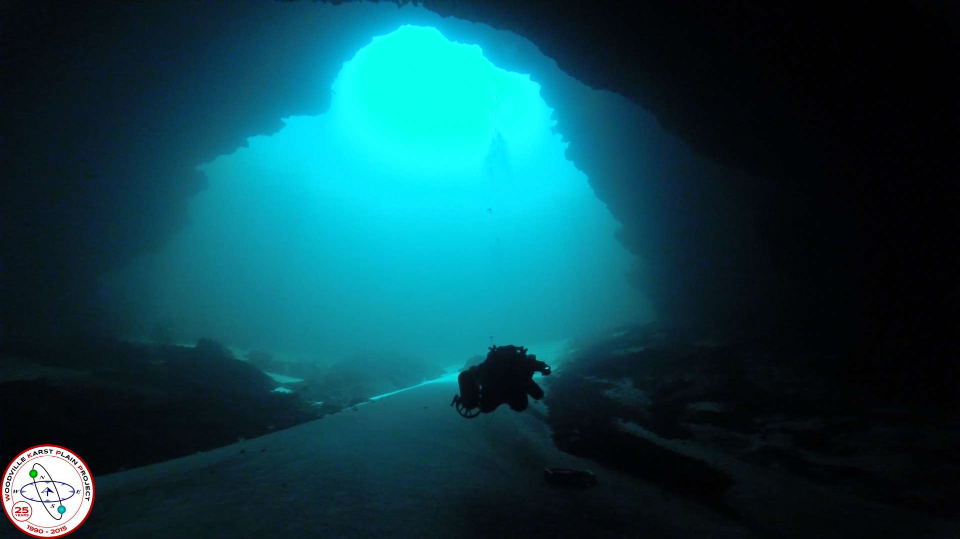
Wakulla Springs Alliance

Agenda 05/19/17
9 am to 12 pm, Renaissance Center
435 N. Macomb Street, 2nd Floor Conference Room

WSA Board Meeting

9:00 Opening
Welcome and meeting agenda review (Seán McGlynn)
Introductions (Board)
Secretary Minutes (Tom Taylor)
Treasurer Report (Bob Henderson)
9:10 Park Status Update - Jim Stevenson
9:30 Debbie Lightsey Park and Beyond: IG Blueprint 2000 Charles Hargrave
10:30 What’s new (about 5 minutes each)
- Legislative Update – Ryan Smart, President of 1000 Friends of Florida
- Website and Social Media, Updates – Tom Taylor
- Springshed Updates – Cal Jamison
  - Corbett property update – Cal Jamison, Ryan Smart
  - Ferrell property update – Cal Jamison, Ryan Smart
  - Wakulla County proposes to eliminate Wakulla Springs Road
- Wakulla Springshed, land use in the unconfined aquifer areas – Gail Fishman
- Land Acquisition
- New letters
  - Wildlife Connection Bradford Brooks Lakes (see logo)
  - Letter 2, Request from Kent Wimmer: This coming Friday, Apr 21, ARC is considering adding 880 acres to the St. Joe Timberlands project. The tract is immediately north of the River Sinks Tract of Wakulla Springs SP and east of Leon Sinks and US 319
  - Letter 3, request by Scott Davis for opinion on dive at Shepard Springs
11:30 Wakulla Springs BMAP / OSTDS update – Debbie Lightsey and Bob Deyle
Comments on the last meeting regarding FDEP assessment of septic tanks
11:55 Items from the floor
12:00 Adjourn

Appendix B
Board Advisors and Guests
* Indicates 5-19-17 Participants

Board Members

Bart Bibler
Bob Deyle *
Gail Fishman *
Albert Gregory
Bob Henderson
Cal Jamison *
Howard Kessler *
Debbie Lightsey
Sean McGlynn *
Ryan Smart *
Jim Stevenson *
Tom Taylor *
Rob Williams

Guests

Doug Barr *
Autumn Calder *
Charles Hargrave *
Mark Heidecker *
Johnny Richardson *
Nick Wooten *

WSA Advisors

Anthony Gaudio
Pam Hall *
Julie Harrington
Chuck Hess *
Todd Kincaid
Bob Knight
Terrance McCaffrey
Pam McVety
Dan Pennington
Bob Thompson *

Appendix C

 | Financial Statement
 | Wakulla Springs Alliance
 | For Period Ended
 | April 30, 2017
INCOME | Budget | In-Kind | Current Month | Y-T-D Trans |  | Checking Account
Fund Balance (January 1, 2017) | 3854.46 |  |  | 3854.46 | BFB | 3854.46
Palmetto Tours |  |  |  |  | Income | 150.00
Board Member Contributions |  |  | 150.00 | 150.00 | Expense | 386.25
Other Donations |  |  |  |  | Grant
 |  |  |  |  | EFB | 3618.21
Subtotal | 0.00 | 0.00 | 150.00 | 150.00
TOTAL | 3854.46 | 0.00 | 150.00 | 4004.46
EXPENDITURES |  |  |  |  | Rest
Secretary Expenses |  |  |  |  | Unrest | 3618.21
Web Support |  |  |  | 325.00
Corporate Filing Fee | 61.25 |  |  | 61.25
 |  |  |  |  | Bank Statement | 3618.21
 |  |  |  |  | Checks not
 |  |  |  |  | Recorded
RESERVES
 |  |  |  |  | Deposits not
 |  |  |  |  | Recorded
 |  |  |  |  | Due to/from
 |  |  |  |  | Projects Fund
 |  |  |  |  | EFB | 3618.21
TOTAL | 61.25 | 0.00 | 0.00 | 386.25 | (Overage) | 0.00

