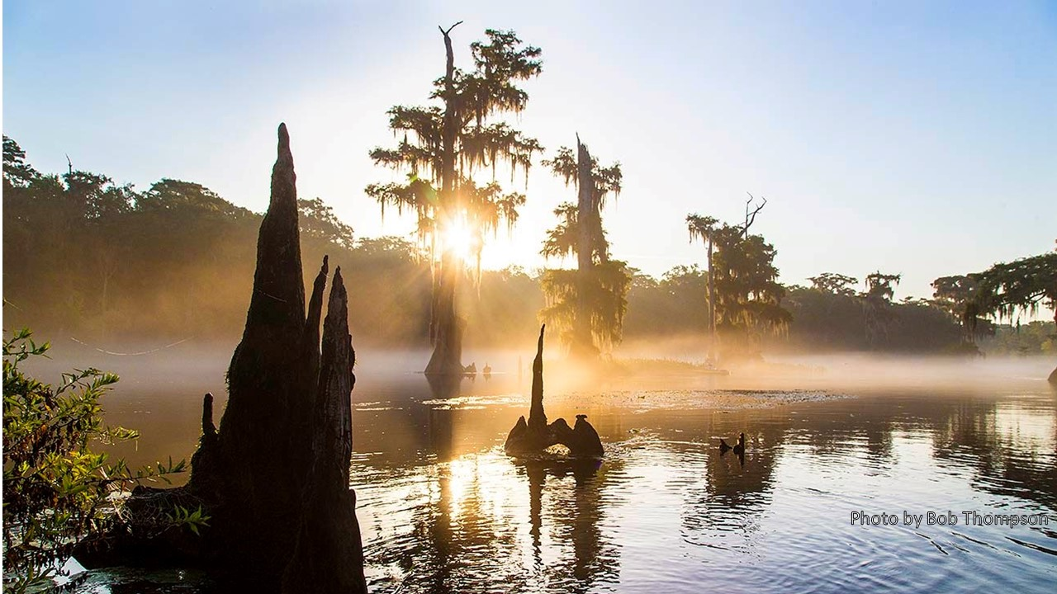
Wakulla Springs Alliance
Friday, November 20, 2020 Board Meeting Notes

Board members present: Bob Deyle, Tom, Taylor, Albert Gregory, Cal Jamison, Terry Ryan, Lindsay Stevens, Jim Stevenson, Debbie Lightsey, Jim Davis
Others present: Chuck Hess, Mark Heidecker, Johnny Richardson, Brian Kaplan, Carlos Herd, Kathleen Coates, Sophie Wacongne-Speer, Andreas Hagberg
Opening
Bob Deyle welcomed everyone went over the agenda and asked for introductions
Presentation: Why is the Water Dark? Part I
Bob Deyle presented an overview of findings from the 4.5-year projected funded with three grants from the Fish and Wildlife Foundation of Florida. He noted that data collected by McGlynn Labs Inc. (MLI) on water quality, light transmission in the spring, and dye studies, form the backbone of the project. Other analyses were conducted by researchers at FSU and FAMU on algal taxonomy and environment DNA. Advanced statistical analyses were conducted by faculty at Boston University.
Deyle addressed three research questions in the overview and then presented detailed findings on the first question:
- What are the light-absorbing substances responsible for the dark water conditions?
- What are the sources of those light-absorbing substances?
- Why have the frequency and duration of dark water conditions increased?
Regarding causes, Deyle reported that three light-absorbing substances are present in the spring:
- Colored Dissolved Organic Matter (CDOM): measured as “true color” (tannins)
- Chlorophyll a: measured as corrected chlorophyll A and pheophytin a
- Suspended particulates: measured as turbidity
Analyses of conditions during times when visibility is both highest and lowest, as well as spectral radiometric analyses of light absorption in the spring, and statistical analyses reveal that two of these substances have significant negative impacts on visibility: CDOM measured as true color and corrected chlorophyll a. Both contribute to dark water conditions when visibility depth is greatest and the apparent color is green rather than brown. Absorption spectra for CDOM indicate that low concentrations of tannins can impart an apparent green color to water. Small increases of each have a greater impact when visibility is greater.
Regarding sources, Deyle reported that water quality analyses completed by MLI indicate that CDOM (tannins) and chlorophyll are delivered to the spring in ground water flowing through all the major caves that converge upstream of the spring vent.
Previous dye studies had established hydrogeologic connections to Wakulla Springs from the Leon Sinks sinking streams, Lost Creek, and Lake Munson via Ames Sink. Dye studies conducted by MLI demonstrated connections with lakes Jackson, Iamonia, and Lafayette.
Analyses of samples from the lakes and the spring vent and/or L well for algal taxonomy and environmental DNA identified taxa at the spring unique to each of the lakes except Iamonia providing additional evidence that chlorophyll observed at the spring may have originated from those lakes.
Deyle will present specifics from the cave water quality analyses, dye studies, and algal/eDNA analyses in December.
Regarding changes in the frequency and duration of dark water conditions, Deyle reported that comparison of CDOM (measured as true color) and chlorophyll levels recorded during the project with historical data indicates that CDOM levels may have increased while chlorophyll levels may have decreased. The trend for chlorophyll is less certain because historical data are few.
In his December presentation, Deyle will address several other possible factors:
- Changes in rainfall patterns
- Changes in ground water withdrawals within the springshed
- Changes due to sea level rise
- Resulting changes in Wakulla Spring - Spring Creek dynamics
- Declining spring pool stage elevation
During Q&A, Mark Heidecker pointed out that many of the chlorophyll measurements reported by MLI on FDEP’s Watershed Information Network (WIN) data base were at or below the reported method detection limits (MDL).
Membership dues and website Join/Donate page
Bob Deyle reiterated that the annual membership dues the Board adopted a couple of months back take effect January 1. To remain a member in good standing or to become a member as of that date, we ask that individuals pay dues via PayPal on our website or by mailing a check to our treasurer, Jim Davis. Dues payments received after June 30 each year count towards the following year. If you pay now you are covered for all of 2021. Only members who have paid dues by January 22 will be eligible to participate in electing new Board Directors in the annual meeting election. Rob Gelhardt has made changes to the Join/Donate page on our website so that people can pay membership dues and/or make financial contributions online. The mailing address also is listed on the website.
Nominating Committee update – Albert Gregory, Howard Kessler, Jim Stevenson
Upcoming meetings and events – Bob Deyle
- WMD MFL workshop today 1:30 – 2:30 pm
Carlos Herd reported that the Water Management District has posted the full draft technical report and accompanying appendices on the district’s website at https://www.nwfwater.com/Water-Resources/Minimum-Flows-Minimum-Water-Levels. Comments should be submitted on line to MFL@nwfwater.com by January 20, 2021.

- WSA December 18 meeting (3rd Friday!) – Why is the Water Dark? Part II

- January 22 annual meeting - Elections of Directors and Officers
What’s new?
- Springshed and river update - Cal Jamison

- Reports from Ferrell Tract tours - Lindsay, Cal, Tom, Bob D

- What else? Bob Deyle passed along news that Carol Schwarz died suddenly earlier in the week. Carol served on the WSA Board circa 2014 and was one of our most effective environmental and land use advocates with local and state government.
Board business meeting
- Oct minutes – Tom Taylor
Approved as submitted.
- Oct financial report – Jim Davis
Jim pointed out substantial income in November from people paying membership dues including our first life member who contributed $2,000. Approved as submitted.
- Interim vice chair appointment– Bob Deyle
Bylaws require that nominations be sent to Secretary at least 14 days in advance of the board meeting at which the vacancy will be filled. At the Board meeting on October 23, Debbie Lightsey agreed to serve as interim vice chair. That served as the nomination notification. No other nominations were received prior to November 7, 14 days prior to the scheduled Nov 20 meeting.
The Board voted unanimously to appoint Debbie.
- Settlement agreement update – Bob Deyle
We have a signed and notarized agreement in place as of Friday, November 6th.
Sean’s attorney had indicated two weeks earlier that our proposed revisions to the agreement were satisfactory and that he just needed to get Sean’s signature. However, the following Monday, he informed our attorney that Sean had changed his mind about wanting a retraction letter.
We managed to come up with an acceptable letter that was within the bounds of the Board’s previous direction so, with the review and approval of the Executive Committee, we provided that letter as an attachment to the settlement agreement.
Bob noted that one clause serves as a mutual non-disparagement pledge. He will send copies of the agreement and letter to all Board members and urged all to familiarize themselves in particular with the non-disparagement clause.
Bob submitted the final invoice from Sean to the Fish and Wildlife Foundation for direct payment to Sean yesterday. They indicated that they would process it promptly.
He indicated that he intended to send a formal thank you letter to Robert Rivas along with a gift certificate to the lodge restaurant, a park entry pass, and two vouchers for river tours.
- General liability insurance update - Bob Deyle
Bob has contacted the agent at Earl Bacon, and he is securing an updated quote from Philadelphia Indemnity. He did not think we would need to prepare an amended application.
As you may recall, the previous quote was for $784, which was the basis for Board approval at our July 31 meeting. So, barring no unforeseen hiccups, we should have the policy in place shortly.
The Board voted unanimously to authorize Bob to purchase the insurance for up to $1,200.

Appendix A
Wakulla Springs Alliance
Friday, November 20, 2020 Board Meeting Agenda
9 to 11:30 am, via Zoom

9:00 Opening
- Welcome and introductions - Bob Deyle
- Agenda review - Bob Deyle
9:15 Presentation: Why is the Water Dark? Part I – Bob Deyle
10:15 Membership dues and website Join/Donate page – Bob Deyle
10:25 Nominating Committee update – Albert Gregory, Howard Kessler, Jim Stevenson
10:30 Upcoming meetings and events – Bob Deyle
- WMD MFL workshop today 1:30 – 2:30 pm
- December 18 meeting (3rd Friday!) – Why is the Water Dark? Part II
- January 22 annual meeting - Elections of Directors and Officers
10:35 What’s new?
- Springshed and river update - Cal Jamison
- Reports from Ferrell Tract tours - Lindsay, Cal, Tom, Bob D
- What else?
10:50 Adjourn
11:00 Board business meeting
- Oct minutes – Gail Fishman
- Oct financial report – Jim Davis
- Interim vice chair appointment– Bob Deyle
- Settlement agreement update – Bob Deyle
- General liability insurance update - Bob Deyle

