Wakulla Springs Alliance

**Friday, April 26, 2019 Board Meeting Minutes**

This section provides information on what you and others can do to support research-based actions to enhance water quality and quantity in Wakulla Springs and springshed and to improve related environmental, economic and social systems. Efforts by all, produce results!

**Background on Wakulla Springs**

• Wakulla Springs Information

• WSA Purpose and Plans

• WSA Action Resources

**Strategic Opportunities**

* Nominate yourself or others for, 2019 WSA Chair, Secretary, board member or advisor, by emailing [Jim Stevenson](mailto:Jim%20Stevenson%20%3cflorida_springs@comcast.net%3e). The success of the WSA depends on its leadership, members, advisors and supporters; make a commitment and make a difference. There will be an election for the board and officers on June
* ~~Provide WSA website management (It is easy, training will be provided~~).
* Attend these WSA meetings: 6-28, 7-26, 8-23, 9-27, 10-25, 11-22, 12-13, all meetings are from 9:00 to 12:00 (Nov 22, 9:00 to 11:00). Put on your calendar.
* Attend [Springs Academy](https://floridaspringsinstitute.org/springs-academy/?utm_source=FSI+News&utm_campaign=ad478c1961-EMAIL_CAMPAIGN_2017_11_03_COPY_03&utm_medium=email&utm_term=0_1610aea1ed-ad478c1961-98086349) classes and/or review past classes.
* There was a motion to send a WSA letter highlighting the environmental impacts of the proposed powerline to City and County Commissioners and others. It was approved unanimously.
* The Hwy 319 holding ponds are under construction. We need to take photos if a sinkhole opens up. Someone said they stopped construction because of a problem. Cal will follow-up on this.
* The new WSA brochure is available for distribution.
* Jim Stevenson agreed to nominate a slate of board members and officers.
* Bruce Chapman will work on WSA bylaws.
* Bob Deyle will take over responsibilities for posting materials to the website. Tom Taylor will assist in the transition.

**WSA January 25 Board Meeting Minutes**

**Overview**

The Wakulla Springs Alliance held their regular Board meeting on April 26, 2019 at the Renaissance Building. The agenda and participants are in Appendices A and B. Review the action items underlined for your commitments and actions you can help with. Our success in protecting and enhancing Wakulla Springs depends on the actions of the WSA board, advisors and supporters. This report is based on the recorder’s notes and does not capture everything or exactly what was said.

**Opening**

* Welcome and meeting agenda review (Seán McGlynn).
* Introductions (Board, advisors and guests – See Appendix B).
* The Secretary’s Report was prepared by Tom Taylor, acting secretary. There was no treasurer report.

**NextEra Powerline**

* Sean McGlynn presented maps of the proposed powerline path, watersheds, sinkholes and pictures of sinkholes opened by powerlines.
* The proposed powerline along Tram Road crosses three springsheds.
* Towers will be every 500 feet and require drilling pilings that may create sinkholes.
* Thousands of trees will be lost.
* There was a motion to send a WSA letter highlighting the environmental impacts of the proposed powerline to City and County Commissioners and others. It was approved unanimously.

**Park and Springs Status (**Jim Stevenson+)

* PBS is doing a documentary on springs, including interviewing legislators.
* Gainer Springs has had the 41,000 acres of land acquired by the NWFWMD in Washington and Bay Counties.
* 8,000 acres has been acquired in the Wakulla Springs springshed.
* Itchetucknee is in the process of acquiring more land.
* Acquisition is one of the best ways to protect springs.



**Springshed Status** (Cal Jamison+) Water levels in sinks have been 1 to 1 ½ feet low for about a month

* Creek flows are lower.
* Spring Creek flow is strong.
* Wakulla Springs clearing. It was 50+ feet yesterday and the mastodon bones could be seen.
* Chlorophyll plus Phaeophytin is lower.
* Sean showed pictures of spring run from when he was in HS, college, hydrilla era and now.
* We need replanting for the recovery of native aquatic vegetation.
* Bob Knight was interested in oxygen data and he will do it.
* The Hwy 319 holding ponds are under construction. We need to take photos if a sinkhole opens up. Someone said they stopped construction because of a problem. Cal will follow-up on this.
* Cadaver dogs found more sites at the Cherokee Sink grave site. There are no grave stones left. They were probably thrown into the sink. Divers may search for them in 4-6 feet of muck. Ground radar mapped the site. The radar was also used to examine a cave.

**Grant updates** (Seán McGlynn+)

* Bob Knight was on the tour yesterday. He has provided new equipment from his grant.
* There is a new $600,000 grant for education efforts. Pete Scalco is the grant manager.
* Ryan Smart is working with the FL Springs Council on this.
* It may be good to study productivity (amount of carbon being fixed by plants (good and bad). The aquatic vegetation study is very important. We need a periphyton analysis of the grasses, as well as, the sediments.
* Susan Foley has been doing paleo studies.
* The new WSA brochure is available for distribution.

**FDEP on Revision of BMAP Nitrogen Targets at Wakulla Springs** (Doug Barr+)

* Doug Barr and Sean met with Tom Frick about moving the target level from .35 to .27.
* The problem is to get Wakulla and Leon Counties to come to terms with the .35. It may take a couple of years.
* Doug and Sean asked DEP to review the rapid periphyton survey and Tom agreed to proceed with this.
* Periphyton grows on the plants. There should be snails on the grasses.
* They are looking at the algae growth on the grasses.
* They were interested in Sean’s reports on the submerged aquatic vegetation.
* This was a good outcome.
* The Wakulla Springs BMAP has 2 standards: .35 N and to restore the biological community. The last part is not in most BMAPs. We may want more than the rapid periphyton survey, which only looks at the periphyton on the sediments not plant life.
* Some studies show blue green algae, which is a toxic cyanotoxin. This may kill the snails and impact birds. The snails are gone from Wakulla Springs and Lake Munson. Nitrogen is necessary for the blue green algae. There was a Michigan researcher, Stevenson, who did a study.
* Reducing the match requirement for the Counties to get acceptance.

**Gimme Green -** Everyone watched this video, that is available on DVD and online.

**Legislative Report** (Vivian Young)

* Water Act addresses everglades and springs. SB 1758 went from good to bad.
* Ag and other provisions have been dropped.
* Ask for senator to restore earlier bill.
* FL Forever budget is being cut.
* Sen 7068 for rural toll roads for big land owners from GA to Collier Country. Oppose! It will cost billions and have big environmental impacts.

**WSA Board and Officer Elections**

* We still do not have nominations for the board and officers.
* Jim Stevenson agreed to nominate a slate of board members and officers.
* Current board members and officers will serve until the elections are held.

**WSA Bylaws**

* Bruce Chapman will work on WSA bylaws.

**Website**

* Bob Deyle will take over responsibilities for posting materials to the website. Tom Taylor will assist in the transition.

**Future Meeting dates for 2019:** 04/26/19 [canceled], 05/24/19, 06/28/19, 07/26/19, 08/23/19, 09/27/19, 10/25/19, 11/22/19, 12/13/19

Appendix A

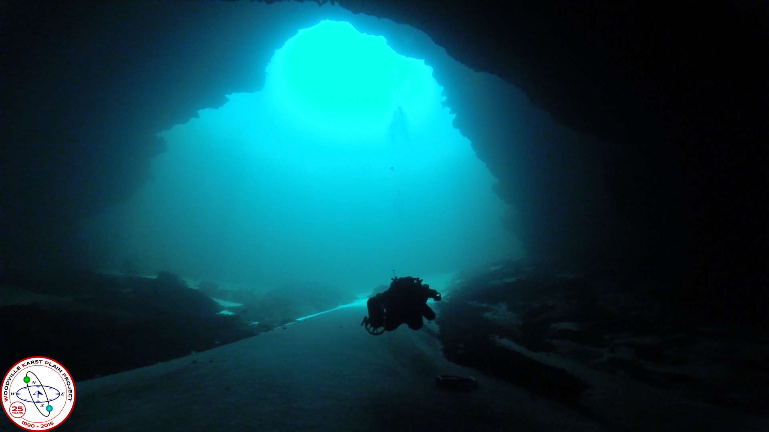

Wakulla Springs Alliance

**Friday, April 26, 2019**

**9 am to 12 pm, Renaissance Center**

**435 N. Macomb Street, 2nd Floor Conference Room**

**WSA April Board Meeting**

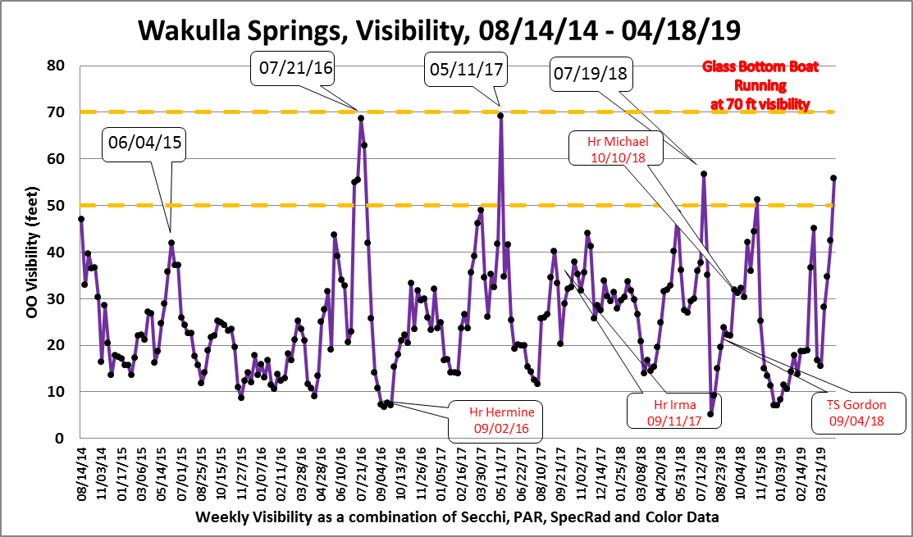

Wakulla Springs is clearing again, approx. 50 foot visibility…

**Park Status Update (Jim Stevenson)**

**Clean Waterways Act Update**

**Water Quality Initiative Update**

**Wakulla Septic Tank Ordinance (Wakulla County Commissioner, Chuck Hess)**

* Old Rule: One Advanced Septic Tank per 5 acres
* New Rule: One conventional septic tank per acre

**What’s New**

* NextEra Powerline
* Grants update (Seán McGlynn)
* Springshed Status (Cal Jamison)
* New WSA brochure
* FDEP on BMAP Nitrogen Target Revisions at Wakulla Springs (Doug Barr)
* FWC herbicide use moratorium (comments)

**30 minute video ‘Gimme Green’**

**Future Meeting dates for 2019:** 04/26/19, 05/24/19, 06/28/19, 07/26/19, 08/23/19, 09/27/19, 10/25/19, 11/22/19, 12/13/19…

Appendix B

**Board, Advisors and Guests**

* Indicates 4-26-19 Participants

Board Members

Doug Barr *

Jim Davis, Treasurer

Gail Fishman *

Albert Gregory *

Jamie Hughes

Cal Jamison *

Howard Kessler, V-Chr.

Debbie Lightsey *

Sean McGlynn, Chair *

Jim Stevenson *

Vivian Young *

WSA Advisors

Bob Deyle *

Anthony Gaudio

Pam Hall

Julie Harrington

Chuck Hess

Todd Kincaid

Bob Knight

Terrance McCaffrey

Pam McVety

Dan Pennington

Bob Thompson

Guests

Bruce Chapman *

Kathleen Coates *

Lydia Eldridge *

Andreas Hagberg *

Mark Heidecker *

Mary Beth Litrico *

Brian Lupiani *

Tom Taylor *

Sophie Wacongne-Speer*

Appendix C

Wakulla County Board of County Commissioners,

The Board of the Wakulla Springs Alliance respectfully requests that the Wakulla County Board of County Commissioners not weaken your Policy 1.3.6 of the Wakulla County Comprehensive Plan, requiring nitrogen reducing septic systems on parcels smaller than five acres in the Wakulla Springs Special Planning Area local. We make this request for these reasons:

* + Any changes to this policy may have consequences for the county’s obligations under the BMAP
  + Changes to this policy could result in unknown environmental impacts, therefore prior to making any changes, Wakulla county needs to communicate with DEP
  + Wakulla County has a grant agreement with DEP to conduct a county-wide wastewater treatment facility feasibility study. The study should result in a comprehensive action plan for the County to address existing and future wastewater treatment needs and methods from a technical, financial and legal perspective. Changes to the policy should wait for results from the feasibility study.

The Board of The Wakulla Springs Alliance thanks you for your consideration on this matter.

Sean McGlynn

President

Wakulla springs Alliance