Wakulla Springs Alliance

Friday, November 30, 2018 Board Meeting Minutes

This section provides information on what you and others can do to support research-based actions to enhance water quality and quantity in Wakulla Springs and springshed and to improve related environmental, economic and social systems. Efforts by all, produce results!

Background on Wakulla Springs

• Wakulla Springs Information
• WSA Purpose and Plans
• WSA Action Resources

Action Items

- Please volunteer for, or nominate others for, 2019 WSA board members and officers, ASAP, by emailing ttaylor@fsu.edu. The success of the WSA depends on it’s leadership, members, advisors and supporters; make a commitment and make a difference. We also need someone to take the lead on updating the WSA bylaws and website management.
- Mark these WSA meetings on your new 2019 calendars: 1-25, 2-22, 3-22, 4-26, 5-24, 6-28, 7-26, 8-23, 9-27, 10-25, 11-22, 12-13, all meeting are 9:00 to 12:00 except Nov 22, 9:00 to 11:00
- There may be a revised letter regarding sewage spills in Tallahassee that may be approved by the Executive Committee. See draft in Appendix D.
- There was a motion to send a letter about mitigation for land taken for Highway 319 widening (after talking to Linda Dockery) made by Debbie Lightsey, seconded by Doug Barr, which passed unanimously. See draft in Appendix E

WSA July Board Meeting Notes

Overview

The Wakulla Springs Alliance held their regular Board meeting on November 30, 2018 at the Renaissance Building. The agenda and participants are in Appendices A and B. Review the action items underlined for your commitments and actions you can help with. Our success in protecting and enhancing Wakulla Springs depends on the actions of the WSA board, advisors and supporters. This report is based on the recorder’s notes and does not capture everything or exactly what was said.

Opening

- Welcome and meeting agenda review (Seán McGlynn).
- Introductions (Board, advisors and guests).
- The Secretary’s Report was made by Tom Taylor, acting secretary. The motion to approve the minutes was made by Jim Steveson, seconded by Doug Barr and passed unanimously.
- Treasurer Report (Jim Davis, treasurer) The report was presented and had been sent out with the agenda. The motion to approve the report was made by Doug Barr, seconded by Debbie Lightsey and passed unanimously.

Waste Management

- Jim Stevenson presented a PowerPoint that showed:
  - Hurricane Michael waste at 3-Rivers and Marianna Caverns State Parks
  - Septic tanks above cave systems
  - Park port-a-johns
  - Itchetucknee pee problems
  - Industrial agriculture operations
  - Silver Glen boats
  - Municipal ocean discharges
  - More

Tallahassee Sewage Spills

- A draft letter regarding sewage spills in Tallahassee was discussed
- Individual letters were encouraged.
- Inviting commissioners to take Jim’s Springs Tour and walk abouts to other problem areas was suggested.
- There may be a revised letter regarding sewage spills in Tallahassee that may be approved by the Executive Committee. See draft in Appendix D.

Wakulla Springs BMAP TMDL

- Doug Barr explained the history of how the Total Maximum Daily Load (TMDL) was set for Wakulla Springs and other springs and recommended that the level should be set at .27 rather than the adopted level of .35.
- A TMDL of .35 will require a 139,564 lb./yr. reduction in Nitrogen. A 250,404 lb./yr. reduction will be needed if the TMDL is changed to .27.
- Doug sent a letter to DEP with his analysis and is waiting for a response.
- UF may have more data.
- Flow reductions may impact concentrations.
- Keep in mind that this is a 15-year BMAP.

Criteria for Verified Class 3 Waters

- Sean McGlynn alerted the group about the change in criteria for Verified Class 3 Waters.
- There was a question of whether waters need to be on the list if a TMDL has been set.
- Linear vegetation surveys are needed.

“Burma Shave” signs for Wakulla Springs

- Rick Abrams the new owner of Indian Springs will permit the signs on his property.
- Jim Stevenson and Cal Jamison will revise the wording for the signs
- [The signs have been erected by a team of WSA and FOWS volunteers]

Springs Updates

- Cal Jamison reported little change.
- Clarity is at 19 feet.
- Spring Creek is flowing
- Lake Henrieta is the highest it has been in 20 years

Wakulla Springs Brochure

- Bob Deyle, Jim Stevenson, Debbie Lightsey and Pam Hall have worked hard on the revisions with assistance from the WMD.

Highway 319 Widening and State Land Mitigation

- There was a loss of 44 acres and with a 1.5 multiplier 66 acres are needed for mitigation
- 5 acres with access to Turner Sink is in process and another 10 acres is under consideration.
- There was a motion to send a letter about mitigation for land taken for Highway 319 widening (after talking to Linda Dockery) made by Debbie Lightsey, seconded by Doug Barr, which passed unanimously. See draft in Appendix E.

Appendix A

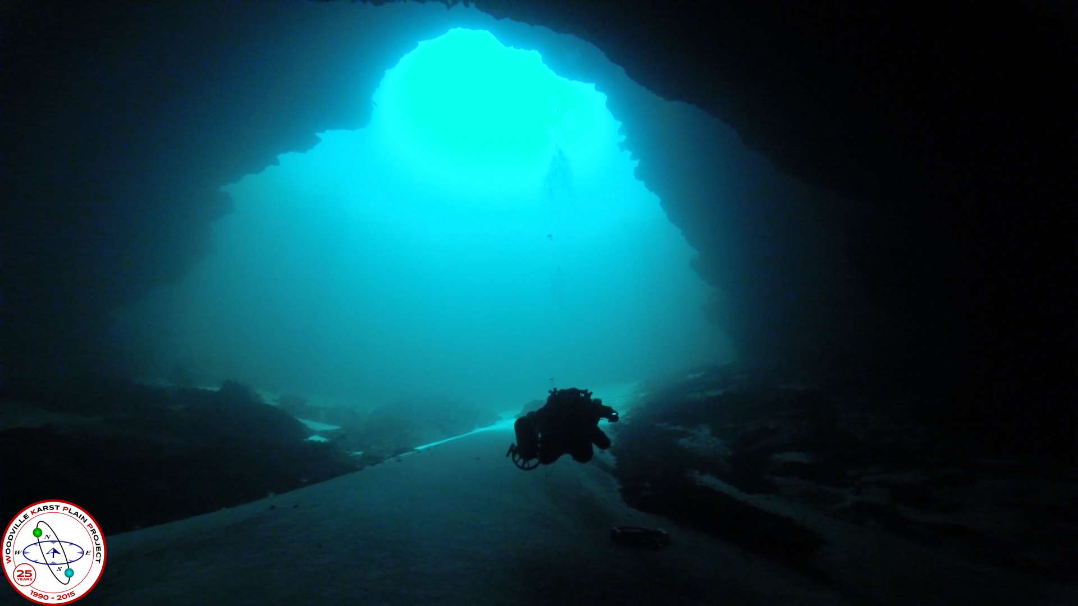
Wakulla Springs Alliance

Agenda, Friday, November 30, 2018
9 am to 12 pm, Renaissance Center
435 N. Macomb Street, 2nd Floor Conference Room
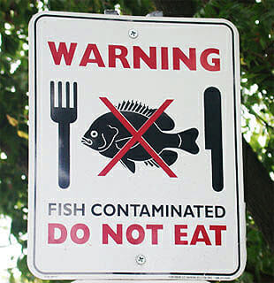

WSA November Board Meeting
9:00 Opening
Welcome and meeting agenda review (Seán McGlynn)
Introductions (Board)
Secretary Report (Tom Taylor, substitute secretary)
Treasurer Report (Jim Davis, treasurer)
9:15 Wakulla and Sally Ward Springs MFL Development and Data Collection – Dr. Paul Thurman, Senior Environmental Scientist NWWMD.
9:45 Waste Management – Recreation and Livestock – Jim Stevenson, founder of Florida Springs Task Force.
- Letter to address sewage spills in Tallahassee.
10:15 Revision of BMAP Nitrogen Target and Loading Reduction – Doug Barr, former Director WMD.
10:45 Changes to the ‘List of Impaired Waters’ and the Wakulla Springs BMAP– Seán McGlynn.
11:15 Questions for speakers
11:25 Whats New
- Letter to the Division of State Lands regarding mitigation agreement for Park land used for widening highway 319 – Seán McGlynn.
- Burma Shave Signs – Cal Jamison.
- Springshed Updates – Cal Jamison.
11:55 Items from the floor
12:00 Adjourn
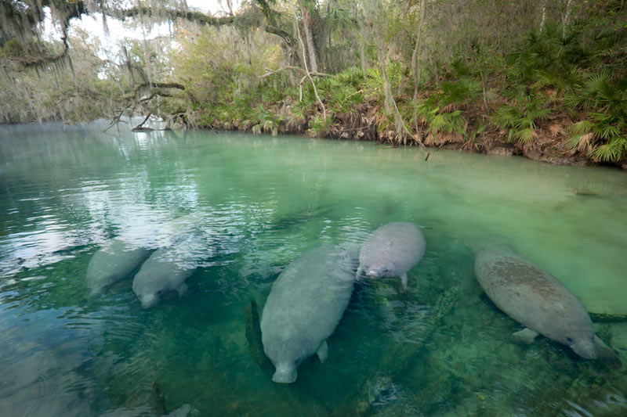

Appendix B
Board, Advisors and Guests
* Indicates 11-30-18 Participants

Board Members

Doug Barr *
Jim Davis, Treasurer *
Gail Fishman *
Albert Gregory *
Jamie Hughes
Cal Jamison *
Howard Kessler, V-Chr. *
Debbie Lightsey *
Sean McGlynn, Chair *
Jim Stevenson *
Vivian Young

Guests

Kathleen Coates *
Eric Etters *
Andreas Hayberg *
Mark Heidecker *
David Henry *
Jim Lemar *
Mary Beth Litrico
Jerry Miller *
Susan Poplin *
Johnny Richardson *
Craig Talzon *
Tom Taylor *
Matt Thro *
Paul Thurman *
Sophie Wawngne-Speer *

WSA Advisors

Bob Deyle
Anthony Gaudio
Pam Hall
Julie Harrington
Chuck Hess
Todd Kincaid
Bob Knight
Terrance McCaffrey
Pam McVety
Dan Pennington
Bob Thompson

Appendix C
 |  |  |  | Financial Statement
 |  |  |  | Wakulla Springs Alliance
 |  |  | For Period Ended
 |  |  |  | October 31, 2018
INCOME | INCOME | Budget | In-Kind | Current Month | Y-T-D Trans
Fund Balance (January 1, 2018) | Fund Balance (Januray 1, 2018) | 3654.95 |  |  | 3654.95 | BFB
Palmetto Tours | Palmetto Tours |  |  | 244.00 | 812.00 | Income
Board Member Contributions (4) | Board Member Contributions (4) |  |  |  |  | Expense
Other Donations | Other Donations |  |  | 100.00 | 100.00 | Grant
 |  |  |  |  |  | EFB
Subtotal | Subtotal | 0.00 | 0.00 | 344.00 | 912.00
TOTAL | TOTAL | 3654.95 | 0.00 | 344.00 | 4566.95
EXPENDITURES | EXPENDITURES |  |  |  |  | Rest
BBEF Dues | BBEF Dues |  |  | 85.00 | 85.00
Web Support | Web Support
Corporate Filing Fee | Corporate Filing Fee | 61.25 |  | 61.25 | 61.25
Grants | Grants |  |  |  |  | Bank Statement
Florida Springs Alliance | Florida Springs Alliance |  |  | 500.00 | 500.00
Board Workshop | Board Workshop |  |  |  |  | Checks not
Awards | Awards |  |  | 189.09 | 189.09 | Recorded
RESERVES | RESERVES
 |  |  |  |  |  | Deposits not
 |  |  |  |  |  | Recorded
 |  |  |  |  |  | Due to/from
 |  |  |  |  |  | Projects Fund
 |  |  |  |  |  | EFB
TOTAL | TOTAL | 61.25 | 0.00 | 835.34 | 835.34 | (Overage)

Appendix D
[Draft letter, to be revised]
November 29, 2018
Mayor John Daily and City Commissioners
and Mr. Reese Goud, City Manager
300 S. Adams St., Tallahassee, FL. 32301

Gentlemen:

The Wakulla Springs Alliance is concerned about the number and frequency of sewage spills, in the Wakulla Springs springshed. On May 4, 2014, the city of Tallahassee’s Pump Station 74 failed and spilled approximately 500,000 gallons of raw sewage into Weems Pond that flows to Upper Lake Lafayette. It is important to know that the lake has many sinkholes that recharge our drinking water supply and contribute flow to Wakulla Springs. On September 26, 2016 Lake Munson received approximately 1.6 million gallons of raw sewage. Lake Munson also has hydrological connections to Wakulla Springs. More recently, on November 9, 2018 another 325,000 gallons of raw sewage was discharged to Holley Pond on Summerbrooke Drive.

We are aware that the City’s wastewater system has been under State enforcement action culminating in a 2009 Consent Order and has been repeatedly fined for sewage spills; yet they continue unabated. Based on State records the City wastewater system has spilled approximately 9 million gallons of sewage since 2006.

The potential for the presence of pathogens, including viruses, bacterium or other microorganisms is extremely high from sewage spills. In addition, sewage may also contain nutrients, solids, intestinal worms and worm-like parasites, oils and grease, runoff from streets, parking lots and roofs, heavy metals, pharmaceuticals, and many toxic chemicals including PCBs, PAHs, dioxins, pesticides, phenols and chlorinated organics. The City’s frequent response is “the solution to pollution is dilution.” But rainfall runoff is also contaminated with many of the same contaminants found in raw sewage; contaminants accumulating and persisting on the bottom of water bodies can make their way into the food web.

Moreover, the sewage spill reports fail to mention potential detrimental effects to our surface water, private wells or the underlying aquifer. Could it be that since most of our streams and lakes are already water quality impaired?

Appendix E
[Draft Letter to be revised]
TO: Ms. Callie DeHaven, Director
Division of State Lands
3800 Commonwealth Blvd. MS 100
Tallahassee, FL 32399

DATE: November 14, 2018

Dear Ms. DeHaven:

As you know, the Wakulla Springs Alliance is striving to protect Wakulla Spring from threats to the state park and the spring. The Division of State Lands has made significant progress in acquiring tracts under the Wakulla Spring Protection Zone project funded by P-2000 around 1999 that contributes to the protection of this outstanding spring.

It is our understanding that the Department of Transportation is required to replace state lands that are used in their projects. We are concerned about the loss of state lands leased to the Division of Recreation and Parks and taken during the current widening of Crawfordville Highway. These lands are within the Wakulla Spring Basin and caves conducting water to the spring lie beneath them. They were acquired by the department for the purpose of protecting the water flowing to Wakulla Spring and also include large constructed ponds to capture and treat the stormwater runoff from the widened highway.

These lands are managed by Wakulla Spring State Park to ensure that the spring water is not impaired by activities on the surface. This park property is protected by Section 4(f) of the US Transportation Act of 1966. Mitigation is required to offset the impacts to these state lands is required and the 2015 Plan did not account for the accounted for the lost protection of the water flowing beneath this land to Wakulla Spring.
1. Please let us know the state park acreage taken by DOT for this project.

2. Please send us a copy of the final mitigation agreement.

Thank you for your consideration of our requests. We look forward to hearing from you.

Seán E. McGlynn, Ph.D.
Chair, Wakulla Springs Alliance
568 Beverly Court
Tallahassee, Florida 32301

Appendix F
WSA Strategies

Tom Taylor reported that he reviewed the results of the strategic planning session held on July 26, 2017 and subsequent efforts, including the recent BMAP discussions. He presented the following goals that everyone agrees to at the August WSA meeting. Next the group reviewed the strategies. The comments at the meeting are bulleted “•”.

Possible WSA Strategic Goals

- Improve Water Quality
- Maintain Water Quantity
- Support Restore Ecosystems
- Promote Acquisition and Management Land
- Advance Science/Research
- Educate the Public & Leaders
- Build a more Effective Board
- Raise Funds for the Alliance

Goals, Strategies and Responsibilities

- Improve Water Quality (Chair needed), Bob Deyle and Cal Jamison.
  - Monitor BMAP litigation and respond appropriately.
    - Follow what the FL Springs Institute is doing
    - The FHBA and other springs have petitioned for a delay in BMAP approval
  - Oppose the Wakulla County PBTS Comp Plan and Ordinance changes.
  - Complete Comprehensive Wastewater Plan (CWP) RFP for facilities plan
  - FDEP Discussion of BMAP Feasibility plan “template” (Greg DeAngelo) – Facilities, Financing and Management
  - Discussion and coordination for financing and management with Septic Tank Companies, Home Builders (TBA), Chamber of Commerce, Development Community (Todd Sperry). Seek agreement about financing and management to bring to local govt (BP-IA, LC), enhancing BMAP requirements for new development
  - Discuss with ED-FDOH (Alex Mahon) about new OSTDS regulations, relationship to COT and LC LDRs, 1 acre minimum for new development in PFAs
  - Comp Plan and LDRs - Reconcile PSPZ and PFAs – both LC and WC staff
  - Credit reduction calculation methods – FDEP staff
  - Enlist input and help from other organizations and committees such as LC Water Resource Committee, LC&COT Science Advisory Committee, Friends of Lake Jackson, Sustainable TLH, Wakulla organizations?? HOAs?
  - Advocate for cluster demonstration projects in new and existing developments,
  - Provide input on the Comprehensive Plan update. (Pam Hall)
  - Provide input on how BP oil spill funds will be used.
    - 15 Million will be used in Wakulla for sewering
- Maintain Water Quantity Cal Jamison
  - Support WMD efforts to set minimum flows and levels.

- Restore Ecosystems (Chair needed), Gail Fishman, Sean McGlynn,
  - Provide sound data on the natural world encompassed within the Wakulla Springs basin, the changes occurring due to human impacts, and other naturally occurring phenomena.

- Acquire and Manage Land Cal Jamison, and Albert Gregory.
  - Address this in the SWIM plans, with the local legislative delegation before and during legislative sessions, with state agencies for funding, with local government commissions and departments, and with a campaign to build public support for protection of the Springs zone
- There is an airport advisory board that needs environmental and resident representatives to address the master plan for management of the land that will affect water quality, wildlife and the eco-system. A lot of development is being considered.
- Ask about the renovation of the FSU Golf Course to consider reuse water and pollution control.

- Advance Science/Research Sean McGlynn (Chair), Bob Deyle, & Cal Jamison
  - Understanding the role of the lakes in Wakulla Springs ecological status, including better analysis of storm water runoff.
    - There are dye and algae studies being conducted by the WSA.
    - Modeling is needed for storm water runoff from landscape to conveyances to lakes, to groundwater and to the aquifer
    - Quantification of nitrogen budgets for lakes is needed
    - There should be a discussion with COT (Marc Heidecker), LC (Johnny Richardson), FDEP (Brian Katz), hydrologists (Alan Niedoroda, Tom Kwader), etc.
    - Consider the history of lake “clean ups” such as removal of sediments from Lake Jackson, Lake Munson drawdowns, Lake Henrietta, etc.
    - Other sources of nitrogen in runoff than fertilizer
    - Integrate lakes as final receiving water body
    - Consider using storm water treatment studies – Bradfordville Storm Water Study (2000?), Statewide Study (2007)
    - BMAP – Agriculture Fertilizer
      - Evidence for effectiveness – BMAP literature, staff help
      - Evidence from existing BMAP plans, first 5-year implementation reports
      - Re-estimate Ag fertilizer using USDA data?? Is this worth it??
    - Initially done with WSA experts and other groups with expertise or as presentations to them for feedback.

- Educate the Public & Leaders Gail Fishman (chair), Debbie Lightsey, Howard Kessler, and Jim Stevenson
  - WSA Burma Shave Campaign (see above)
  - Big Bend Environmental Candidate Forum
  - Host public presentations at special meetings.
  - We will get septic tank information out. The CONA-Sustainable Tallahassee sustainability award can include Springs related criteria. Having a TAPP presentation could be a check item.
  - We could have a special springshed tour for key leaders.
  - There are PSAs on dog poop. TAPP has a $200k budget and we can talk to them. Debbie will follow-up on this. They have a good video on fertilizer. It would be good to get them to focus on springs as well as lakes.
  - Keep website and FB current.
  - Howard Kessler will look for information on pharmaceuticals in the water.
  - Jim Stevenson is doing an OLLI group that can become advocates. There will also be tours for McClay and other schools.

- Build a more Effective Board Howard Kessler
  - Review the bylaws should be reviewed to determine if updates are needed, including clarification of definition of “members.”

- Raise Funds for the Alliance
  - Encourage board members to provide a $100 annual contribution.
  - Create possible sponsor/supporter categories and amounts, e.g. WS Eagle, Osprey, Limpkin, Coot
  - Seek grants with administrative fees

