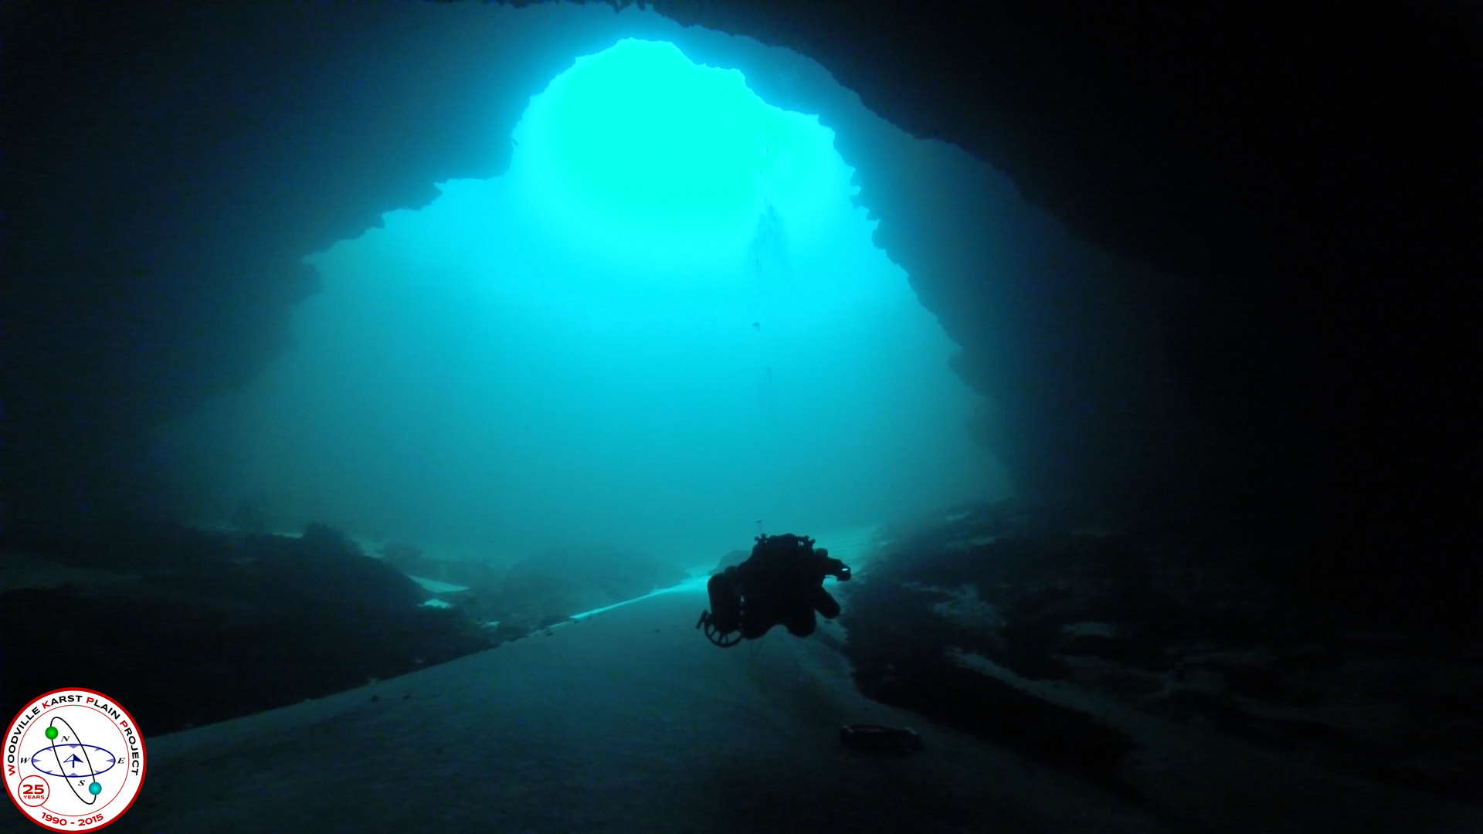
Wakulla Springs Alliance

Agenda, Friday, April 27, 2018
10:00 am to 1:00 pm
Woodville Community Center
8000 Old Woodville Rd, Tallahassee, FL 32305
10:00 Opening
Welcome and meeting agenda review (Seán McGlynn)
Introductions (Board)
Secretary Minutes (Bart Bibler)
Approved the March 23, 2018 Meeting Minutes.
Treasurer Report (Jim Davis)
Cal Jamison – Motion; Jim Stevenson – Second; Approved the Treasurer’s Report dated through the end of March.
10:15 Implementation of OSTDS Remediation Plan by the Florida Department of Health
- Eberhard Roeder, PhD, PE, CPM, Environmental Manager
  - Florida Department of Health, Division of Disease Control and Health Protection
  - Bureau of Environmental Health, Onsite Sewage Programs
The Department of Environmental Protection expects to adopt a new BMAP for Wakulla Springs by July 2018. The BMAP will include an OSTDS remediation plan. This presentation will discuss how the Department of Health will implement OSTDS remediation plans for nutrient-impaired Outstanding Florida Springs as mandated through the Florida Springs and Aquifer Protection Act, Florida Statute, Sections 373.801 through 373.813.
Eb’s PowerPoint Presentation is attached (revised version released by FDOH on May 14).
An owner should inspect and, if necessary, pump out a conventional septic tank every 3 to 5 years
Septic tanks convert nitrogen types into nitrate/nitrite.
The concentration of nitrate from a conventional septic tank may still deliver nitrate concentration of > 20mg/l to the groundwater.
Florida Statute requires that “new” OSTDS in Outstanding Florida Springs Primary Focus Areas must meet the nitrogen reduction standard in the Septic Tank Remediation Plan. DOH has a list of what is defined as “new.” This is different than a “repair.” Also discussed the definition of “failure” – 1) can’t flush your toilet because of backup; 2) effluent puddling above the drainfield; or 3) the tank or piping breaks such that the tank effluent isn’t all getting to the drainfield.
The Fl Springs Protection Act establishes new OSTDS requirements, including that new permits after July 1, 2018 on lots less than an acre in a PFA will require a nitrogen-reducing OSTDS, unless the applicant can demonstrate that a septic to sewer project will occur within five years. It is unclear whether local governments can require nitrogen-reducing OSTDS for even smaller lots. This needs to clarified.
Also discussed the Notice of Sewer Availability, which by law requires hookup of septic tanks within one year. This often does not occur by the utility. The WSA may advocate that this must be done by utility once a sewer is installed (not optional).
Great deal of concern expressed about enforcement of advanced OSTDS operation and maintenance requirements by County Health Departments. This is an historical problem, especially in Wakulla County. If it is not adequately enforced, we’re not going to achieve the nitrogen reduction expected by these septic tank upgrade requirements.
Approximately 8000 aerobic treatment units have been permitted in Florida.
The FDOH is revising their OSTDS rule (64E-6, FAC) to address in-ground nitrogen reducing biofilters, and identifying Aerobic Treatment Units that have been certified for >50% nitrogen reduction.
10:45 Questions
11:00 Wakulla Springs BMAP / OSTDS update – Bob Deyle, Bart Bibler and Seán McGlynn
The next FDEP BMAP meeting will be held on May 17, to discuss a first Draft BMAP.
A meeting with four members of the WSA has been requested with Drew Bartlett, FDEP, to be held on May 22. A WSA Water Quality Committee meeting/call will be held to discuss our expectations for the draft BMAP ahead of the May 17 meeting.
11:30 What’s New
- WSA Meeting Schedule for 2018
See Attachment.
- Legislative Update – Vivian Young
Funding for Florida Forever will be a priority. A post Session summary was sent out by Vivian to WSA members.
- SAV Planting – Cal Jamison
WS State Park has approved WSA to conduct some experimental plantings of various Submerged Aquatic Vegetation.
- Dye Study Update – Seán McGlynn
Sean showed pictures and a graph of dye concentration over time. (see attached update).
- Basin Tours – Jim Stevenson
Jim gave a tour with the Deputy Director of DEP for State Lands on the tour. He was so impressed that he arranged for a tour of Florida’s Cabinet aides, which was conducted last week.
- Grant Update – Bob Deyle, Seán McGlynn
- BBEF – Jim Stevenson
Big Bend Environmental Forum will be held on August 9 at Tallahassee City Commission Chambers. This usually motivates several candidates to take the Wakulla Springs Overland Tour. There will be a WSA exhibit. Jim would appreciate volunteers for staffing the exhibit, and a one gallon glass jar for display of Wakulla Springs water quality challenges.
- Camp Indian Springs – Cal Jamison
The new owner intends to reopen it as a Camp. He has also allowed access so that WSA can install charcoal packs as a potential receptor for the Lake Lafayette dye study.
- Wakulla Springs Panel – Seán McGlynn
A Wakulla Springs panel gave a presentation at FSU on April 5. It was held in conjunction with the Florida Chapter of Environmental Professionals.
- Land use in vulnerable areas of the Wakulla Springs Springshed – Gail Fishman
The City’s Airport property currently has a high number of monarch butterflies (caterpillars).
- Website and Social Media, Updates – Tom Taylor
Tom recently added a video of the Lake Lafayette dye study.
- Springshed Updates – Cal Jamison
The water clarity is improving at Wakulla Springs – approximately 40 feet deep. Minimum visibility threshold for the use of the glass bottom boats is 70 feet. It is anticipated to reach this visibility within the next couple weeks.
12:45 Items from the floor
Cal Jamison urged support for the new Wakulla County Historical society. And he encouraged attendance at the Friends of Wakulla Springs Board meetings, held the first Wednesday of each month at the Lodge at Wakulla Springs State Park.

Bart Bibler pointed out that his new company website, WakullaSpringsProtection.com, is up and running. Its purpose is to help raise funds for WSA, FOWS, and other lead advocate groups trying to protect WS.
13:00 Adjourn

Attachments: Minutes
Attachments: WSA March Financials

New Video Links
Wakulla Springs Improves
http://www.wctv.tv/content/news/Local-spring-water-quality-improves-480176093.html

Wakulla Springs Dye Study
https://www.tallahassee.com/media/cinematic/video/500763002/watch-it-sean-mcglynn-explains-wakulla-springs-alliance-dye-trace-study/
