Wakulla Springs Alliance

Friday, July 27, 2018 Board Meeting Minutes

This section provides information on what you and others can do to support research-based actions to enhance water quality and quantity in Wakulla Springs and springshed and to improve related environmental, economic and social systems. Efforts by all, produce results!

Background on Wakulla Springs

• Wakulla Springs Information
• WSA Purpose and Plans
• WSA Action Resources

Upcoming Events

- Put the WSA Board meeting on your calendar (Aug 24, Sep 28, Oct 26, Nov 30 (5th Fri), Dec 21. All 2018 WSA Board Meetings will be held in the 2nd floor conference room at the Renaissance Building, 435 N. Macomb St.
- Big Bend Environmental Candidate Forum, August 9 Forum 6:00 in the King Building.
- DEP is presenting the BMAP to the Wakulla County Commission public meeting on August 20. We need Chuck Hess and other people there to ask the key questions. Everyone is encouraged to attend.

Action Items

- Debbie Lightsey will draft a letter to FL Geological Survey requesting them to coordinate the water studies. Everyone should tell Debbie what groups should be involved.
- Doug Barr moved and Howard Kessler seconded the motion to approve the License Plate Grant application, which passed unanimously.
- Carlos Heard will explore DEP funding for a Waculla Co. Wastewater Facility Study study.
- A motion to do analysis advocacy regarding the Wakulla County Performance Based Treatment Systems Comp Plan and Ordinance Changes, including requesting involvement of the FOWS and seek funding for the study, was made by Debbie Lightsey, seconded by Doug Barr and passed unanimously.
- Pam Hall is doing an analysis of the Wakulla contribution to Wakulla Springs and will present it to Wakulla and BMAP staff as the Commission considers changing acreage requirements for nitrogen reducing septic systems.
- The Wakulla sign ordinance prohibits permanent signs but allows temporary signs for 180 days. Cal will check to see if it is OK to swap out the Save Wakulla Burma Shave-like signs every 179 days. Jim will be meeting with the Friends of Wakulla Springs to involve them.
- Jim Stevenson will send a list of those who have gone the Wakulla Watershed Tours
- Sean will draft a letter to Theresa Heiker to request a status report on the Comprehensive Wastewater plan RFP, possibly with a call and/or email.
- There is an airport advisory board that needs an environmental and resident representatives to address the master plan for management of the land that will affect water quality, wildlife and the eco-system. A lot of development is being considered.
- Ask those renovating of the FSU Golf Course to consider reuse water and pollution controls.
- Attend the Big Bend Environmental Candidate Forum, August 9 Forum 6:00 in the King Building. Submit questions for the candidates and talk to them at the reception before the forum.

WSA July Board Meeting Notes

Opening

- Welcome and meeting agenda review (Seán McGlynn)
- Introductions (Board, advisors and guests)
- Secretary Report (prepared by Bart Bibler, Secretary ) Motion by Doug Barr and seconded by Jim Stevenson was approved unanimously
- Treasurer Report (Jim Davis, treasurer) there was no report

Discussion and vote to approve next Liscence Plate grant – Seán McGlynn

- The grant application proposed to look at marine springs including Spring Creek plus sinks in Georgia, Lake Miccosukee, etc. Some will be dye studies in the caverns. Also doing Submerged Aquatic Vegetation, SAV, studies. Lake Talquin has high nutrients and may explain some questions. Lake Munson will be related to the County regular measurements.
- Pam Hall will help with the analysis
- The study of the marine springs will provide new information on flows and more.
- WSA is coordinating with FGS on Lake Miccosukee. Also coordinate with the County, City and others. Everyone needs to agree on the methods, data sharing, analysis and conclusions. There is a shared water database. The FL Water Quality Monitoring Group has regular meetings. STORET has been transferred to WIN, Watershed Information Network that is integrated into a national database. Water quality and flow data needs to be integrated.
- Debbie Lightsey will draft a letter to FGS requesting them to coordinate the water studies. Everyone should tell Debbie what groups should be involved.
- Doug Barr moved and Howard Kessler seconded the motion to approve the License Plate Grant application, which passed unanimously.

Wakulla County PBTS Comp Plan and Ordinance Changes

- The proposal reduces the exemption for PBTS from 5 to 1 acre.
- A Wastewater Facility Study should be done before making this decision
- There may be WMD or DEP funding for the study.
- Carlos Heard will explore funding from DEP for a Waculla County Wastewater Facility Study study.
- Leon and Wakulla have about 7500 septic tanks in the Primary Focus Areas, PFA. Replacement will cost about $20,000 each.
- In 20 years all standard systems must be removed to comply with the BMAP. It is better to put in the right system once and rather than forcing the owner to upgrade later.
- Pam Hall is doing an analysis of the Wakulla contribution to Wakulla Springs and will present it to Wakulla and BMAP staff as the Commission considers changing acreage requirements for nitrogen reducing septic systems.
- DEP is presenting the BMAP to the Wakulla County Commission public meeting on August 20. We need Chuck Hess and other people there to ask the key questions. Everyone is encouraged to attend.
- A motion to do analysis, advocacy including requesting involvement of the FOWS and seek funding for the study, was made by Debbie Lightsey, seconded by Doug Barr and passed unanimously.

WSA Burma Shave Campaign – Jim Stevenson

- The team is Jim Stevenson, Cal Jamison, Sean McGlynn and Debbie Lightsey
- They have selected 2 signs
- The Wakulla sign ordinance prohibits permanent signs but allows temporary signs for 180 days. Cal will check to see if it is OK to swap out the Save Wakulla Burma Shave-like signs every 179 days.
- This may be coordinated with the Friends of Wakulla Springs and Jim will be meeting with them.

Springshed Updates – Cal Jamison

- Creeks full and flowing.
- Placing charcoal packs to catch dye in about 10 springs.
- Sheppard Spring has more sulphus and less algae, DEP was installing data points for water flow studies.
- Met Rich Abrams owner of Indian Springs when placing dye packets. He was cleaning up the big meeting hall for meetings. He is supportive of the research and WSA.

Basin Tours – Jim Stevenson
- Rick Minor and others went on the tour recently
- Jim will send a list of those who have gone the Wakulla Watershed Tours

WSA Strategies

Tom Taylor reported that he reviewed the results of the strategic planning session held on July 26, 2017 and subsequent efforts, including the recent BMAP discussions. He presented the following goals that everyone agree to. Next the group reviewed the strategies. The comments at the meeting are bulleted “•”.

Possible WSA Strategic Goals

- Improve Water Quality
- Maintain Water Quantity
- Support Restore Ecosystems
- Promote Acquisition and Management Land
- Advance Science/Research
- Educate the Public & Leaders
- Build a more Effective Board
- Raise Funds for the Alliance

Goals, Strategies and Responsibilities

- Improve Water Quality Bart Bibler (chair), Bob Deyle and Cal Jamison.
  - Monitor BMAP litigation and respond appropriately.
    - Bart is following what the FL Springs Institute is doing
    - The FHBA and other springs have petitioned for a delay
  - Oppose the Wakulla County PBTS Comp Plan and Ordinance changes.
    - See notes above
  - Address the damming of Dove Pond in Welaunee-Canopy 1
    - This has a long and complicated history
    - No action at this time.
    - We are willing to consider a presentation for discussion only.
  - Complete Comprehensive Wastewater Plan (CWP) RFP for facilities plan – get it out to bid (Theresa Heiker, Tony Park, Vince Long)
    - Sean will draft a letter to Theresa Heiker to request a status report on the Comprehensive Wastewater plan RFP, possibly with a call and/or email.
    - We need to explore when and how the RME and funding will be addressed to satisfy the BMAP.
  - FDEP Discussion of BMAP Feasibility plan “template” (Greg DeAngelo) – Facilities, Financing and Management
  - Discussion and coordination for financing and management with Septic Tank Companies, Home Builders (TBA), Chamber of Commerce, Development Community (Todd Sperry). Seek agreement about financing and management to bring to local govt (BP-IA, LC), enhancing BMAP requirements for new development
  - Discuss with ED-FDOH (Alex Mahon) about new OSTDS regulations, relationship to COT and LC LDRs, 1 acre minimum for new development in PFAs
  - Comp Plan and LDRs - Reconcile PSPZ and PFAs – both LC and WC staff
  - Credit reduction calculation methods – FDEP staff
  - Enlist input and help from other organizations and committees such as LC Water Resource Committee, LC&COT Science Advisory Committee, Friends of Lake Jackson, Sustainable TLH, Wakulla organizations?? HOAs?
  - Advocate for cluster demonstration projects in new and existing developments,
  - Provide input on the Comprehensive Plan update. (Pam Hall)
  - Provide input on how BP oil spill funds will be used.
    - 15 Million will be used in Wakulla for sewer
- Maintain Water Quantity Bart Bibler (chair) and Cal Jamison
  - Support WMD efforts to set minimum flows and levels.
- Restore Ecosystems Bob Deyle (Chair), Gail Fishman, Sean McGlynn,
  - Provide sound data on the natural world encompassed within the Wakulla Springs basin, the changes occurring due to human impacts, and other naturally occurring phenomena.
- Acquire and Manage Land Cal Jamison, and Albert Gregory.
  - Address this in the SWIM plans, with the local legislative delegation before and during legislative sessions, with state agencies for funding, with local government commissions and departments, and with a campaign to build public support for protection of the Springs zone
- There is an airport advisory board that needs an environmental and resident representatives to address the master plan for management of the land that will affect water quality, wildlife and the eco-system. A lot of development is being considered.
- Ask about the renovaton of the FSU Golf Course to consider reuse water and pollution control.

- Advance Science/Research Sean McGlynn (Chair), Bob Deyle, & Cal Jamison
  - Understanding the role of the lakes in Wakulla Springs ecological status, incliuding better analysis of stormwater runoff.
    - There are dye and algae studies being conducted by the WSA.
    - Modeling is needed for stormwater runoff from landscape to conveyances to lakes, to groundwater and to the aquifer
    - Quantification of nitrogen budgets for lakes is needed
    - There should be a discussion with COT (Marc Heidecker), LC (Johnny Richardson), FDEP (Brian Katz), hydrologists (Alan Niedoroda, Tom Kwader), etc.
    - Consider the history of lake “clean ups” such as removal of sediments from Lake Jackson, Lake Munson drawdowns, Lake Henrietta, etc.
    - Other sources of nitrogen in runoff than fertilizer
    - Integrate lakes as final receiving water body
    - Consider using stormwater treatment studies – Bradfordville Storm Water Study (2000?), Statewide Study (2007)
    - BMAP – Agriculture Fertilizer
      - Evidence for effectiveness – BMAP literature, staff help
      - Evidence from existing BMAP plans, first 5 year implementation reports
      - Re-estimate Ag fertilizer using USDA data?? Is this worth it??
    - Initially done with WSA experts and other groups with expertise or as presentations to them for feedback.

- Educate the Public & Leaders Gail Fishman (chair), Debbie Lightsey, Howard Kessler, and Jim Stevenson
  - WSA Burma Shave Campaign (see above)
  - Big Bend Environmental Candidate Forum
    - August 9 Forum 6:00 in the King Building
    - Go and ask questions, more impress the candidates more
  - Host public presentations at special meetings.
  - We will get septic tank information out. The CONA-Sustainable Tallahassee sustainability award can include Springs related criteria. Having a TAPP presentation could be a check item.
  - We could have a special springshed tour for key leaders.
  - There are PSAs on dog poop. TAPP has a $200k budget and we can talk to them. Debbie will follow-up on this. They have a good video on fertilizer. It would be good to get them to focus on springs as well as lakes.
  - Keep website and FB current.
  - Howard Kessler will look for information on pharmaceuticals in the water.
  - Jim Stevenson is doing an OLLI group that can become advocates. There will also be tours for McClay and other schools.

- Build a more Effective Board Howard Kessler
  - Review the bylaws should be reviewed to determine if updates are needed, including clarification of definition of “members.”
- Raise Funds for the Alliance
  - Encourage board members to provide a $100 annual contribution.
  - Create possible sponsor/supporter categories and amounts, e.g. WS Eagle, Osprey, Limpkin, Coot
  - Seek grants with administrative fees.
Appendix A
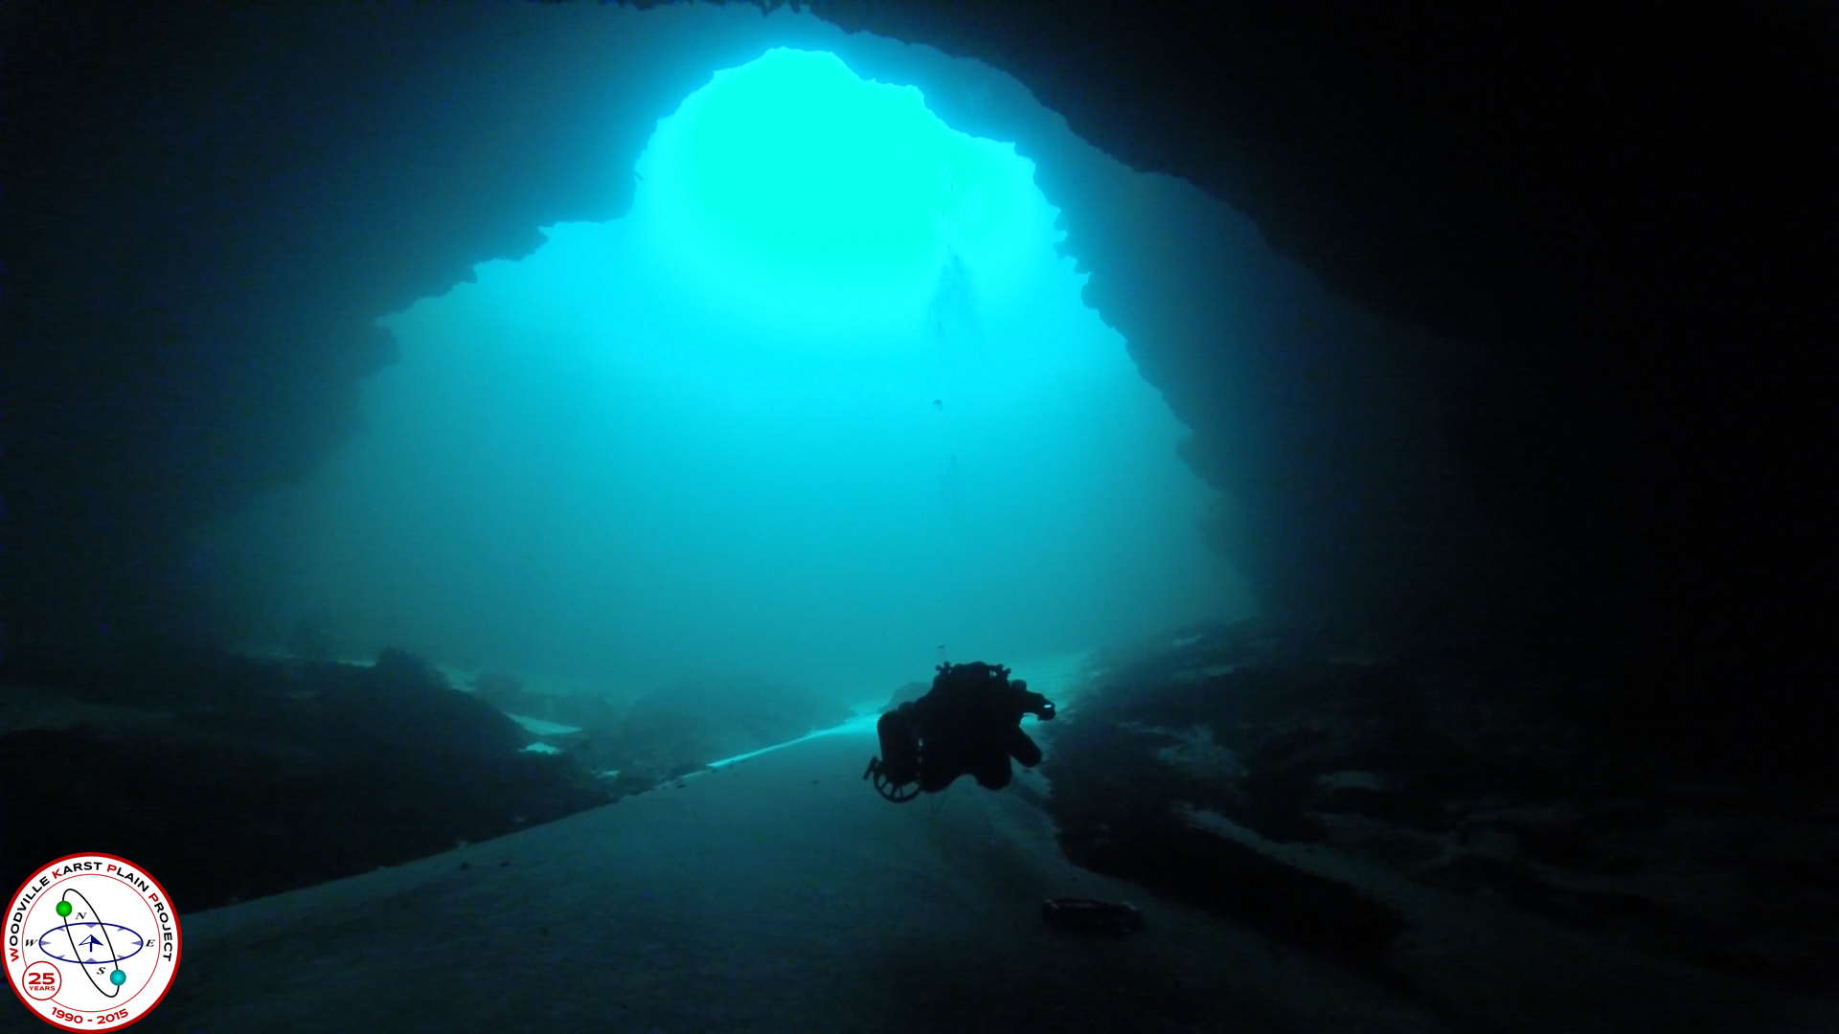
Wakulla Springs Alliance

Agenda, Friday, July 27, 2018
9 am to 12 pm, Renaissance Center
435 N. Macomb Street, 2nd Floor Conference Room

WSA July Board Meeting
9:00 Opening
Welcome and meeting agenda review (Seán McGlynn)
Introductions (Board)
Secretary Report (Bart Bibler, secretary )
Treasurer Report (Jim Davis, treasurer)
9:10 Discussion and vote to approve next Liscence Plate grant – Seán McGlynn
9:20 Discussion of the BMNAP litigation – Seán McGlynn
9:40 Questions
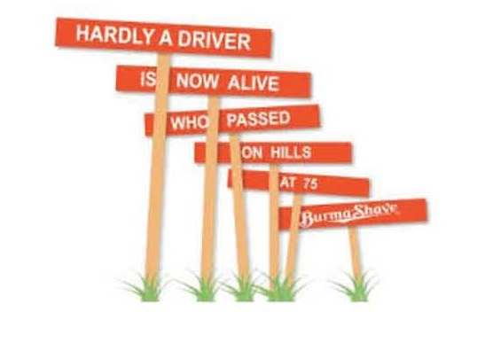
9:50 Projects and Partners, the next Springs Funding and Open Forum
10:00 Questions
10:10 WSA Burma Shave Campaign – Jim Stevenson
10:40 Whats New
- Camp Indian Springs – Cal Jamison
- Springshed Updates – Cal Jamison
- Basin Tours – Jim Stevenson
- BBEF – Jim Stevenson and Seán McGlynn
- WSA Meeting Schedule for 2018 – Seán McGlynn
- Dye Study Update – Seán McGlynn
11:45 Items from the floor
12:00 Adjourn

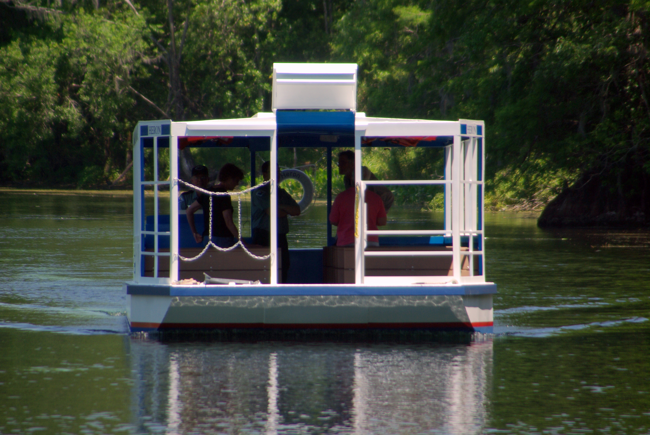

Appendix B
Board, Advisors and Guests
* Indicates 7-27-18 Participants

Board Members

Doug Barr *
Bart Bibler, Sec
Jim Davis, Trea
Gail Fishman
Albert Gregory *
Jamie Hughes
Cal Jamison *
Howard Kessler, V-Chr *
Debbie Lightsey *
Sean McGlynn, Chair *
Jim Stevenson *
Vivian Young

Guests

Mark Heidecker *
Carlos Herd *
Mary Beth Litrico *
Johnny Richardson *
Tom Taylor *
Ming Ye *

WSA Advisors

Anthony Gaudio
Pam Hall *
Julie Harrington
Chuck Hess *
Todd Kincaid
Bob Knight
Terrance McCaffrey
Pam McVety
Dan Pennington
Bob Thompson
Appendix C

Anthony Gaudio: We can fix the problem of septic systems
My View; Published 12:00 a.m. ET Jan. 20, 2014 | Updated 12:05 a.m. ET Jan. 20, 2014
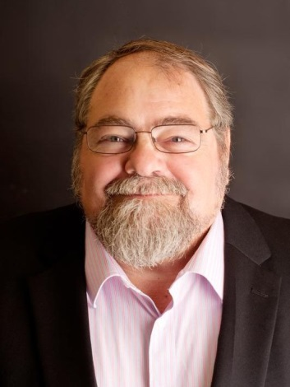
(Photo of Anthony Gaudio: Beth Johnson)
CONNECTTWEETLINKEDINCOMMENTEMAILMORE
What’s the problem with septic tanks?
The short answer is that, in most soil conditions, there is no problem for properly designed, installed and maintained septic systems. The EPA determined in 1999 that septic systems can be a permanent component of a community’s wastewater disposal infrastructure for protecting public health and the environment.
Here in Leon County, suitable soil conditions are mostly found north of the Cody Scarp, a geologic designation that approximates the path of Tram Road. Tallahassee’s Red Hills region has a deep clay layer that limits nutrient discharge from septic tanks to ground water.
Conditions south of the Cody Scarp are entirely different. Here there are sandy soils over porous karst limestone rock. In these soils, nutrients flow freely through sandy layers into the aquifer.
Septic tanks and drainfields create bacteria-rich environments, which do a good job of treating human waste, but they do not remove much of the nutrients phosphorus and nitrogen. These are discharged from the tanks into the soil beneath the drainfield. Some of the phosphorus is stored in the soil and some of the nitrogen is used by the plants growing over the drainfield. But more than half of the nitrogen, which is water soluble, goes wherever the water goes, rapidly percolating into the aquifer.
High nitrogen concentrations are a significant part of the degradation of Wakulla Springs, where the aquifer surfaces in spectacular fashion. The city of Tallahassee’s central sewer sprayfields were identified as the major source of nitrogen that contributed to this problem. In response, the city utility is spending $227 million to bring down its nutrient discharge. After this process is completed, the U.S. Geologic Survey estimates that the largest contributor to the spring’s nutrient problem will be septic tanks below the Cody Scarp, an area designated as the Primary Springs Protection Zone (PSPZ). Reducing the nutrient contribution of septic systems to the springs should now become an important policy objective of local and state governments.
There are approximately 40,000 septic systems in Leon County; 7,600 are in the PSPZ, and these are the systems that need our attention. For comparison, after upgrades are completed, the city sewer sprayfields will discharge 3 milligrams per liter of total nitrogen, while standard septic systems studied in the PSPZ discharge from 50 to 70 mg/l.
Fortunately, we have many possible engineering solutions available. Nitrogen-reducing septic systems can reduce discharge by up to 70 percent, with more advanced systems in development. City sewer can economically be extended to some of the areas now served by septic, like the Lake Munson area. Cluster systems, which collect waste from a number of homes but treat it locally instead of sending it to a large sewer plant, can be used in existing residential and business districts such as Woodville. These systems can be built incrementally as demand and financial capacity exist.
However all of these approaches have similar costs per home or business. Treating wastewater to remove nitrogen and support development has costs no matter what engineering solution is used. The most economically sensible approach is to gear the engineering solution to the environmental and development needs.
Our challenge is to identify and finance these solutions. One method is to create a countywide onsite wastewater utility, often referred to as a Responsible Management Entity (RME). This utility could collect an onsite wastewater disposal fee from all county septic systems, similar to a solid waste or stormwater fee. This would not unfairly burden residents in the PSPZ with the costs of needed upgrades and could create a mechanism for identifying the need, and paying for the maintenance, repair and upgrades for all county septic system users.
The Leon County Water Resource Committee and the Wakulla Springs Alliance offered this concept to the Leon County Sales Tax Committee as a recommendation, and it was accepted as Project No. 39 Alternative Sewer Solutions: Creating Comprehensive Wastewater Management for Leon County Unincorporated Area (Nitrogen Reduction and Infill Development).
Taking responsibility for our wastewater and its environmental impacts is the responsibility of all of us, and the sooner we take collective corrective action the less costly those actions will be.

Anthony Gaudio is a retired Florida certified underground utility contractor and master septic tank contractor. He is president of Sustainable Tallahassee and a member of the Wakulla Springs Alliance. Contact him at anthony@gaudioenterprises.com.

